Long-term Trends in Fisheries and Limnological Data for Georgetown Lake, Montana and their Management Applications

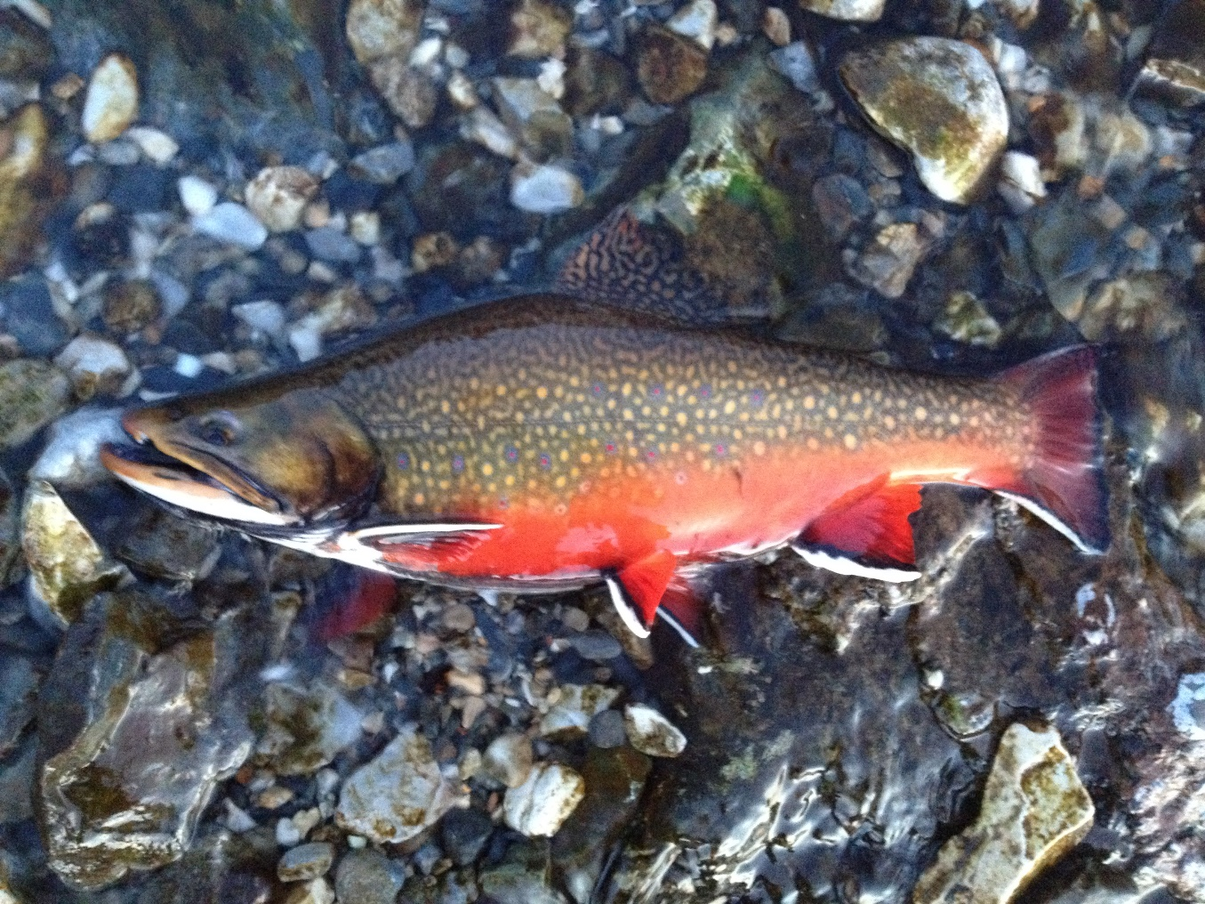

Brad Liermann, Fisheries Management Biologist
Montana Fish, Wildlife and Parks
November 2024

Introduction
Georgetown Lake is a high elevation reservoir located in southwestern Montana, about 8 miles south of the town of Philipsburg. It is approximately 2088 surface acres at full pool making it the largest still-water body in the upper Clark Fork River drainage (Berg 2009). The fishery is managed as a put, grow, and take fishery for rainbow trout and brook trout and as a wild, self-sustaining kokanee salmon (kokanee) fishery. Georgetown Lake routinely ranks in the top 10 in Montana for angling pressure and is equally important as both a summer and winter ice-fishing destination. This highly productive reservoir is generally known for producing large numbers of quality sized rainbow trout, abundant kokanee, as well as being a premier location for catching trophy brook trout.
The rainbow trout fishery in Georgetown Lake is sustained by annual stocking from Montana Fish, Wildlife and Parks (MFWP) hatcheries. Rainbow trout spawning does occur in Stuart Mill Creek and North Fork Flint Creek, but the amount of recruitment this spawning provides to the population is unknown. Rainbow trout stocking densities and strains have varied through time (Table 1). Gerrard rainbow trout stocking ended in 2009 due to the brood source being determined to not be an actual Gerrard strain. Eggs from the Canadian Gerrard brood stock were obtained by MFWP and stocking of actual Gerrard strain rainbow trout was initiated in Georgetown Lake in 2015. Brook trout stocking was initiated in 2004 due to a reduction in angler catch rates observed for this species (Table 1). Brook trout have traditionally been an important component of the Georgetown Lake fishery.
Georgetown Lake has been monitored by Montana Fish, Wildlife and Parks (MFWP) for many years due to its importance as a recreational fishery. Unfortunately, monitoring efforts have not always been completed routinely and the techniques used to assess population size and size structure have also varied. The most common technique used to assess the fishery in Georgetown Lake in the past was winter creel survey. More recently, gill netting has been initiated as an additional method to better monitor this important fishery. This report provides a summary of recent and long-term data available on Georgetown Lake for both winter creel surveys and gill net surveys and provides an assessment of the current state of the fishery. This report also provides an overview of a fish kills that occurred in 2018 and 2023 and provides data assessing the survival of the three rainbow strains currently stocked into Georgetown Lake. Recent limnological data and comparisons to historical data are also presented to assess potential changes in these conditions and their impacts on the fisheries.
Methods
Gill netting
Gill netting was initiated on Georgetown Lake in 2004 to supplement historic winter creel survey data collection efforts. Gill netting is a standard monitoring tool that is used widely throughout Montana and the western United States to monitor and assess lake fisheries. As such, the information is useful for comparing fish populations between years and between water bodies. Gill nets are effective at capturing many different species and size classes of fish making them useful for monitoring sport fish populations and for assessing entire fish communities. Gill netting was also initiated on Georgetown Lake to better assess the status of undesirable fishes in the reservoir including lake trout (which have been previously sampled in the reservoir) and
Table 1. Total number and strains of trout stocked in Georgetown Lake from 2010 through 2023.
Year | Species | Strain | Number stocked
2010 | Rainbow trout | Arlee | 66,875
2010 | Rainbow trout | Eagle Lake | 93,696
2010 | Brook trout |  | 48,488
2011 | Rainbow trout | Arlee | 75,455
2011 | Rainbow trout | Eagle Lake | 100,680
2011 | Brook trout |  | 58,643
2012 | Rainbow trout | Arlee | 68,366
2012 | Rainbow trout | Eagle Lake | 106,652
2012 | Brook trout |  | 64,835
2013 | Rainbow trout | Arlee | 72,986
2013 | Rainbow trout | Eagle Lake | 100,630
2013 | Brook trout |  | 49.328
2014 | Rainbow trout | Arlee | 83,136
2014 | Rainbow trout | Eagle Lake | 109,674
2014 | Brook trout |  | 50,000
2015 | Rainbow trout | Arlee | 82,521
2015 | Rainbow trout | Eagle Lake | 88,990
2015 | Rainbow trout | Gerrard | 24,949
2015 | Brook trout |  | 50,543
2016 | Rainbow trout | Arlee | 53,247
2016 | Rainbow trout | Eagle Lake | 82,416
2016 | Rainbow trout | Gerrard | 24,724
2016 | Brook trout |  | 14,379
2017 | Rainbow trout | Arlee | 80,894
2017 | Rainbow trout | Eagle Lake | 78,412
2017 | Rainbow trout | Gerrard | 20,974
2017 | Brook trout |  | 42,302
2018 | Rainbow trout | Arlee | 50,717
2018 | Rainbow trout | Eagle Lake | 80,336
2018 | Rainbow trout | Gerrard | 22.992
2018 | Brook trout |  | 51,164
2019 | Rainbow trout | Arlee | 53,487
2019 | Rainbow trout | Eagle Lake | 86,132
2019 | Rainbow trout | Gerrard | 38,256
2019 | Brook trout |  | 54,950
2020 | Rainbow trout | Arlee | 50,199
2020 | Rainbow trout | Eagle Lake | 84,000
2020 | Rainbow trout | Gerrard | 31,541
2020 | Brook trout
2021 | Rainbow trout | Arlee | 52,831
2021 | Rainbow trout | Eagle Lake | 59,525
2021 | Rainbow trout | Gerrard | 32,789
2021 | Brook trout |  | 41,135
2022 | Rainbow trout | Arlee | 107,357
2022 | Rainbow trout | Eagle Lake | 98,175
2022 | Rainbow trout | Gerrard | 54,825
2022 | Brook trout
2023 | Rainbow trout | Arlee | 53,384
2023 | Rainbow trout | Eagle Lake | 79,123
2023 | Rainbow trout | Gerrard | 28,000
2023 | Brook trout |  | 22,880

other species that could potentially be introduced into the reservoir (i.e. northern pike, etc…) (Berg 2009).
Gill netting efforts completed on Georgetown Lake have followed the methods outlined in Berg (2009). Gill netting was initially conducted every year from 2004-2006 to provide a baseline data set for the fishery. Gill netting was conducted subsequently in 2008, 2010, 2011, 2013, 2015, 2017, 2018, 2020, 2021, 2022, and 2023 with the goal of sampling at least every two years. In 2004, a total of 15 gill nets were set at various locations throughout the lake. The number of nets set was increased in 2005 to 18 nets to provide additional coverage of the lake and all 18 sites have been sampled in subsequent years. Gill net data from 2004 are not included in this report due to this discrepancy in net numbers.
The gill nets used are the standard Montana Fish, Wildlife and Parks experimental gill nets which are 1.8 m (6 feet) deep and 38 m (125 feet) long. These experimental nets are constructed of monofilament and consist of five panels of various mesh sizes including 1.9 cm (3/4 inch), 2.5 cm (1 inch), 3.2 cm (1 ¼ inch), 3.8 cm (1 ½ inch) and 5.1 cm (2 inch) square mesh panels. Both sinking and floating gill nets were used in order to better assess the entire fish community, with a total of 13 floating nets and five sinking nets deployed. Gill nets were deployed in mid-September each year and identical netting locations were used in attempt to standardize the sampling efforts from year to year, except for net 16 which was set at different locations some years (Figure 1). The netting locations were navigated to using previous years’ GPS coordinates with GPS coordinates being recorded at the outer buoy of each net set.
Catch rates were calculated for specific size groups of trout and salmon. These size groups were fish greater than 300 mm for rainbow and brook trout and fish greater than 200 mm for kokanee. The greater than 300 mm size group was used for rainbow and brook trout to limit the number of Age 0 and Age 1 fish that contributed to these catch rates. Eliminating Age 0 and 1 fish from this analysis prevents significant skewing of abundance due to high recruitment years (i.e. years of good survival of age 0 fish planted). Also, in certain years of high growth, some Age 0 rainbow trout can attain a large enough size to recruit into the gill net catch (appx. 170 mm) which biases the catch rates for these years. Similarly, the 200 mm size group for kokanee eliminates Age 1 kokanee from the analysis which limits the bias of natural recruitment and also potentially high growth years for the Age 1 year class which can both affect kokanee catch rates. These size classes also represent fish that are more likely to be caught by anglers and thus are better indicators of the quality of the fishery.
Rainbow Trout Strain Evaluation
An evaluation of rainbow trout strain performance was initiated in 2016. Tetracycline marks were used to differentiate the three strains of rainbow trout stocked into Georgetown Lake. These marks were placed on these fish while they were being raised at a MFWP hatchery via tetracycline infused feed pellets. The marks were detected by observing whole vertebrae under a low power dissecting microscope. The sample was irradiated by a black light lamp under the microscope to fluoresce the tetracycline mark. For strain identification, Arlee strain fish were given no tetracycline and thus had no marks. Gerrard strain fish were given one dose of tetracycline to develop a single mark and Eagle Lake strain fish were given two separate doses of tetracycline to develop two marks on the vertebrae.
Since tetracycline marking was initiated in 2016, only Age 0 were assessed for marks from 2017 samples. The length of Age 0 fish was delineated using a length frequency histogram and for 2017, the upper range of Age 0 fish appeared to be approximately 260 mm. This was a conservatively low estimate of the upper range of Age 0 fish, as accidentally including Age 1+d fish with no marks would bias the results towards unmarked fish (Arlee strain). Thus, samples from fish greater than 260 mm were not included in the results. Samples for strain evaluation in 2020-2022 were collected from all size classes of rainbow trout as fish up to Age 5+ should have been marked by this period. It is assumed that by 2021, all of the fish sampled were Age 6 or younger and would have been marked as a juvenile in the hatchery, but it is possible that some fish older than Age 6 were mis-identified as Arlee strain by having no mark.
Some difficulty in discerning double tetracycline marks was encountered with a number of fish in the 2017 samples. For unknown reasons, the second (outer) tetracycline mark appeared to not form well on all fish and thus, sample size of vertebrae read on all fish with at least a single mark was increased to four to six vertebrae. It was observed on multiple samples that only a single mark would be observed on the first or second vertebrae viewed, but that a second mark would be observed on subsequent vertebrae. It was found that a sample size of four to six vertebrae was adequate to clarify whether fish had a single or double mark. It was rare to find a single mark that was not discernible, as the first mark appeared to have been more clearly developed on both the Gerrard (single mark) and Eagle Lake strains (double mark).
Winter Creel Survey
Winter creel surveys were used to monitor angler catch rates and average length of harvested fish including rainbow trout, brook trout and kokanee. Georgetown Lake provides excellent ice fishing opportunities and thus receives substantial pressure during the winter season, which allows for a relatively large number of anglers to be surveyed. Winter creel survey is believed to be advantageous at Georgetown Lake compared to creel surveys conducted during other seasons, as all the salmonids commonly targeted by anglers are harvested during this time period, including rainbow trout, kokanee and brook trout. Summer/fall creel surveys, on the other hand, may only provide limited catch rates for kokanee due to the difficulty associated with catching kokanee during these months in Georgetown Lake. This is due extensive weed growth limiting anglers from trolling for kokanee which is a very effective method for catching this species during summer and fall months. Also, fall salmon snagging is not allowed at Georgetown Lake, despite this type of angling being allowed at many other regional lakes.
The methods of winter creel surveys previously conducted for Georgetown Lake are relatively simple and do not follow typical creel survey methodologies (Malvestuto 1996). However, this data is the longest term data set and provides a historical perspective of the fishery. These surveys have typically been completed during January. This is a reliable time of year to collect creel survey data as the ice is completely formed and angling pressure appears to be consistent. Over the years, winter creel surveys have been completed at various points throughout the month of January with no specific dates being targeted. The surveys were completed in attempt to reach a minimum number of rainbow trout (appx. 100) to provide sufficient sample size to analyze the size structure of this population. During some years, the total number of anglers interviewed in a party was recorded along with the total number of each species caught by the angler and the total number of angler hours spent fishing up to the point of the interview. The total length of observed fish was commonly measured, although not all fish were measured and

Figure 1. Gill net locations for Georgetown Lake completed from 2005-2023.
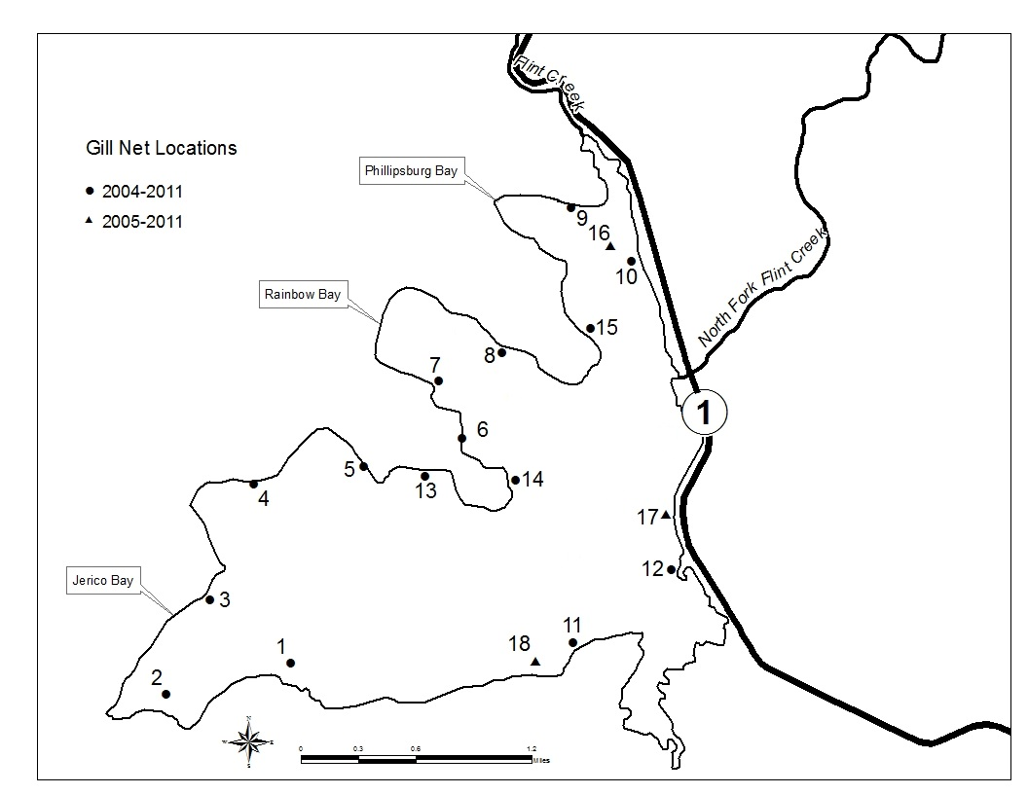
length measurements were not completed every sample year. Some demographic information was also recorded in some years including the city and state where the angler resided. The locations of angler interviews were not recorded in the historic data (pre-2010), although it is assumed that interviews were conducted around most of the reservoir due to its relatively small size.
Angler catch rates were calculated for each species based on the means-of-ratios methodology (Malvestuto 1996). Angler catch rates were calculated using the total number of fish captured per day divided by the total number of angler hours exerted on that day. The means-of-ratios were then calculated by taking the average of these daily catch rates for the entire sample period (month of January). Summary statistics were calculated using typical parametric procedures to calculate variance and 95% confidence intervals for independent observations (Malvestuto 1996).
From 2010 through 2023, the creel surveys were initiated relatively early in the morning (8:00-9:00 am) to ensure an adequate sample size of anglers and to allow time to interview anglers around the lake. The creel clerk drove around the entire lake and interviewed all anglers observed that were within walking distance from the lake shore at accessible sites. These surveys began in the morning at Flint Creek Dam and continued down the west side of the lake (Sunnyside and Comer’s Point). The creel clerk would then drive around to the south side of the lake (Denton’s Point) and finally up the east side of the lake (Grassy Point, Pump House and Red Bridge) with the entire lake typically being covered each survey day. Both weekdays and weekends were surveyed from 2010 through 2023 with both being surveyed in proportion to the number of these days in a given week (2 weekend days for every 5 weekdays). Additional data was collected from 2010 through 2023 that was not collected in previous years including where the angler was fishing, what species the angler was targeting and their opinion on the quality of the fishing.
Limnology
Primary productivity in lakes and reservoirs is generally driven by the abundance of nitrogen and phosphorous within them (Wetzel 1982). The abundance of zooplankton and other aquatic invertebrates are also related to the amount of primary productivity (Wetzel 1982) and these organisms constitute the primary forage base for salmon and trout in Georgetown Lake. Zooplankton are a particularly important forage base for kokanee which are nearly obligate zoo-planktivores in most lakes and reservoirs. Thus, measurement of these factors can shed light on the growth and survival of particularly salmon but also trout in reservoirs such as Georgetown Lake.
With recent observations of significant improvement in growth rates of kokanee and rainbow trout, several productivity indices were investigated to better understand the causes of these changes in growth including measuring nitrogen, phosphorous, Secchi depths, phytoplankton abundance, zooplankton abundance and zooplankton species composition. Water samples were collected using methods described in Stafford (2013). Total Nitrogen and Total Phosphorus were the indices of nutrients assessed while Chlorophyll-a and Secchi depth were the indices used to assess the abundance of phytoplankton in Georgetown Lake. Zooplankton were collected via vertical net hauls from ~0.5 m above the bottom to the surface using the same net as Stafford (2013). Zooplankton were preserved in 70% ethanol and later identified using the same method as Stafford (2013). All of these indices were compared to the same indices from 2009-2011 to assess changes in these variables in Georgetown Lake over time (Stafford 2013).
Results
Gill netting
Fish species captured in Georgetown Lake during gill netting surveys include rainbow trout, kokanee, brook trout, largescale suckers, longnose suckers, and redside shiners. Lake trout are also occasionally captured, although they are at very low abundance. Largescale suckers and redside shiners are also captured in very low abundance. Rainbow trout are the most abundant fish captured during gill netting while kokanee were typically the second most abundant species sampled. Longnose suckers are the most abundant native non-game species captured each year.
Comparison of catch rates through period of record for gill netting suggest that catch rates have been stable for rainbow trout greater than 300 mm across this entire period, but appear to have declined somewhat from 2020 through 2023 (Figure 2). Catch rates for rainbow trout greater than 300 mm have typically been 12-15 fish per net night, however catch rates were at or
Figure 2. Catch rates of rainbow trout greater than 300 mm (95% confidence intervals) for Georgetown Lake gill netting completed from 2005-2023.
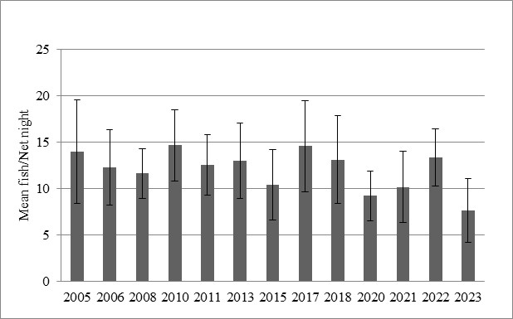
substantially below 10 fish per net night in 2020, 2021, and 2023 (Figure 2). Catch rates were similar in 2022 to pre-2020 rates.
Catch rates for kokanee greater than 200 mm were between five and 10 fish per net night from 2005 through 2018. Catch rates increased substantially in 2020 and 2021 and were found to be between 13-15 fish per net night. Catch rates dropped again in 2022 and 2023 to more typical catch rates of 5-8 fish per net night (Figure 3). Inter-annual variation in catch rates tended to be higher for kokanee than for rainbow trout (Figures 2 and 3).

Figure 3. Kokanee catch rates (95% confidence intervals) for fish greater than 200 mm for Georgetown Lake gill netting completed from 2005-2023.
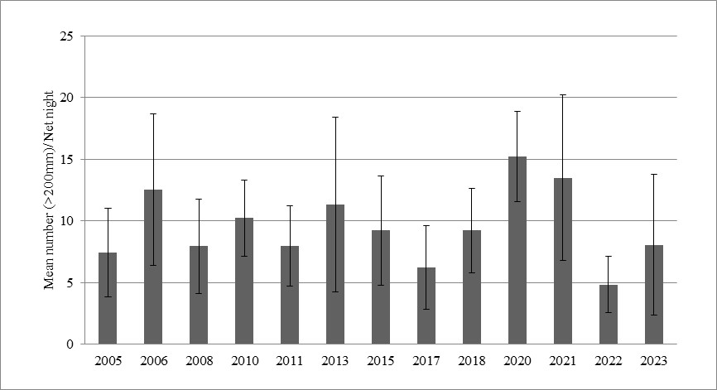

Brook Trout catch rates have been quite variable through the period of record for gill netting. Catch rates initially increased each sampling year and peaked in 2010. This period was reflective of a population that was establishing with steadily increasing catch rates. Catch rates from 2011 through 2018 were near the long-term average but were still well below the highest catch rates observed in 2010, although catch rates did improve during 2020 to 2022 to over two fish per net night and exceeded four fish per net night in 2023.
Figure 4. Brook trout greater than 300 mm catch rates (95% confidence intervals) for Georgetown Lake gill netting completed from 2005-2023.
+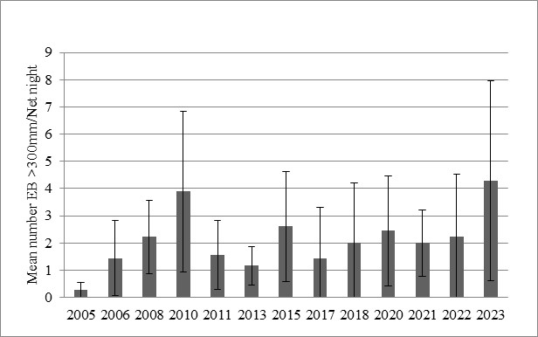
Size structure
A comparison of average length data was completed for the three main recreational species sought by anglers in Georgetown Lake to assess potential changes in the size structure of these populations. Length frequency histograms were also constructed for each year of sampling, but histograms will not be presented in this report, due to the large number of graphs. The average length of rainbow trout greater than 300 mm was generally between 350 and 370 mm from 2004-2015 (Figure 5). A noticeable increase in this index was observed in 2017 through 2022 with lengths averaging approximately 400 mm. Rainbow trout caught in 2023 showed another increase with average length being 433 mm (Figure 5). A comparison of length frequency histograms for rainbow trout also demonstrates this increase with noticeable increases in the number of fish greater than 450 mm since 2018.

Figure 5. Average lengths and 95% confidence intervals for rainbow trout greater than 300 mm captured during gill net surveys on Georgetown Lake from 2004-2023.
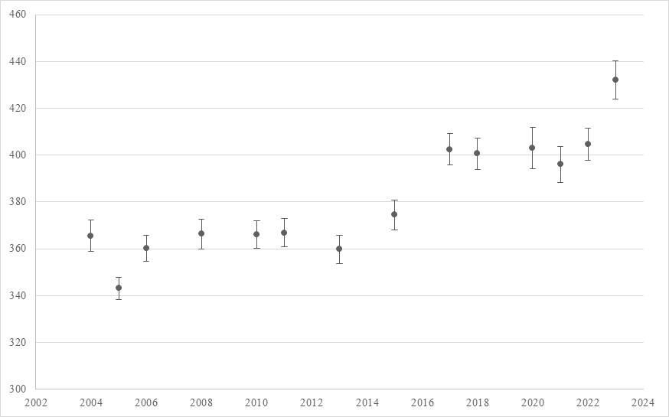

The average length of brook trout greater than 300 mm has varied through time in Georgetown Lake. A comparison of this index suggests that the number of brook trout in this size class improved from 2015-2018 (Figure 6). In previous years, average lengths in this size class averaged between 350 and 390 mm. Average lengths of fish greater than 300 mm increased to 386, 410, and 437 mm in 2015, 2017 and 2018, respectively. The loss of brook trout greater than 400 mm during the 2011 and 2013 gill netting efforts was documented by Liermann (2013). Length frequency histograms also indicate that the number of brook trout greater than 400 mm has improved in recent years.
Figure 6. Average lengths and 95% confidence intervals for brook trout greater than 300 mm captured during gill net surveys on Georgetown Lake from 2005-2023.
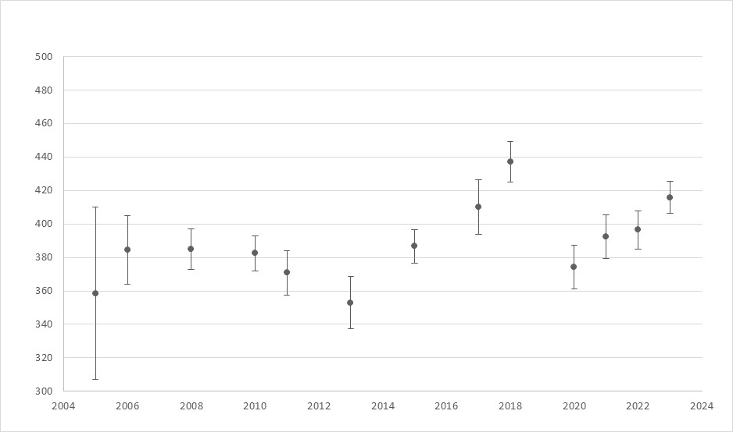
The average length of kokanee greater than 200 mm has also varied since gill netting was initiated in 2004. Generally, this index decreased through time to the lowest average of 262 mm observed in 2013. Since 2013, there has been a trend of increasing average length up to 2017 and 2018 when kokanee averaged 283 and 293 mm (Figure 7). Following this increase, a very large increase in average length was observed in 2020 and 2021 to 340 mm and 313 mm. These were the highest average lengths ever observed during gill netting. Kokanee average lengths fell to more normal values in 2022 and 2023 (Figure 7).

Figure 7. Average lengths and 95% confidence intervals for kokanee greater than 200 mm captured during gill net surveys on Georgetown Lake from 2004-2023.
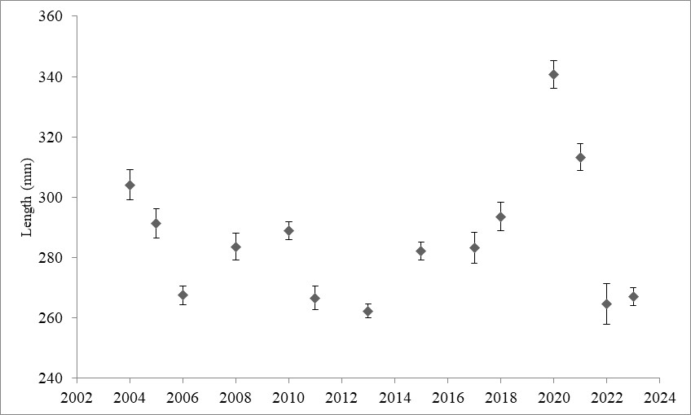s

Winter Creel Survey
Creel surveys were completed during January in 2014, 2016, 2018, 2019, 2021 and 2023 to assess angler catch composition and catch rates. Angler catch rates for rainbow trout were steady throughout this period and were generally near 0.5 fish per angler hour (Figure 8). These catch rates were also very similar to catch rates observed in the 1990’s and 2000’s. Catch rates did drop substantially in 2021 and 2023, similar to what was observed during gill netting efforts the previous fall.

Figure 8. Angler catch rates and 95% confidence intervals for rainbow trout in Georgetown Lake from 1978 through 2023. Years with no data represent years when no winter creel surveys were completed.
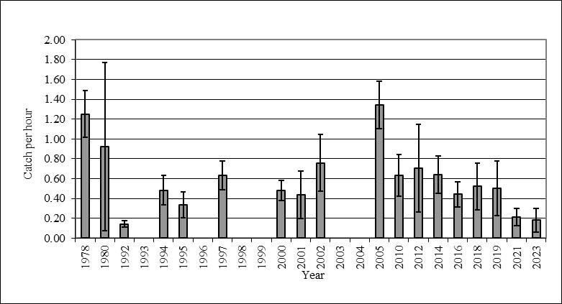

Unlike rainbow trout, kokanee catch rates have varied substantially from 2014 through 2023 (Figure 9). The kokanee catch rate in 2014 was 2.8 fish per hour, which was higher than was observed during most years within the past decade. Unfortunately, catch rates were much lower from 2016 to 2023. These catch rates are lower than most years, with catch rates from 2018 to 2023 being some of the lowest observed throughout the years of creel monitoring. Interestingly, these low catch rates did not mirror gill net catch rates suggesting that this trend may not truly be population dynamics and may be an artifact of angling conditions. Brook trout catch rates during the winter creel survey continue to be low enough, that comparison of catch rates is not effective at assessing trends in this fishery.

Figure 9. Angler catch rates and 95% confidence intervals for kokanee in Georgetown Lake from 1978 through 2023. Years with no data represent years when no winter creel surveys were completed.
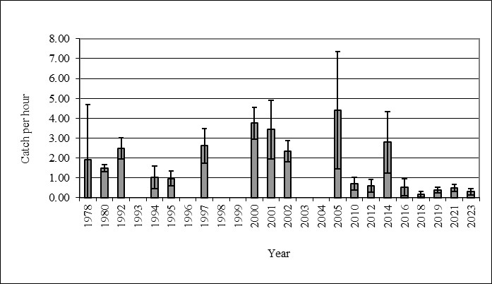

Size Structure
Length data collected during winter creel surveys suggest that rainbow trout average length is likely increasing in Georgetown Lake from 2018 through 2023. This trend is similar to the trend observed for rainbow trout in the gill netting data set. Over the previous multiple decades, rainbow trout average lengths for fish measured during the winter creel survey generally averaged between 300 and 350 mm. From 2018 through 2022, rainbow trout lengths averaged closer to 400 mm and approximately 430 mm in 2023 (Figure 10).

Figure 10. Mean length and 95% confidence intervals for rainbow trout measured during winter creel surveys completed on Georgetown Lake from 1976 to 2023.
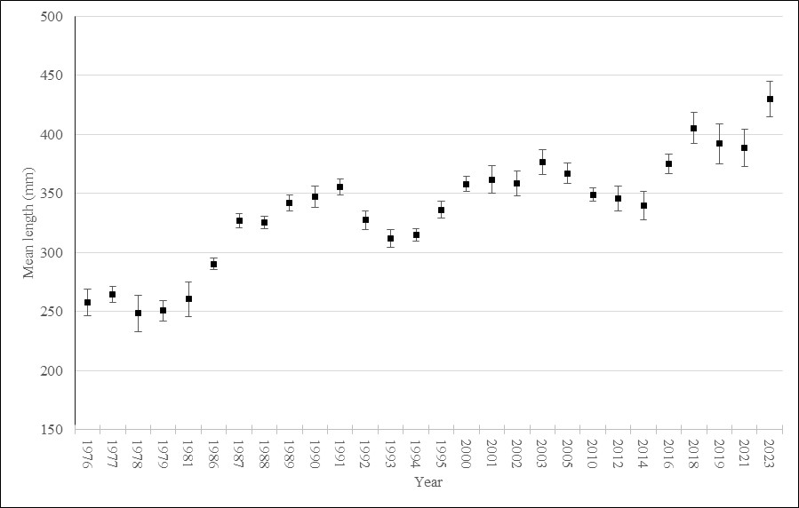

Length data collected for kokanee during winter creel surveys suggest that kokanee average lengths have varied substantially in recent years from historic averages. Kokanee average lengths during winter creel surveys have generally averaged between 210 and 250 mm (average = 233 mm) over several decades of sampling (Figure 11). Kokanee lengths averaged 243 mm among all fish sampled in 2018 and 2019. Average length increased significantly in 2021 to 277 mm but then dropped to an average of 217 mm in 2023, which is below the long-term average.

Figure 11. Mean length and 95% confidence intervals for kokanee measured during winter creel surveys completed on Georgetown Lake from 1976 to 2023.
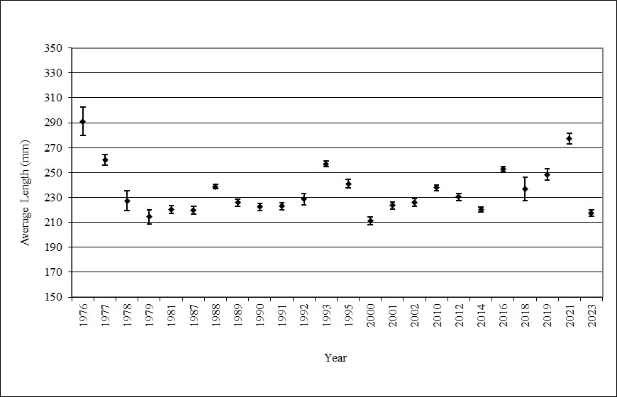

Limnology Surveys
Georgetown Lake is believed to be a phosphorous limited reservoir, as are most freshwater lakes and reservoirs in the United States (Wetzel 1982, Stafford 2012). Total phosphorous was found to vary during the study period with measurements being highest in 2021 and declining annually through 2023 at both survey sites (Figure 12). Total phosphorous was also substantially higher from 2021 to 2023 than was observed in 2009 through 2011 by Stafford (2013) (Figure 13).

Figure 12. Total Phosphorous measured from 2021-2023 at the Deep Hole and Mid Lake sites.
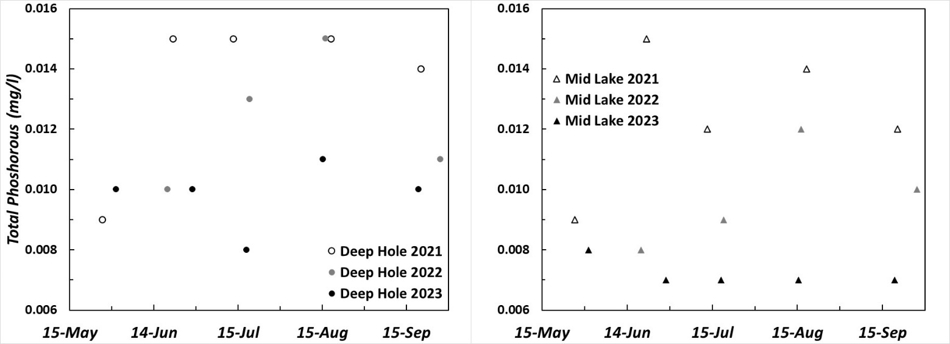

Figure 13. Comparison of Total Phosphorous measured at the Deep Hole and Mid Lake sites during the 2009-2011 and 2021-2023 sampling periods.
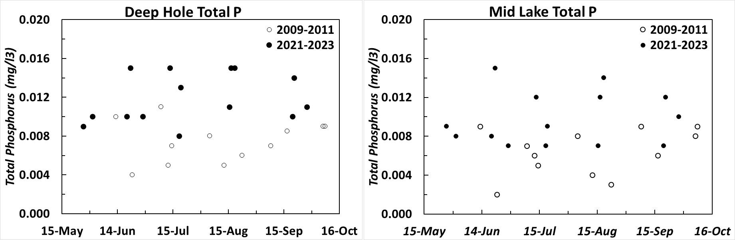

Total nitrogen was less variable monthly and interannually between 2021 and 2023 than total phosphorous (Figure 14). Some increase in total nitrogen was observed from 2021 to 2023 particularly at the Deep Hole site. Total nitrogen measurements were similar between 2021-2023 to the measurements collected by Stafford (2013) from 2009-2011 (Figure 15). This lack of change in nitrogen abundance even during major biological shifts at other trophic levels (increase in mean length of kokanee and rainbow trout) is to be expected as nitrogen is not the limiting nutrient in Georgetown Lake.

Figure 14. Total Nitrogen measured from 2021-2023 at the Deep Hole and Mid Lake sites.
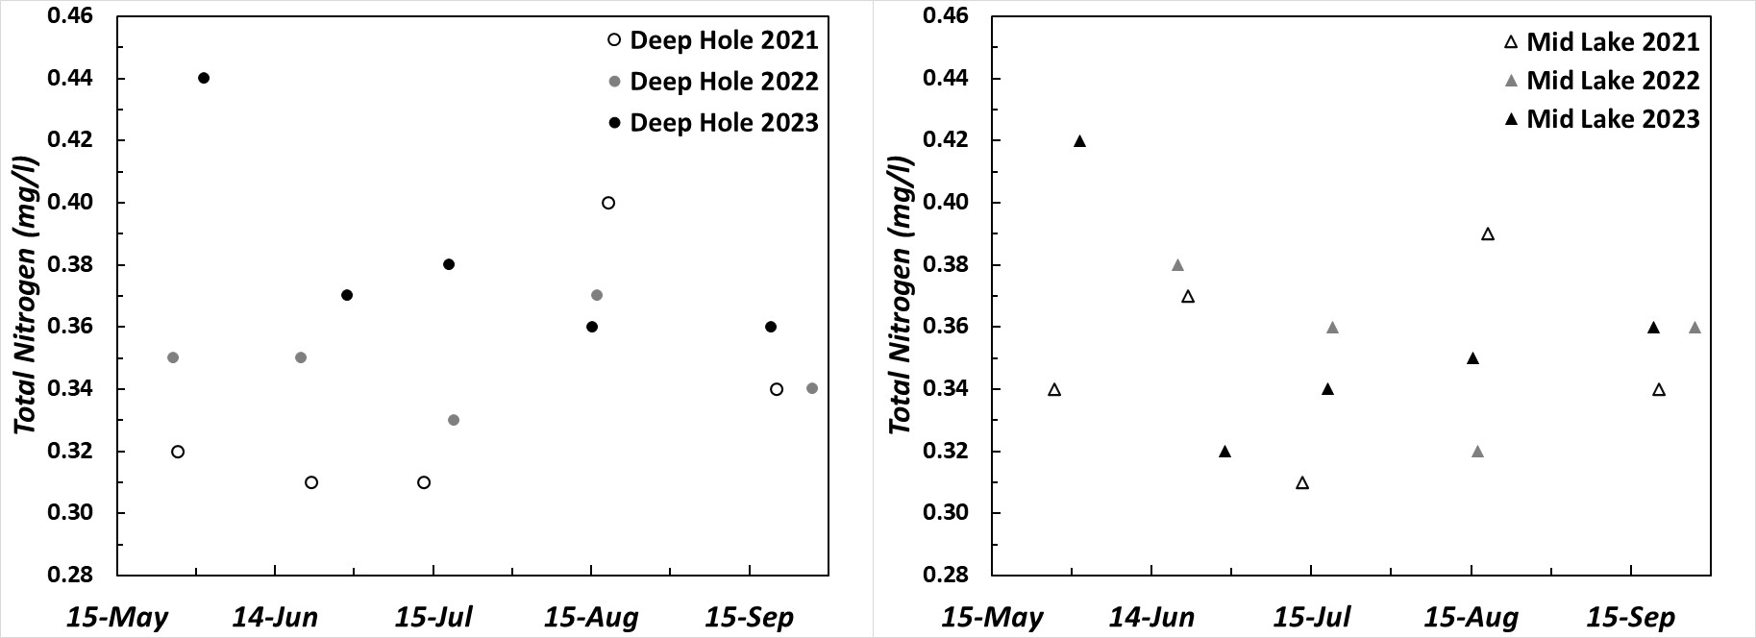
Figure 15. Comparison of Total Nitrogen measured at the Deep Hole and Mid Lake sites during the 2009-2011 and 2021-2023 sampling periods.
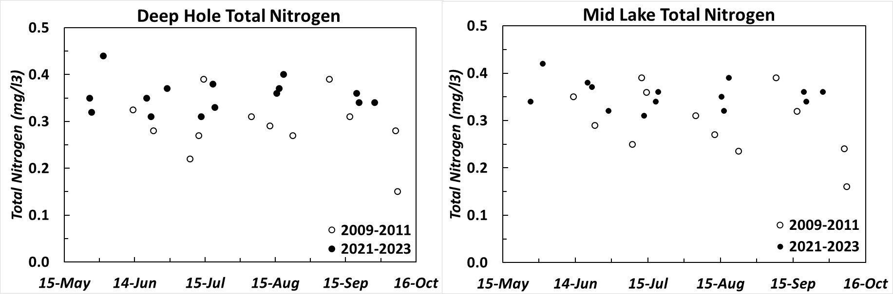

Secchi readings at the Mid Lake, Secchi New and Deep Hole sites did not vary substantially from 2021 through 2023 (Figure 16). Secchi readings did generally increase from spring through summer with them peaking in July and August and diminishing slightly in September. The low readings during spring turn-over and fall likely reflect phytoplankton bloom effects on clarity during these time periods. Secchi readings were consistently lower at the Deep Hole location than the Mid Lake and Secchi New sites. Secchi readings were also generally similar from 2009-2011 period to the 2021-2023 period except at the Deep Hole site where readings were generally higher in 2009-2011 than were observed in 2021-2023 (Figure 17).

Figure 16. Secchi depth readings from 2021-2023 at the Deep Hole, Secchi New and Mid Lake sites.
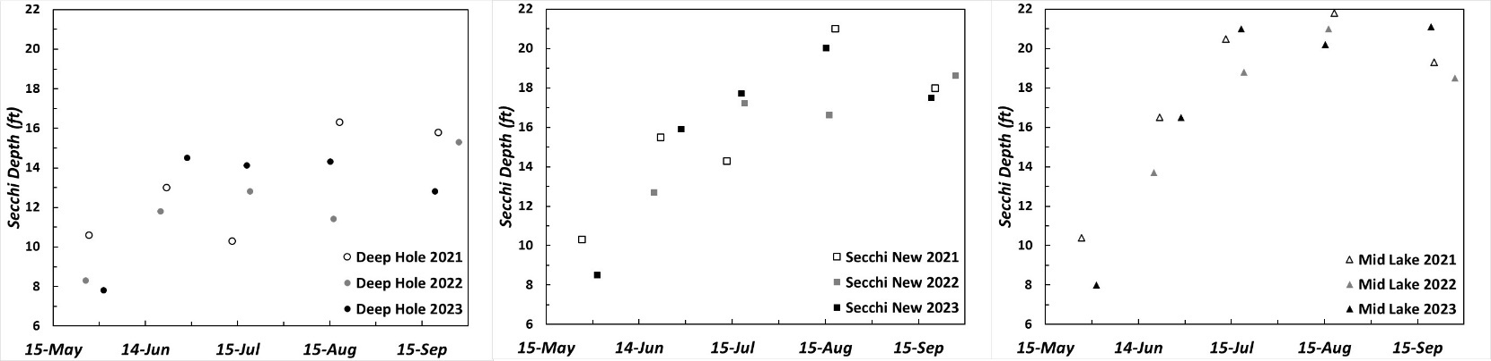

Figure 17. Comparison of Secchi Depth readings at the Deep Hole, Secchi New and Mid Lake sites during the 2009-2011 and 2021-2023 sampling periods.
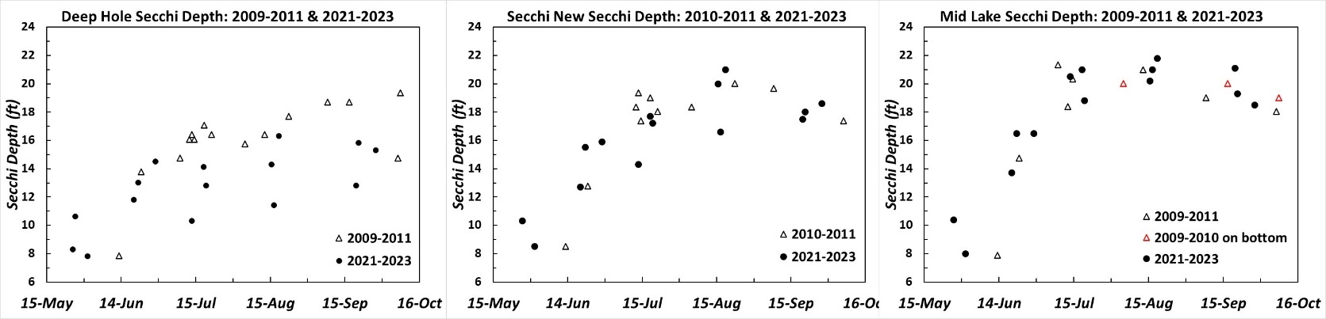

No discernable trends were observed for Chlorophyll-a at either Mid Lake or Deep Hole from 2021 to 2023 (Figure 18). Some reductions of chlorophyll-a may have occurred at the Deep Hole, but the high variability precludes any strong conclusions. Chlorophyll-a readings from 2021-2023 did appear to be somewhat higher at the Deep Hole than readings in 2009-2011, but this trend was not observed at the Mid Lake site (Figure 19).

Figure 18. Chlorophyll-a measurements from 2021-2023 at the Deep Hole, Secchi New and Mid Lake sites.
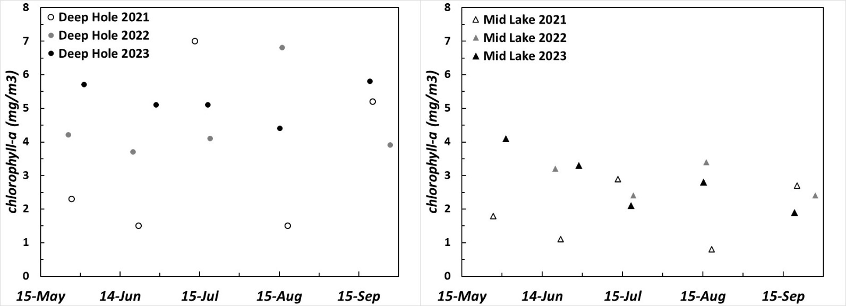

Figure 19. Comparison of Chlorophyll-a measurements at the Deep Hole, Secchi New and Mid Lake sites during the 2009-2011 and 2021-2023 sampling periods.
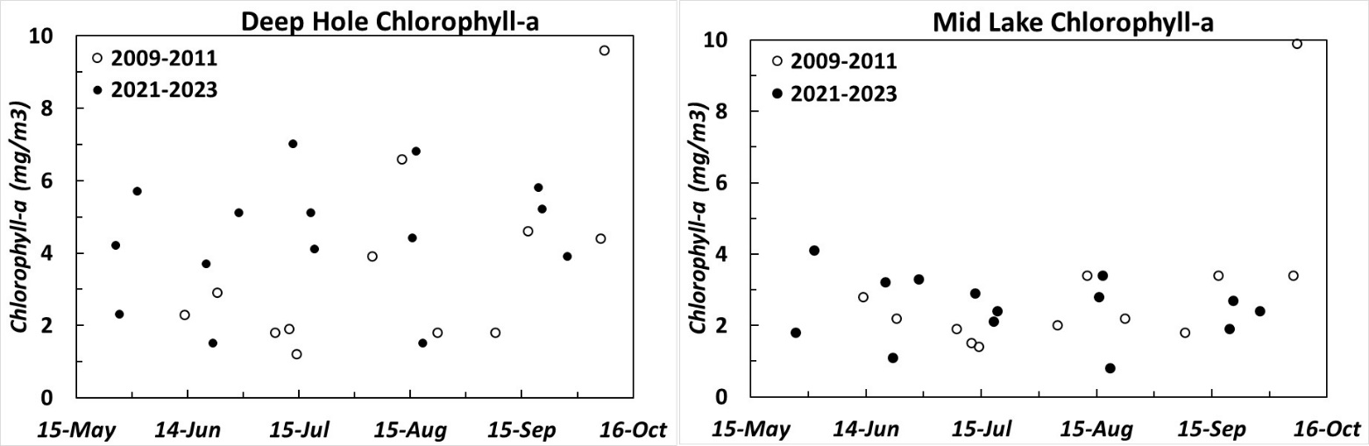

Winter dissolved oxygen concentrations are measured annually on Georgetown Lake. These readings are generally taken in late December, late February and late March. While annual data is available, the most relevant dissolved oxygen data is from winter 2017-2018 and winter 2022-2023, as these are years when winterkill was observed at Georgetown.
Dissolved oxygen conditions in spring 2018 were very poor with measurements at Comer’s Point being 2 mg/l or less from 1 m of depth to the bottom (Figure 20). Slightly higher concentrations were observed at the surface but were still below 2.5 mg/l. Very poor conditions were also observed at the Pumphouse location with all readings being 4 mg/l or less. Groundwater upwelling is very prominent in the vicinity of the Pumphouse, so these values likely represent some of the highest dissolved oxygen conditions around Georgetown Lake. This is despite groundwater typically having relatively low dissolved oxygen concentrations due to lack of atmospheric exposure. Dead fish were reported via phone calls and Facebook posts directly after ice off in May 2018. Both ground and boat surveys were completed to assess the extent of the winterkill and will be discussed in the Discussion section.
Dissolved oxygen conditions in spring 2023 were also very poor, although not as poor as was observed in 2018. Dissolved oxygen concentrations at Comer’s Point were about 4 mg/l at the surface and declined with depth (Figure 21). Dissolved oxygen concentrations were slightly better at the Pumphouse site but were still only 5 mg/l at the surface and declined with depth (Figure 21). Other years from 2017 through 2024 had higher quality dissolved oxygen measurements (high enough that winterkill was not anticipated) and thus will not be displayed in this report. Dead fish were reported via phone calls and Facebook posts directly after ice off in May 2023. A boat survey was completed within days of initial phone calls to assess the winterkill and will be discussed in the Discussion section.

Figure 20. Dissolved Oxygen and temperature profiles for Georgetown Lake in March 2018.
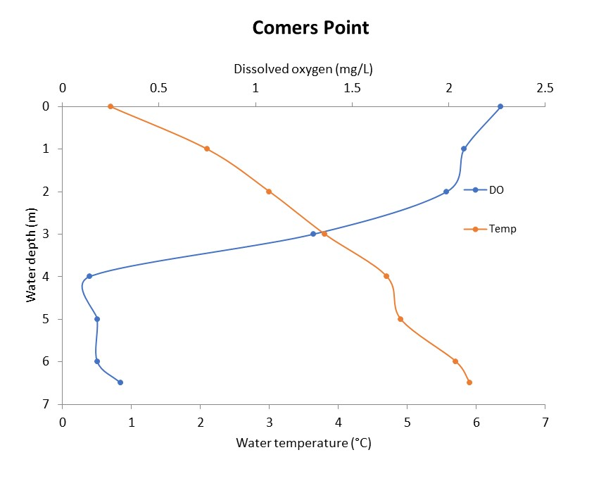
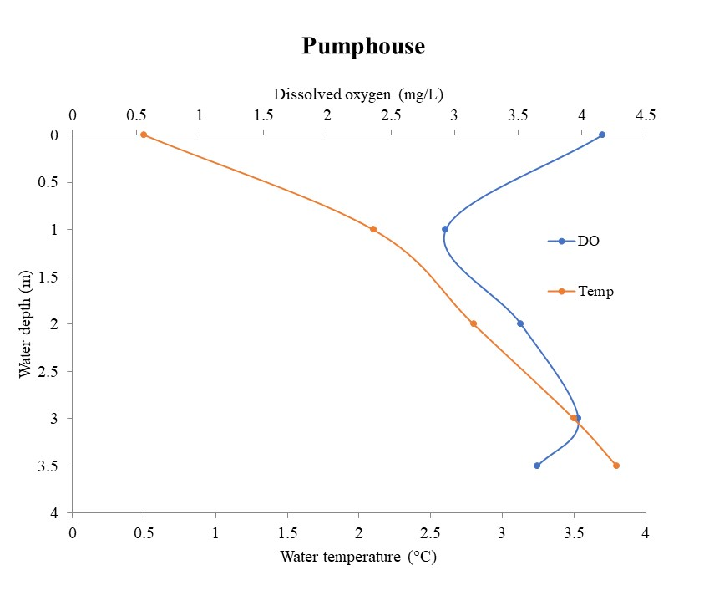

Figure 21. Dissolved oxygen and temperature profiles for Georgetown Lake in March 2023.
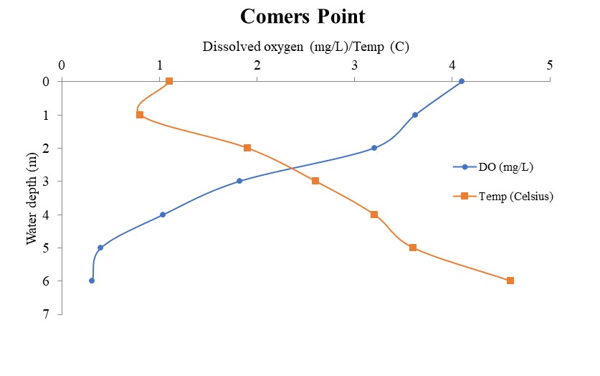
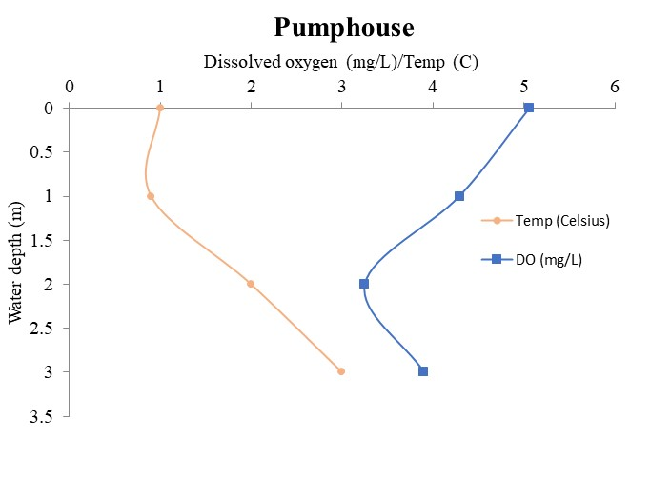
The issue of low dissolved oxygen at Georgetown Lake during winter was identified many years ago by MFWP biologists. Thus, MFWP has a long-term data set of dissolved oxygen measurements at Georgetown Lake. While the instrumentation to measure dissolved oxygen has varied over the years, the data is likely accurate enough to compare across time (data from 2009 through 2024 was collected with known high-quality instruments). A comparison of dissolved oxygen measurements 1 m below the ice was used to assess this change (Figure 22). Comparison of dissolved oxygen data from 1975 through 2024, suggests that there is a declining trend in winter dissolved oxygen (Figure 22). Linear regression analysis of this data was not statistically significant (p = 0.055), although the test was very close to significant.

Figure 22. Dissolved oxygen trends for Comers Point in mid-March at 1 meter below the ice.
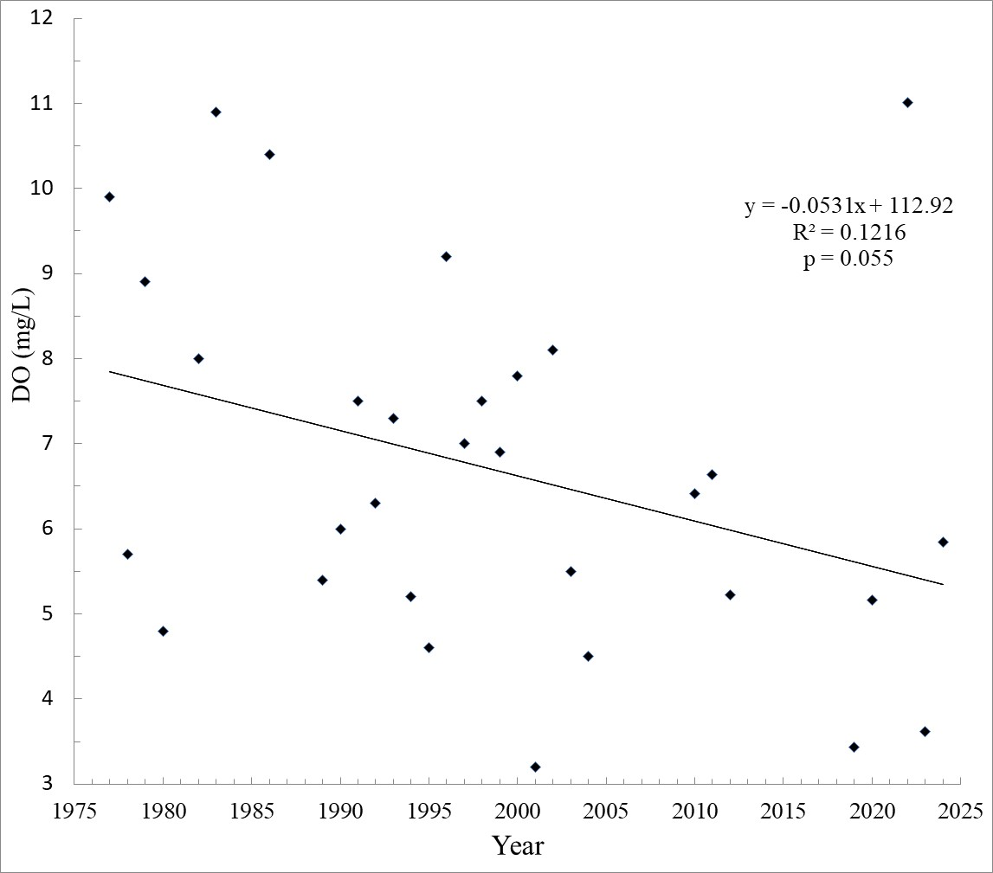
When assessing Figure 22 and comparing residual plots, the March 2022 measurement is clearly an extreme outlier in this data set. It is uncertain what would cause issues with the readings as the instrument was calibrated. Dissolved oxygen measurements at all sites were above normal suggesting this outlier was not a data recording error etc.... Further discussion of potential issues with the 2022 data are provided in the Discussion section. Due to 2022 being such an outlier, the regression analysis was completed again without the 2022 reading and the model was highly significant (p<0.001).
Rainbow Trout Strain Evaluation
A total of 76 vertebrae from rainbow trout captured in 2017 were read for tetracycline marks. These fish were all between 190 and 270 mm to ensure that they were from a marked year class, as tetracycline marking was initiated in 2016. For unknown reasons, some samples were quite desiccated despite similar handling procedures, and it was apparent after viewing several of these samples that discerning particularly double tetracycline marks would be difficult. Thus, any desiccated samples encountered were not read and removed from the data set to avoid collecting erroneous data.
Of the 76 readable vertebrae, a total of 43 fish were found to have single tetracycline marks indicative of Gerrard strain fish. A total of 23 Eagle Lake and 10 Arlee Strain fish were observed. An expected number for catch rates was calculated using the stocking rate of the various strains in 2017 (Table 3). The chi-squared test used to test for differences between observed and expected strain catch rates was highly significant (p<0.001). The Gerrard strain was found to be a much higher percentage of the catch than expected at 43 fish versus the expected 8.8 fish. The number of Arlee strain fish captured was found to be much lower than expected (Table 3).
Table 3. Assessment of 2017 catch rates of three strains of rainbow trout less than 260 mm TL and results of a Chi-squared test comparing expected catch versus actual catch.
Strain | Count | Stocking rate | Expected # based on stocking rates | Chi-squared value
Gerrard | 43 | 20,974 | 8.8 | p<0.001
Eagle Lake | 23 | 78,412 | 33.1 | p<0.001
Arlee | 10 | 89,894 | 34.1 | p<0.001
An additional 1,041 vertebrate were read for rainbow trout sampled in Georgetown Lake from spring 2022 to fall 2023. Spring and summer gill netting series were completed in 2022 and 2023 in addition to the typical fall gill netting series. The additional spring and summer series were completed to provide diet data for a Master’s Thesis project being completed by Montana State University (Furey, in prep.). Gill net catch rates from these sample periods will not be reported here but will be reported in this thesis. These additional 1,041 vertebrae were read to determine the strain of rainbow trout for assessment of diet as a component of this project (Furey, In prep.).
The Arlee strain was again significantly under-represented in the sample at 10% of the fish captured despite being 35% of the rainbow trout stocked while the Gerrard strain was over-represented at 38% of the fish captured despite being only 20% of the rainbow trout stocked. The Eagle Lake strain was captured in approximately equal proportion to their stocking density with them making up 52% of the fish captured versus being 45% of the rainbow trout stocked.
Table 4. The total number and percentage (in parentheses) of each strain (Gerrard, Eagle Lake, and Arlee) of rainbow trout sampled from 2021, 2022, and 2023 by 100-mm length class, and the proportion of each strain stocked (averaged from the last five years). Table provided by K. Furey with MSU.
Length Class | Gerrard | Eagle Lake | Arlee
100 | 56 (73) | 14 (18) | 7 (9)
200 | 58 (27) | 116 (55) | 38 (18)
300 | 118 (29) | 262 (65) | 22 (6)
400 | 130 (47) | 122 (44) | 26 (9)
500 | 37 (52) | 26 (36) | 9 (12)
Total | 399 (38) | 540 (52) | 102 (10)
Proportion stocked (%) | 20 | 45 | 35

A chi-squared test was completed on the total number of each strain captured during the six sample periods from Spring 2022 through Fall 2023 (Table 5). This test was highly significant (p>0.001) suggesting that there was a difference in observed versus expected abundance based on stocking density of the three strains of rainbow tdd rout. The clear differences were that the Gerrard strain was found to be in much higher proportion to their stocking rates and the Arlee strain was found in much lower proportion to their stocking rates (Table 5).
Table 5. Results of strain assignment versus stocking rates (average number of each strain stocked from 2019 through 2023) for all size classes of rainbow trout. A Chi-square test was used to test the observed number of each strain versus expected value based on stocking rates.
Strain | Count | Stocking rate | Expected # based on stocking rates | Chi-squared value
Gerrard | 399 | 28,000 | 199 | p<0.001
Eagle Lake | 540 | 80,200 | 470 | p<0.001
Arlee | 102 | 63,500 | 372 | p<0.001

Discussion
Both gill net and winter creel survey data demonstrate stable trends for the rainbow trout fishery in Georgetown Lake from 2004 through 2018/2019. However, both methods also suggest that rainbow trout abundance declined in the early 2020’s. Rainbow trout gill net catch rates for fish greater than 300 mm were consistently between 10-15 fish per net night from 2005-2017, but have since been consistently between 7-10 fish per net night (Figure 2). Winter creel survey catch rates were between 0.5 and 0.6 fish per angler hour through 2019, but dropped to approximately 0.2 fish per angler hour in 2021 and 2023 (Figure 2).
The size structure of rainbow trout caught during gill netting and winter creel surveys has also changed. The average length of rainbow trout caught during both gill netting and winter creel surveys increased to approximately 400 mm in the 2018/2019 sampling periods and both methods showed another increase in average length in 2023. The congruence of these two data sets lends validity to the fact that a change in size structure has occurred. The increase in rainbow trout size also happened nearly synonymous with the reduction in catch rates observed in gill netting. This trend of increased size in rainbow trout during a period of reduced catch rates again reinforces that a reduction in abundance has occurred. This pattern represents density dependent growth commonly seen in salmonids in lake/reservoir environments (i.e. lower densities leads to higher growth).
The cause for reduced rainbow trout densities in Georgetown Lake is not completely understood. Stocking rates have remained consistent for over 20 years. The stocking of Gerrard Strain rainbow trout was initiated in 2015 but stocking densities of Arlee and Eagle Lake Strains were reduced accordingly in attempt to not affect the densities of rainbow trout in the fishery. An increase in phosphorus in the system was observed in 2021-2023, however an increase in productivity would generally lead to an overall increase in biomass with both size and abundance of fish expected to increase, not a reduction in abundance and increase in size. This is not to say that nutrients aren’t a factor in increasing size, but they are likely not the only factor and population size/density appears to also be affecting rainbow trout size.
One likely scenario that could lead to fewer rainbow trout and larger average size is an increase in angler pressure and harvest. Georgetown Lake has experienced a significant increase in pressure over the past two decades (Figure 23). Angling pressure at Georgetown Lake generally averaged between 40-50,000 angler days per year in the early1990’s, 50-60,000 angler days in late 1990’s and 2000’s, and 60-80,000 in the last decade (although there has been significant variability in recent estimates). MFWP’s winter creel survey data indicates that a significant portion of Georgetown Lake anglers harvest fish and thus increasing pressure no doubt has led to increased harvest. With this increase in angling pressure that Georgetown Lake has experienced in the previous couple of decades, it is suspected that this is the primary factor leading to the reduction of rainbow trout abundance.
Figure 23. Angling pressure (angler days) expended at Georgetown Lake over the last several decades. These data are compiled from a mail survey completed biennially by MFWP.
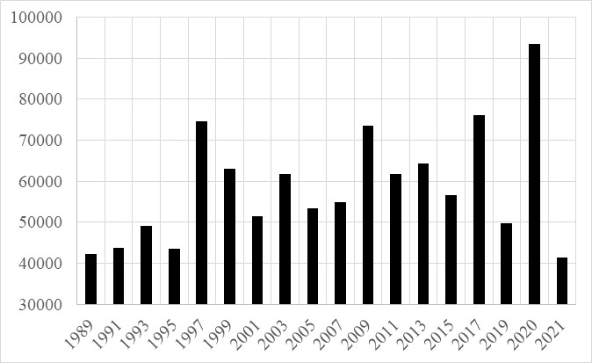
Another factor that could be affecting rainbow trout abundance are the two winterkill events experienced in 2018 and 2023. A minimal reduction in rainbow trout gill net catch rates was observed in 2018 following that winterkill event (Figure 2) and gill net catch rates were still above the long-term average. Based on this, it doesn’t appear that the 2018 winterkill event had a substantial effect on rainbow trout abundance. The 2023 winterkill appeared to be a smaller event than 2018 in terms of observed dead fish during MFWP’s boat survey days after the fish kill. Dissolved oxygen conditions also appeared to be better in March 2023 than 2018 (Figures 21 and 22), confirming that conditions were likely not as bad during that event. Reduced gill net catch rates were observed in the fall of 2023 following this winterkill event. Based on these variable results, it is somewhat unclear how much impact these events are having on the rainbow trout fishery. It is suspected that winterkill has potentially had some impact on rainbow trout abundance but likely does not fully explain the observed reduction in rainbow trout numbers during the early 2020’s. See additional discussion of winterkill events later in this report.
Significant changes have been observed in the Georgetown Lake kokanee fishery in recent years. The average size of kokanee greater than 200 mm sampled in gill nets in 2020 was 340 mm. Previously, kokanee generally averaged between 225 and 275 mm for this size class for many years (Figure 2). This increase in kokanee size was also observed in the winter creel survey data (Figure 11). Curiously, during the years when average size was highest (2020 and 2021), gill net catch rates were also some of the highest observed. This suggests that abundance was also high during the period when average size was very high. Kokanee are generally known to exhibit very density dependent growth patterns due to their reliance on zooplankton as their primary food source (Rieman and Meyers 1992). This data suggests that something changed within the Georgetown Lake ecosystem that led to higher growth despite a general trend of steady to increasing abundance.
It is very possible that increased nutrients in Georgetown Lake is tied to the increase in average size observed for kokanee. Kokanee are primarily zooplanktivores and zooplankton abundance and size are closely tied to nutrients in lacustrine (lake or reservoir) environments due to phytoplankton generally being the primary food source for zooplankton (Wetzel 1982). Many studies have tied increase kokanee growth and abundance to increases in nutrients including situations where phosphorous and nitrogen were intentionally added to reservoirs to induce additional kokanee growth (Thompson 1999, Schindler et al. 2006, etc...). Interestingly, it was observed in Kootenay Lake that average size of kokanee did not actually increase following nutrient additions. Instead, kokanee in Kootenay Lake appeared to become sexually mature earlier than occurred before nutrient additions (Thompson 1999). Nonetheless, increased growth and survival of kokanee was observed by these studies due to nutrient additions to these reservoirs. Based on these findings, an increase in nutrients in Georgetown Lake could logically lead to an increase in both abundance and size of zooplankton and in turn improved growth rates and potentially survival of kokanee. An increase in phosphorus (the limiting nutrient in Georgetown Lake) was observed in 2021-2023 in comparison to samples collected in 2009-2011 by Stafford (2013) and is likely a primary factor in the increased growth observed in kokanee and potentially their abundance.
Additional predation pressure on kokanee could also be an obvious cause of increased size. Again, kokanee commonly display strong density dependent growth patterns in which lower density generally leads to higher growth rates (Rieman and Meyers 1992). Predation pressure that leads to reduced densities of kokanee would likely lead to higher growth rates. An obvious source of predation is Gerrard rainbow trout which have been found to be a highly piscivorous strain particularly on kokanee (e.g. Thompson 1999). Gerrard rainbow trout were stocked into Georgetown Lake starting in 2015 to provide additional predation on kokanee and hopefully improve their size as well as improve the rainbow trout fishery. Results from a graduate project conducted by Montana State University has found that there is essentially no predation of kokanee by Gerrard Strain or other strains of rainbow trout in Georgetown Lake (Furey 2024, in prep.). Results also indicate that brook trout were not preying on fish or more specifically kokanee. These results were based on both diet analysis and stable isotope analysis and both techniques corroborated the results of the lack of piscivory of all strains and species of trout (Furey 2024, in prep.).
Further evidence that predation is likely not the cause of increased kokanee size is the increase in kokanee gill net catch rates observed in 2021 and 2022. For density dependent mechanisms to explain the increase in size, kokanee abundance would need to decline. This did not appear to occur, as 2021 and 2022 are some of the highest gill net catch rates observed for kokanee in recent decades.
It is possible that gill net selectivity for larger kokanee is occurring, and this could explain the increase in catch rates in 2021 and 2022. However, it is unlikely that this could explain the entirety of the substantial increase in catch rates observed. Interestingly, a comparison of past years with larger than average size of kokanee does not equate to above average catch rates (e.g. 2005, 2010, 2018- Figures 3 and 7). However, a comparison of length frequency histograms does indicate that during 2020, a substantial number of fish suspected to be Age 1 fish were greater than 200 mm and thus were included in that size class catch rate. This occurred in a lesser extent in 2021. It appears that Age 1 kokanee in 2020 averaged approximately 230 mm and were likely recruited into the 200 mm and greater size class, which would bias the catch rate for this size class, as Age 1 kokanee in Georgetown Lake typically average 170-190 mm (Figure 24). Further analysis of the size selectivity of the experimental gill nets used in Georgetown Lake should be completed to aid in understanding its influence on CPUE data which is typically extrapolated to abundance.
Figure 24. Length frequency histograms for kokanee from Georgetown Lake gill netting in 2018, 2020 and 2021. Histograms for 2020 suggest that Age 1 kokanee are heavily represented in the size class of fish greater than 200 mm while this occurred to a lessor extent in 2021. The histogram for 2018 represents a typical histogram observed during most sampling years.
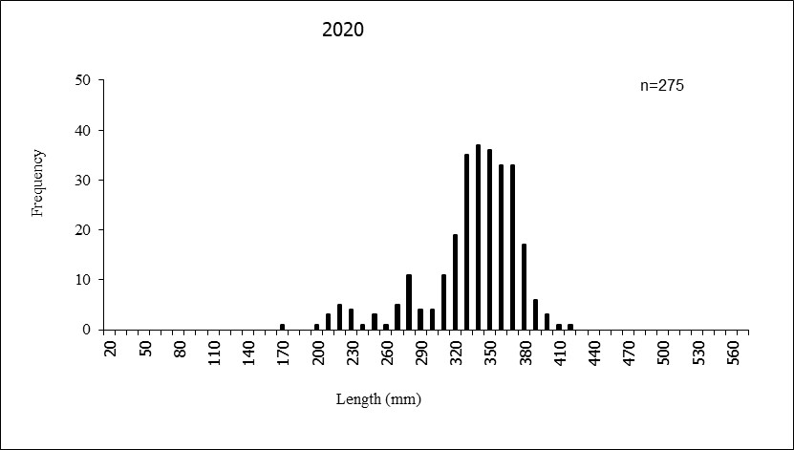
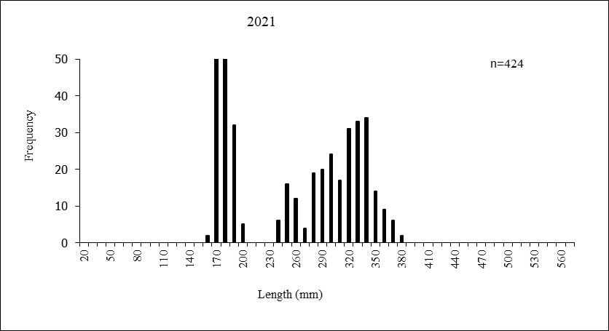
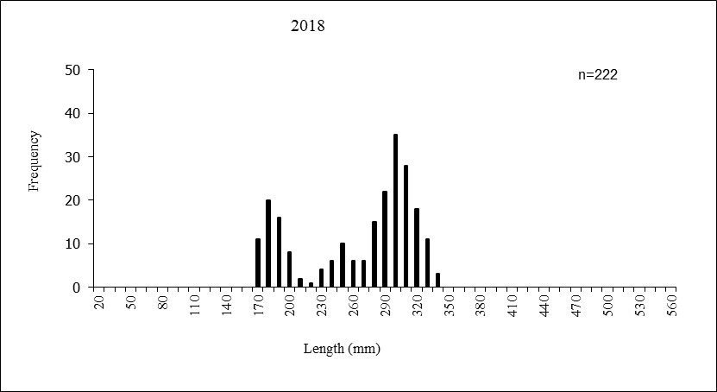

Winterkill
Due to Georgetown Lake being a relatively shallow, yet very productive lake, low dissolved oxygen levels are relatively common during winter. Low dissolved oxygen is typically caused by the decomposition of weeds, phytoplankton and other detritus in a lake or reservoir. A large portion of dissolved oxygen in lakes and reservoirs can be taken up by microbes that live at the sediment-water interface that are responsible for this decomposition (Wetzel 1982). The use of dissolved oxygen via respiration by these microbes can reduce dissolved oxygen levels even in a water body as large as Georgetown Lake. While the abundant nutrients available in Georgetown Lake facilitate the creation of an excellent trout and salmon fishery, it also leads to high decomposition rates and thus can significantly deplete dissolved oxygen during the winter.
MFWP takes dissolved oxygen measurements each winter to assess the potential for winterkill. In 2018, dissolved oxygen levels were very low at the three sites traditionally measured (Figure 20). Comer’s Point is the site that best represents conditions likely observed throughout a large portion of Georgetown Lake due to its depth and location (Stafford 2013). Dissolved oxygen levels at Comer’s Point on March 28, 2018 were below 2.5 ppm just under the ice and also at 1 m below the ice. These were the highest readings throughout the profile (Figure 20). This is much lower than is observed at this site in more typical years (Stafford 2013). Poor dissolved oxygen conditions were also observed at the Pumphouse and Deep Hole monitoring sites in 2018.
Dissolved oxygen concentrations below 7 ppm are generally considered deleterious to growth of salmonids and swimming performance is reduced below 5 ppm (Carter 2005). Dissolved oxygen concentrations below 3 ppm are likely lethal for salmonids although temperature does influence the lethality with low dissolved oxygen being more lethal at higher water temperatures (Carter 2005). Nonetheless, conditions observed at Comer’s Point in 2018 were at levels that could cause significant mortality of salmonids in the system. Significant ground water upwelling is present at the Pumphouse monitoring site and is demonstrated by the generally higher temperatures during the winter and higher dissolved oxygen concentrations measured in the lower depths of the profiles (Figure 20). Thus, portions of the reservoir that have significant groundwater input such as Pumphouse and Denton’s Point are likely refuge sites for Georgetown Lake salmonids during tough overwinter conditions, despite groundwater typically having lower dissolved oxygen than surface water (due to the lack of atmospheric diffusion). As demonstrated in Figure 20, dissolved oxygen conditions were still quite low even at the Pumphouse monitoring site in March 2018, suggesting that even refuge sites with significant ground water influence were likely at threatening levels of low dissolved oxygen concentrations in March 2018.
Multiple phone calls and emails were received in early May 2018 reporting a fish kill at Georgetown Lake. The ice had recently completely melted off of Georgetown Lake and large numbers of dead fish were reported in Eccleston’s Bay near Comer’s Point. An investigation via boat and also a shoreline investigation of Eccleston’s Bay were completed by MFWP two days after initial reports and confirmed that a large number of dead fish were present. These fish were mostly comprised of larger adult rainbow trout (375-500 mm in length) although two adult kokanee were also found. Interestingly, no brook trout were observed dead. It was visually estimated that at least 500-1000 dead fish were either floating or on the shore in Eccleston’s Bay. This is likely a significant underestimate of mortality as some fish were likely being scavenged by birds and a large number of mortalities were also sinking (some mortalities were observed on the reservoir bottom). Additional dead fish were also reported along the shore west of Denton’s Marina but were not investigated by MFWP.
During the fish kill investigation, hourly gill net sets were completed to capture fish to test for the possibility that pathogens or infectious disease could have caused the fish kill. The area was also surveyed in attempt to locate moribund fish for testing. Moribund fish are still alive but appear to be ailing and are likely to die and it is assumed that moribund fish are likely affected by the condition or infection that caused the fish kill. Moribund fish are best for disease testing, as sampled fish need to still be alive to properly complete the suite of tests generally completed by the MFWP Fish Health Laboratory to assess fish kills (K. Staigmiller, MFWP Fish Health Coordinator, pers. comm.). Unfortunately, no moribund fish could be located and instead five, apparently healthy fish that were caught during hourly gill net sets and were prepared for disease testing. These nets were set in Eccelston’s Bay and the sample consisted of one brook trout and four rainbow trout that were 375-475 mm TL. Disease testing was completed in July 2018 and no disease was found in any of the sampled fish (K. Staigmiller, pers. comm.). Based on these results, it is suspected that infectious disease was not the cause of the fish kill. The lack of moribund fish does suggest the fish kill initiated earlier in the year during ice cover, which is consistent with winterkill caused by low dissolved oxygen.
Gill netting was completed in fall 2018 after detecting the fish kill in spring 2018 to assess its effects on the Georgetown Lake fishery. Gill net catch rates for rainbow trout were surprisingly near average at 13.1 fish per net night. Also, neither average length nor length frequency histogram analysis showed any significant departure in size structure from previous years for rainbow trout. Gill net catch rates for both kokanee and brook trout improved in 2018 from previous years and comparisons of length metrics (average length and length frequency histograms) for both species showed no substantial changes. This data suggests that the winter kill observed at Georgetown Lake did not have a substantial negative effect on these fisheries. This is surprising considering that likely thousands of large rainbow trout were killed during the winter of 2017/2018 based on the number of fish observed by MFWP.
Another winterkill event was observed by anglers and reported to MFWP in May 2023. Dissolved oxygen conditions were observed as being low in March 2023 and the possibility of winterkill was anticipated (Figure 21). Again, MFWP staff did a boat survey of the lake within a week of ice-off and the winterkill event being reported. It was estimated that approximately 1,000 dead fish were observed around the perimeter of the reservoir with a majority of the dead fish again being larger rainbow trout (>16”). This was likely a significant underestimate of the total mortalities as some dead fish were observed sunken and many fish likely sunk in deep enough areas to make their visibility impossible. No disease testing was completed in 2023 as no moribund fish were observed, similar to 2018.
Dissolved oxygen conditions in Georgetown Lake were not as poor in 2023 as was observed in 2018, likely making this winterkill event less severe. In 2018, only the Eccleston Bay and Denton’s Point area was searched for dead fish in comparison to nearly the entire Georgetown Lake shoreline in 2023. It appeared based on the densities of dead fish in Eccelston’s Bay in 2018 versus 2023, that the winterkill in 2023 had likely caused approximately 20-30% as many mortalities as was observed in 2018. This is difficult to assess and fish could likely get distributed differently depending on wind conditions post ice-off. Nonetheless, it did appear that the 2023 winterkill event caused significantly less mortality than the 2018 event.
Gill netting was completed in Fall 2023 following this winterkill event and rainbow trout greater than 300 mm were captured in lower numbers than previous years. Rainbow trout greater than 300 mm were captured at 7.6 fish per net night versus the 10.7 and 13.3 fish per net night observed in 2021 and 2022, respectively. These lower catch rates were not statistically significant based on overlapping 95% confidence intervals, but this is not a sensitive statistical test. The confidence intervals were very close to not overlapping when comparing 2022 to 2023, suggesting that this difference approached statistical significance. Nonetheless, these reduced catch rates of rainbow trout could potentially be a real effect of winterkill, but also may be caused by increasing angler pressure or normal cyclical populations dynamics.
Plotting mid-March dissolved oxygen measurements at Comers Point suggests that dissolved oxygen conditions are declining through the decades at Georgetown Lake, although the relationship was not significant at alpha=0.05. The p-value for this analysis was 0.055 however, so very close to significant. Plotting this data also indicates a major outlier in the March 2022 sample. A comparison of 2022 data from January through March show that depletion of dissolved oxygen did not occur at 1 meter below the ice, but did occur at lower depths. Oxygen depletion is shallow lakes and reservoir generally occurs throughout the water column and the lack of depletion is an odd observation that suggests this data point may be erroneous. However, dissolved oxygen profiles collected at Deep Hole and Pumphouse sites on the same day were also generally high. This demonstrates that the Comer’s Point reading was not recorded incorrectly and suggests that poor calibration of the sensor or other sensor issues were the cause of incorrect readings, if readings were indeed incorrect. Nonetheless, due to the March 2022 reading being such an outlier, regression analysis was completed with the removal of that data point and the relationship was highly significant (p<0.001).
This declining trend in dissolved oxygen at Comer’s Point is concerning for future management of Georgetown Lake. This trend suggests that biological oxygen demand is increasing in the system. While eutrophication and an increase in biological oxygen demand at the sediment interface is a typical long-term trend as lakes and reservoirs age, nutrient sampling at Georgetown Lake found that suspended phosphorous and nitrogen declined from the late1970’s through 2010 and 2011 (Stafford 2013). The reduction in nutrients observed by Stafford (2013) again is not typical of lake and reservoir evolution but is also counter to what appears to be occurring with biological oxygen demand at the sediment interface based on long term winter dissolved oxygen trends. Stafford (2013) found that macrophyte densities in Georgetown Lake did increase in comparison to data from the late 1970’s again suggesting potential eutrophication of the system. One potential theory is that a nutrient shift has occurred in Georgetown Lake into the production of macrophytes versus phytoplankton. Macrophytes decompose slower than phytoplankton and this decay initiates at the end of the growing season while phytoplankton decay is highest after the spring and summer blooms. Accordingly, a substantial amount of macrophyte decay occurs later, slower and under ice cover when oxygen cannot easily be replenished. This scenario would lead to additional biological oxygen demand in the winter and subsequent reduced dissolved oxygen and could explain the trend of decreasing winter dissolved oxygen in Georgetown Lake. The traditional sampling methods used on Georgetown Lake of open water nutrient sampling would not clearly define this trend. Thus, further research into this theory and into whether Georgetown Lake is experiencing eutrophication or oligotrophication along with the mechanisms driving this pattern is warranted.
The primary management tool available to managers to minimize future winter kill at Georgetown Lake is no doubt reservoir elevation management. Georgetown Lake is currently managed for flood control, hydropower, and irrigation. While the water right allowing for the impoundment of Georgetown Lake is a hydropower water right, these other uses also influence the management of Georgetown Lake outflows. Dissolved oxygen profiles for Georgetown Lake annually indicate that dissolved oxygen routinely drops below levels acceptable for trout and salmon one meter below the ice at most locations (e.g. Figures 20 and 21). The portion of the water profile within this top one meter of Georgetown Lake is thus likely extremely important to the survival of trout and salmon during a good portion of winters.
It is logical to assume that lowering reservoir elevation likely impacts this band of oxygenated water, as the larger the volume of water present at ice-up (when diffusion from the atmosphere stops), the longer it likely takes for respiration at the sediment interface to use the available dissolved oxygen throughout the water column. Thus, water level management that provides that largest volume of water going into ice-up can likely help reduce the impact of dissolved oxygen depletion.
While maximizing reservoir volume is an important management tool going into winter, other factors do influence low dissolved oxygen conditions in Georgetown Lake. During the winter 2017/2018 when the larger winterkill event occurred, Georgetown Lake elevations were relatively high with the lowest winter elevation being approximately 6428.3 or 1.2 feet below full crest. During the other winterkill event in 2023, Georgetown Lake’s lowest pool elevation was 6428.5, so pool elevations were again relatively high. Interestingly, Georgetown Lake has been drawn down 1.5 to 2 feet below full crest during other years the past 15 years and did not experienced a fish kill.
Other factors that likely affect dissolved oxygen conditions in Georgetown Lake include depth of snow and length of time ice covers the lake. The 2017/2018 winter was a cold extended winter that led to high snow pack at Georgetown Lake. Snow water equivalent at the Peterson Meadows Snotel Site was 149% of normal on April 1, 2018, while the snow water equivalent was 168% of normal at the Warm Springs Snotel Site. Both of these sites are located within the Georgetown Lake watershed and thus this data exhibits that snow pack was very high that year. Excessive snow depth limits the penetration of sunlight into lakes and reservoirs which limits photosynthesis by algae, macrophytes and phytoplankton (Wetzel 1982). This is the primary source of oxygen production in lakes and reservoirs during winter. The above average snow conditions along with the extended nature of the winter likely reduced photosynthesis in Georgetown Lake in winter 2017/2018 which reduced dissolved oxygen enough to cause the winterkill.
Similarly, 2023 was also a relatively high snow pack year with snow conditions being 118% of normal at the Warm Springs Snotel site above Georgetown Lake and 100% of normal at the Peterson Meadows Snotel site above Georgetown Lake. This relatively high snowpack along with a late ice-off date of May 16 likely influenced the low dissolved oxygen conditions in 2023. Another factor that can impact light penetration and thus dissolved oxygen is ice-depth which should be assessed further.
Flint Creek Dam is currently owned by Granite County. MFWP has a relatively long history of working with Granite County to ensure water levels in Georgetown Lake are managed in a way that is not detrimental to its fisheries. Flint Creek Dam is operated under a Federal Energy Regulatory Commission License that stipulates various conditions that must be met by operators to protect the fisheries of Georgetown Lake. This License also requires Granite County to gain approval from MFWP, the U.S. Forest Service and the U.S. Fish and Wildlife Service before operating outside of these conditions. MFWP will continue to work with Granite County in attempt to ensure that this license is being followed, particularly during critical periods to minimize the impacts that water management actions have on habitat conditions, particularly winter habitat conditions.
Rainbow Trout Strain Evaluation
The strain evaluation completed on rainbow trout in Georgetown Lake in 2017 and 2021-2023 yielded interesting results. While the sample size was not extensive in 2017, the results clearly demonstrate that Gerrard rainbow trout provided significantly more fish to the catch than the other two strains (Table 3). Substantially more vertebrae were read by a graduate student at Montana State University (MSU) and found similar results (Table 4) (Furey 2024, in prep). Again, Arlee Strain rainbow trout were found to underperform in terms of survival while the Gerrard Strain tended to overperform. The samples read by MSU also provided results over multiple age classes which demonstrates similar results for older age classes as well (Table 4).
One factor that could be affecting the study design for this assessment is that Gerrard rainbow trout are stocked during September while Arlee and Eagle Lake rainbow trout are stocked in May and June. Fall plantings have been assessed at Browns Lake, MT using Arlee and Eagle Lake Strains and have been found to provide better survival than spring plants (L. Knotek, Fisheries Biologist, MFWP, pers. comm.). Generally, fall stocked rainbow trout are larger than spring stocked fish which would allow them to more easily avoid predation and potentially have more lipids and other energy reserves for overwintering. Gerrard rainbow trout are 125-150 mm when stocked into Georgetown Lake while Eagle Lake and Arlee rainbow trout are typically 100-112 mm when stocked in the spring. This difference in length is likely biologically significant, but is probably not large enough to completely explain the differences in survival being observed.
Another factor potentially affecting spring stocked rainbow trout is they must survive late spring and summer in Georgetown Lake which is a time when predators metabolic rates are highest. Thus, they may have to avoid more predation pressure when initially stocked and through the following summer in comparison to fall stocked fish. While Furey (in prep.) found minimal predation of fish by either rainbow or brook trout, it is suspected that predation may still be a factor on newly stocked rainbow trout due to them lacking instinctual behaviors necessary survive in a natural environment. Avian predation may also be a factor as seagulls and other birds are commonly present at stocking sites during spring stocking events. The initial period directly after stocking and the following several months are likely a stocked fish’s most vulnerable period. Contrary to the above possible factors that may reduce spring stocked fish survival, late spring stocked fish likely have the advantage of entering Georgetown Lake when invertebrates and other food sources are most available which could improve their survival. This could be true particularly for the Eagle Lake Strain which is stocked in June, as the Arlee Strain is typically stocked in May just after ice-off when food abundance may be low.
The low catch rates of Arlee rainbow trout in the 2017 assessment and the 2021-2023 assessment have clearly shown that this strain is not surviving as well as the other two. This is concerning as Arlee rainbow trout are the most stocked strain of rainbow trout in Georgetown Lake and are also used throughout Montana. The reasons for the apparent poor survival of Arlee rainbow trout are unknown but may be due to their early stocking timing. Arlee rainbow trout have been stocked in Georgetown Lake in mid-May for the past couple of decades. With early May being the typical time for ice-off on Georgetown Lake, these fish are stocked nearly directly after ice off. Conditions for survival of juvenile rainbow trout may not be ideal during mid-May compared to June (when Eagle Lake Strain are stocked). For instance, zooplankton sampling completed in mid-May generally had lower densities than the June sampling period and could indicate that food availability is limited for fish stocked in May, particularly if zooplankton are an important portion of their diet. Fall stocking of Arlee Strain rainbow trout have been successful at other locations in Western Montana (L. Knotek, MT Fish, Wildlife and Parks, pers. comm.).
Another reason for the apparent poor survival of Arlee rainbow trout may be due to domestication of the strain. Poor survival of hatchery trout in the wild is a well-documented occurrence, particularly in strains that are highly domesticated (Araki et al. 2008, Blouin et al. 2021). Traits such as feeding on food pellets (rather than invertebrates), not using available cover to avoid predation, exceptionally high growth rates, and others can easily be selected for in a hatchery environment. Multiple papers have also found that domestication can have deleterious impacts on survival in the wild, even in as short of time span as one generation (Christie et al. 2016, Blouin et al. 2021). Selection for traits favorable for surviving in hatchery raceways such as high growth rates have been found to be genetically derived (Christie et al. 2016, Blouin et al. 2021). The effects that selection of these traits and subsequent alteration of genetic make-up is clearly detrimental to survival in the wild and does ultimately impact their successful return to the creel (Araki et al. 2008. Blouin et al. 2021).
Reducing the selection for these traits can have beneficial results for hatchery fish survival. For instance, eggs were recently harvested from Eagle Lake rainbow trout stocked into Clark Canyon Reservoir in Southwestern Montana and raised in a MFWP hatchery. The progeny of these rainbow trout were stocked into Clark Canyon Reservoir and their survival was assessed via tetracycline marks. It was found that the progeny of wild fish survived significantly better than standard hatchery Eagle Lake rainbow trout stocked that year (M. Jaeger, Fisheries Biologist, MFWP, pers. comm.). This experiment suggests that one generation of selection in the wild can have significant benefits to Eagle Lake rainbow trout survival in Montana lakes and reservoirs. Infusion of wild gametes into hatchery strains is another technique that can mitigate adverse selection that occurs in hatcheries. The possibility of the infusion of wild gametes into Arlee rainbow trout should likely be explored based on their poor performance in Georgetown Lake in 2017 and 2021-2023. A recent examination of the genetic diversity of the Arlee Strain was completed and sufficient genetic diversity was found (R. Kovach, pers. comm.), suggesting poor genetic diversity and subsequent inbreeding depression are not factors in the observed poor survival. While genetic diversity was high, selection for traits that improve survival in a hatchery but reduce survival in the wild can occur in as quick as one generation in captivity (Christie et al. 2016, Blouin et al. 2021). Thus, significant selection and subsequent domestication is likely to have occurred over the 60+ years the Arlee brood has been in existence.
Based on the poor survival of Arlee rainbow trout in Georgetown Lake, MFWP will likely be altering the stocking regime in Georgetown Lake. Gerrard rainbow trout will also no longer be available in Montana as MFWP will discontinue maintaining this brood stock after 2024. Gerrard rainbow trout have reduced interest state-wide as their survival was found to be inadequate in other bodies of waters in Montana, unlike the results observed at Georgetown Lake. Current plans are to supplement the Eagle Lake rainbow trout stocked in Georgetown Lake with juvenile Eagle Lake rainbow trout harvested from an egg take at Holter Reservoir, MT. Adults captured each spring at Holter Reservoir are spawned and the embryos are reared at various hatcheries throughout Montana. Based on previous results of wild Eagle Lake rainbow trout stocking in Clark Canyon Reservoir (M. Jaeger, pers. comm.), we suspect that these fish will demonstrate better survival and growth in Georgetown Lake. Eagle Lake rainbow trout from the Ennis Broodstock will also continue to be planted in Georgetown Lake and the number planted will likely vary with the availability of wild Eagle Lake rainbow trout. Similar densities of rainbow trout will continue to be stocked in Georgetown Lake in upcoming years, but additional evaluations of strain survival will need to occur to assess survival and subsequent stocking densities. The effect stocking densities and survival of the new wild Eagle Lake Strain have on overall rainbow trout size structure will also need to be evaluated. Stocking densities will need to be adjusted using this data to meet the size structure goals for Georgetown Lake.

Literature Cited
Araki H., B. A. Berejikian, M. J. Ford, M. S. Blouin. 2008. Fitness of hatchery reared
salmonids in the wild. Evolutionary Applications: Volume 1, Issue 2, Special Issue: Evolutionary perspectives on salmonid conservation and management. May 2008, pp 342-355.
Berg, R. K. 2009. Fisheries assessment of Georgetown Lake, Silver Lake, and East Fork Rock Creek Reservoir. Montana Fish, Wildlife and Parks, Missoula. 40 pp.
Blouin, M. S., M.C. Wrey, S. R. Bollmann, J. C. Skaar, R. G. Twibell, C. Fuentes. 2021. Offspring of first-generation hatchery steelhead trout (Oncorhynchus mykiss) grow faster in the hatchery than offspring of wild fish, but survive worse in the wild: Possible mechanisms for inadvertent domestication and fitness loss in hatchery salmon. PLoS ONE 16(12): e0257407. https://doi.org/10.1371/journal.pone.0257407
Carter, K. 2005. The effects of dissolved oxygen on steelhead trout, coho salmon, and chinook salmon biology and function by life stage. A Report to: California Regional Water Quality Control Board, North Coast Region.
Christie, M., M. Marine, S. Fox, et al. 2016. A single generation of domestication heritably alters the expression of hundreds of genes. Nat Commun 7, 10676. https://doi.org/10.1038/ncomms10676.
Furey, K. M. In Preparation. Using dietary dynamics to assess the efficacy of biocontrol and to predict the effects of warming water temperatures on salmonids. Thesis to be submitted to the Montana State University Ecology Dept. Bozeman, MT.
Liermann, B. W. and T. D. Tholl. 2003. Noxon and Cabinet Gorge Reservoir Monitoring Comprehensive Report 2000-2002. Report to Avista Corporation, Spokane, Washington. Montana Fish, Wildlife and Parks, Thompson Falls. 34 pp.
Malvestuto, S. P. 1996. Sampling the recreational creel. Pages 591-620 in B. R. Murphy and D. W. Willis, editors. Fisheries techniques, 2nd edition. American Fisheries Society, Bethesda, Maryland.
Roberts, E., A. Strainer, and T. Humphrey. 2011. Missouri River, Canyon Ferry, Hauser and Holter Fisheries Management. Montana Fish, Wildlife and Parks, Helena. 50 pp.
Rieman, B. E. and D. L. Meyers. 1992. Influence of fish density and relative productivity on growth of kokanee in ten oligotrophic lakes and reservoir in Idaho. Transactions of the American Fisheries Society, 121:2, 178-191.
Rieman, B. E. and M. A. Maiolie. 1995. Kokanee population density and resulting fisheries. North American Journal of Fisheries Management. 15:1, 229-237.
Schindler, E. U., D. Sebastian, L. Vidmanic, H. Andrusak, J. Stocker, M. Bassett, and K. I. Ashley. 2009. Arrow Lakes Reservoir Fertilization Experiment Year 8 (2006) Report. Fisheries Project Report No. RD 125. Fish and Wildlife Science and Allocation Ministry of Environment, British Columbia.
Stafford, C.P. 2013. Long-Term Trends in the Water Quality of Georgetown Reservoir,
Montana. Report to the Montana Natural Resource Damage Program and Montana Department of Environmental Quality, Helena.

Thompson, L. C. 1999. Abundance and production of zooplankton and kokanee salmon
(Oncorhynchus nerka) in Kootenay Lake, British Columbia during artificial fertilization.
University of British Columbia. Accessed from: https://open.library.ubc.ca/collections/ubstheses/831/items/1.0074840

Wetzel, R. G. 1983. Limnology, 2nd Edition. Saunders College Publishing.

