Introduction
The Ruby Reservoir supports a year-round Rainbow Trout fishery. Ruby River Reservoir will be managed to maximize densities of Rainbow Trout to provide a recreational fishery with good catch rates and maintain a wild Brown Trout fishery. Over the past decade, angling pressure on Ruby River Reservoir has varied between 6,826 and 11,662 angler-days between 2001 and 2019. Use by nonresident angler’s average about 20% of the total use. Monitoring data show the Ruby River Reservoir supports a robust Rainbow Trout fishery with average catch rates of about 12 fish per net. The Rainbow Trout management goal is to maintain a fishery that supports netting catch rates of 15 fish per net. The goal of 15 fish per net was selected because these densities typically support good year-round catch rates. Stocking rates for Ruby River Reservoir vary from 55,000 to 65,000 fish annually; however, recent otolith microchemistry studies indicated that about 75% of Rainbow Trout in the reservoir are of wild, not hatchery, origin. Therefore, a management strategy that emphasizes improving spawning habitat and protecting spawning fish and critically evaluating the most effective stocking approaches will be employed. That management direction will also benefit wild Brown Trout.
The Rainbow Trout fishery in Ruby River Reservoir will be optimized by protecting wild spawning fish and improving their habitats and improving survival of stocked fish. Otolith microchemistry research determined hatchery or wild origin of Ruby River Reservoir rainbow trout indicated between 44% and 100% were wild fish spawned in tributaries; the average wild contribution by sampling year was 75% and by cohort was 78%. FWP annually stocks between 55,000 and 65,000 rainbow trout in the Ruby River Reservoir.
Recruitment of Rainbow Trout to Ruby River Reservoir is uneven among years and there has been increased angler effort targeting spawning fish in tributaries to the reservoir. Seasonal closures (December 1 to the third Saturday in May) are recommended in the Ruby River between the reservoir and Sweetwater Creek and tributaries to the reservoir (Garden, Peterson, Barton Gulch, and Davey creeks). Seasonally closing areas where Rainbow Trout spawn is intended to improve recruitment of wild fish to the reservoir fishery by reducing harvest and catch-and-release mortality of adult fish and angler redd trampling mortality of embryos. That approach is also intended to improve wild Brown Trout abundances in the reservoir. Relative performance and contribution of different Rainbow Strains, hatchery practices, and stocking timings and methods will be evaluated to increase survival of stocked fish and improve overall abundance of Rainbow Trout. Stocking approaches will be assessed by comparing proportion of wild versus hatchery fish within a year and overall abundance among years. Emphasis will be placed on strains and techniques that support high densities of Rainbow Trout (15 fish per net) and maintain good angler catch rates under standard Central District regulations.

Study Area
Located on the Ruby River in Madison County, Ruby Reservoir is about 7 miles south of the town of Alder, Montana. The earthen Dam was constructed in 1938, it is owned by the Montana Department of Natural Resources and Conservation (DNRC) and it is operated by the Ruby Water Users Association. The primary purpose for the reservoir is for irrigation use for downstream ranches and farms. Water is diverted downstream into two main irrigation canals called the west bench canal and the east bench canal. When Ruby Reservoir is at full pool it is 37,642 acre-feet of water that covers 970 surface acres.
Methods
Sampling Methods
The fisheries data analyzed in this report were collected over last 45 years (1979-2024) from Ruby Reservoir. Annual monitoring is conducted every spring usually during the last week of April or the first week of May. Experimental floating gill nets that are 125 feet long and 6 feet deep that have five 25 foot panels that range from ¾ inch up to 2 ½ inch bars are set overnight in the same four locations once annually (Figure 1). All fish captured are measured to the nearest mm or tenth of an inch and weighted to the nearest gram or hundredth of a pound.
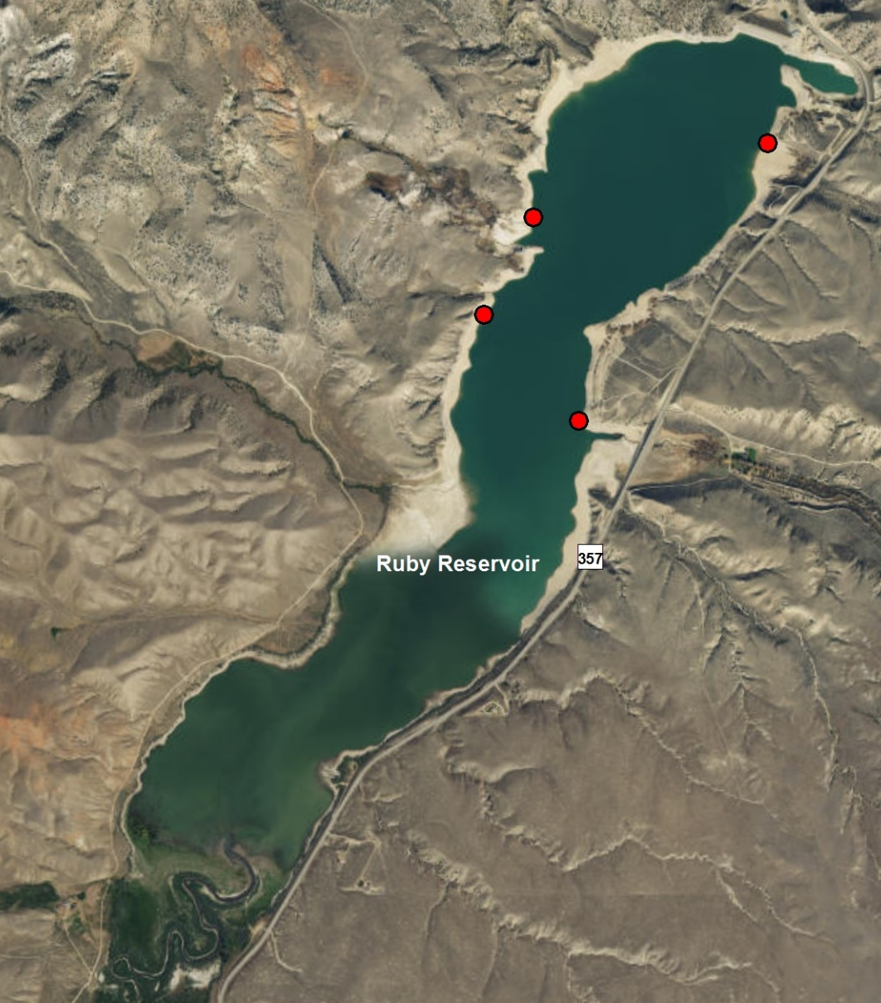
Figure 1. Annual gill net sampling locations in Ruby Reservoir.

Relative weight
Relative weights ($W_{r}$) were calculated as per (Wege and Anderson 1978):
$$W_{r}=\frac{W}{W_{s}}*100,$$
where $W$ is the weight of an individual fish and $W_{s}$ is the “standard weight” of a fish of the same length, derived from published length-weight relationships.

Condition
Fulton’s condition factor ($K$) was used to calculate the condition of fish:
$$K=\frac{W}{L^{3}}*c,$$
where $W$ was the weight of an individual fish, $L$ the length, and the constant $c$ a simple scaling factor.

Size Structure
The size structure of a fish population reflects a complex interplay of environmental drivers and population dynamics (Neumann and Allen 2007), and the relative frequencies of size classes provide a glimpse into these processes. We used two methods to describe the size structure of this fishery: 1) descriptive statistics of lengths through time, and 2) proportional stock density. Proportional stock density is the percentage of fish in each of set of length classes specific to each species of fish. We used the Gabelhouse classification scheme to partition fish into one of six classes: 1) sub-stock, 2) stock, 3) quality, 4) preferred, 5) memorable, and 6) trophy (Gabelhouse 1984). We then calculated the proportional stock density (PSD) of each class as:
$${\text{PSD}}_{\text{class}}=100\left(\frac{\text{number of fish in class}}{\text{total number of fish}}\right).$$
We used the FSA package (Ogle et al. 2018) in the R programming environment to calculate relative weights (R Core Team 2018).
Results
Ruby River Reservoir
Data Summary
In 2024, 192 Rainbow Trout and 6 Brown Trout were captured in Ruby Reservoir and compared to a long-term dataset comprised of 3806 Rainbow Trout and 444 Brown Trout. Rainbow and Brown Trout in Ruby Reservoir averaged 348 and 390 mm, respectively (Tables 1 and 3). Rainbow and Brown Trout were longer and heavier in 2024 than the long-term average, although Rainbow Trout condition was above average and Brown Trout condition was below average (Tables 2 and 4). Both Rainbow and Brown Trout relative weight trended upward in 2024 when compared to the previous year (Figures 2 and 3).
Table 1. Ruby Reservoir Rainbow Trout data summary.
 |  |  |  | Length |  |  |  |  | Weight |  |  | Condition |  |  | Relative Weight
 |  | n |  | Min | Max | Avg | SD |  | Avg | SD |  | Avg | SD |  | Avg | SD
Rainbow Trout |  | 3806 |  | 188 | 523.2 | 347.9 | 56.4 |  | 432.9 | 191 |  | 35.2 | 4.5 |  | 89.4 | 11.6
Table 2. Ruby Reservoir Rainbow Trout data summary for the latest year.
 |  |  |  | Length |  |  |  |  | Weight |  |  | Condition |  |  |  |  | Relative Weight
 |  | n |  | Min | Max | Avg | SD |  | Avg | SD |  | Avg | SD |  |  | Avg |  | SD
Rainbow Trout |  | 192 |  | 244 | 462 | 350.6 | 55.6 |  | 445.9 | 187.6 |  | 35.9 | 4.1 |  |  | 91.2 |  | 10.7

Table 3. Ruby River Reservoir Brown Trout data summary.
 |  |  |  | Length |  |  |  |  | Weight |  |  | Condition |  |  | Relative Weight
 |  | n |  | Min | Max | Avg | SD |  | Avg | SD |  | Avg | SD |  | Avg | SD
Brown Trout |  | 444 |  | 136 | 787.4 | 390.1 | 101.9 |  | 666.5 | 676.8 |  | 32.8 | 4.5 |  | 84.8 | 11.7

Table 4. Ruby River Reservoir Brown Trout data summary for the latest year.
 |  |  |  | Length |  |  |  |  | Weight |  |  | Condition |  |  | Relative Weight
 |  | n |  | Min | Max | Avg | SD |  | Avg | SD |  | Avg | SD |  | Avg | SD
Brown Trout |  | 6 |  | 368 | 560 | 424.8 | 78.9 |  | 728.3 | 473.3 |  | 31.1 | 1.7 |  | 80.7 | 4.7

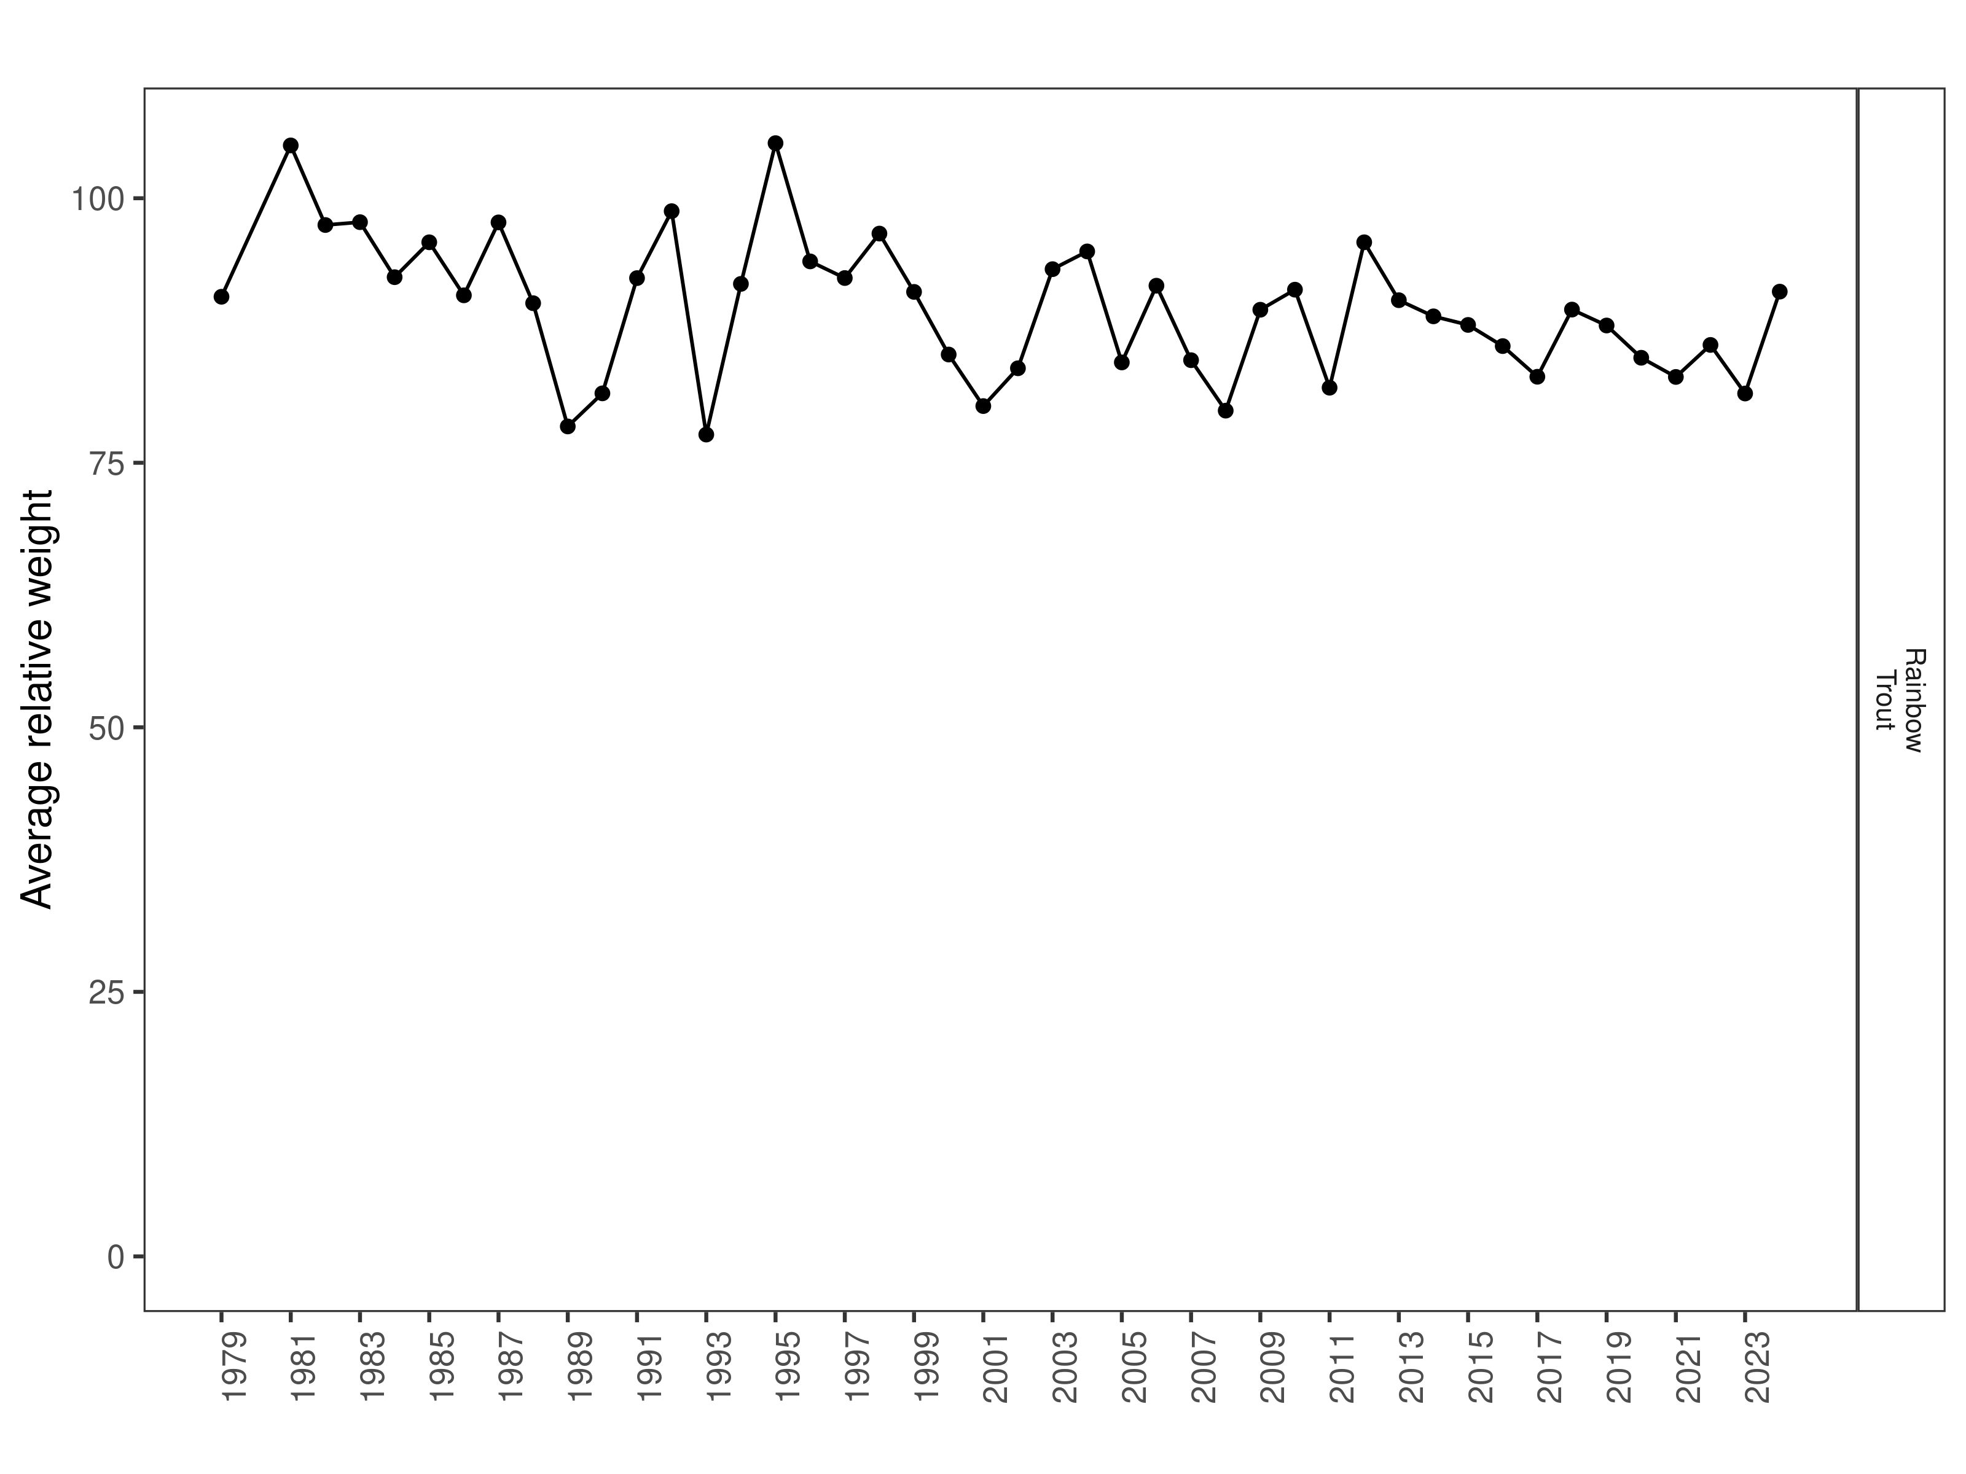
Figure 2. Ruby Reservoir Rainbow Trout relative weight through time.

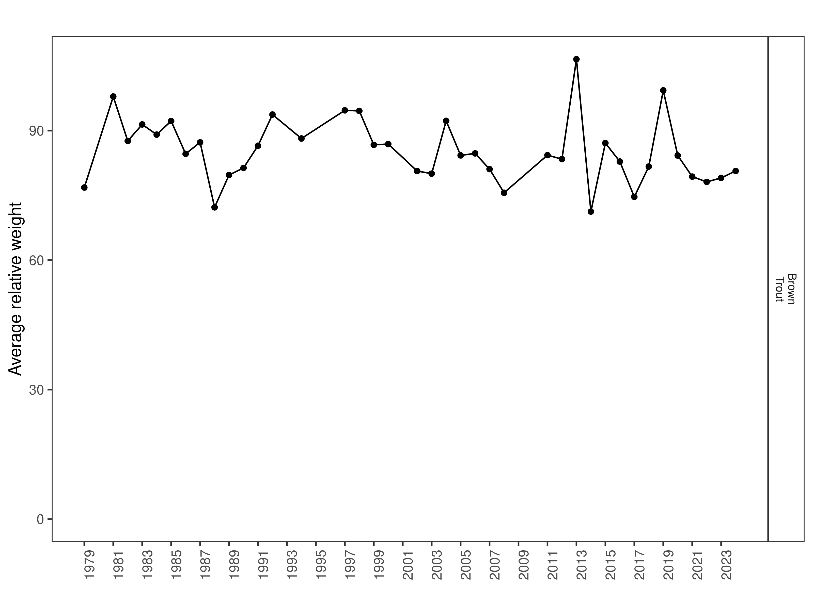
Figure 3. Ruby River Reservoir Brown Trout relative weight through time.
Size Structure
Distribution of Rainbow Trout lengths in 2024 was wider than the previous year but the median length was smaller (Figure 4). Primarily younger (280 mm - 330 mm) Rainbow Trout were sampled in the Ruby Reservoir in 2024; however, at least two older cohorts were also well-represented (Figure 5). Distribution of Brown Trout lengths in 2024 was also wider with a smaller median length than the previous year (Figure 6). This observation is based off a relatively small sample size of 6 fish. The length distribution for Brown Trout sampled in Ruby River Reservoir were few and varied in size in 2024 (Figure 5).
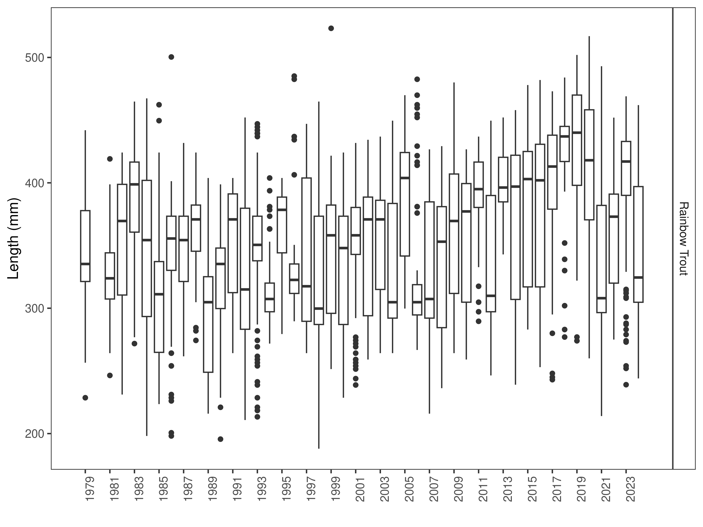
Figure 4. Ruby Reservoir Rainbow Trout length distributions. The box-and-whisker plots divide the distribution of the data into the first quartile (the lower limit of the box), the median (heavy black line), and third quartile (the upper limit of the box). The whiskers denote data points within 1.5 * the interquartile range (the difference between the first and third quartiles). Dots denote data points further than 1.5 * the interquartile range from the box.
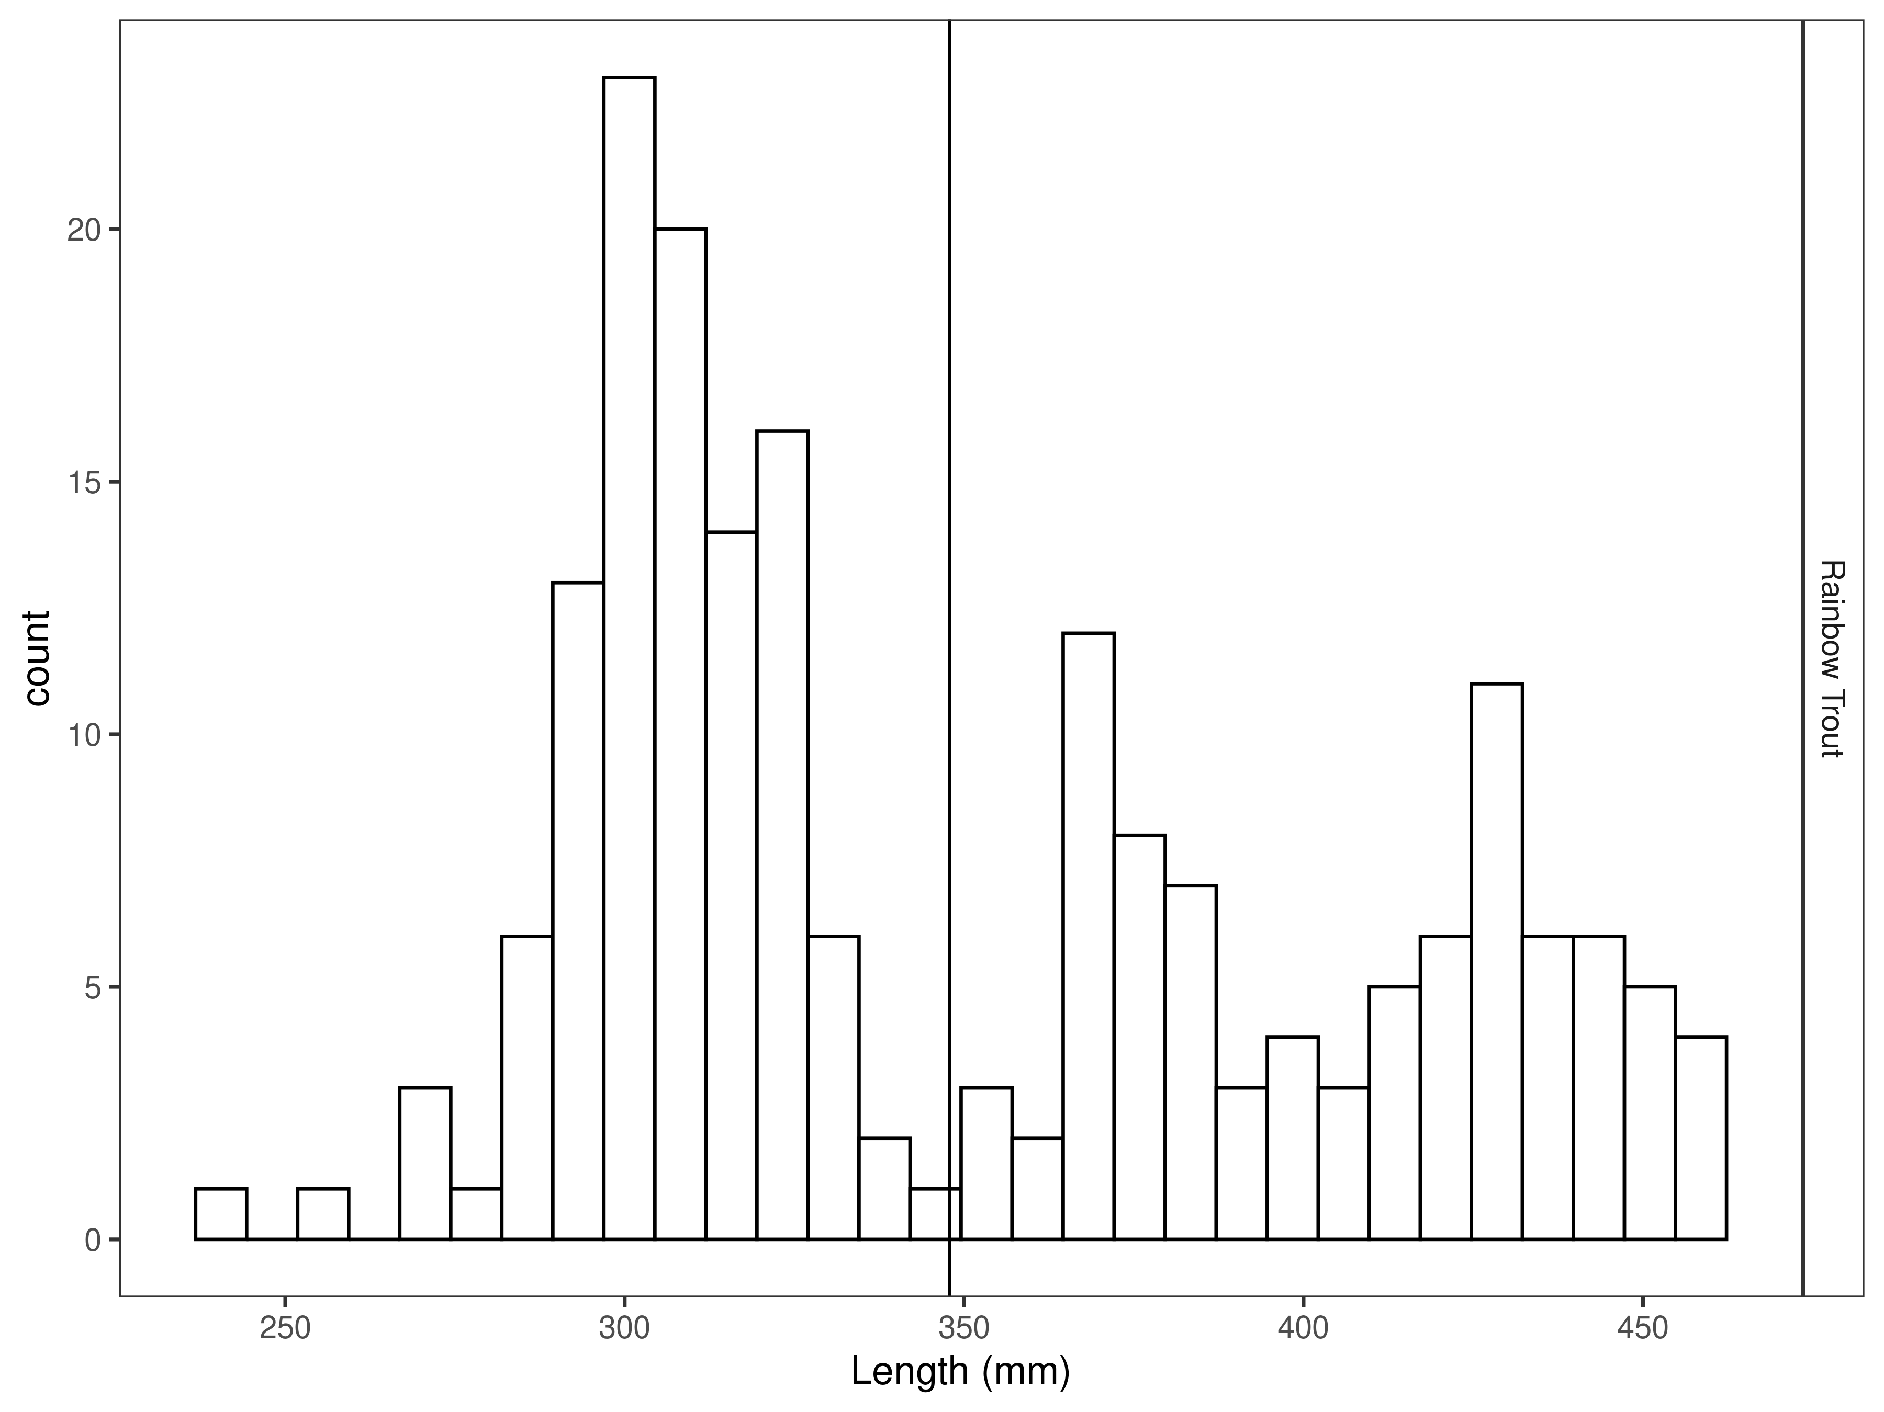
Figure 5. Ruby Reservoir Rainbow Trout length distribution for latest year, with long-term species-averages indicated by the vertical black line.

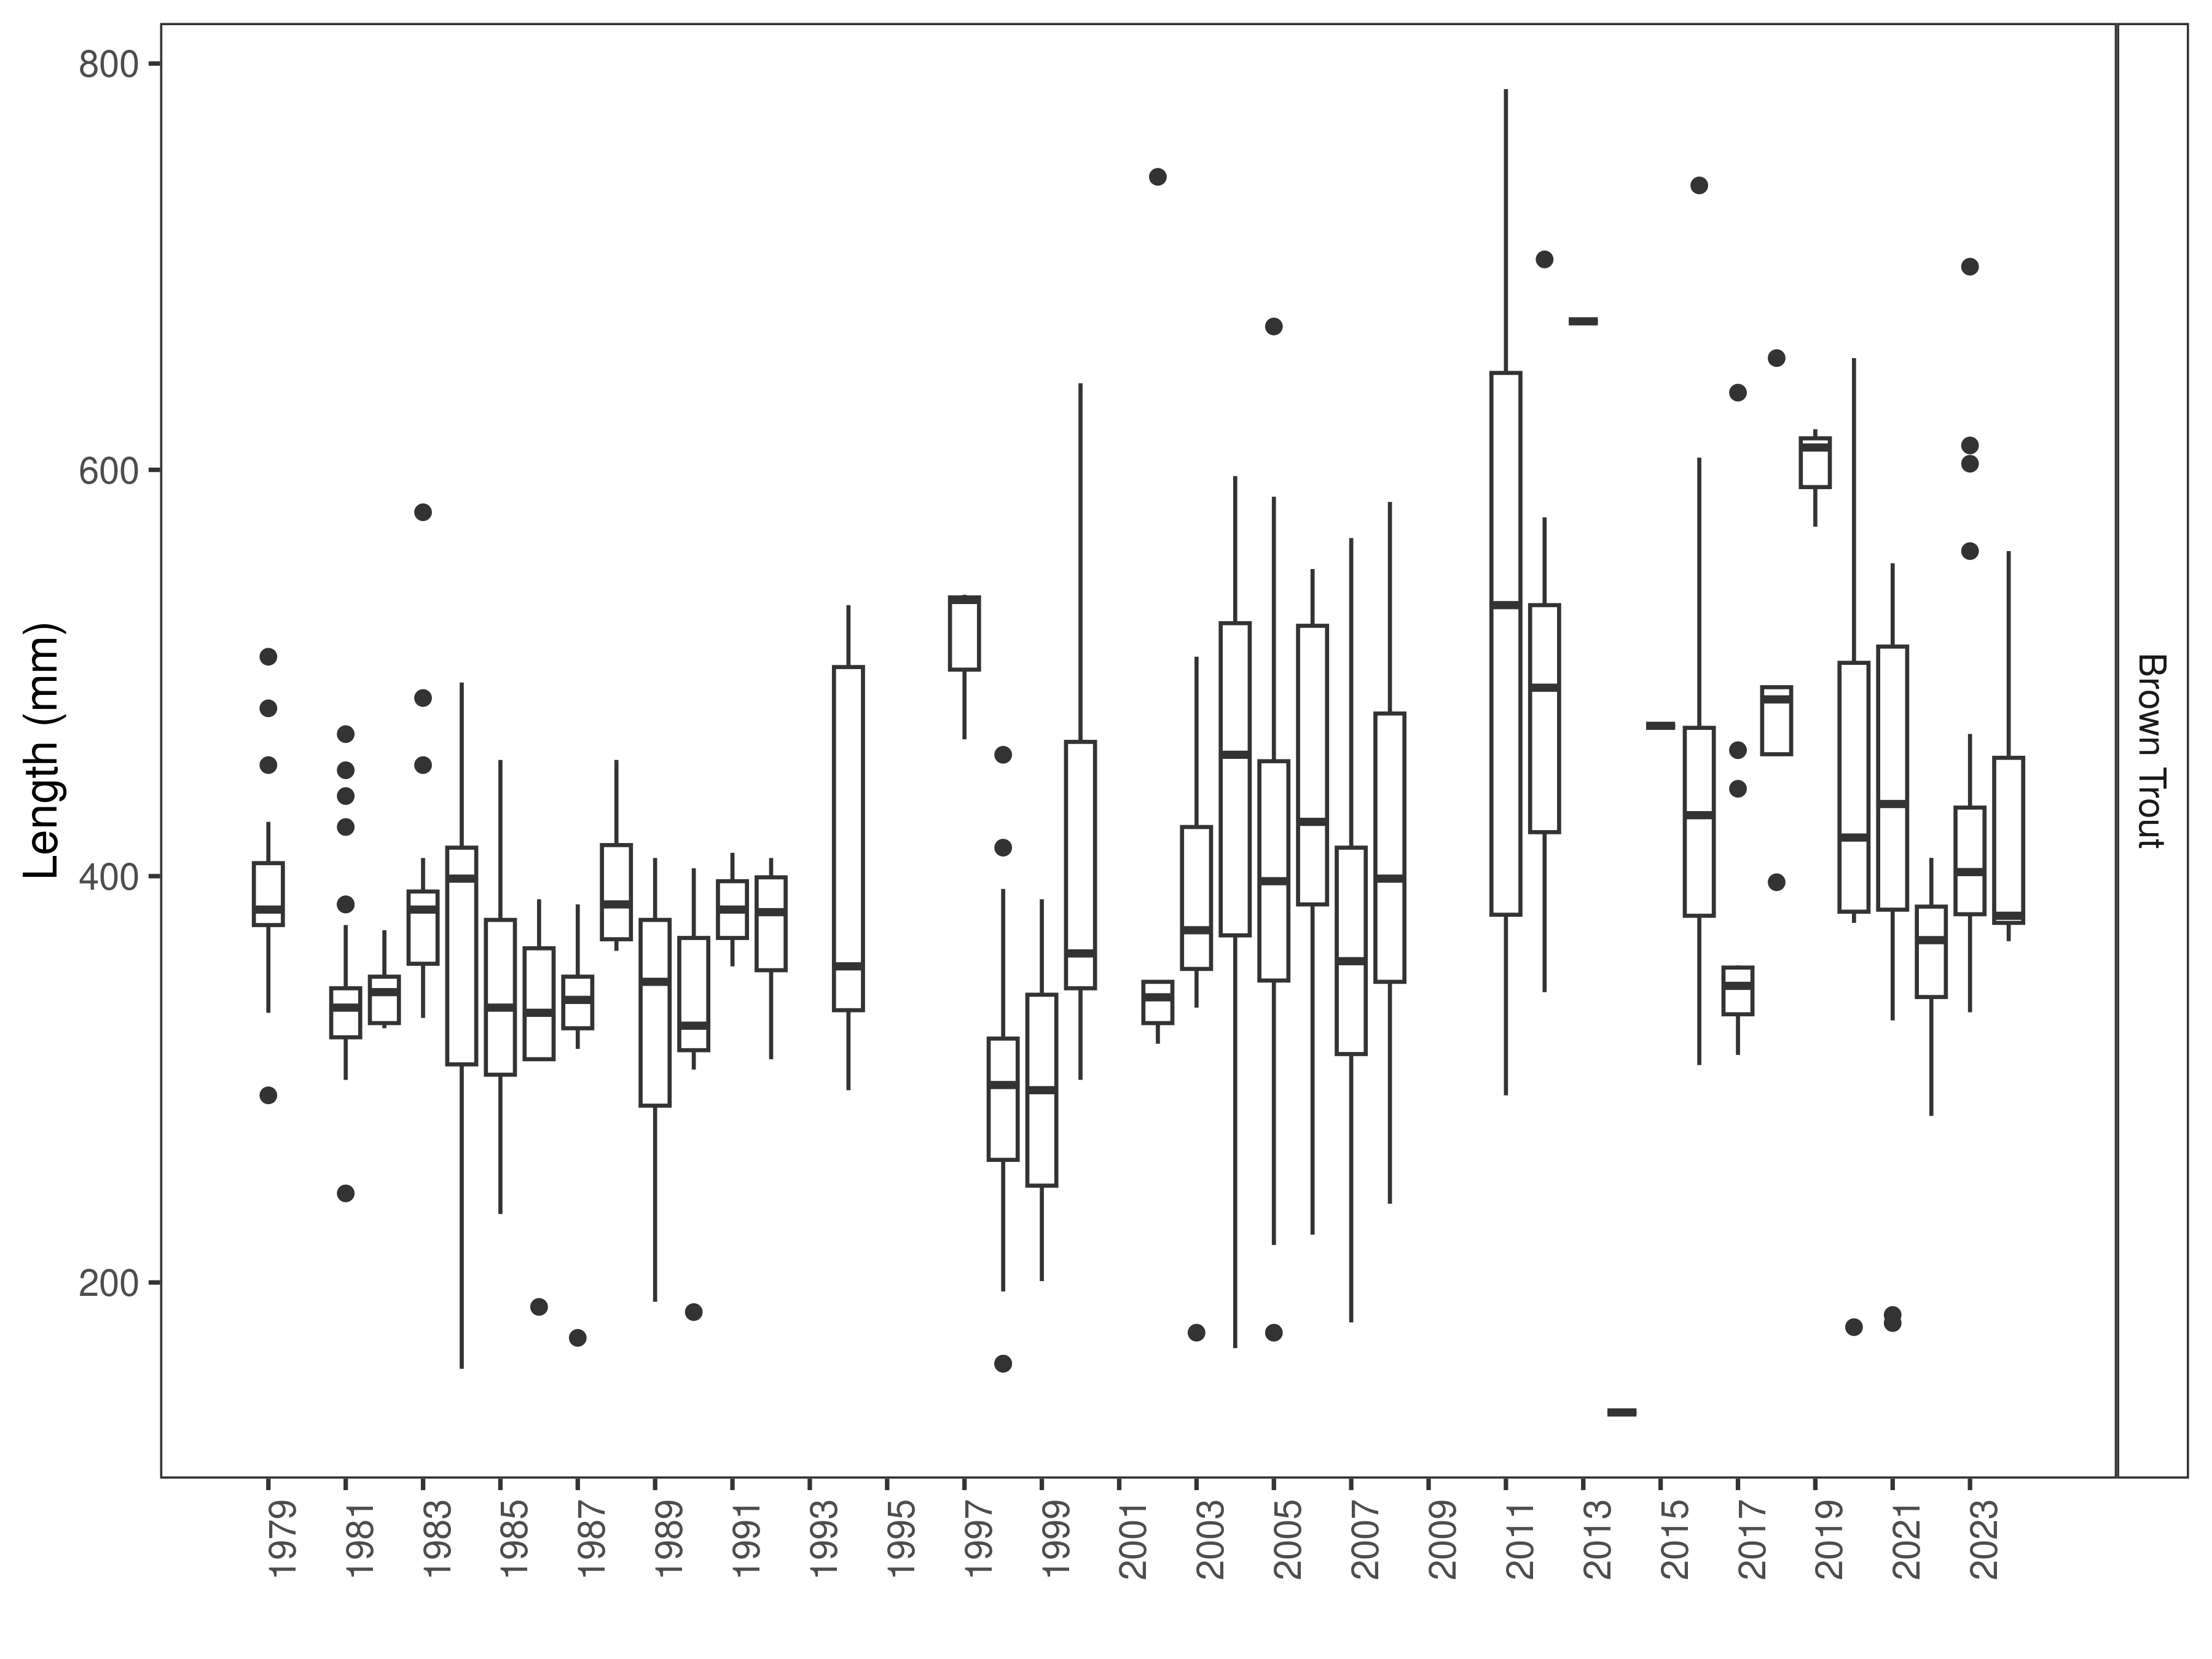
Figure 6. Ruby River Brown Trout length distributions. The box-and-whisker plots divide the distribution of the data into the first quartile (the lower limit of the box), the median (heavy black line), and third quartile (the upper limit of the box). The whiskers denote data points within 1.5 * the interquartile range (the difference between the first and third quartiles). Dots denote data points further than 1.5 * the interquartile range from the box.

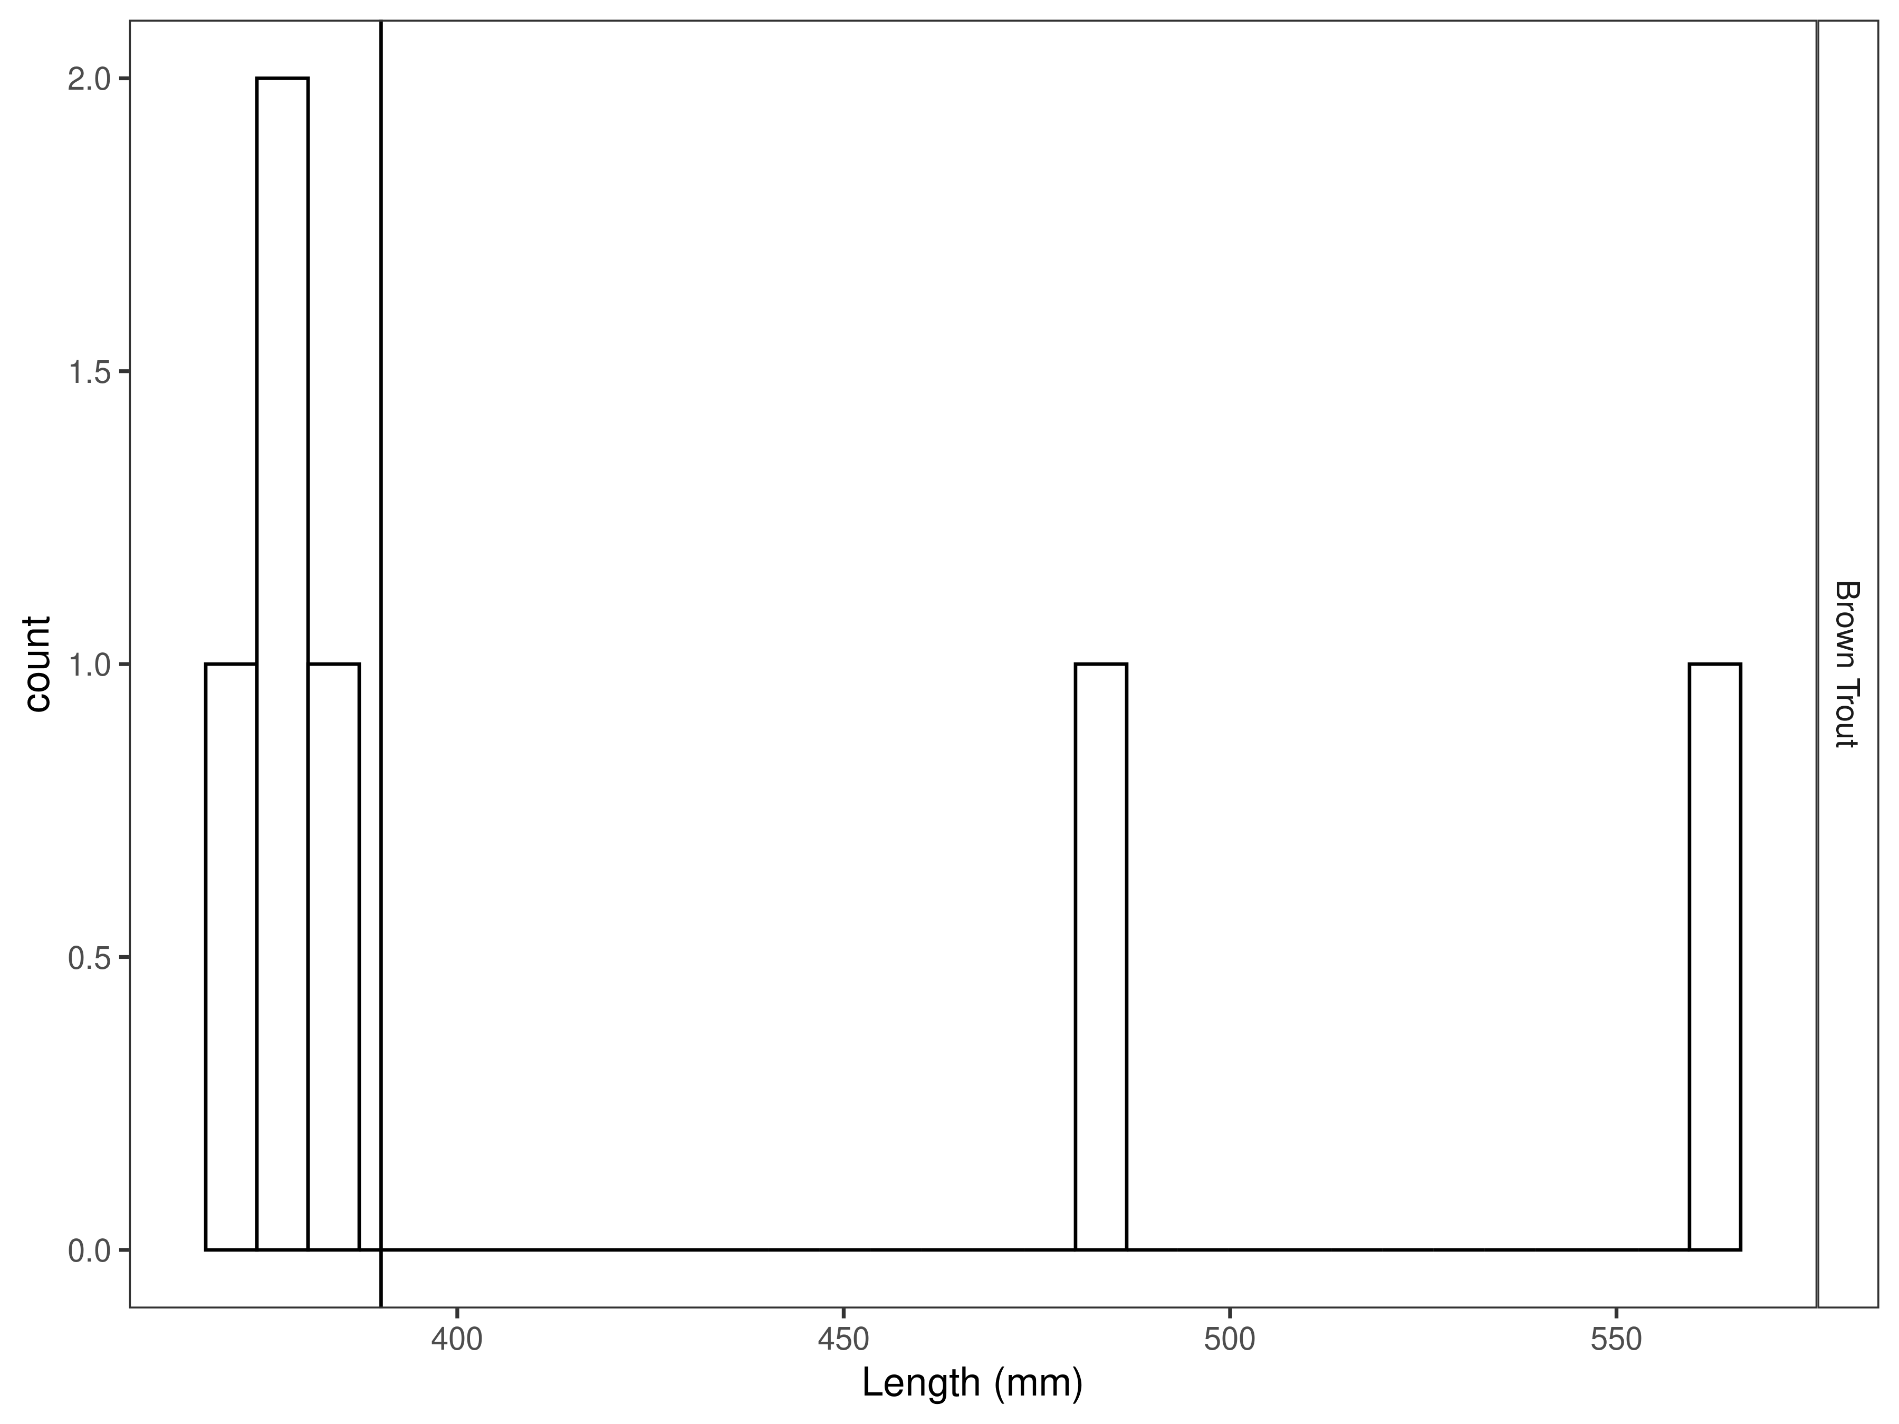
Figure 7. Ruby Reservoir Brown Trout length distribution for latest year, with long-term species-averages indicated by the vertical black line.
Catch per unit effort
In 2024, 48 Rainbow Trout were caught per net night, which is significantly higher than most recent years (Figure 8 and Table 5) and is more than twice the long-term average (Table 6).

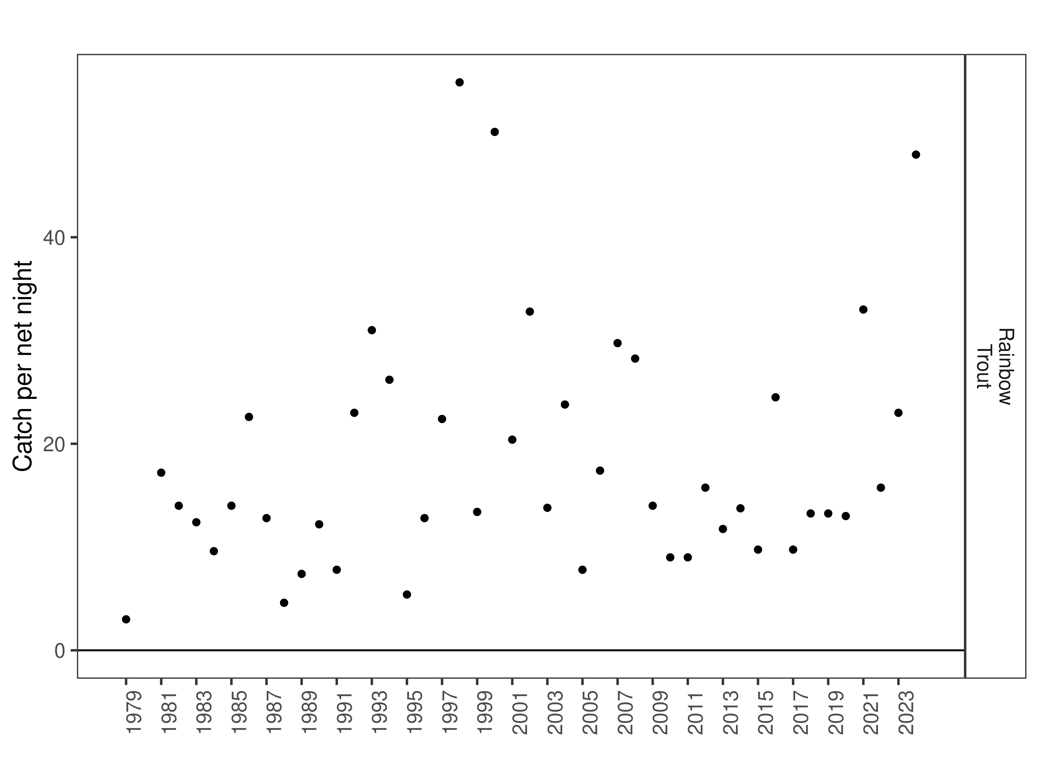
Figure 8. Ruby River Reservoir catch per net night. The dot indicates the mean value within each year, and the line the minimum and maximum.

Table 5. Long-term Rainbow Trout catch per net night through time.
 |  | mean | min | max
Rainbow Trout | 1979 | 3.0 | 3.0 | 3.0
Rainbow Trout | 1981 | 17.2 | 17.2 | 17.2
Rainbow Trout | 1982 | 14.0 | 14.0 | 14.0
Rainbow Trout | 1983 | 12.4 | 12.4 | 12.4
Rainbow Trout | 1984 | 9.6 | 9.6 | 9.6
Rainbow Trout | 1985 | 14.0 | 14.0 | 14.0
Rainbow Trout | 1986 | 22.6 | 22.6 | 22.6
Rainbow Trout | 1987 | 12.8 | 12.8 | 12.8
Rainbow Trout | 1988 | 4.6 | 4.6 | 4.6
Rainbow Trout | 1989 | 7.4 | 7.4 | 7.4
Rainbow Trout | 1990 | 12.2 | 12.2 | 12.2
Rainbow Trout | 1991 | 7.8 | 7.8 | 7.8
Rainbow Trout | 1992 | 23.0 | 23.0 | 23.0
Rainbow Trout | 1993 | 31.0 | 31.0 | 31.0
Rainbow Trout | 1994 | 26.2 | 26.2 | 26.2
Rainbow Trout | 1995 | 5.4 | 5.4 | 5.4
Rainbow Trout | 1996 | 12.8 | 12.8 | 12.8
Rainbow Trout | 1997 | 22.4 | 22.4 | 22.4
Rainbow Trout | 1998 | 55.0 | 55.0 | 55.0
Rainbow Trout | 1999 | 13.4 | 13.4 | 13.4
Rainbow Trout | 2000 | 50.2 | 50.2 | 50.2
Rainbow Trout | 2001 | 20.4 | 20.4 | 20.4
Rainbow Trout | 2002 | 32.8 | 32.8 | 32.8
Rainbow Trout | 2003 | 13.8 | 13.8 | 13.8
Rainbow Trout | 2004 | 23.8 | 23.8 | 23.8
Rainbow Trout | 2005 | 7.8 | 7.8 | 7.8
Rainbow Trout | 2006 | 17.4 | 17.4 | 17.4
Rainbow Trout | 2007 | 29.8 | 29.8 | 29.8
Rainbow Trout | 2008 | 28.2 | 28.2 | 28.2
Rainbow Trout | 2009 | 14.0 | 14.0 | 14.0
Rainbow Trout | 2010 | 9.0 | 9.0 | 9.0
Rainbow Trout | 2011 | 9.0 | 9.0 | 9.0
Rainbow Trout | 2012 | 15.8 | 15.8 | 15.8
Rainbow Trout | 2013 | 11.8 | 11.8 | 11.8
Rainbow Trout | 2014 | 13.8 | 13.8 | 13.8
Rainbow Trout | 2015 | 9.8 | 9.8 | 9.8
Rainbow Trout | 2016 | 24.5 | 24.5 | 24.5
Rainbow Trout | 2017 | 9.8 | 9.8 | 9.8
Rainbow Trout | 2018 | 13.2 | 13.2 | 13.2
Rainbow Trout | 2019 | 13.2 | 13.2 | 13.2
Rainbow Trout | 2020 | 13.0 | 13.0 | 13.0
Rainbow Trout | 2021 | 33.0 | 33.0 | 33.0
Rainbow Trout | 2022 | 15.8 | 15.8 | 15.8
Rainbow Trout | 2023 | 23.0 | 23.0 | 23.0
Rainbow Trout | 2024 | 48.0 | 48.0 | 48.0

Table 6. Catch per net night per species in the latest year.
 |  | mean | cpue_min | cpue_max
Rainbow Trout | 2024 | 48.0 | 48.0 | 48.0
Rainbow Trout | long-term average | 18.4 | 3.0 | 55.0

The 2024 Brown Trout catch rate was 1.5 fish per net, night which is lower than the previous and several recent years (Figure 9 and Table 7) and about half of the long-term average (Table 8).

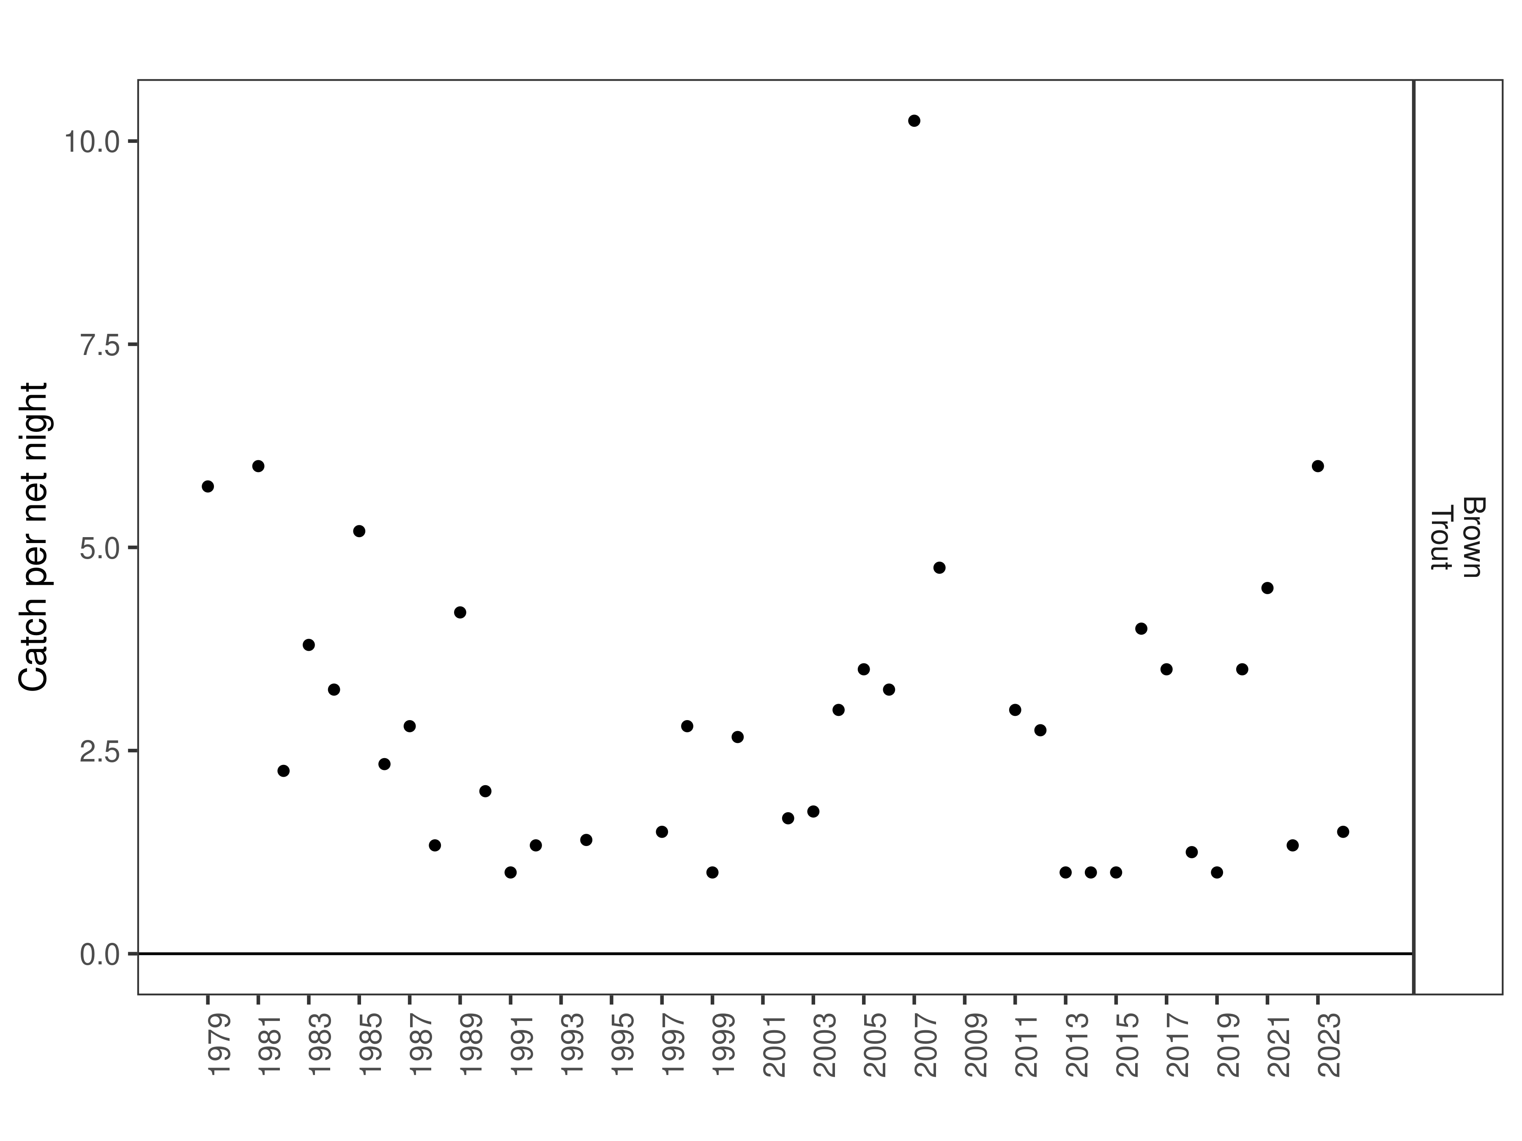
Figure 9. Ruby Reservoir Brown Trout catch per net night. The dot indicates the mean value within each year, and the line the minimum and maximum.

Table 7. Long-term Brown Trout catch per net night through time.
 |  | mean | min | max
Brown Trout | 1979 | 5.8 | 5.8 | 5.8
Brown Trout | 1981 | 6.0 | 6.0 | 6.0
Brown Trout | 1982 | 2.2 | 2.2 | 2.2
Brown Trout | 1983 | 3.8 | 3.8 | 3.8
Brown Trout | 1984 | 3.2 | 3.2 | 3.2
Brown Trout | 1985 | 5.2 | 5.2 | 5.2
Brown Trout | 1986 | 2.3 | 2.3 | 2.3
Brown Trout | 1987 | 2.8 | 2.8 | 2.8
Brown Trout | 1988 | 1.3 | 1.3 | 1.3
Brown Trout | 1989 | 4.2 | 4.2 | 4.2
Brown Trout | 1990 | 2.0 | 2.0 | 2.0
Brown Trout | 1991 | 1.0 | 1.0 | 1.0
Brown Trout | 1992 | 1.3 | 1.3 | 1.3
Brown Trout | 1994 | 1.4 | 1.4 | 1.4
Brown Trout | 1997 | 1.5 | 1.5 | 1.5
Brown Trout | 1998 | 2.8 | 2.8 | 2.8
Brown Trout | 1999 | 1.0 | 1.0 | 1.0
Brown Trout | 2000 | 2.7 | 2.7 | 2.7
Brown Trout | 2002 | 1.7 | 1.7 | 1.7
Brown Trout | 2003 | 1.8 | 1.8 | 1.8
Brown Trout | 2004 | 3.0 | 3.0 | 3.0
Brown Trout | 2005 | 3.5 | 3.5 | 3.5
Brown Trout | 2006 | 3.2 | 3.2 | 3.2
Brown Trout | 2007 | 10.2 | 10.2 | 10.2
Brown Trout | 2008 | 4.8 | 4.8 | 4.8
Brown Trout | 2011 | 3.0 | 3.0 | 3.0
Brown Trout | 2012 | 2.8 | 2.8 | 2.8
Brown Trout | 2013 | 1.0 | 1.0 | 1.0
Brown Trout | 2014 | 1.0 | 1.0 | 1.0
Brown Trout | 2015 | 1.0 | 1.0 | 1.0
Brown Trout | 2016 | 4.0 | 4.0 | 4.0
Brown Trout | 2017 | 3.5 | 3.5 | 3.5
Brown Trout | 2018 | 1.2 | 1.2 | 1.2
Brown Trout | 2019 | 1.0 | 1.0 | 1.0
Brown Trout | 2020 | 3.5 | 3.5 | 3.5
Brown Trout | 2021 | 4.5 | 4.5 | 4.5
Brown Trout | 2022 | 1.3 | 1.3 | 1.3
Brown Trout | 2023 | 6.0 | 6.0 | 6.0
Brown Trout | 2024 | 1.5 | 1.5 | 1.5

Table 8. Brown Trout catch per net night in the latest year.
 |  | mean | cpue_min | cpue_max
Brown Trout | 2024 | 1.5 | 1.5 | 1.5
Brown Trout | long-term average | 2.9 | 1.0 | 10.2

Discussion
C/f of Rainbow Trout was significantly higher than average. Most recruitment of Rainbow Trout is derived from wild fish and it is likely the large number of younger fish observed is driven by the relatively good water year in 2022. Although Brown Trout abundances were low, little inference can be made about interannual differences given the low number of fish we typically catch. Management will continue to emphasize natural recruitment with spawning closures and tributary habitat improvement coupled with stocking success evaluation.

References
Gabelhouse, Donald W. 1984. “A Length-Categorization System to Assess Fish Stocks.” North American Journal of Fisheries Management 4 (3): 273–85.
Neumann, R. M., and M. S. Allen. 2007. “Size Structure.” Analysis and Interpretation of Freshwater Fisheries Data. American Fisheries Society, Bethesda, Maryland, 375–421.
Wege, Gary J., and Richard O. Anderson. 1978. “Relative Weight (Wr): A New Index of Condition for Largemouth Bass.” New Approaches to the Management of Small Impoundments. American Fisheries Society, North Central Division, Special Publication 5: 79–91.

