Introduction
Clark Canyon Reservoir can support a robust fishery known for relatively fast-growing and large Rainbow Trout. Additional fisheries exist for wild Brown Trout and Burbot. Clark Canyon reservoir has year-round angling opportunities and is managed as a cold-water sport fishery for trout. Other fish species that inhabit the reservoir include Common Carp, Longnose Sucker, Mountain Whitefish, Redside Shiner, Rocky Mountain Sculpin and White Sucker.
Clark Canyon Reservoir is managed to maximize densities of rainbow trout, provide trophy rainbow trout, and maintain wild brown trout and burbot fisheries. Over the past decade, angling pressure on Clark Canyon Reservoir has varied from 14,076 angler-days in 2015 to 32,880 angler-days in 2009. Total use by nonresident anglers averages about 40% and has varied from 7% to 67% of all angler-days over the last decade. Monitoring data show Clark Canyon Reservoir supports a robust rainbow trout fishery with average catch rates of about 9 fish per net and fish up to 23 inches regularly observed. The rainbow trout management goal for Clark Canyon Reservoir is to create a fishery that supports netting catch rates of about 15 fish > age 1 per net and a trophy component with at least 5% of fish measuring over 24 inches. The goal of 15 fish per net was selected because rainbow trout body condition in Clark Canyon begins to decline at that relative abundance, which is a function of average reservoir carrying capacity.
Stocking rates for Clark Canyon Reservoir vary from 150,000 to 350,000 fish annually and a positive relationship exists between stocking rate and the number of rainbow trout observed in netting surveys. However, recent otolith microchemistry studies indicated that about 75% of rainbow trout in the reservoir are of wild, not hatchery, origin. Therefore, a management strategy that emphasizes improving spawning habitats, protecting spawning fish, and evaluating the most effective strains and stocking approaches will be employed. This management direction will also benefit wild brown trout. Because of the relatively high harvest rate and contribution of wild trout to the fishery, the combined trout harvest limit in Clark Canyon Reservoir is three trout daily and in possession. Drivers of the reservoir burbot population are relatively unknown, although harvest appears to impact abundance and size-structure. Because of declining relative abundances and size structure over the past decade, more restrictive regulations were implemented in 2019 where harvest is restricted to three burbot over 23 inches to ensure fish live long enough to reach spawn ages to provide sufficient recruitment.
Recruitment of Rainbow trout to Clark Canyon Reservoir is uneven among years and there has been increased angler effort targeting spawning fish in tributaries to the reservoir. Seasonally closing areas where Rainbow trout spawn is intended to improve recruitment of wild fish and overall abundance of Rainbow trout in the reservoir fishery by reducing harvest and catch-and-release mortality of adult fish and angler redd trampling mortality of embryos. This regulation is also intended to improve wild brown trout abundances in Clark Canyon Reservoir by providing protection during brown trout spawning season.
Study Area
Clark Canyon Reservoir is located in Beaverhead County about 20 miles south of Dillon, Montana. Its dam impounds the Red Rock River, Horse Prairie Creek and the headwaters of the Beaverhead River. The structure was constructed in 1961-1964 by the United States Bureau of Reclamation, to store water for downstream irrigation and flood control. The reservoir has a total capacity of 253,442 acre-feet and when full has a surface area of 5,903 acres. Reservoir elevation and storage fluctuates widely among years.
The Bureau of Reclamation (BOR) manages the reservoir and the land surrounding the reservoirs 17 miles of shoreline which has 9 different campgrounds, and a total of 96 different campsites and Clark Canyon Reservoir offers a wide range of recreation activities.
Methods
Sampling Methods
The fisheries data analyzed in this report were collected over last 36 years (1988-2024). Annual monitoring occurs during the first or second week of October. Experimental floating gill nets 125 feet long and 6 feet deep that have five 25-foot panels that range from ¾ inch up to 2 ½ inch bars are set overnight in the same five locations for one night (Figure 1). All fish captured are measured to the nearest mm or tenth of an inch and weighted to the nearest gram or hundredth of a pound.

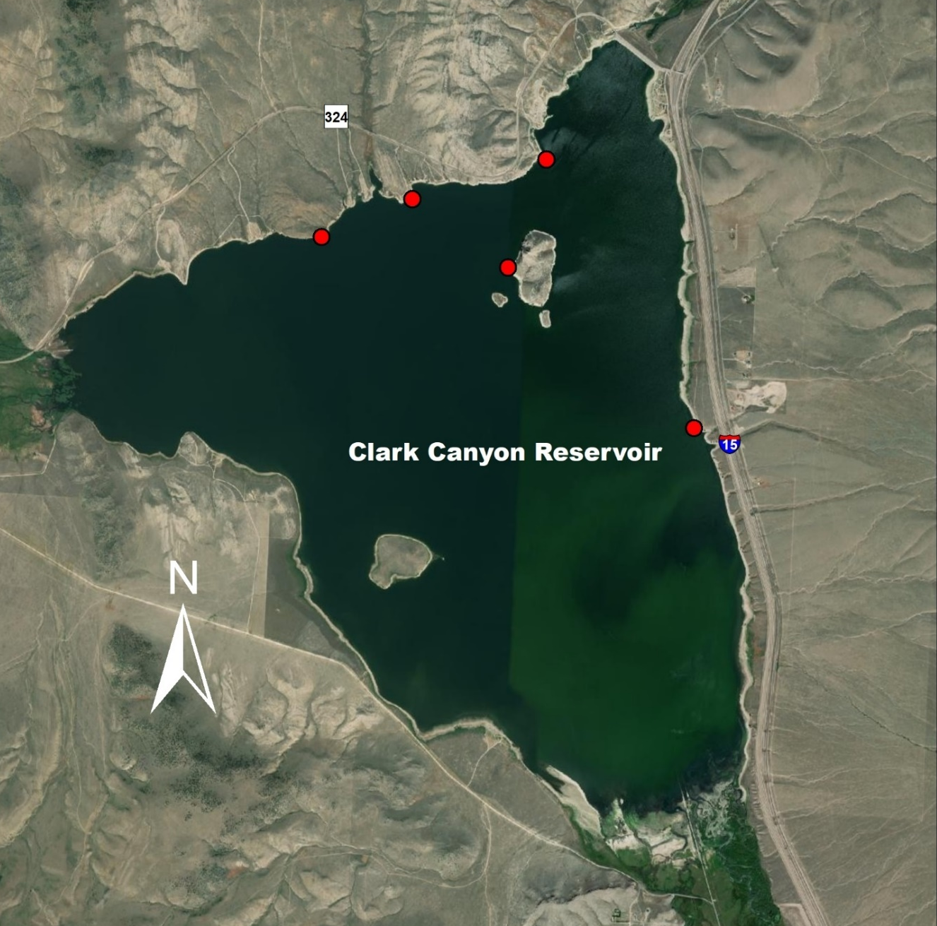
Figure 1. Annual gill net sampling locations in Clark Canyon Reservoir.

Relative weight
Relative weights ($W_{r}$) were calculated as per (Wege and Anderson 1978):
$$W_{r}=\frac{W}{W_{s}}*100,$$
where $W$ is the weight of an individual fish and $W_{s}$ is the “standard weight” of a fish of the same length, derived from published length-weight relationships.

Condition
Fulton’s condition factor ($K$) was used to calculate the condition of fish:
$$K=\frac{W}{L^{3}}*c,$$
where $W$ was the weight of an individual fish, $L$ the length, and the constant $c$ a simple scaling factor.

Size Structure
The size structure of a fish population relects a complex interplay of environmental drivers and population dynamics (Neumann and Allen 2007), and the relative frequencies of size classes provide a glimpse into these processes. We used two methods to describe the size structure of this fishery: 1) descriptive statistics of lengths through time, and 2) proportional stock density. Proportional stock density is the percentage of fish in each of set of length classes specific to each species of fish. We used the Gabelhouse classification scheme to partition fish into one of six classes: 1) sub-stock, 2) stock, 3) quality, 4) preferred, 5) memorable, and 6) trophy (Gabelhouse 1984). We then calculated the proportional stock density (PSD) of each class as:
$${\text{PSD}}_{\text{class}}=100\left(\frac{\text{number of fish in class}}{\text{total number of fish}}\right).$$
We used the FSA package (Ogle et al. 2018) in the R programming environment to calculate relative weights (R Core Team 2018).
Results
Clark Canyon Reservoir
Data Summary
In 2024, 80 Rainbow Trout and 34 Brown Trout and were captured in Clark Canyon Reservoir and compared to a long-term dataset comprised of 2,590 Rainbow Trout and 809 Brown Trout. Rainbow and Brown Trout in Clark Canyon Reservoir average 428 mm and 474, respectively (Tables 1 and 3). Rainbow and Brown Trout were shorter and lighter in weight in 2024 than the long-term average, although Rainbow Trout condition was average and Brown Trout condition was below average (Tables 2 and 4). Rainbow Trout relative weight slightly increased when compared to the previous year and the long-term average, while Brown Trout relative weight was lower than the previous year and the long-term average (Figures 2 and 3).
Table 1. Clark Canyon Reservoir Rainbow Trout data summary.
 |  |  |  | Length |  |  |  |  | Weight |  |  | Condition |  |  | Relative Weight
 |  | n |  | Min | Max | Avg | SD |  | Avg | SD |  | Avg | SD |  | Avg | SD
Rainbow Trout |  | 2590 |  | 155 | 675 | 428 | 111.1 |  | 995.7 | 594 |  | 39.2 | 4.4 |  | 99 | 11.4

Table 2. Clark Canyon Reservoir Rainbow Trout data summary for the latest year.
 |  |  |  | Length |  |  |  |  | Weight |  |  | Condition |  |  | Relative Weight
 |  | n |  | Min | Max | Avg | SD |  | Avg | SD |  | Avg | SD |  | Avg | SD
Rainbow Trout |  | 80 |  | 157 | 605 | 382.1 | 110.9 |  | 736.8 | 567.9 |  | 39.2 | 3.8 |  | 99.2 | 10

Table 3. Clark Canyon Reservoir Brown Trout data summary.
 |  |  |  | Length |  |  |  |  | Weight |  |  | Condition |  |  | Relative Weight
 |  | n |  | Min | Max | Avg | SD |  | Avg | SD |  | Avg | SD |  | Avg | SD
Brown Trout |  | 809 |  | 114 | 919.5 | 473.6 | 96 |  | 1243.6 | 729.1 |  | 37.4 | 6.6 |  | 97.6 | 17.4

Table 4. Clark Canyon Reservoir Brown Trout data summary for the latest year.
 |  |  |  | Length |  |  |  |  | Weight |  |  | Condition |  |  | Relative Weight
 |  | n |  | Min | Max | Avg | SD |  | Avg | SD |  | Avg | SD |  | Avg | SD
Brown Trout |  | 34 |  | 208 | 630 | 451 | 80.6 |  | 938.7 | 473.3 |  | 34 | 3.4 |  | 88.5 | 8.8
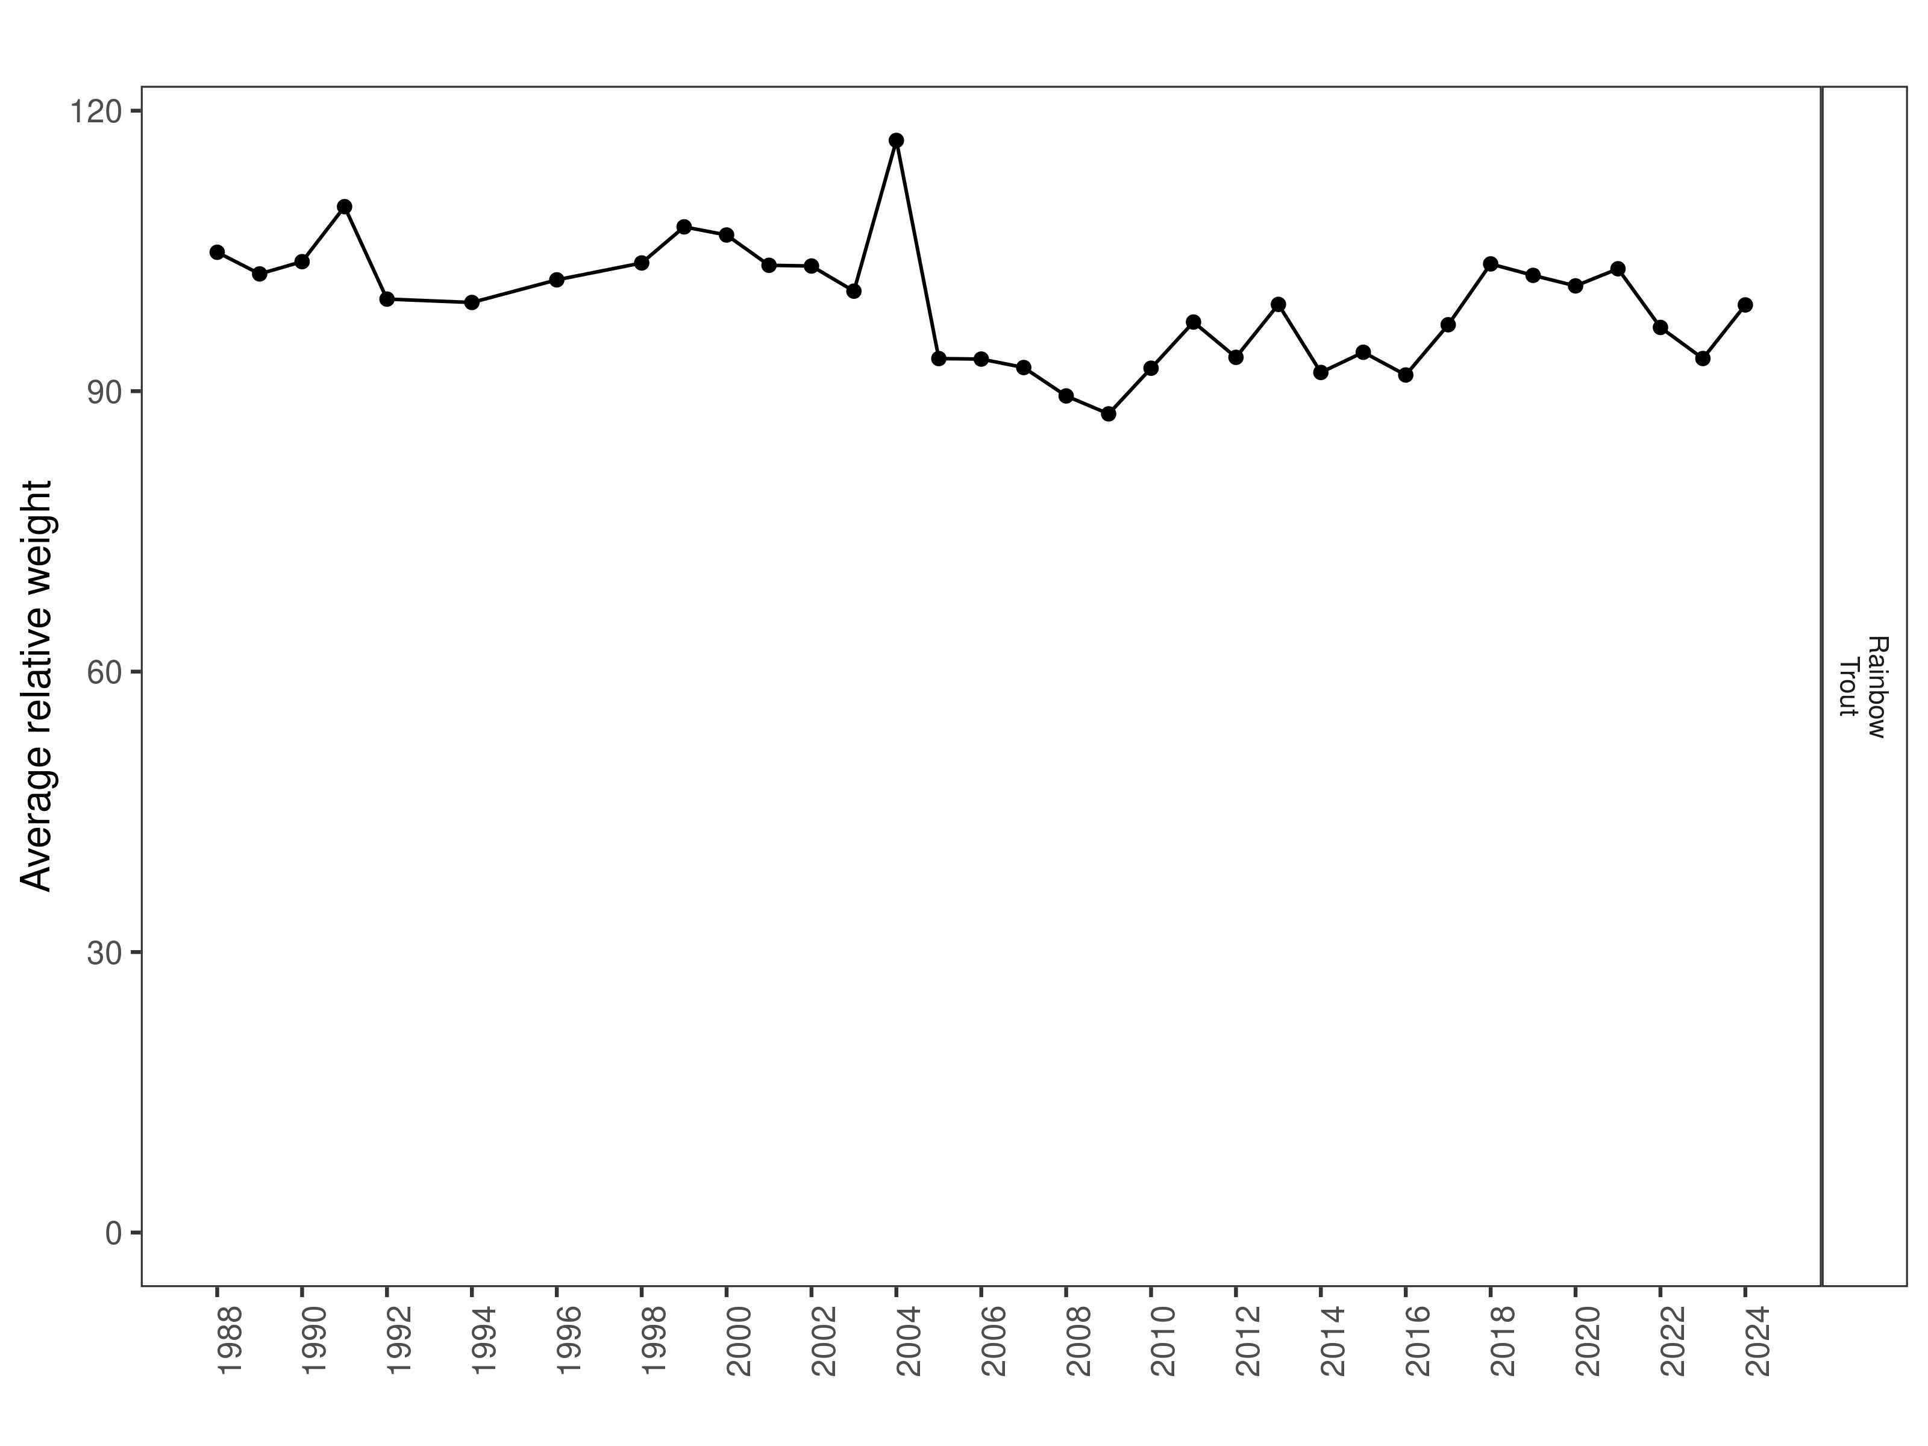
Figure 2. Clark Canyon Reservoir Rainbow Trout relative weight through time.

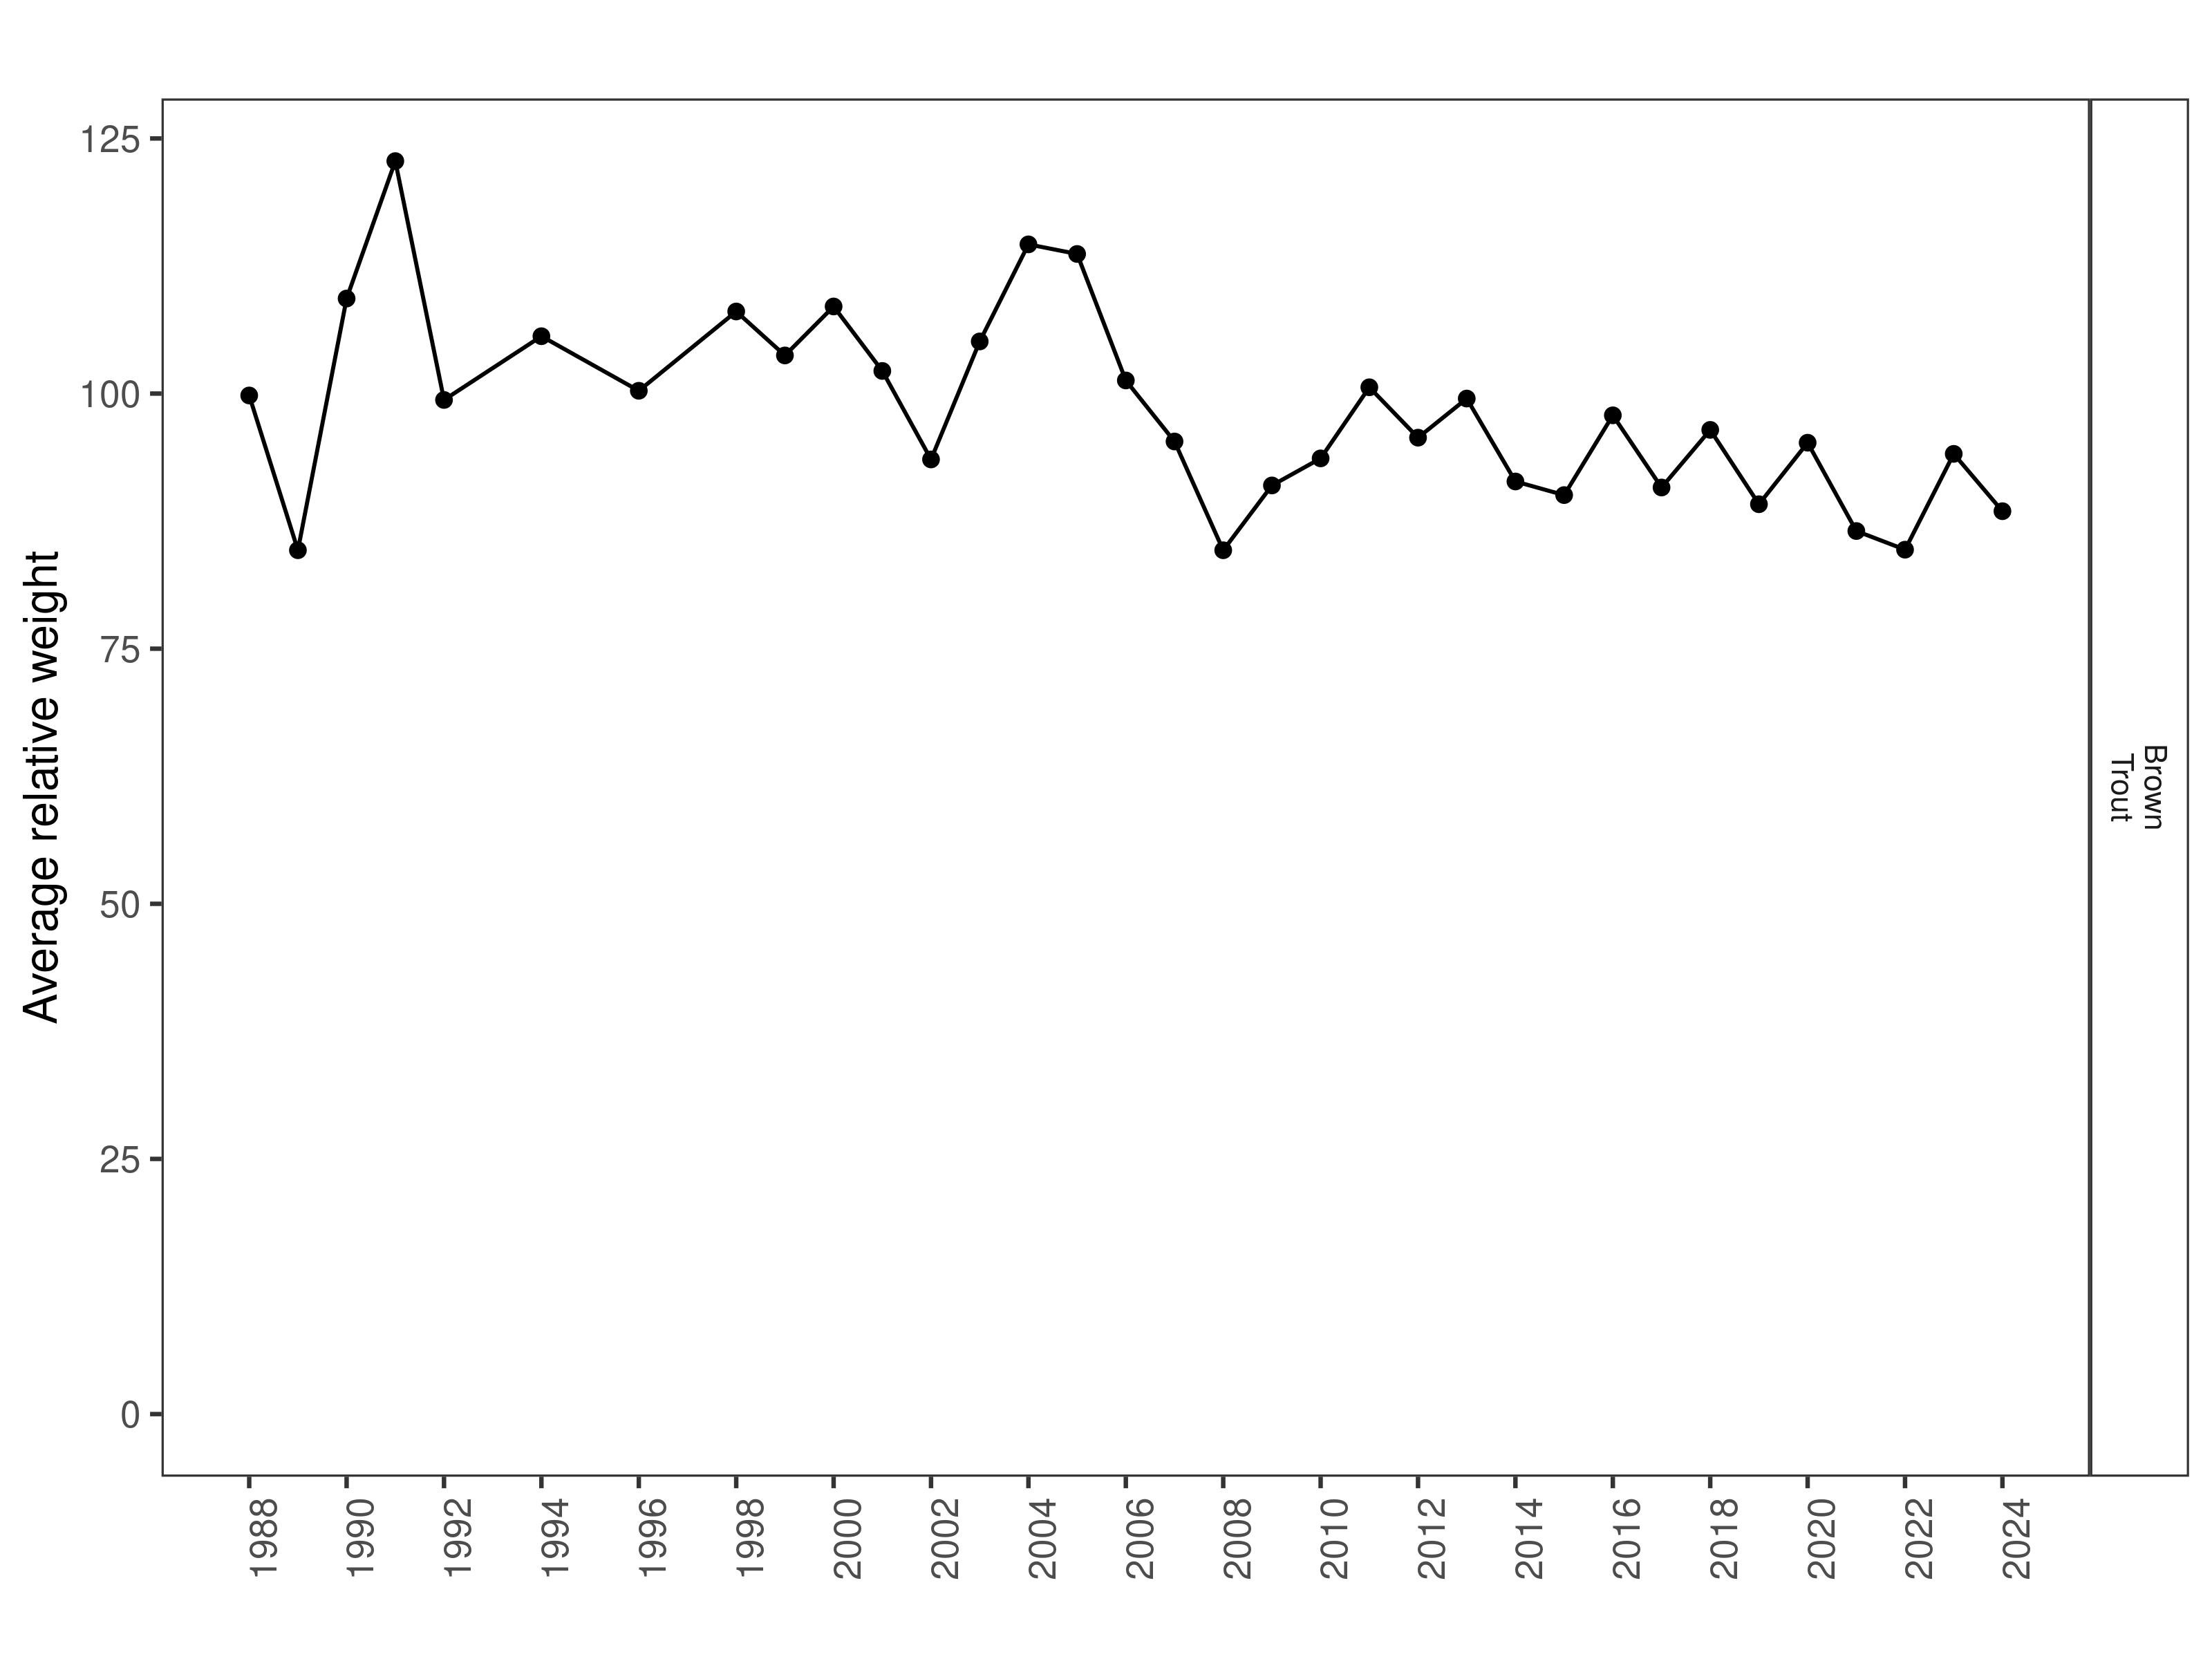
Figure 3. Clark Canyon Reservoir Brown Trout relative weight through time.

Size Structure
Distribution of Rainbow Trout lengths in 2024 was wider than the previous year but the median length was significantly lower (Figure 4). Most Rainbow Trout were 2-year-old fish that ranged between 250 mm and 350 mm, although there were two smaller cohorts of fish that were greater than 400 mm (Figure 5). Distributions of Brown Trout lengths in 2024 was larger than in the previous year but the median length was lower (Figure 6). Most Brown Trout sampled in Clark Canyon Reservoir in 2024 were between 380 mm and 560 mm (Figure 7).

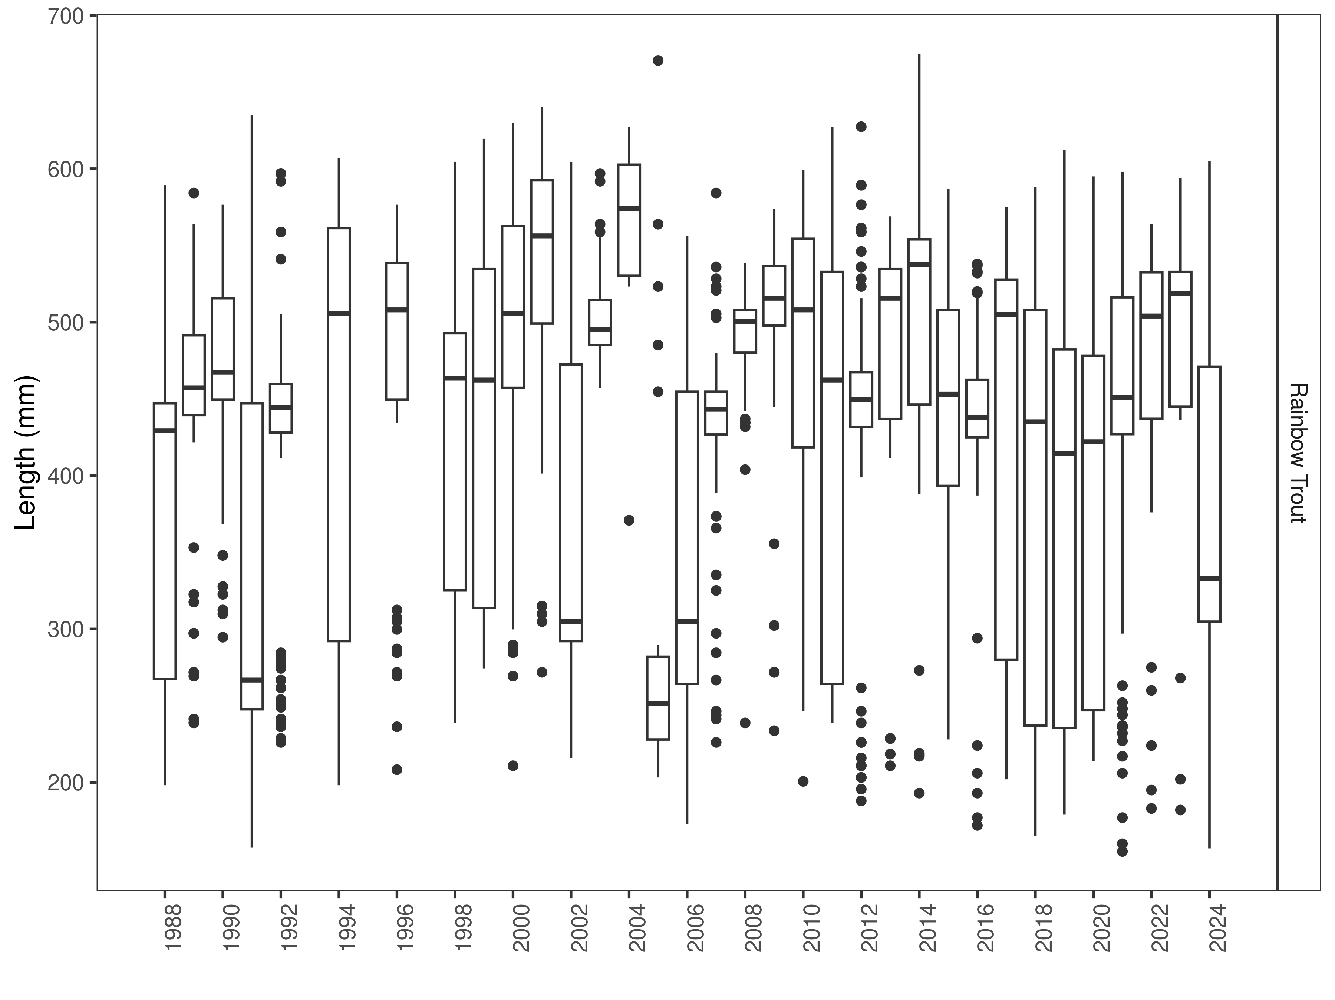
Figure 4. Clark Canyon Reservoir distribution of Rainbow Trout lengths through time. The box-and-whisker plots divide the distribution of the data into the first quartile (the lower limit of the box), the median (heavy black line), and third quartile (the upper limit of the box). The whiskers denote data points within 1.5 * the interquartile range (the difference between the first and third quartiles). Dots denote data points further than 1.5 * the interquartile range from the box.
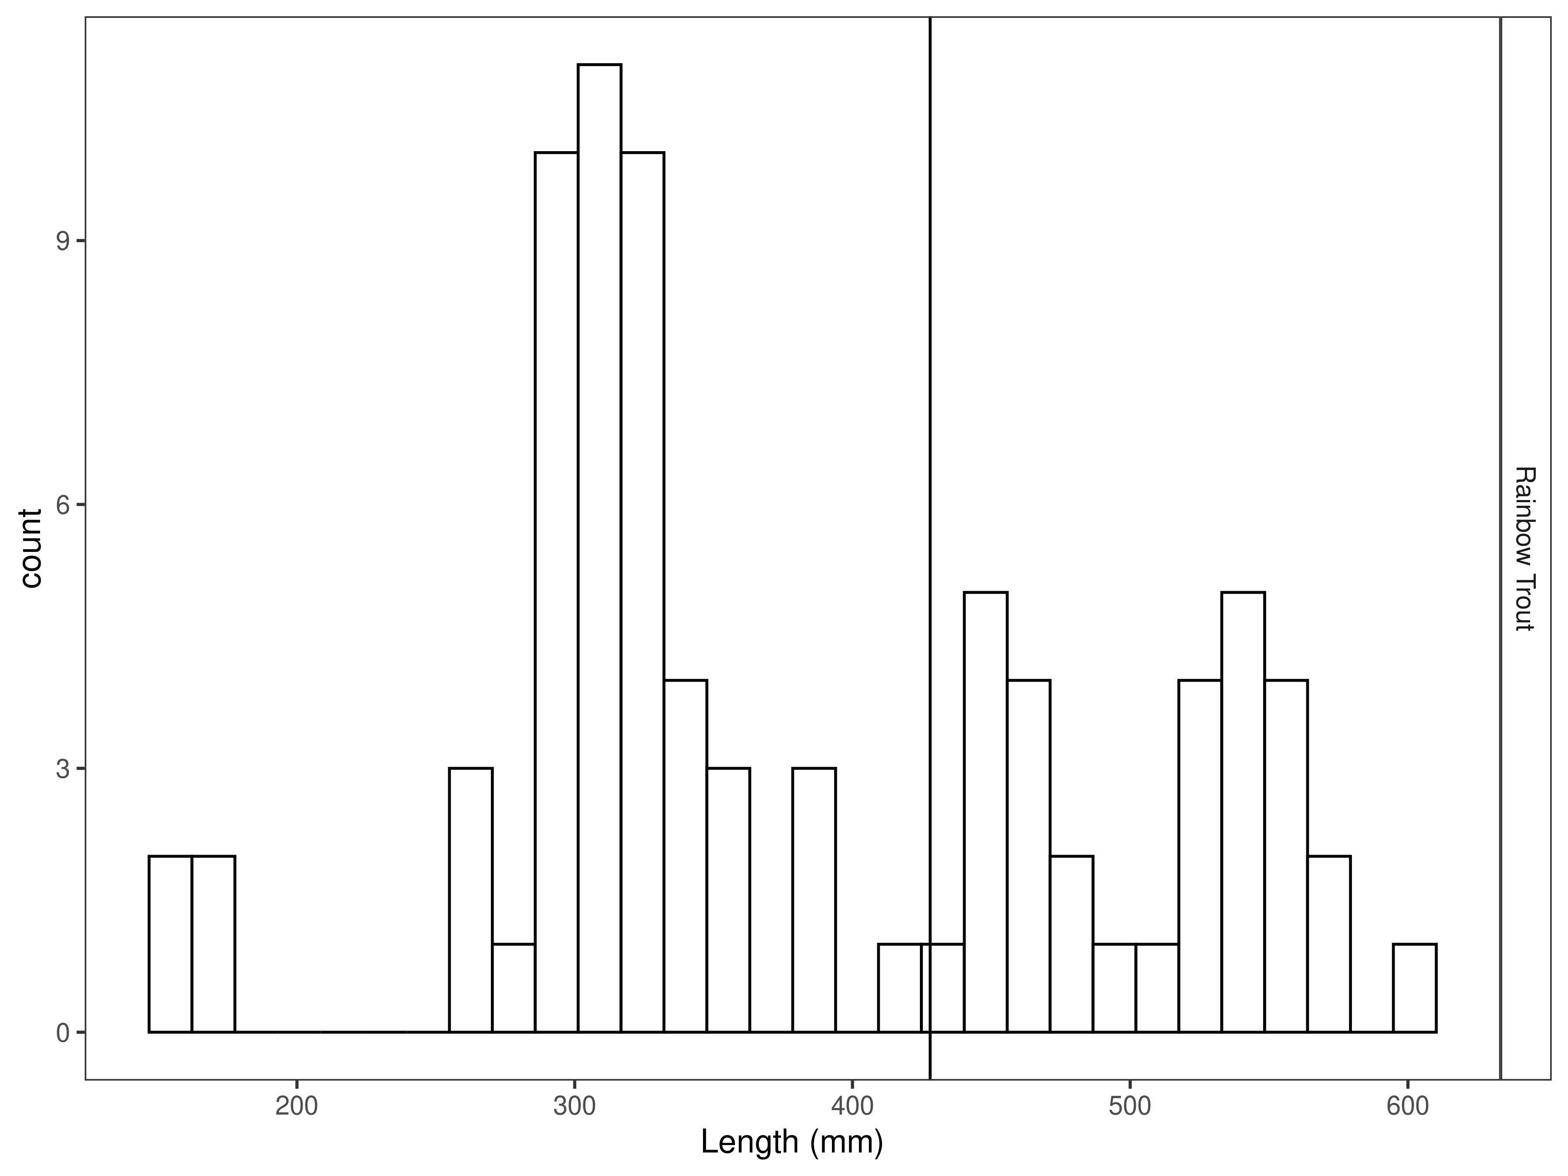
Figure 5. Clark Canyon Reservoir Rainbow Trout length distribution for latest year, with long-term species-averages indicated by the vertical black line.

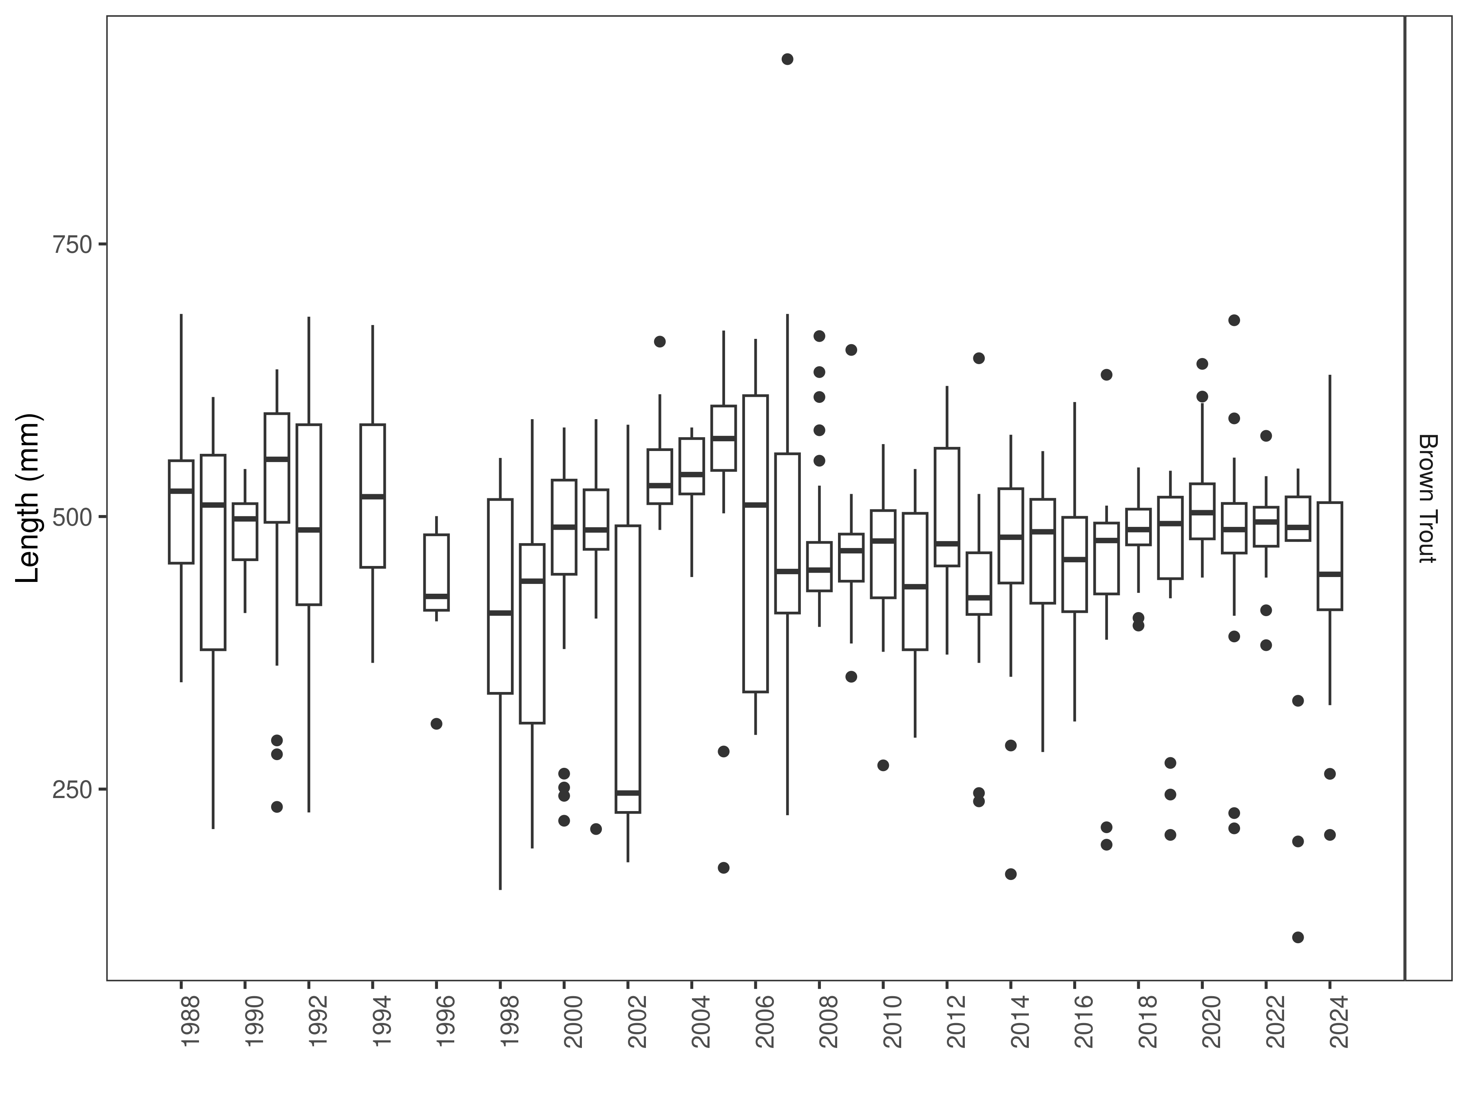
Figure 6. Clark Canyon Reservoir distribution of Brown Trout lengths through time. The box-and-whisker plots divide the distribution of the data into the first quartile (the lower limit of the box), the median (heavy black line), and third quartile (the upper limit of the box). The whiskers denote data points within 1.5 * the interquartile range (the difference between the first and third quartiles). Dots denote data points further than 1.5 * the interquartile range from the box.
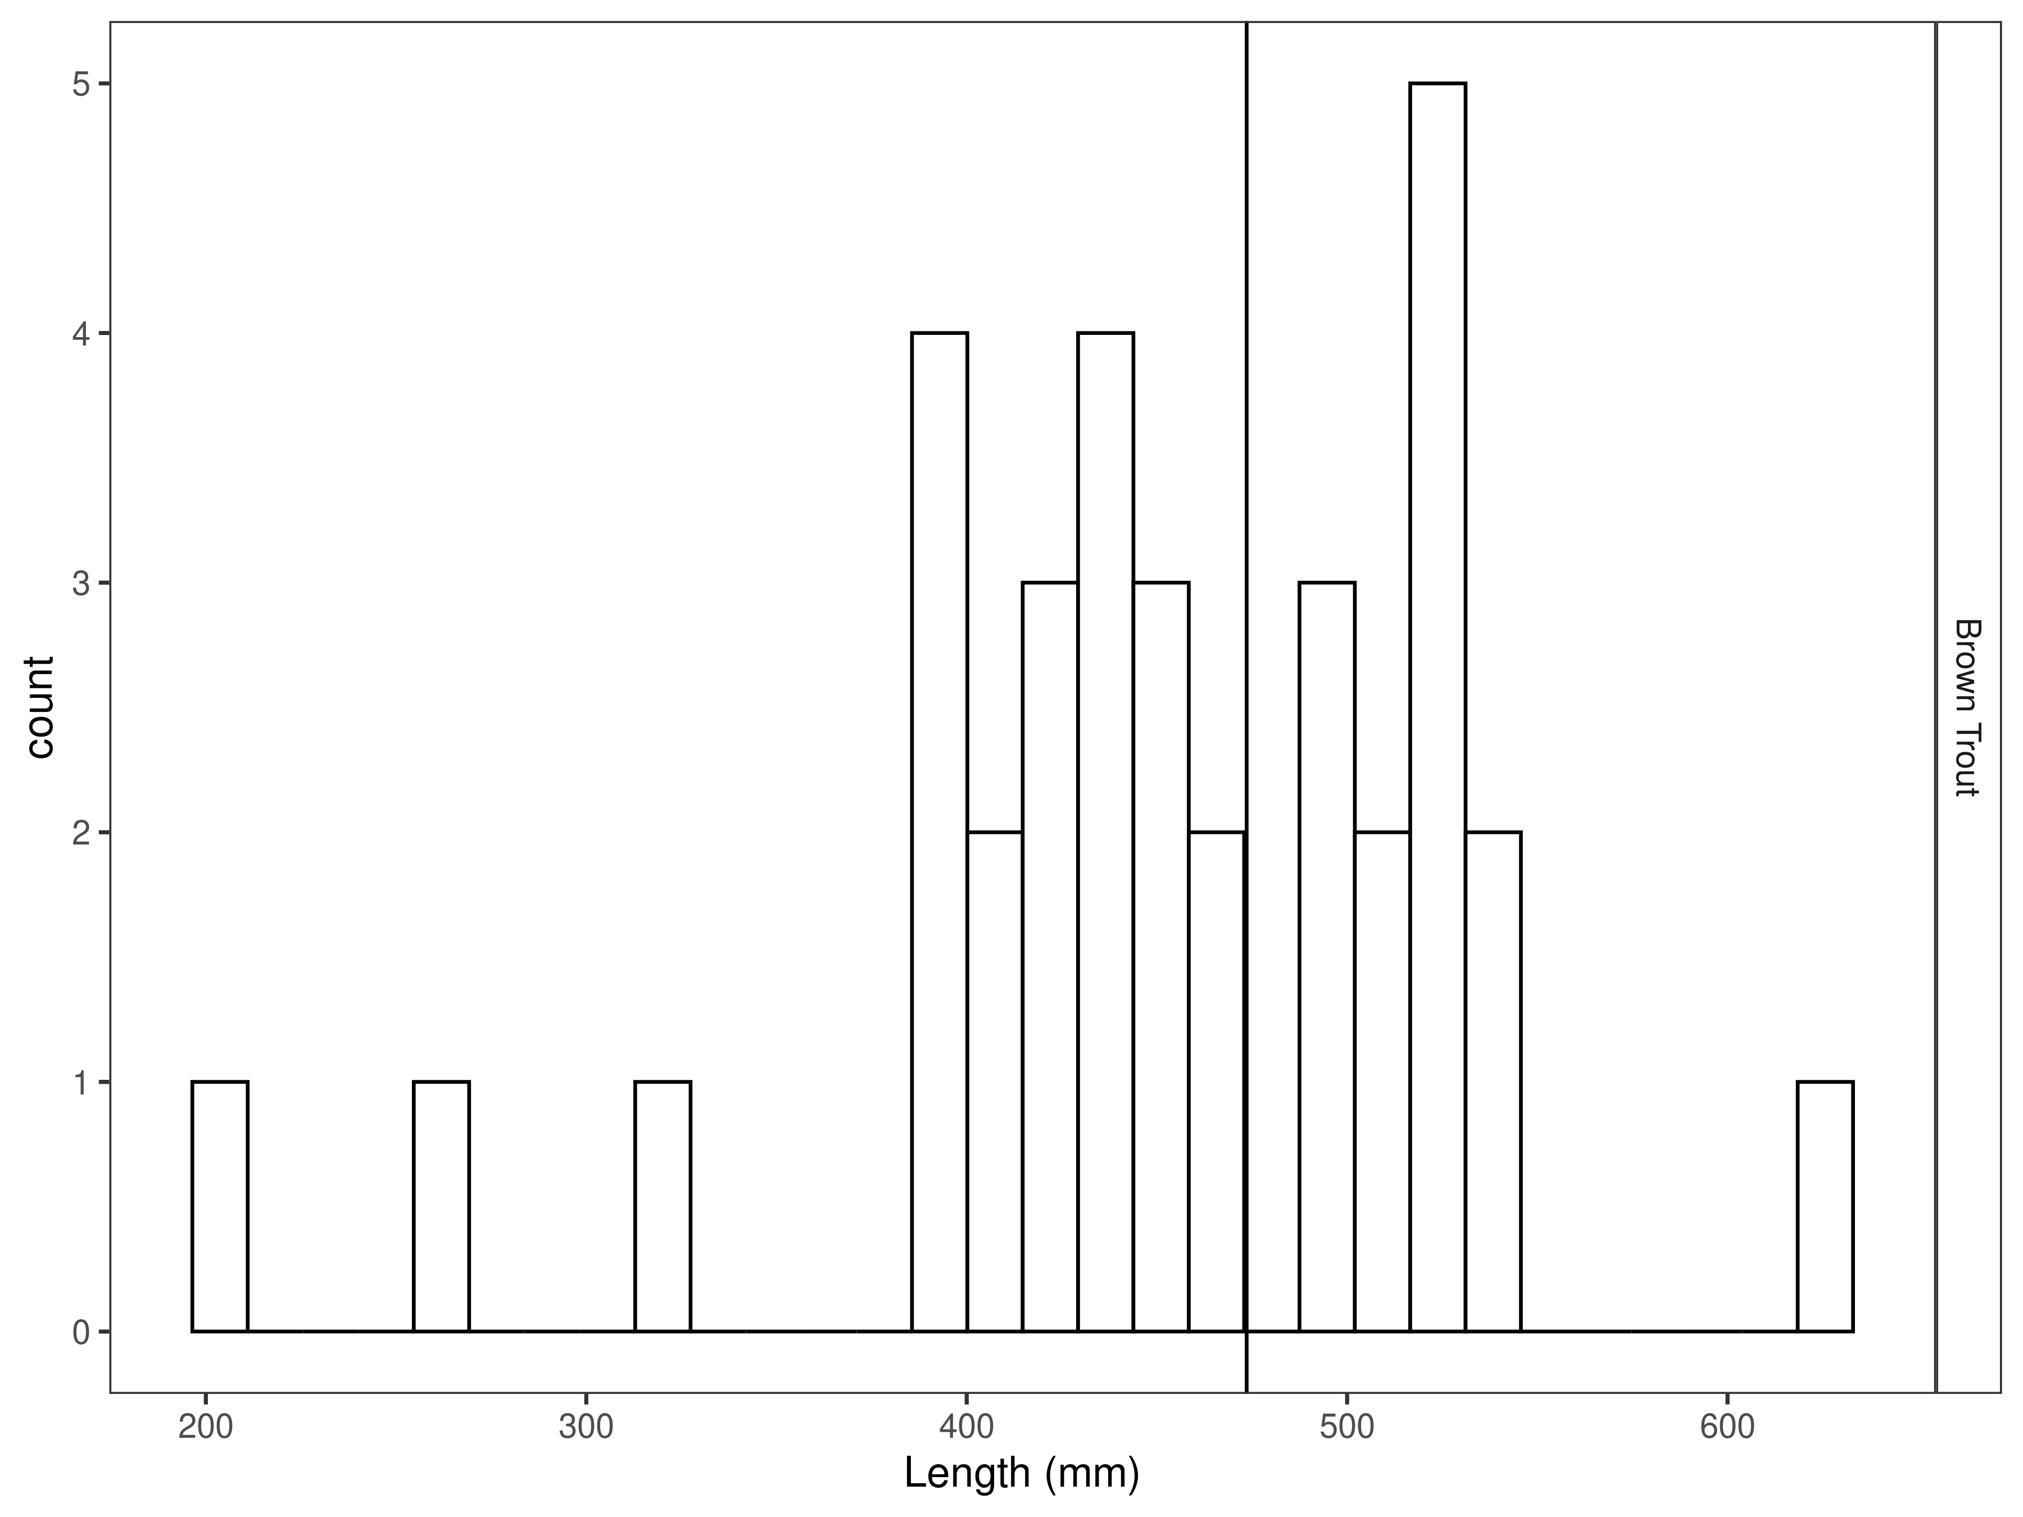
Figure 7. Clark Canyon Reservoir Brown Trout length distribution for latest year, with long-term species-averages indicated by the vertical black line.

Catch per unit effort
In 2024, 16 Rainbow Trout per net night were caught, which is higher than previous year (3.6 fish per net night) and the long-term average (13 fish per net night; Figure 8, Tables 5 and 6).
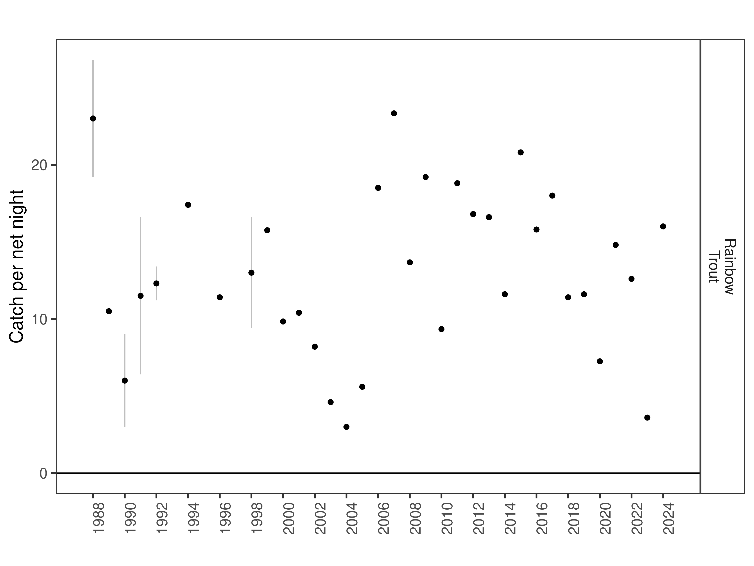
Figure 8. Clark Canyon Reservoir Rainbow Trout catch per net night. The dot indicates the mean value within each year, and the line the minimum and maximum.

Table 5. Long-term Rainbow Trout catch per net night through time.
 |  | mean | min | max
Rainbow Trout | 1988 | 23.0 | 19.2 | 26.8
Rainbow Trout | 1989 | 10.5 | 10.5 | 10.5
Rainbow Trout | 1990 | 6.0 | 3.0 | 9.0
Rainbow Trout | 1991 | 11.5 | 6.4 | 16.6
Rainbow Trout | 1992 | 12.3 | 11.2 | 13.4
Rainbow Trout | 1994 | 17.4 | 17.4 | 17.4
Rainbow Trout | 1996 | 11.4 | 11.4 | 11.4
Rainbow Trout | 1998 | 13.0 | 9.4 | 16.6
Rainbow Trout | 1999 | 15.8 | 15.8 | 15.8
Rainbow Trout | 2000 | 9.8 | 9.8 | 9.8
Rainbow Trout | 2001 | 10.4 | 10.4 | 10.4
Rainbow Trout | 2002 | 8.2 | 8.2 | 8.2
Rainbow Trout | 2003 | 4.6 | 4.6 | 4.6
Rainbow Trout | 2004 | 3.0 | 3.0 | 3.0
Rainbow Trout | 2005 | 5.6 | 5.6 | 5.6
Rainbow Trout | 2006 | 18.5 | 18.5 | 18.5
Rainbow Trout | 2007 | 23.3 | 23.3 | 23.3
Rainbow Trout | 2008 | 13.7 | 13.7 | 13.7
Rainbow Trout | 2009 | 19.2 | 19.2 | 19.2
Rainbow Trout | 2010 | 9.3 | 9.3 | 9.3
Rainbow Trout | 2011 | 18.8 | 18.8 | 18.8
Rainbow Trout | 2012 | 16.8 | 16.8 | 16.8
Rainbow Trout | 2013 | 16.6 | 16.6 | 16.6
Rainbow Trout | 2014 | 11.6 | 11.6 | 11.6
Rainbow Trout | 2015 | 20.8 | 20.8 | 20.8
Rainbow Trout | 2016 | 15.8 | 15.8 | 15.8
Rainbow Trout | 2017 | 18.0 | 18.0 | 18.0
Rainbow Trout | 2018 | 11.4 | 11.4 | 11.4
Rainbow Trout | 2019 | 11.6 | 11.6 | 11.6
Rainbow Trout | 2020 | 7.2 | 7.2 | 7.2
Rainbow Trout | 2021 | 14.8 | 14.8 | 14.8
Rainbow Trout | 2022 | 12.6 | 12.6 | 12.6
Rainbow Trout | 2023 | 3.6 | 3.6 | 3.6
Rainbow Trout | 2024 | 16.0 | 16.0 | 16.0

Table 6. Rainbow Trout catch per net in the latest year.
 |  | mean | cpue_min | cpue_max
Rainbow Trout | 2024 | 16.0 | 16.0 | 16.0
Rainbow Trout | long-term average | 13.0 | 3.0 | 23.3

In 2024, 6.8 Brown Trout per net night were caught, which is higher than the previous year (3.4 fish per net night) and the long-term average (4.6 fish per net night; Figure 9, Table 7 and 8).

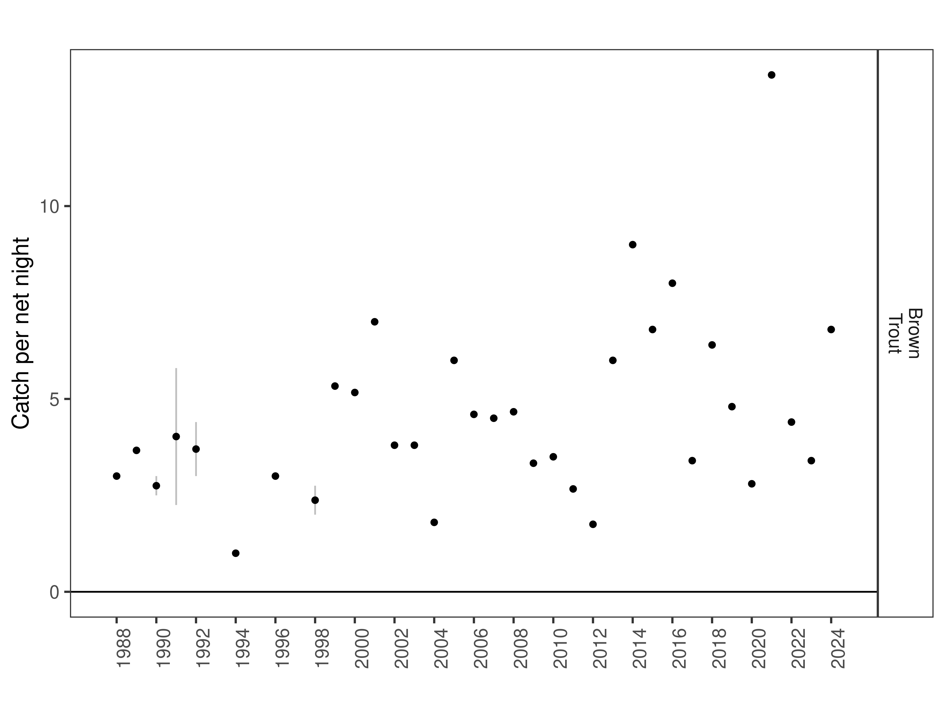
Figure 8. Clark Canyon Reservoir Brown Trout catch per net night. The dot indicates the mean value within each year, and the line the minimum and maximum.

Table 7. Long-term Brown Trout catch per net night through time.
 |  | mean | min | max
Brown Trout | 1988 | 3.0 | 3.0 | 3.0
Brown Trout | 1989 | 3.7 | 3.7 | 3.7
Brown Trout | 1990 | 2.8 | 2.5 | 3.0
Brown Trout | 1991 | 4.0 | 2.2 | 5.8
Brown Trout | 1992 | 3.7 | 3.0 | 4.4
Brown Trout | 1994 | 1.0 | 1.0 | 1.0
Brown Trout | 1996 | 3.0 | 3.0 | 3.0
Brown Trout | 1998 | 2.4 | 2.0 | 2.8
Brown Trout | 1999 | 5.3 | 5.3 | 5.3
Brown Trout | 2000 | 5.2 | 5.2 | 5.2
Brown Trout | 2001 | 7.0 | 7.0 | 7.0
Brown Trout | 2002 | 3.8 | 3.8 | 3.8
Brown Trout | 2003 | 3.8 | 3.8 | 3.8
Brown Trout | 2004 | 1.8 | 1.8 | 1.8
Brown Trout | 2005 | 6.0 | 6.0 | 6.0
Brown Trout | 2006 | 4.6 | 4.6 | 4.6
Brown Trout | 2007 | 4.5 | 4.5 | 4.5
Brown Trout | 2008 | 4.7 | 4.7 | 4.7
Brown Trout | 2009 | 3.3 | 3.3 | 3.3
Brown Trout | 2010 | 3.5 | 3.5 | 3.5
Brown Trout | 2011 | 2.7 | 2.7 | 2.7
Brown Trout | 2012 | 1.8 | 1.8 | 1.8
Brown Trout | 2013 | 6.0 | 6.0 | 6.0
Brown Trout | 2014 | 9.0 | 9.0 | 9.0
Brown Trout | 2015 | 6.8 | 6.8 | 6.8
Brown Trout | 2016 | 8.0 | 8.0 | 8.0
Brown Trout | 2017 | 3.4 | 3.4 | 3.4
Brown Trout | 2018 | 6.4 | 6.4 | 6.4
Brown Trout | 2019 | 4.8 | 4.8 | 4.8
Brown Trout | 2020 | 2.8 | 2.8 | 2.8
Brown Trout | 2021 | 13.4 | 13.4 | 13.4
Brown Trout | 2022 | 4.4 | 4.4 | 4.4
Brown Trout | 2023 | 3.4 | 3.4 | 3.4
Brown Trout | 2024 | 6.8 | 6.8 | 6.8

Table 8. Brown Trout catch per net night in the latest year.
 |  | mean | cpue_min | cpue_max
Brown Trout | 2024 | 6.8 | 6.8 | 6.8
Brown Trout | long-term average | 4.6 | 1.0 | 13.4

Discussion
C/f of Rainbow Trout was not significantly different than average or the long-term management goal of 15 fish > age 1 per net. However, there was wide variation among nets and considerable uncertainty in the 2024 estimate driven by one net that had many more fish (42) than the remaining four (12, 12, 10, 4). Given the relatively low numbers of fish stocked the previous three years, it is possible that net was a biased outlier and abundances are lower than reported. Most recruitment of Rainbow Trout is derived from wild fish so it is similarly possible that the large number of younger fish observed is accurate and driven by the relatively good water year in 2022. Sampling in 2025 will help refine the 2024 Rainbow Trout relative abundance estimate. Management will continue to emphasize natural recruitment with spawning closures and tributary habitat improvement coupled with stocking success and strain evaluation.

References
Gabelhouse, Donald W. 1984. “A Length-Categorization System to Assess Fish Stocks.” North American Journal of Fisheries Management 4 (3): 273–85.
Neumann, R. M., and M. S. Allen. 2007. “Size Structure.” Analysis and Interpretation of Freshwater Fisheries Data. American Fisheries Society, Bethesda, Maryland, 375–421.
Wege, Gary J., and Richard O. Anderson. 1978. “Relative Weight (Wr): A New Index of Condition for Largemouth Bass.” New Approaches to the Management of Small Impoundments. American Fisheries Society, North Central Division, Special Publication 5: 79–91.

