Introduction
The Beaverhead River can provide a trout fishery unique in both abundance and average size of fish; however, both characteristics of the fishery have fluctuated through time. Reservoir releases, particularly during discrete periods of drought, have been implicated as a limiting factor for brown trout (Oswald 2009, Jaeger and Bateman 2016). Stochastic input of sediment from Clark Canyon Creek during periods of low discharge also has a negative effect on the trout population; however, sediment flushing flows have been identified and implemented as a mitigative management action (Jaeger and Bateman 2016, Jaeger and Bateman 2020).
All flowing waters in this drainage that support trout populations are managed as wild trout fisheries, emphasizing habitat protection and natural reproduction. The Beaverhead River contains fish species common to Southwestern Montana, including Rainbow Trout, Brown Trout, Brook Trout, Westslope Cutthroat Trout (primarily in isolated tributaries), hybrid cutthroat trout, Burbot, Common Carp, Longnose Dace, Longnose Sucker, Mountain Whitefish, Redside Shiner, Rocky Mountain Sculpin, and White Sucker. Tributaries and their connections with the Beaverhead River are critical for supporting natural reproduction, providing rearing habitat for juvenile trout, and delivering cool summer streamflow.

The current wild trout management strategy replaced hatchery-based management of trout over 50 years ago. Maintenance of healthy fish habitats for all life stages is needed for this strategy to succeed, and the predicted changes in streamflow and water temperature are a high priority for fishery management in this drainage. The BOR’s Drought Management Plan and Winter Release Guidelines dictate instream flows in the Beaverhead River. FWP partners with BOR and irrigators to release periodic flushing flows to maintain and improve habitats in the Beaverhead River and Poindexter Slough. Over fifty 310 or 124 permits are issued annually by the Beaverhead and Ruby Valley Conservation Districts or FWP to minimize impacts of proposed manipulations to the bed or banks of streams. The Beaverhead Watershed Committee’s Drought Resiliency Plan and focus on alleviating habitat degradation or pollution issues through on-the-ground projects and improved land use practices are critical in managing fish habitat.

The Beaverhead River is managed to maximize densities of wild trophy Rainbow and Brown Trout in the tailwater and as a recreational wild Brown Trout and Mountain Whitefish fishery in lower reaches (FWP 2023). Beaverhead River tailwater (Clark Canyon Dam to Barrett’s Diversion) Brown Trout densities average about 1500 fish per mile and typically range between 550 and 2500 fish per mile, with about 20% being over 18”. Rainbow Trout densities average about 600 fish per mile and typically range from 300 to 1000 fish per mile with about 35% being over 18”. Primary drivers of the trout population and size structure in the tailwater include overwinter flows, stochastic sediment input from Clark Canyon Creek, and trout population density. Limnological issues, such as summertime destabilization of Clark Canyon Reservoir also influence the fishery. In the lower Beaverhead River, Brown Trout densities average about 900 fish per mile and typically range from 450 to 1400 fish per mile. Primary population drivers in the lower river are summertime instream flows and temperatures, with sediment and nutrient input likely serving as secondary drivers. Beaverhead River angling regulations will be adaptively managed in both reaches in response to population densities (FWP 2023). Partnering with BOR and water users to deliver varied flow regimes for channel maintenance and fish habitat needs is a primary management strategy. Seasonal closures to reduce angling-related mortality during low flows and high temperatures are common on the lower Beaverhead River and will be implemented as described by FWP policy. Angling pressure is high on the Beaverhead River, with most use occurring in the tailwater. Angling effort has varied from 14,574 angler days in 2001 to 48,601 angler days in 2013 but has generally increased through time; average angler use between 1982 and 2001 was about 24,000 angler days and between 2001 and 2020 was about 33,000 angler days. Over half of the angler days logged on the Beaverhead River are from non-resident anglers. Angler use of the Beaverhead River results in over $21,000,000 of direct expenditures.

The purpose of this report is to update the characteristics of the fish populations in several long-term monitoring sections to provide time series datasets that can be used to develop or evaluate management actions pursuant to regularly achieving fisheries management goals for the Beaverhead River.

Study Area
The Beaverhead River originates at the outlet of Clark Canyon Reservoir, an irrigation storage facility constructed by the BOR in 1964, and flows 79.5 miles before joining the Big Hole River to form the Jefferson River. Directly downstream from Clark Canyon Dam, the Beaverhead River tailwater extends 16 miles through a canyon, before meeting its largest irrigation diversion, the East Bench Irrigation Project, at Barretts. The downstream lower Beaverhead River is heavily used for irrigation as it flows through the broad, open Beaverhead Valley. The river drains an area of approximately 5,000 square miles. A large portion of the drainage consists of rugged mountains ranging from 9,000 to 11,000 feet in elevation. The river elevation at the dam outlet is 5,450 ft, and at the mouth is 4,600 ft. Major tributaries entering the river in downstream progression are Grasshopper Creek, Rattlesnake Creek, Poindexter Slough, Blacktail Deer Creek, and the Ruby River. Most streams and reservoirs in the Beaverhead River watershed are intensively managed for irrigated agriculture.

Fisheries characteristics for five different long-term trend sections are described in this report (Figure 1). The Hildreth section is the upstream most monitoring section and comprises the 1.22 miles between the Interstate 15 bridge (High Bridge) located just downstream of the mouth of Clark Canyon Creek the next bridge located on private property. The Half Pipe section begins at the Pipe Organ FAS boat ramp and continues downstream 1.25 miles and ends about a ¼ mile upstream of the BLM Henneberry cabin. The Fish and Game section begins at the boat ramp located next to the Highway 222 bridge and continues downstream 2.05 miles to the mouth of Poindexter Slough. The Anderson section begins at the boat launch located next to Anderson Lane bridge and continues downstream 3.63 miles to the next private bridge. The Poindexter section begins directly downstream of the Dillon canal irrigation headgate and continues downstream 0.6 miles.
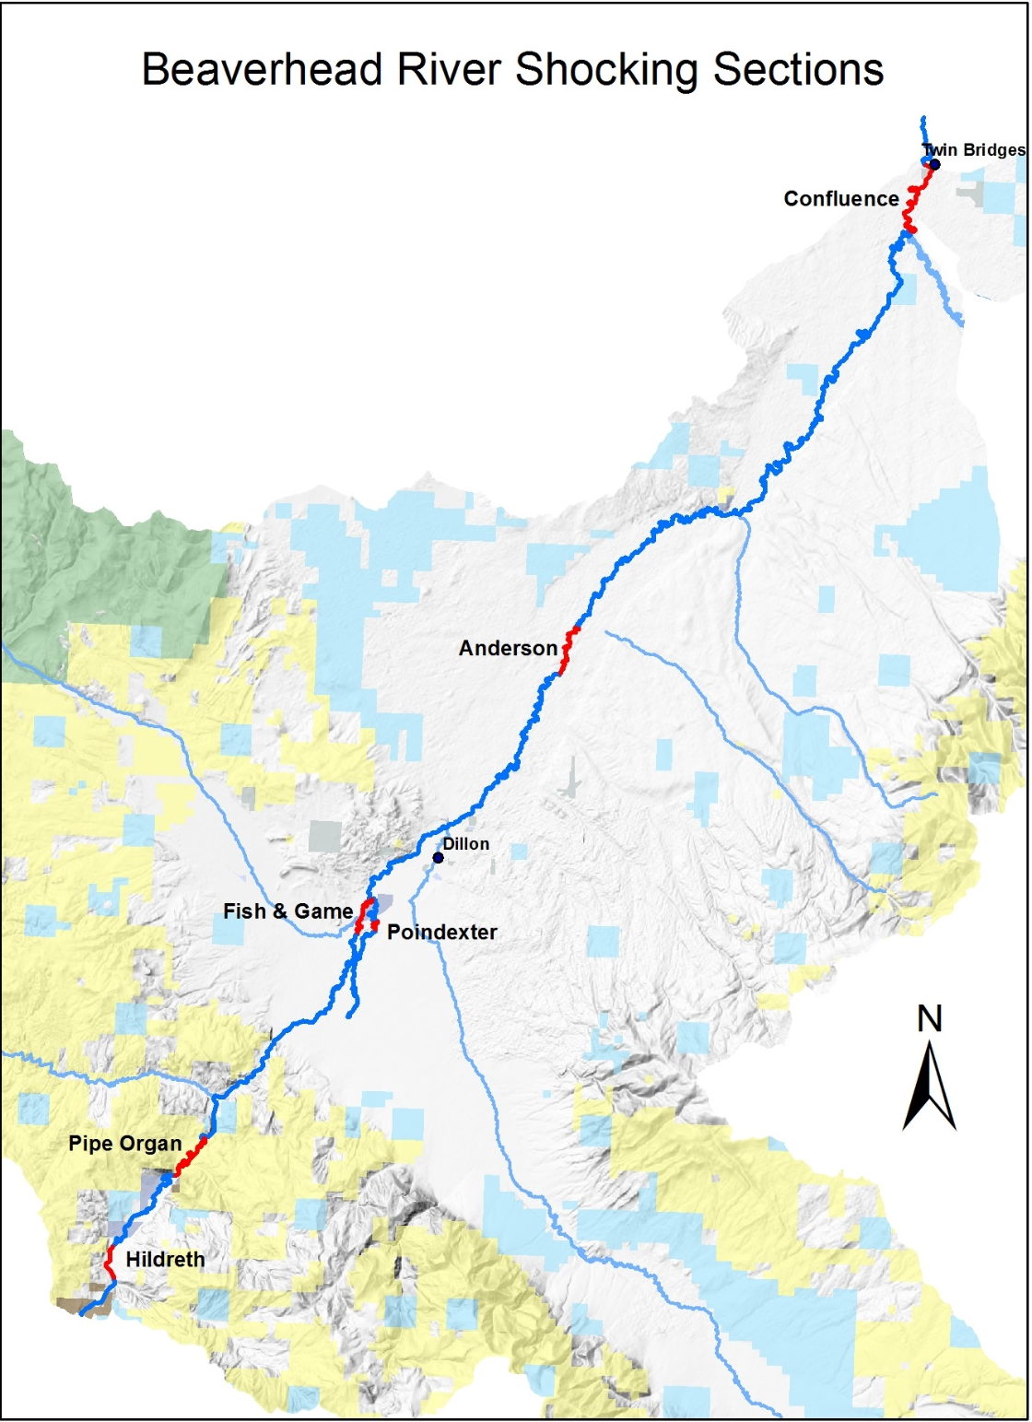
Figure 1. Long-term Beaverhead River sampling sections. The Pipe Organ Section on the above map has been renamed as Half Pipe Section.
Methods
Sampling Methods
The fisheries data analyzed in this report were collected the during spring mark-recapture abundance surveys on five different river sections that represent the entire Beaverhead River trout fishery. The Hildreth section represents the upper tailwater and includes 57 years (1967-2024) of monitoring data. The Pipe Organ section was historically monitored for 50 years (1967-2017), in 2018 the section was shortened and renamed as Half Pipe section, which has been monitored for 6 years from 2018-2024. The Fish and Game section has been monitored for 42 years (1982-2024). The Anderson section has been monitored for 49 years (1975-2024). Poindexter slough has been monitored for 56 years (1968-2024). Sampling did not occur during some years or periods of years in each section. Trout were collected from a drift boat by mobile anode electrofishing each March or April during single pass marking and recapture runs 7 to 14 days apart (Vincent 1971). All captured trout >203 mm (8 inches) were measured to the nearest mm or tenth of an inch and weighed to the nearest gram or hundredth of a pound. Poindexter slough is the only dataset that includes fish smaller than 203 mm. The study sections and data collection methods are described in more detail by Oswald (2009).

Relative weight
Relative weights ($W_{r}$) were calculated as per (Wege and Anderson 1978):
$$W_{r}=\frac{W}{W_{s}}*100,$$
where $W$ is the weight of an individual fish and $W_{s}$ is the “standard weight” of a fish of the same length, derived from published length-weight relationships.

Condition
Fulton’s condition factor ($K$) was used to calculate the condition of fish:
$$K=\frac{W}{L^{3}}*c,$$
where $W$ was the weight of an individual fish, $L$ the length, and the constant $c$ a simple scaling factor.

Size Structure
The size structure of a fish population reflects a complex interplay of environmental drivers and population dynamics (Neumann and Allen 2007), and the relative frequencies of size classes provide a glimpse into these processes. We used two methods to describe the size structure of this fishery: 1) descriptive statistics of lengths through time, and 2) proportional stock density. Proportional stock density is the percentage of fish in each set of length classes specific to each species of fish. We used the Gabelhouse classification scheme to partition fish into one of six classes: 1) sub-stock, 2) stock, 3) quality, 4) preferred, 5) memorable, and 6) trophy (Gabelhouse 1984). We then calculated the proportional stock density (PSD) of each class as:
$${\text{PSD}}_{\text{class}}=100\left(\frac{\text{number of fish in class}}{\text{total number of fish}}\right).$$
We used the FSA package (Ogle et al. 2018) in the R programming environment to calculate relative weights (R Core Team 2018).

Mark-recapture abundance estimates
Abundance was estimated using maximum likelihood estimation to allow the effects of covariates such as age class and/or length to be included on the probability of detection. This method assumes that the population is closed. We used the glm function from the stats package in the R programming environment to estimate the effects of length on the probability of detection, and to then calculate abundance (R Core Team 2018). Reported abundance estimates are based on model-averaged estimates. Chi-square goodness-of-fit tests were used to evaluate the adequacy of model fit (Williams, Nichols, and Conroy 2002). The Akaike Information Criterion was used to assess the best predictive model, and the single top model was used to make predictions and inference on abundance (Akaike 1998).

Results
Hildreth Section:
Data Summary
In 2024, 594 Brown Trout and 96 Rainbow Trout were captured in the Hildreth section of the Beaverhead River and compared to a long-term dataset comprised of 54,958 Brown Trout and 15,809 Rainbow Trout. Brown and Rainbow Trout in the Hildreth Section average 403 and 416 mm, respectively (Tables 1 and 3). Brown and Rainbow Trout were longer and heavier in 2024 than the long-term average, although Brown Trout condition was above average and Rainbow Trout condition below average (Tables 2 and 4). Both Brown and Rainbow Trout relative weight trended upward slightly in 2024 after declining in each of the past three years (Figures 2 and 3).
Table 1. Hildreth data summary.
 |  |  |  | Length |  |  |  |  | Weight |  |  | Condition |  |  | Relative Weight
 |  | n |  | Min | Max | Avg | SD |  | Avg | SD |  | Avg | SD |  | Avg | SD
Brown Trout |  | 54958 |  | 96.5 | 711.2 | 402.6 | 72.3 |  | 682.7 | 339.6 |  | 33.6 | 8.4 |  | 86.9 | 21.7

Table 2. Hildreth data summary for the latest year.
 |  |  |  | Length |  |  |  |  | Weight |  |  | Condition |  |  | Relative Weight
 |  | n |  | Min | Max | Avg | SD |  | Avg | SD |  | Avg | SD |  | Avg | SD
Brown Trout |  | 594 |  | 222 | 557 | 428.8 | 54.5 |  | 796.3 | 251.2 |  | 35.3 | 3.5 |  | 91.7 | 8.8

Table 3. Hildreth data summary.
 |  |  |  | Length |  |  |  |  | Weight |  |  | Condition |  |  | Relative Weight
 |  | n |  | Min | Max | Avg | SD |  | Avg | SD |  | Avg | SD |  | Avg | SD
Rainbow Trout |  | 15809 |  | 96.5 | 711.2 | 416.3 | 90.8 |  | 891.4 | 503.8 |  | 39.9 | 8.4 |  | 101 | 21.3
Table 4. Hildreth data summary for the latest year.
 |  |  |  | Length |  |  |  |  | Weight |  |  | Condition |  |  | Relative Weight
 |  | n |  | Min | Max | Avg | SD |  | Avg | SD |  | Avg | SD |  | Avg | SD
Rainbow Trout |  | 96 |  | 224 | 578 | 470.5 | 63.3 |  | 1104.9 | 360.6 |  | 37.4 | 4.1 |  | 94.3 | 10.6

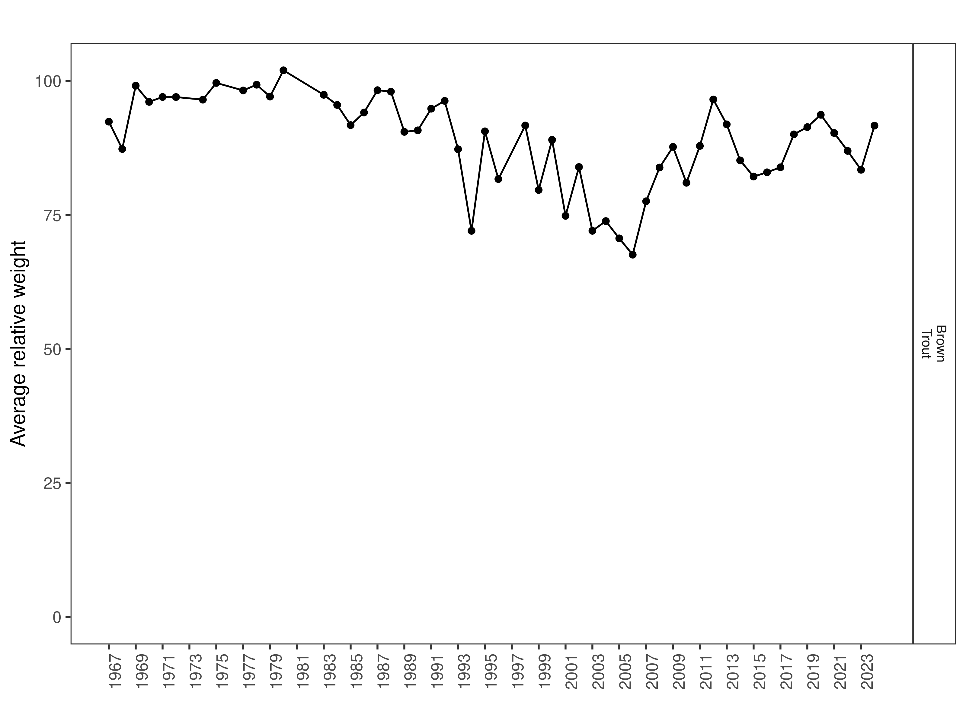
Figure 2. Hildreth Brown Trout relative weight through time.
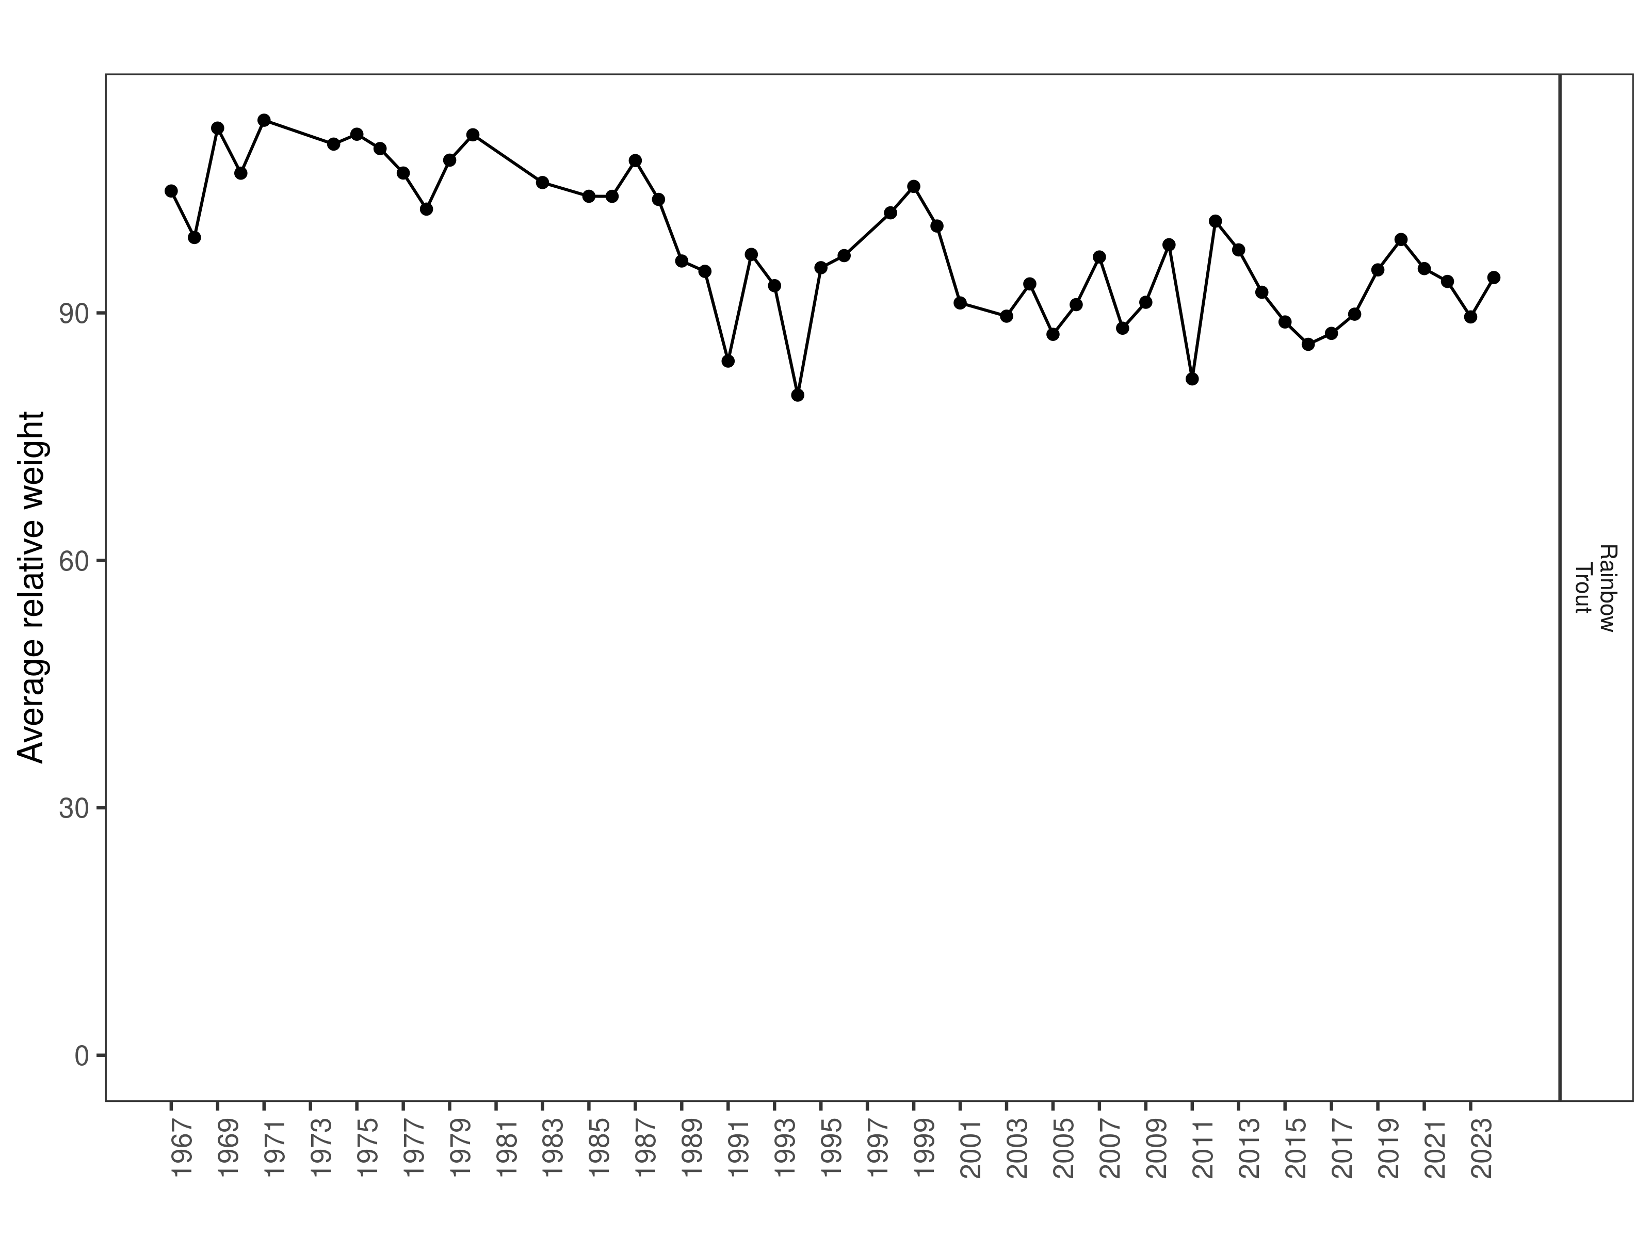
Figure 3. Hildreth Rainbow Trout relative weight through time.

Size Structure
Distributions of Brown and Rainbow Trout lengths in 2024 overlapped most previous years, although Rainbow Trout distribution was skewed higher and was narrower than the previous year (Figures 4 and 5). While most Brown and Rainbow Trout were above average length in 2024, the Brown Trout population was more balanced whereas the Rainbow Trout population showed little evidence of recent recruitment (Figures 6 and 7).

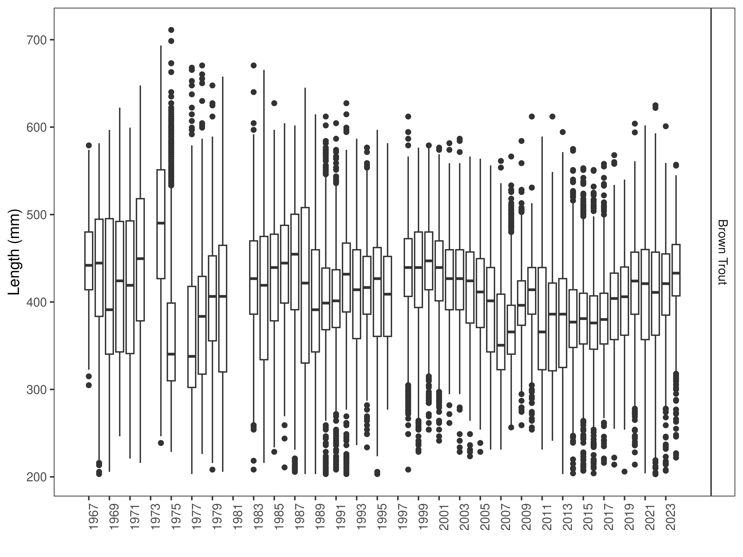
Figure 4. Hildreth distribution of Brown Trout lengths through time. The box-and-whisker plots divide the distribution of the data into the first quartile (the lower limit of the box), the median (heavy black line), and third quartile (the upper limit of the box). The whiskers denote data points within 1.5 * the interquartile range (the difference between the first and third quartiles). Dots denote data points further than 1.5 * the interquartile range from the box.
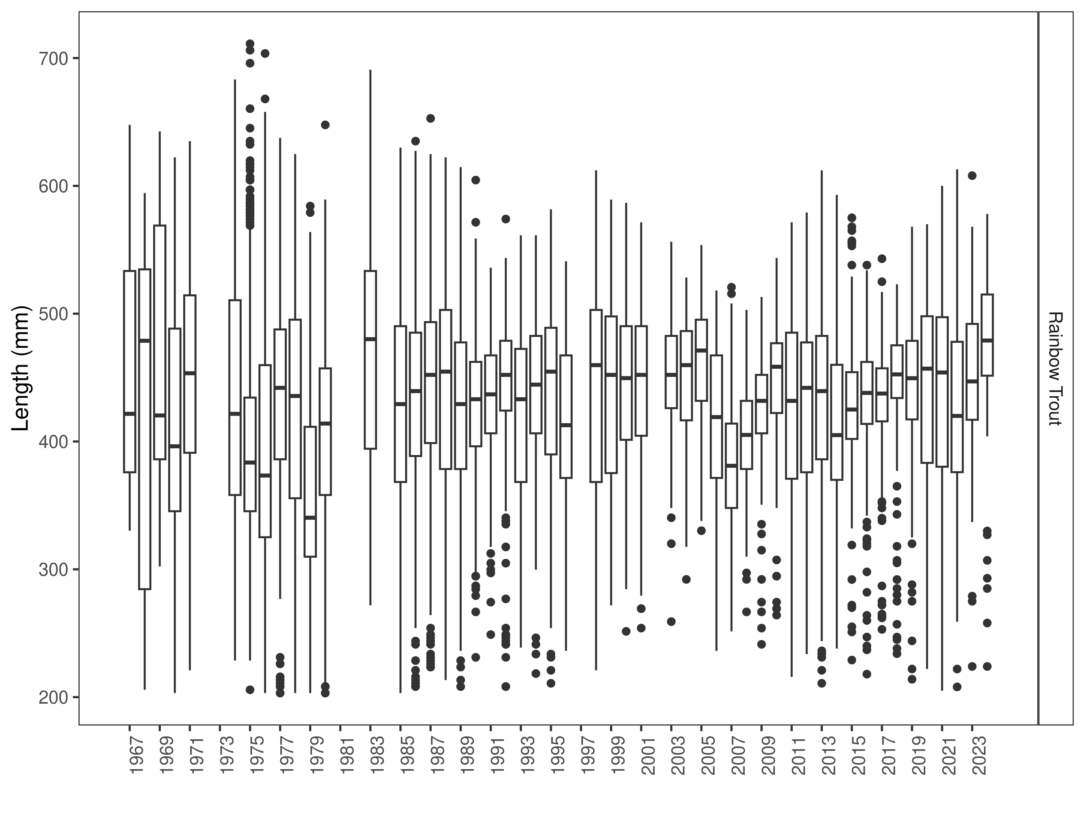
Figure 5. Hildreth distribution of Rainbow Trout lengths through time. The box-and-whisker plots divide the distribution of the data into the first quartile (the lower limit of the box), the median (heavy black line), and third quartile (the upper limit of the box). The whiskers denote data points within 1.5 * the interquartile range (the difference between the first and third quartiles). Dots denote data points further than 1.5 * the interquartile range from the box.
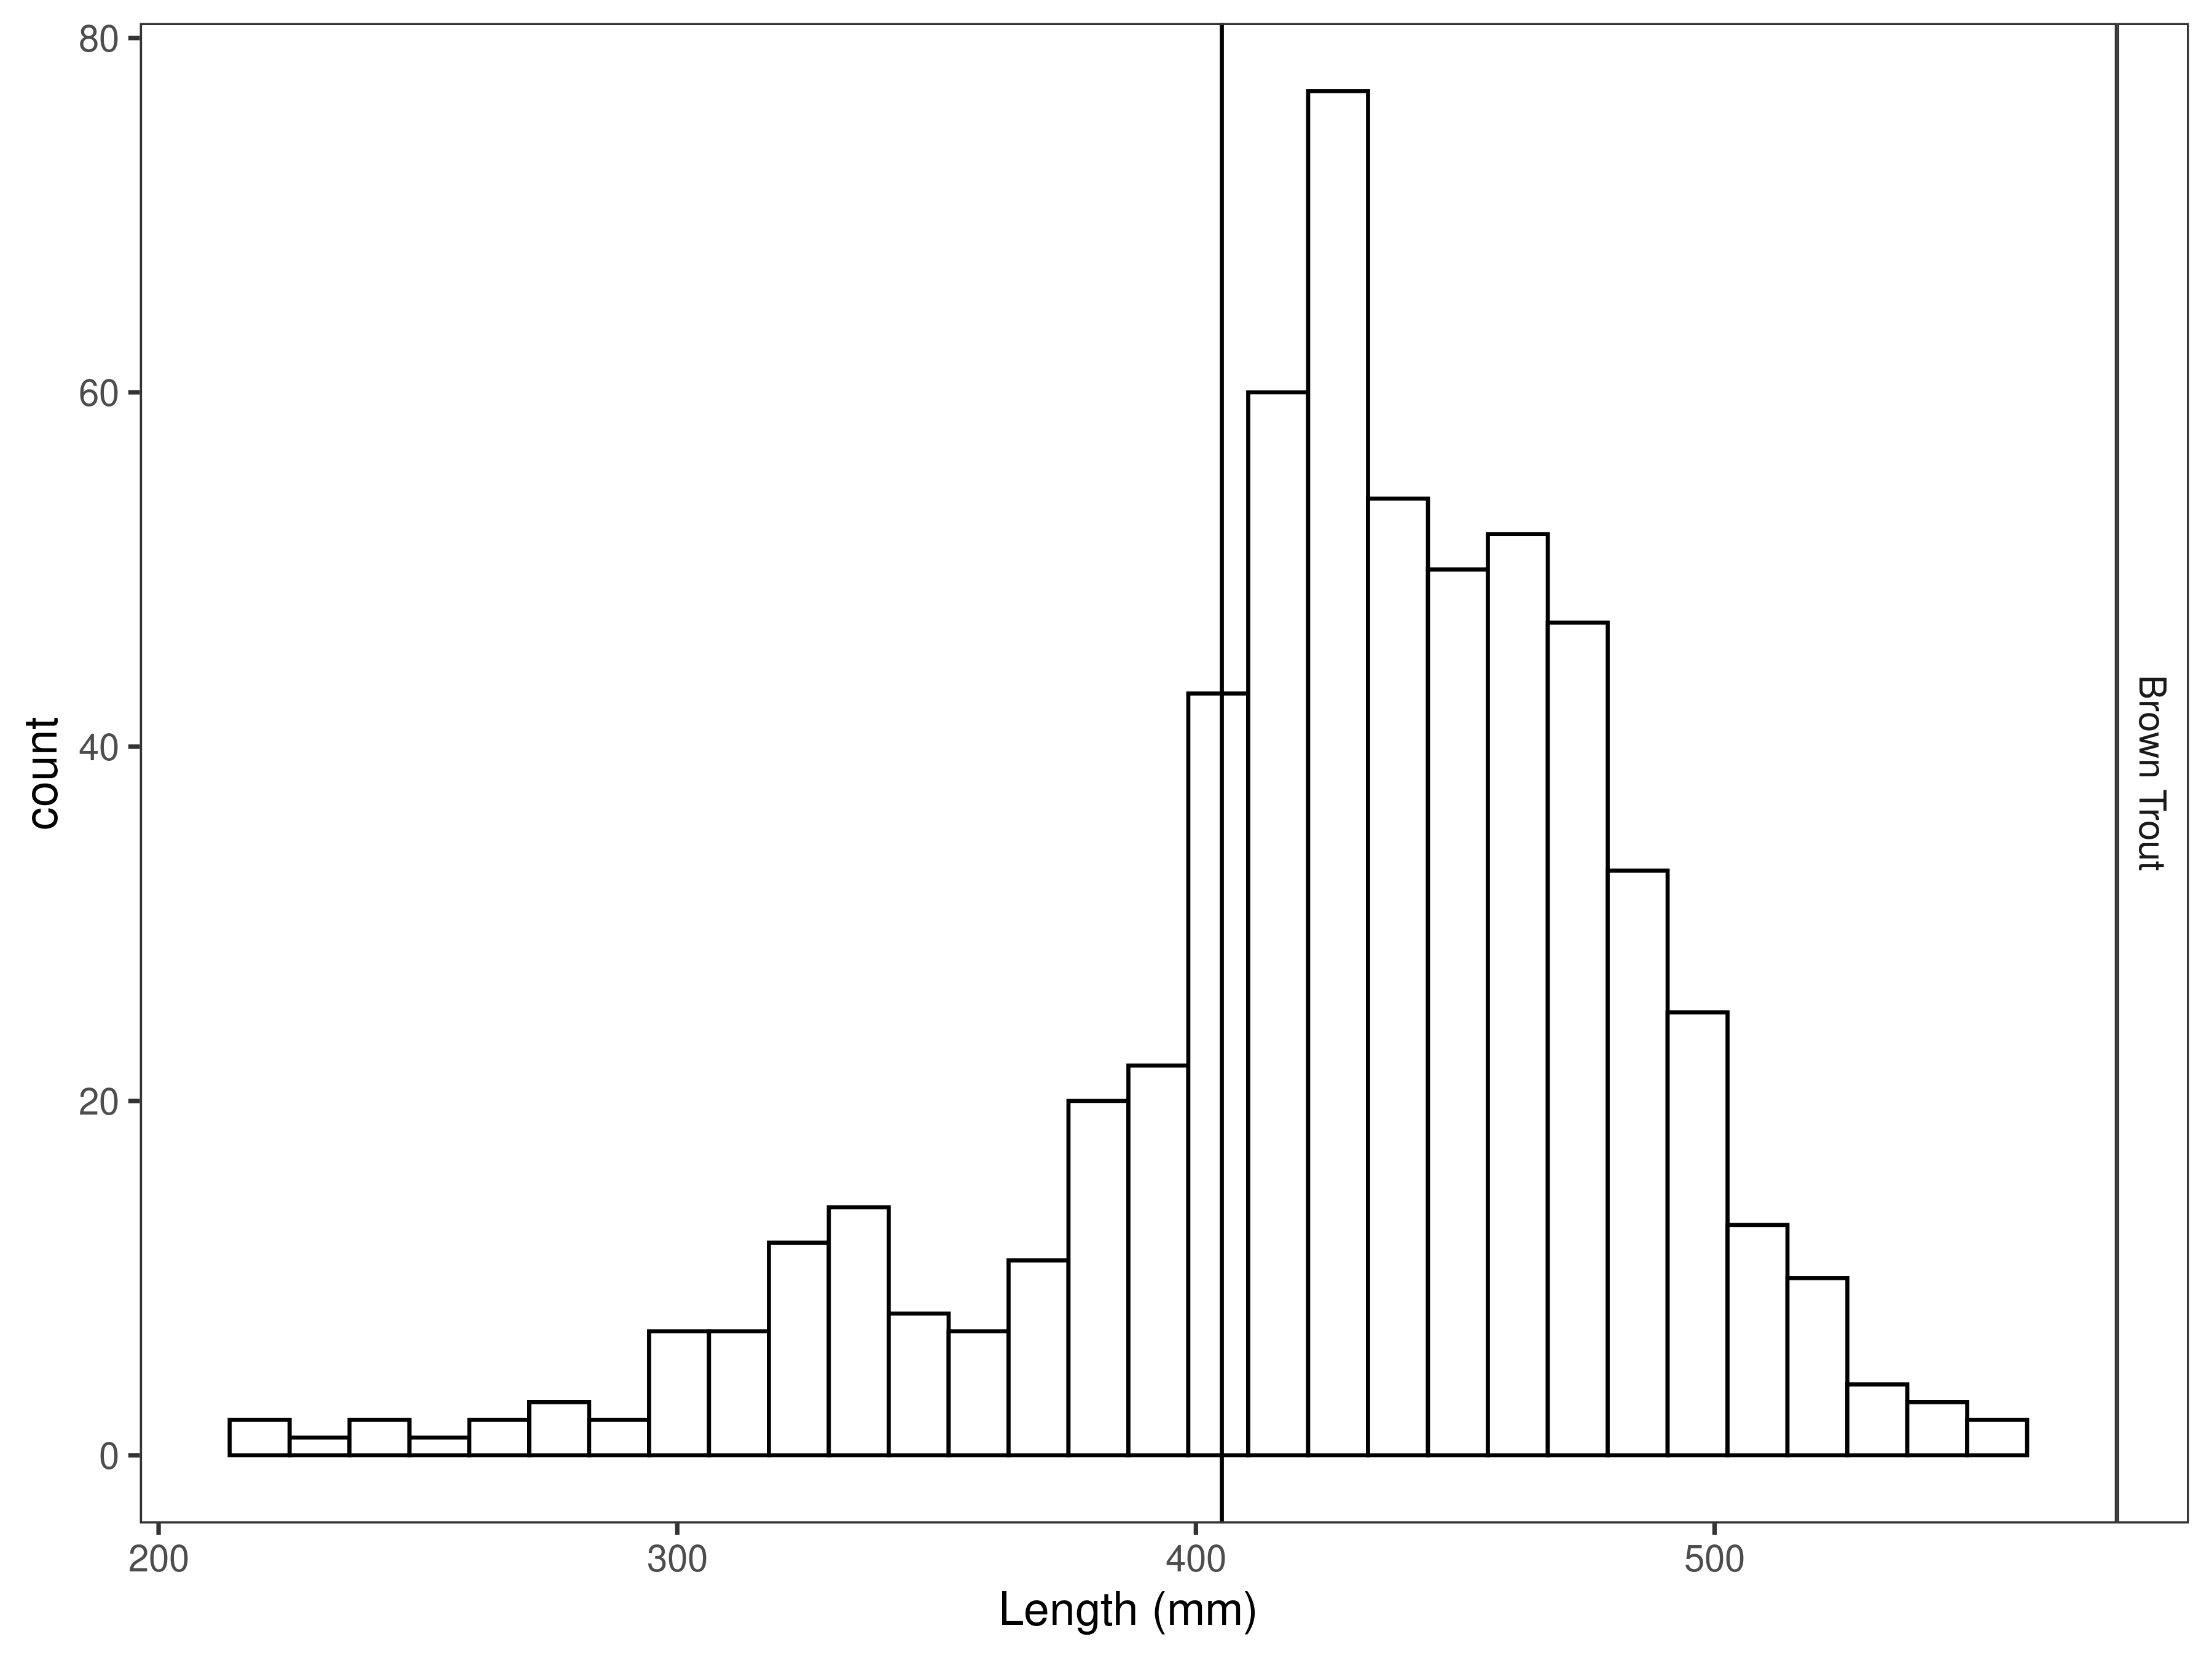
Figure 6. Hildreth length distribution by species for latest year, with long-term species-averages indicated by the vertical black line.
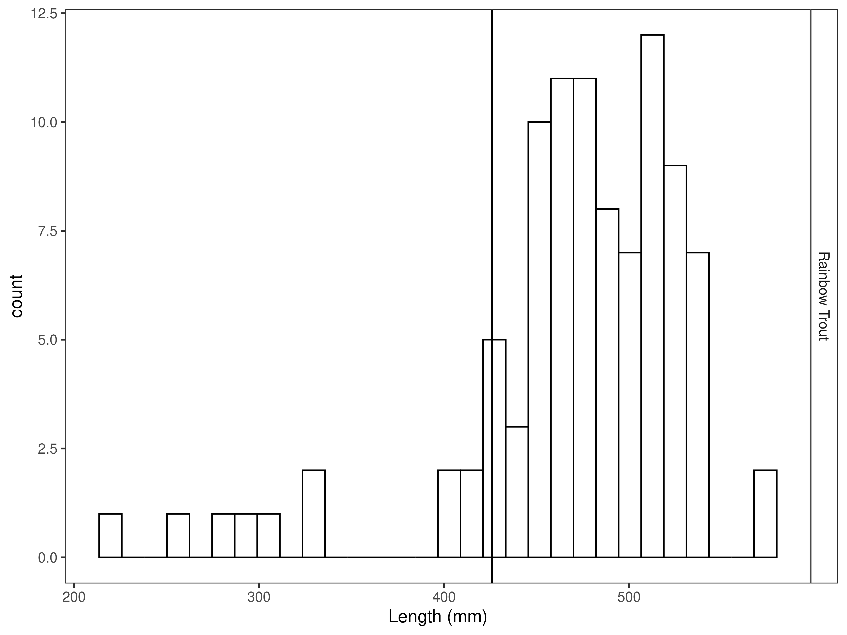
Figure 7. Hildreth length distribution by species for latest year, with long-term species-averages indicated by the vertical black line.

Mark-recapture abundance estimates
Recapture rates were similar for Brown Trout across lengths (Figure 8), although there were few recaptures of smaller rainbow trout (Figure 9), which resulted in poorly estimated capture efficiency for fish less than 400 mm (Figure 11). Capture efficiency was relatively stable across the sizes of fish encountered; the null model (constant capture efficiency) had about as much model weight for both Brown and Rainbow Trout as the three length-based models combined (Tables 5-9). The Brown trout abundance estimate decreased from 980 per km to 728 per km in 2024. The Rainbow Trout abundance estimate slightly increased from 129 per km in 2023 to 136 per km in 2024.

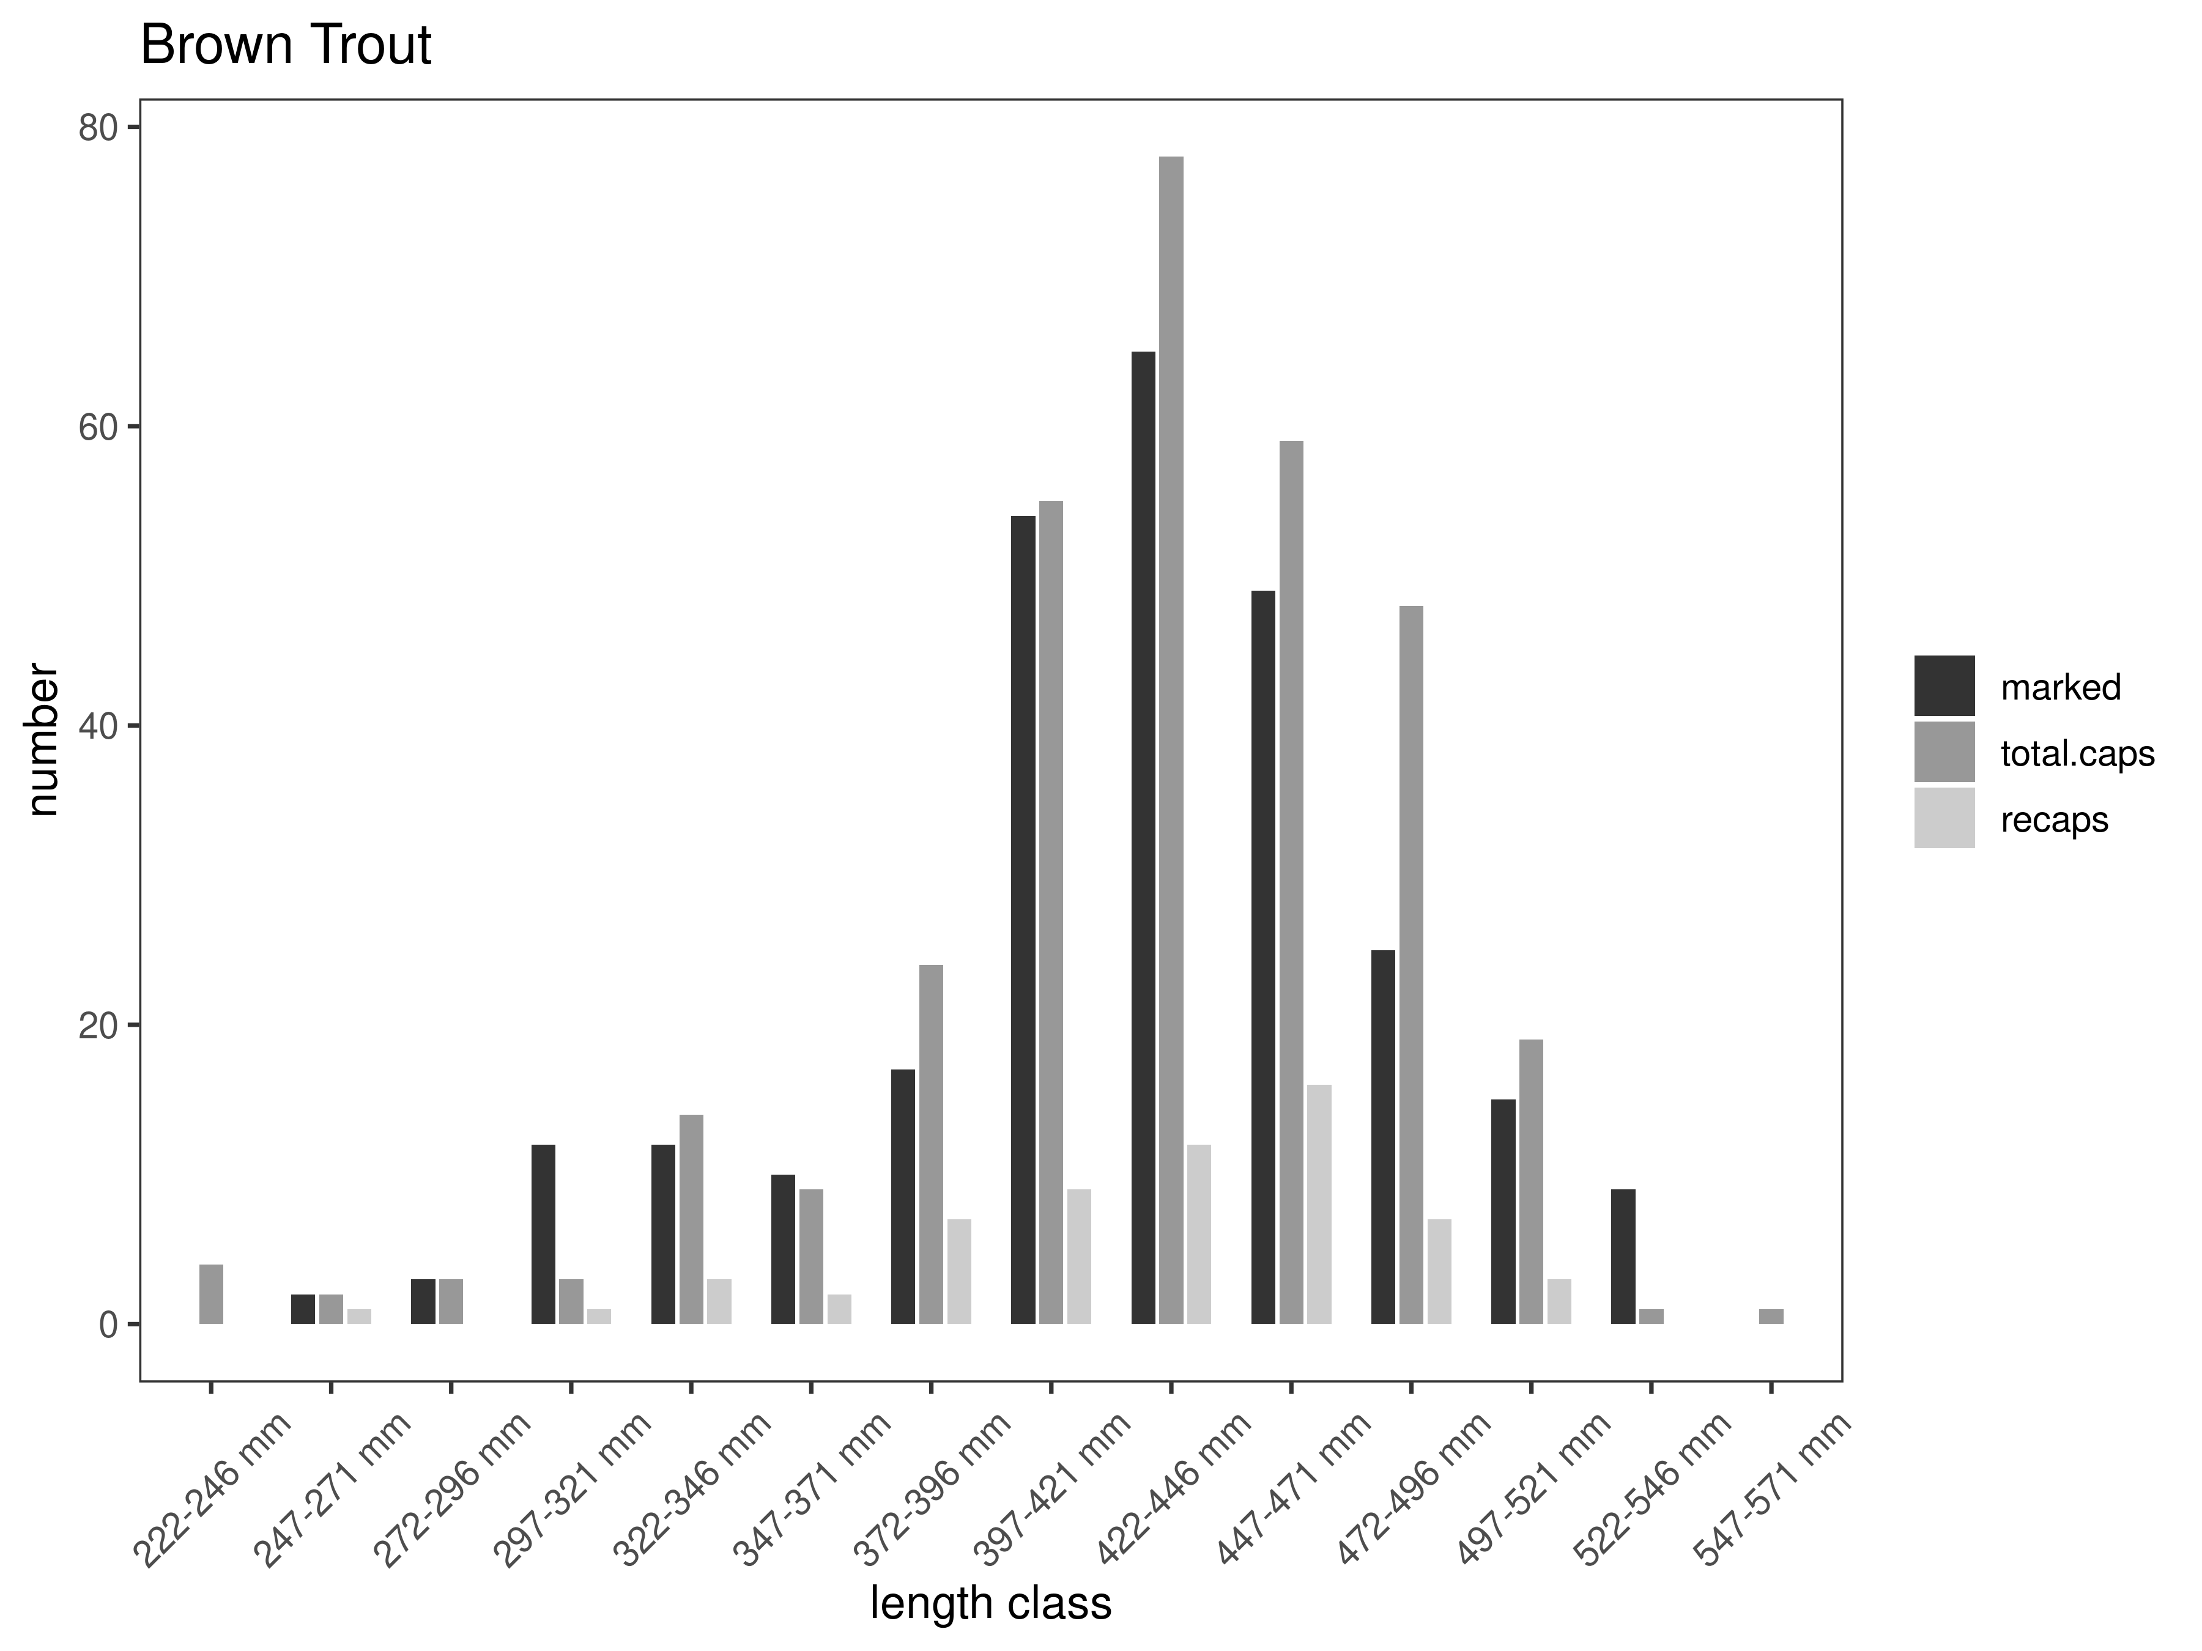
Figure 8. Hildreth capture-recapture summary across length groups for brown trout in latest year. marked= number of fish marked on initial pass, total. caps = number of fish caught on second pass, and recaps = number of marked fish caught on the second pass.
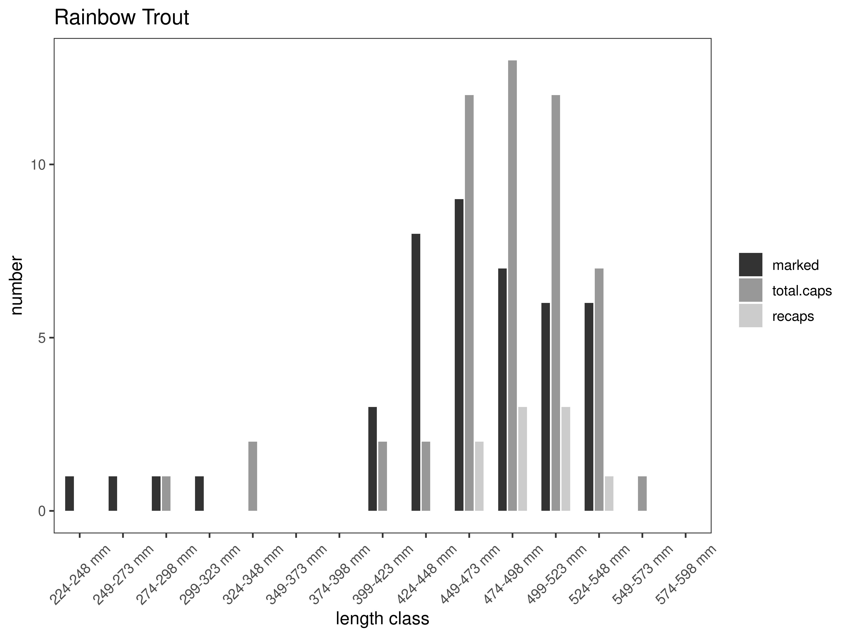
Figure 9. Hildreth capture-recapture summary across length groups for rainbow trout in latest year. marked= number of fish marked on initial pass, total.caps = number of fish caught on second pass, and recaps = number of marked fish caught on the second pass.
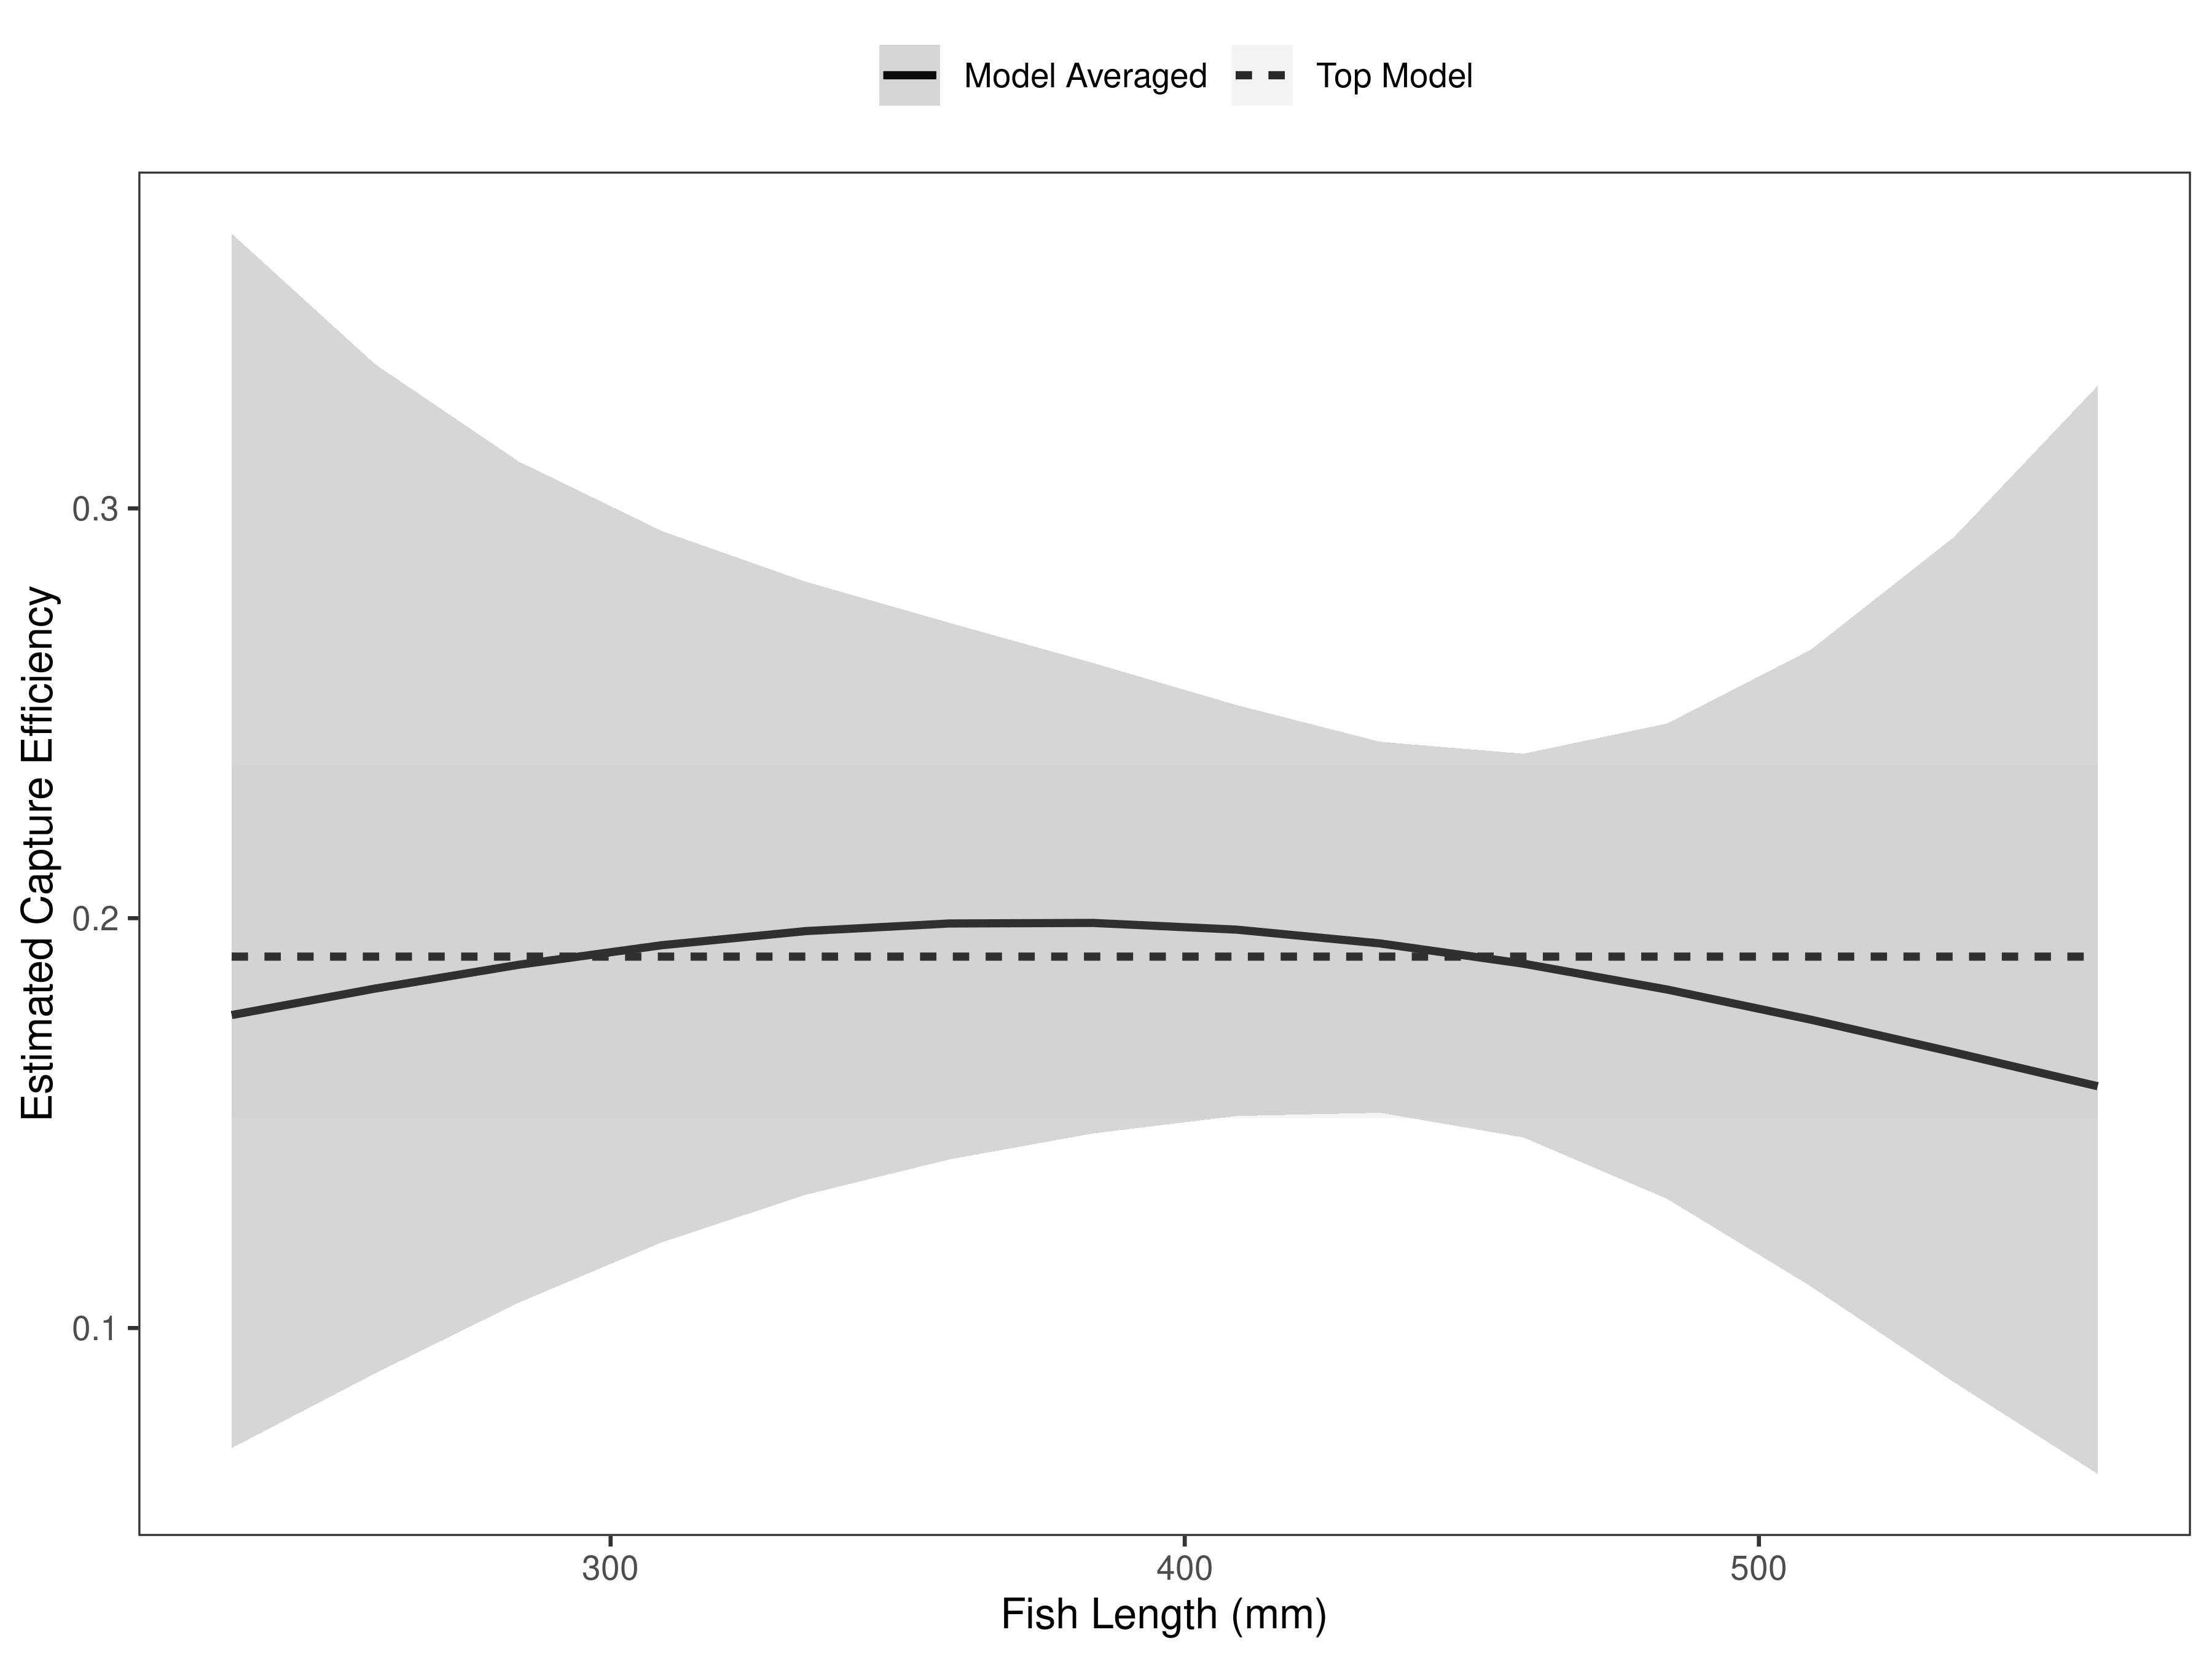
Figure 10. Hildreth model-averaged estimates of capture efficiency of brown trout in latest year.
Table 5. Model selection results from four models used for two-pass abundance estimation of brown trout in latest year. Models: `Len` = capture efficiency modeled as a function of length class, `Len.sq` = capture efficiency modeled as a quadratic function of length class with the intercept estimated, `FA+` = capture efficiency modeled as a quadratic function of length class with intercept fixed, `Null` = constant capture efficiency.
Model | K | AICc | deltaAICc | ModLik | AICcWt | LnLik | CumWt
Null | 1 | 313.77 | 0.000000 | 1.00 | 0.43 | -155.8809 | 0.43
FA+ | 2 | 314.78 | 1.002752 | 0.61 | 0.26 | -155.3696 | 0.70
Len | 2 | 315.25 | 1.478336 | 0.48 | 0.21 | -155.6074 | 0.90
Len.sq | 3 | 316.81 | 3.036874 | 0.22 | 0.10 | -155.3676 | 1.00

Table 6. Model averaged abundance estimates of fish per kilometer (Pop. Estimate) across length groups and estimated biomass (Biomass Estimate, kg) for the latest year.
 |  | Pop. Estimate | 2.5% | 97.5% | Biomass Estimate | 2.5% | 97.5%
Brown Trout | 2024 | 728 | 653 | 803 | 1,135.4 | 1,009.9 | 1,261.0

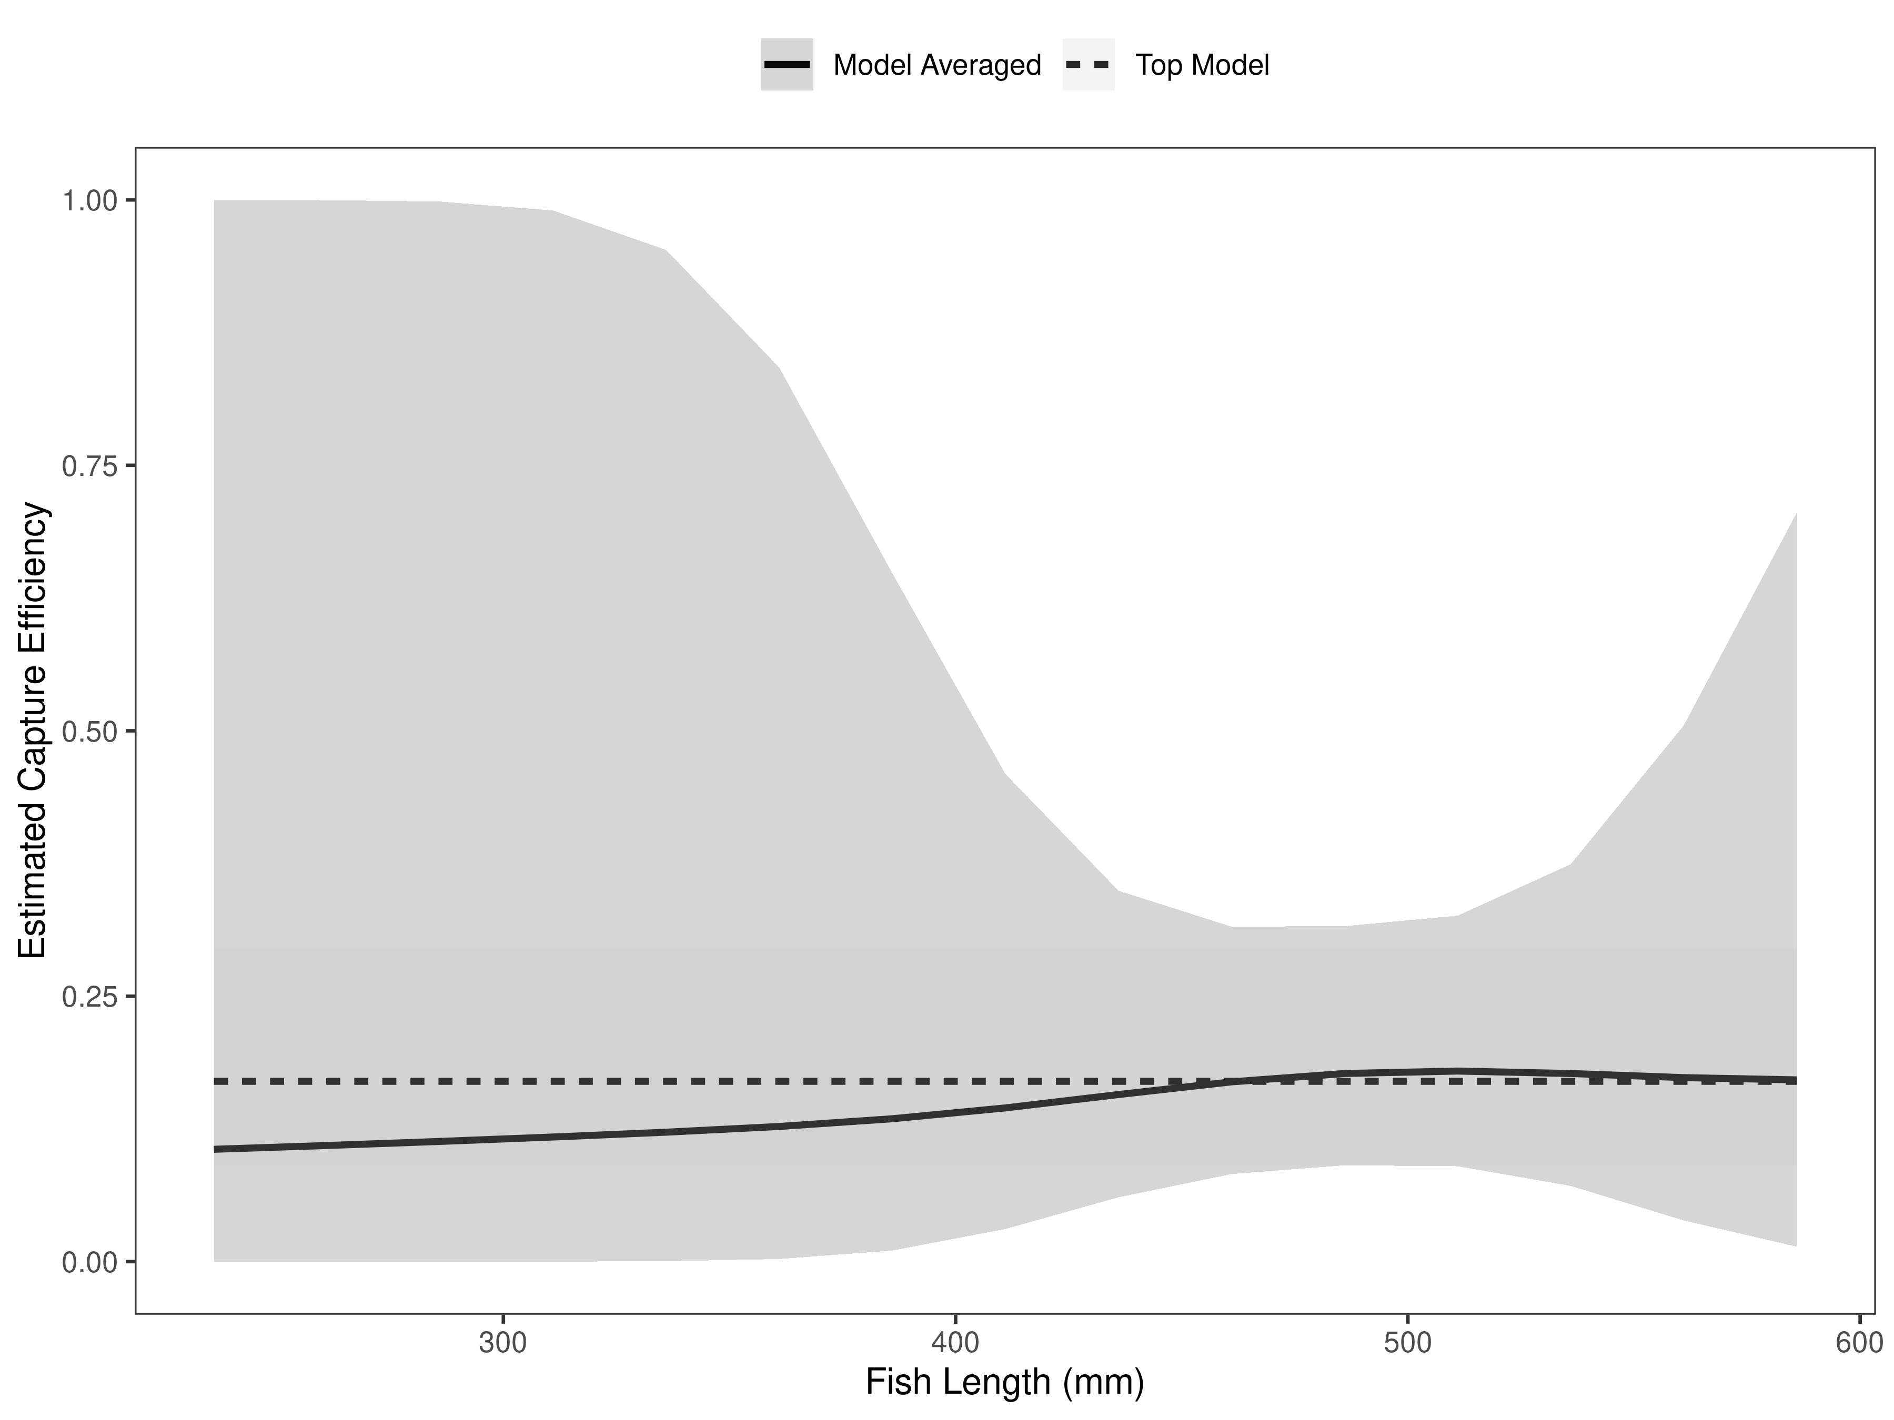
Figure 11. Hildreth model-averaged estimates of capture efficiency of rainbow trout in latest year.

Table 7. Model selection results from four models used for two-pass abundance estimation of rainbow trout in latest year. Models: `Len` = capture efficiency modeled as a function of length class, `Len.sq` = capture efficiency modeled as a quadratic function of length class with the intercept estimated, `FA+` = capture efficiency modeled as a quadratic function of length class with intercept fixed, `Null` = constant capture efficiency.
Model | K | AICc | deltaAICc | ModLik | AICcWt | LnLik | CumWt
Null | 1 | 50.37 | 0.000000 | 1.00 | 0.47 | -24.14611 | 0.47
FA+ | 2 | 52.02 | 1.651283 | 0.44 | 0.21 | -23.89096 | 0.68
Len | 2 | 52.20 | 1.832124 | 0.40 | 0.19 | -23.98138 | 0.87
Len.sq | 3 | 52.99 | 2.616628 | 0.27 | 0.13 | -23.24874 | 1.00

Table 8. Model averaged abundance estimates of fish per kilometer (Pop. Estimate) across length groups and estimated biomass (Biomass Estimate, kg) for the latest year.
 |  | Pop. Estimate | 2.5% | 97.5% | Biomass Estimate | 2.5% | 97.5%
Rainbow Trout | 2024 | 136 | 95 | 177 | 265.1 | 182.5 | 347.6

There were 728 Brown Trout and 136 Rainbow Trout per kilometer in the Hildreth Section in 2024 (Table 5). Estimates were precise; the Brown Trout abundance was estimated to within ±75 fish and Rainbow Trout to within ±41 fish (Table 5). Brown Trout abundances were between the 25th and 75th percentiles and within management goals for the Hildreth Section (Figure 12; FWP 2023). Although formal management goals have not been established for Rainbow Trout, abundances were consistent with the last 8 years of past estimates going back to 2017 (Figure 13). Rainbow Trout biomass has generally been more stable than Brown Trout biomass through time, although neither was atypical in 2024 (Figures 14 and 15).

Table 9. Model averaged abundance estimates of fish per kilometer (Pop. Estimate) across length groups and estimated biomass (Biomass Estimate, kg) for the latest year.
 |  | Pop. Estimate | 2.5% | 97.5% | Biomass Estimate | 2.5% | 97.5%
Brown Trout | 2024 | 728 | 653 | 803 | 1,135.4 | 1,009.9 | 1,261.0
Rainbow Trout | 2024 | 136 | 95 | 177 | 265.1 | 182.5 | 347.6

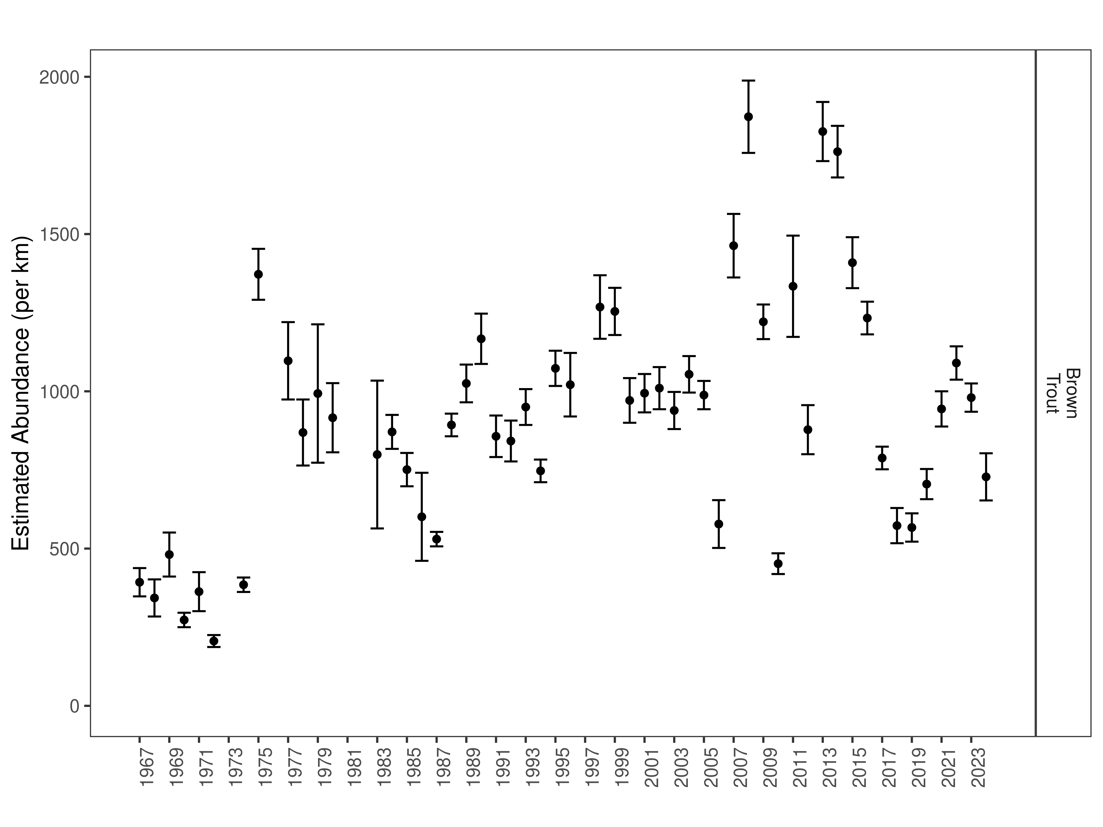
Figure 12. Hildreth mark-recapture Brown Trout abundance estimates (fish per kilometer) through time using the maximum likelihood method. These estimates (mean and 95% confidence intervals) represent the model-averaged estimates across all length groups.
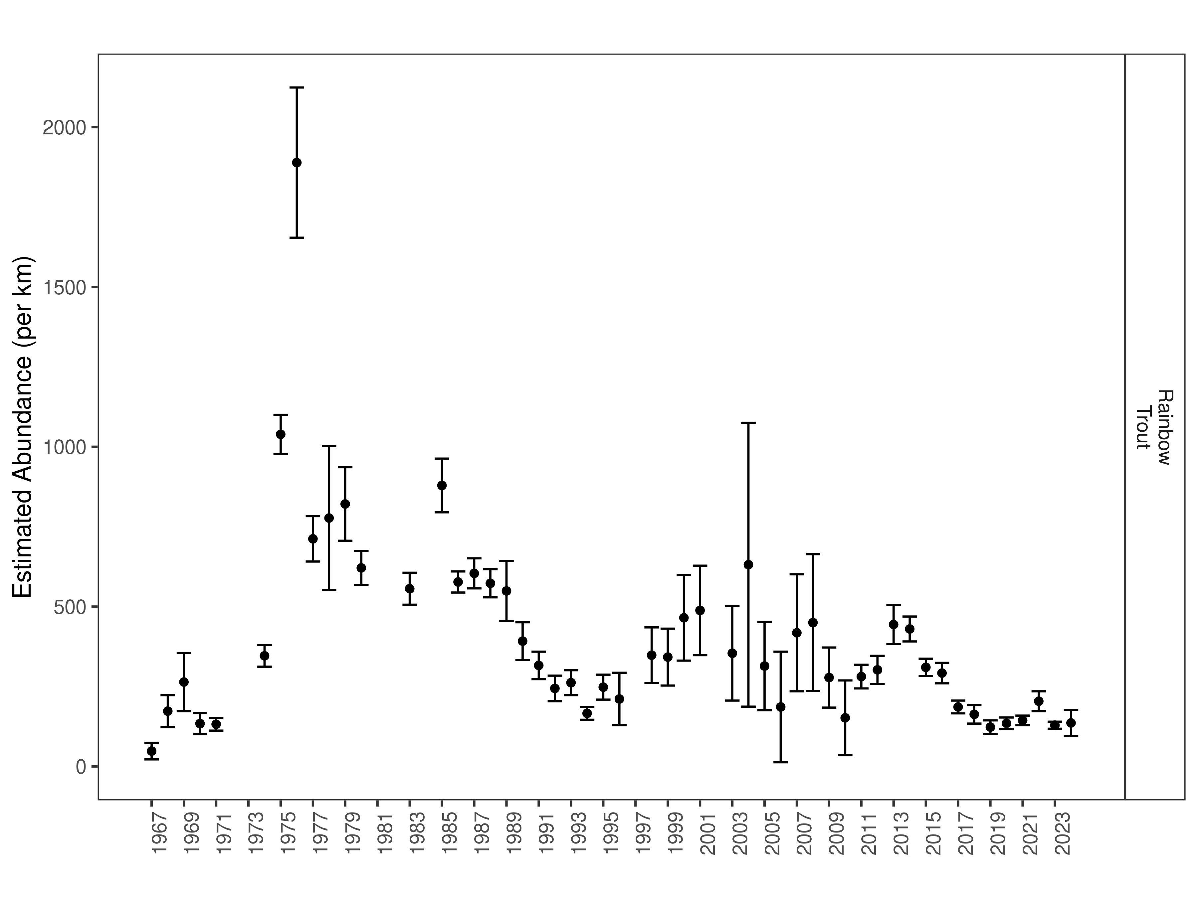
Figure 13. Hildreth mark-recapture Rainbow Trout abundance estimates (fish per kilometer) through time using the maximum likelihood method. These estimates (mean and 95% confidence intervals) represent the model-averaged estimates across all length group.
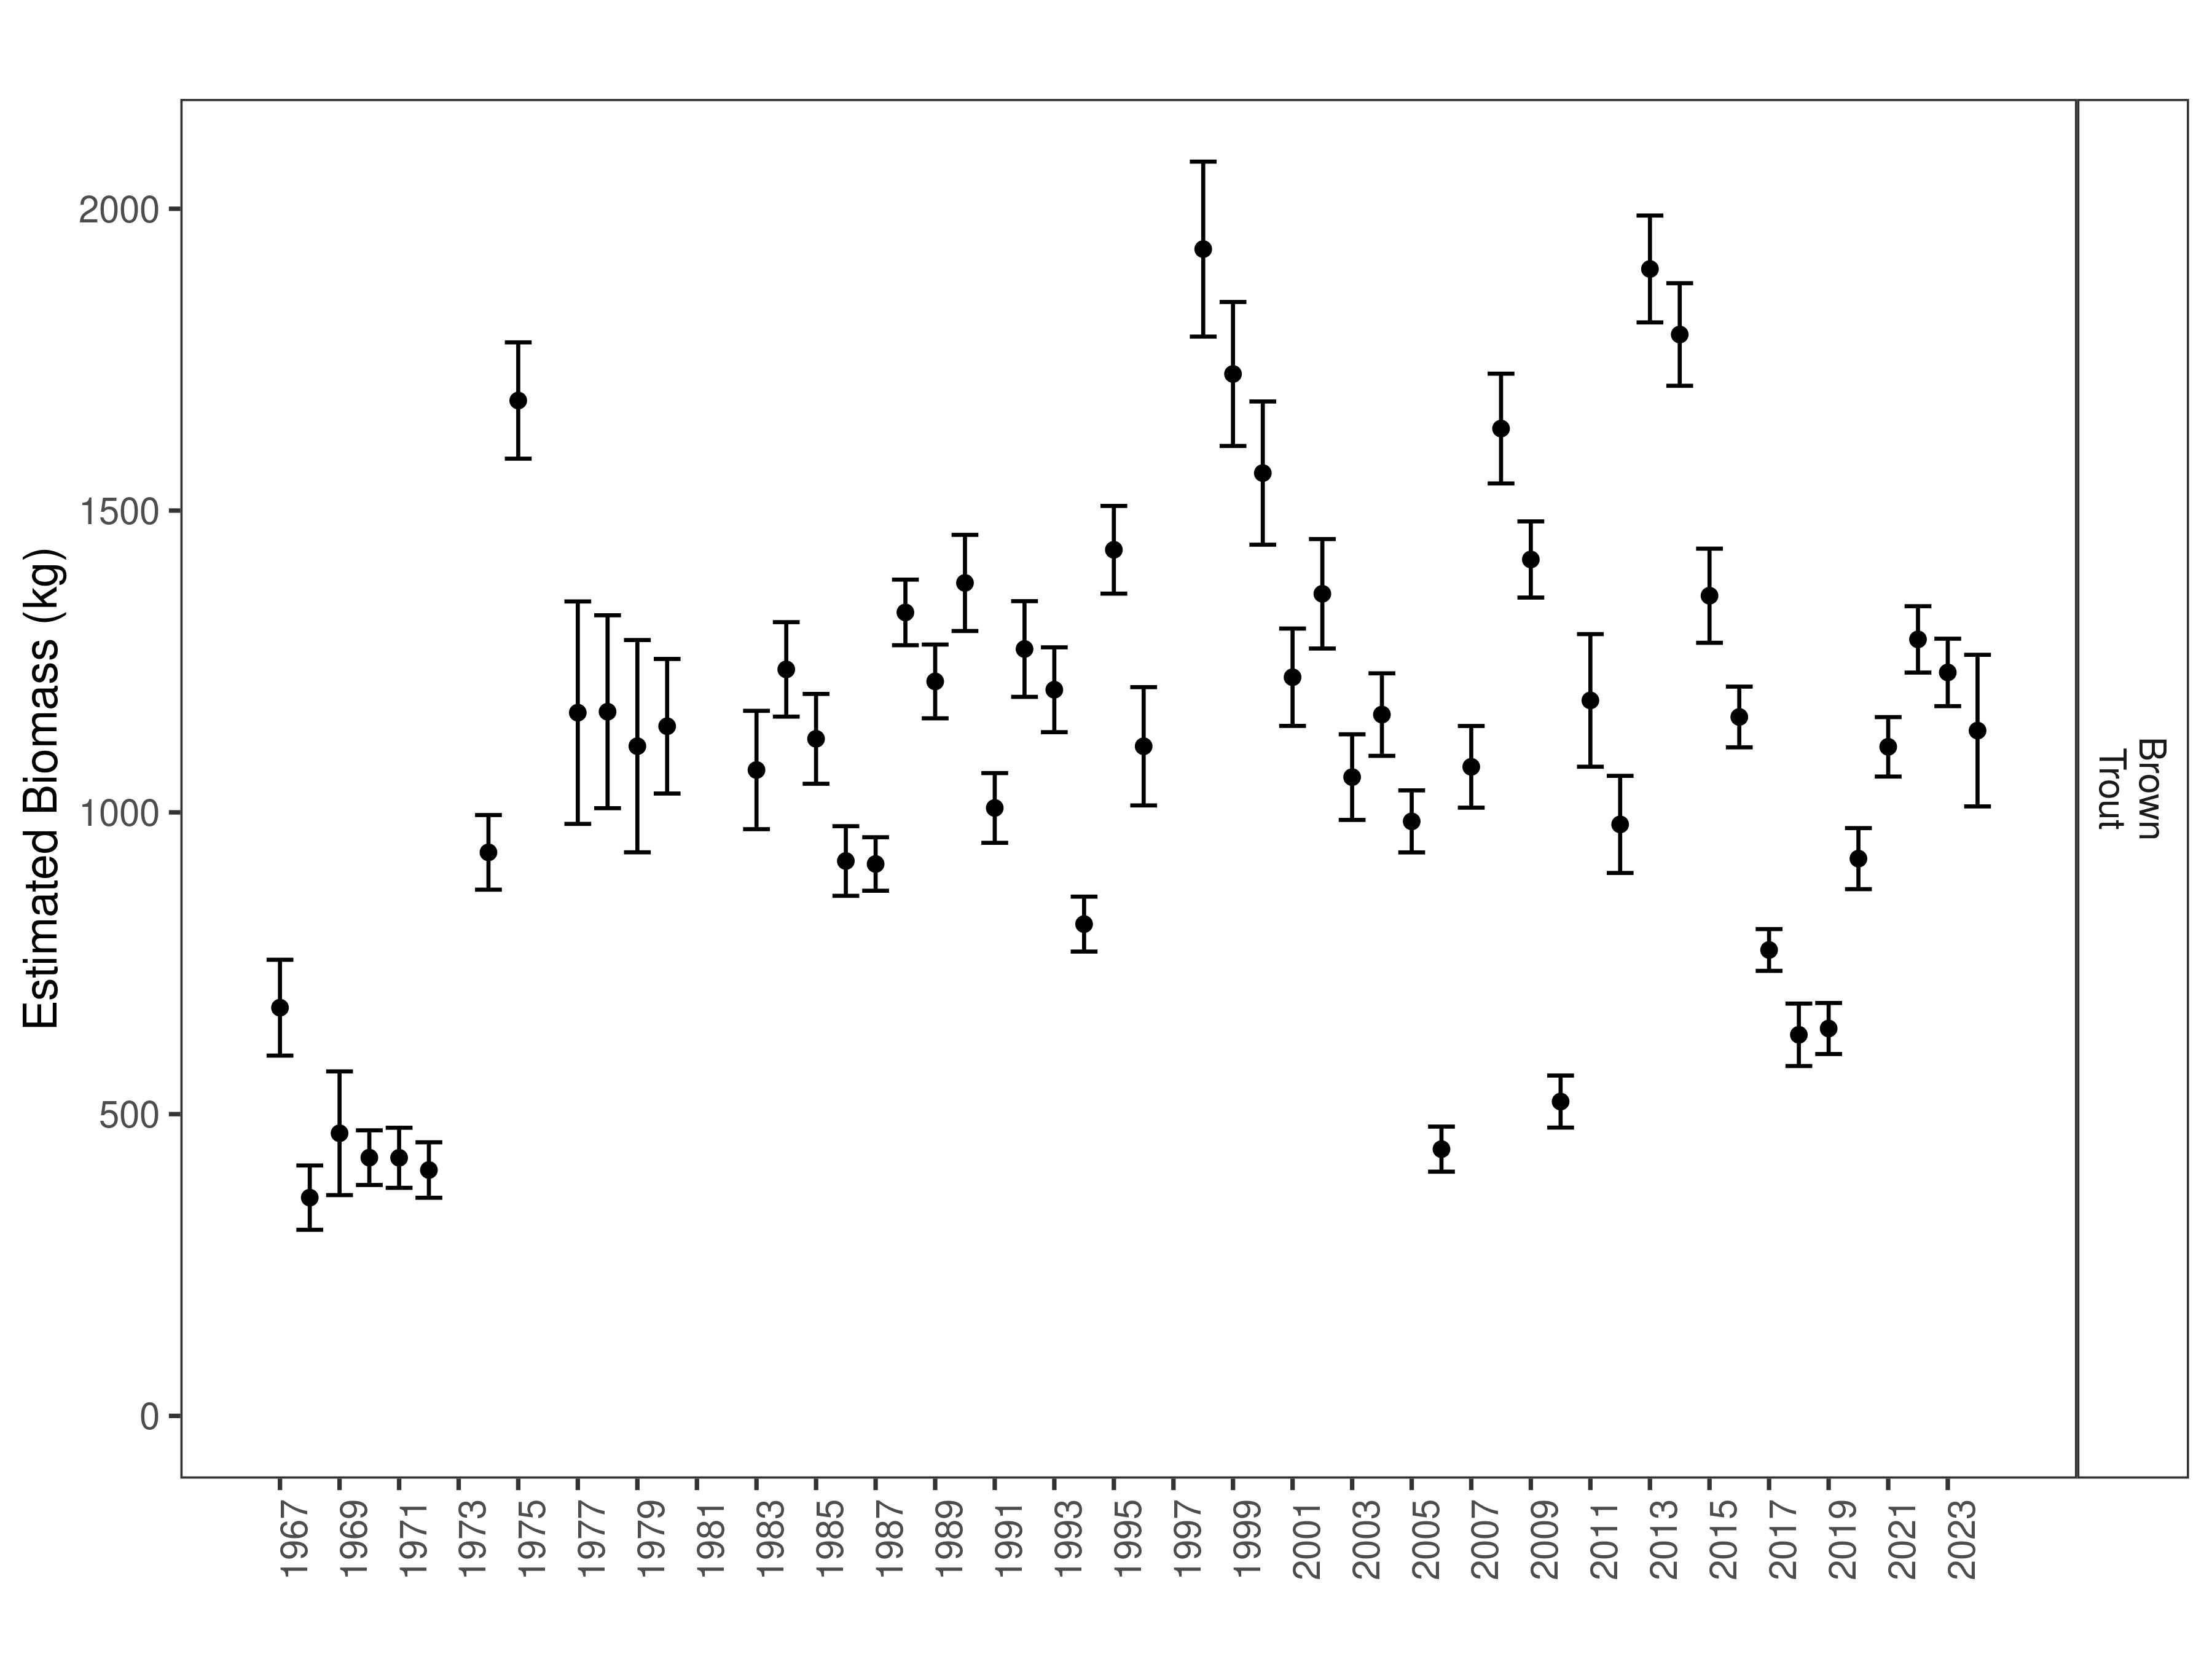
Figure 14. Hildreth estimates of biomass through time.
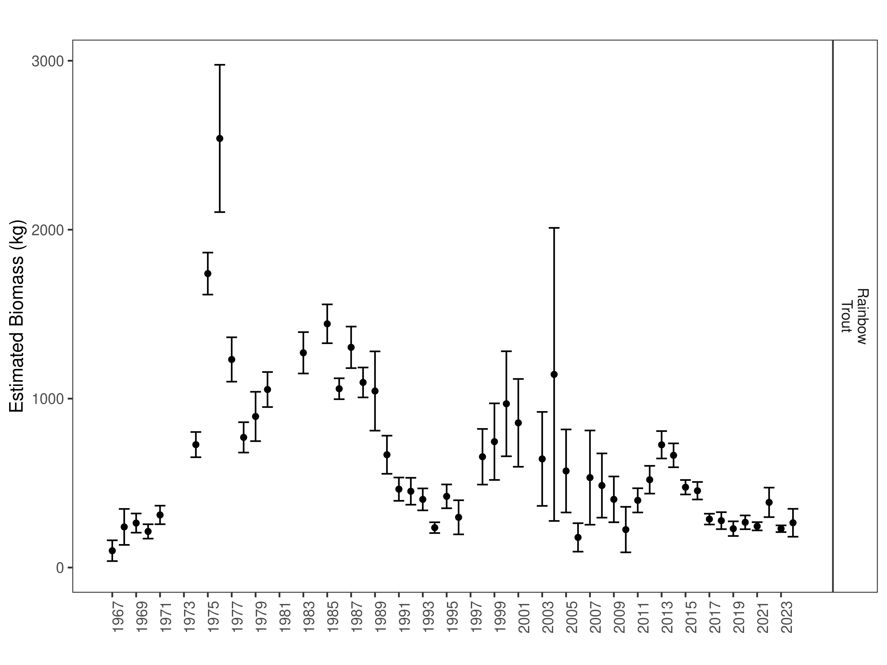
Figure 15. Hildreth estimates of biomass through time.

Half Pipe Section:
Data Summary
In 2024, 429 Brown Trout were captured in the Half Pipe section of the Beaverhead River and compared to a long-term dataset comprised of 4,485 Brown Trout. Brown Trout in the Half Pipe Section average 383 mm (Table 10). Brown Trout were longer and heavier in 2024 than the long-term average and condition was above average (Table 11). Brown Trout relative weight trended upward in 2024 after holding at a lower level in each of the past 5 years (Figure 16).

Table 10. Half Pipe data summary.
 |  |  |  | Length |  |  |  |  | Weight |  |  | Condition |  |  | Relative Weight
 |  | n |  | Min | Max | Avg | SD |  | Avg | SD |  | Avg | SD |  | Avg | SD
Brown Trout |  | 4485 |  | 204 | 565 | 383 | 54 |  | 557.9 | 228.4 |  | 34 | 4.6 |  | 87.8 | 11.7

Table 11. Half Pipe data summary for the latest year.
 |  |  |  | Length |  |  |  |  | Weight |  |  | Condition |  |  | Relative Weight
 |  | n |  | Min | Max | Avg | SD |  | Avg | SD |  | Avg | SD |  | Avg | SD
Brown Trout |  | 429 |  | 204 | 548 | 412.4 | 65.4 |  | 820.3 | 304.8 |  | 40.1 | 3.6 |  | 104 | 9.2

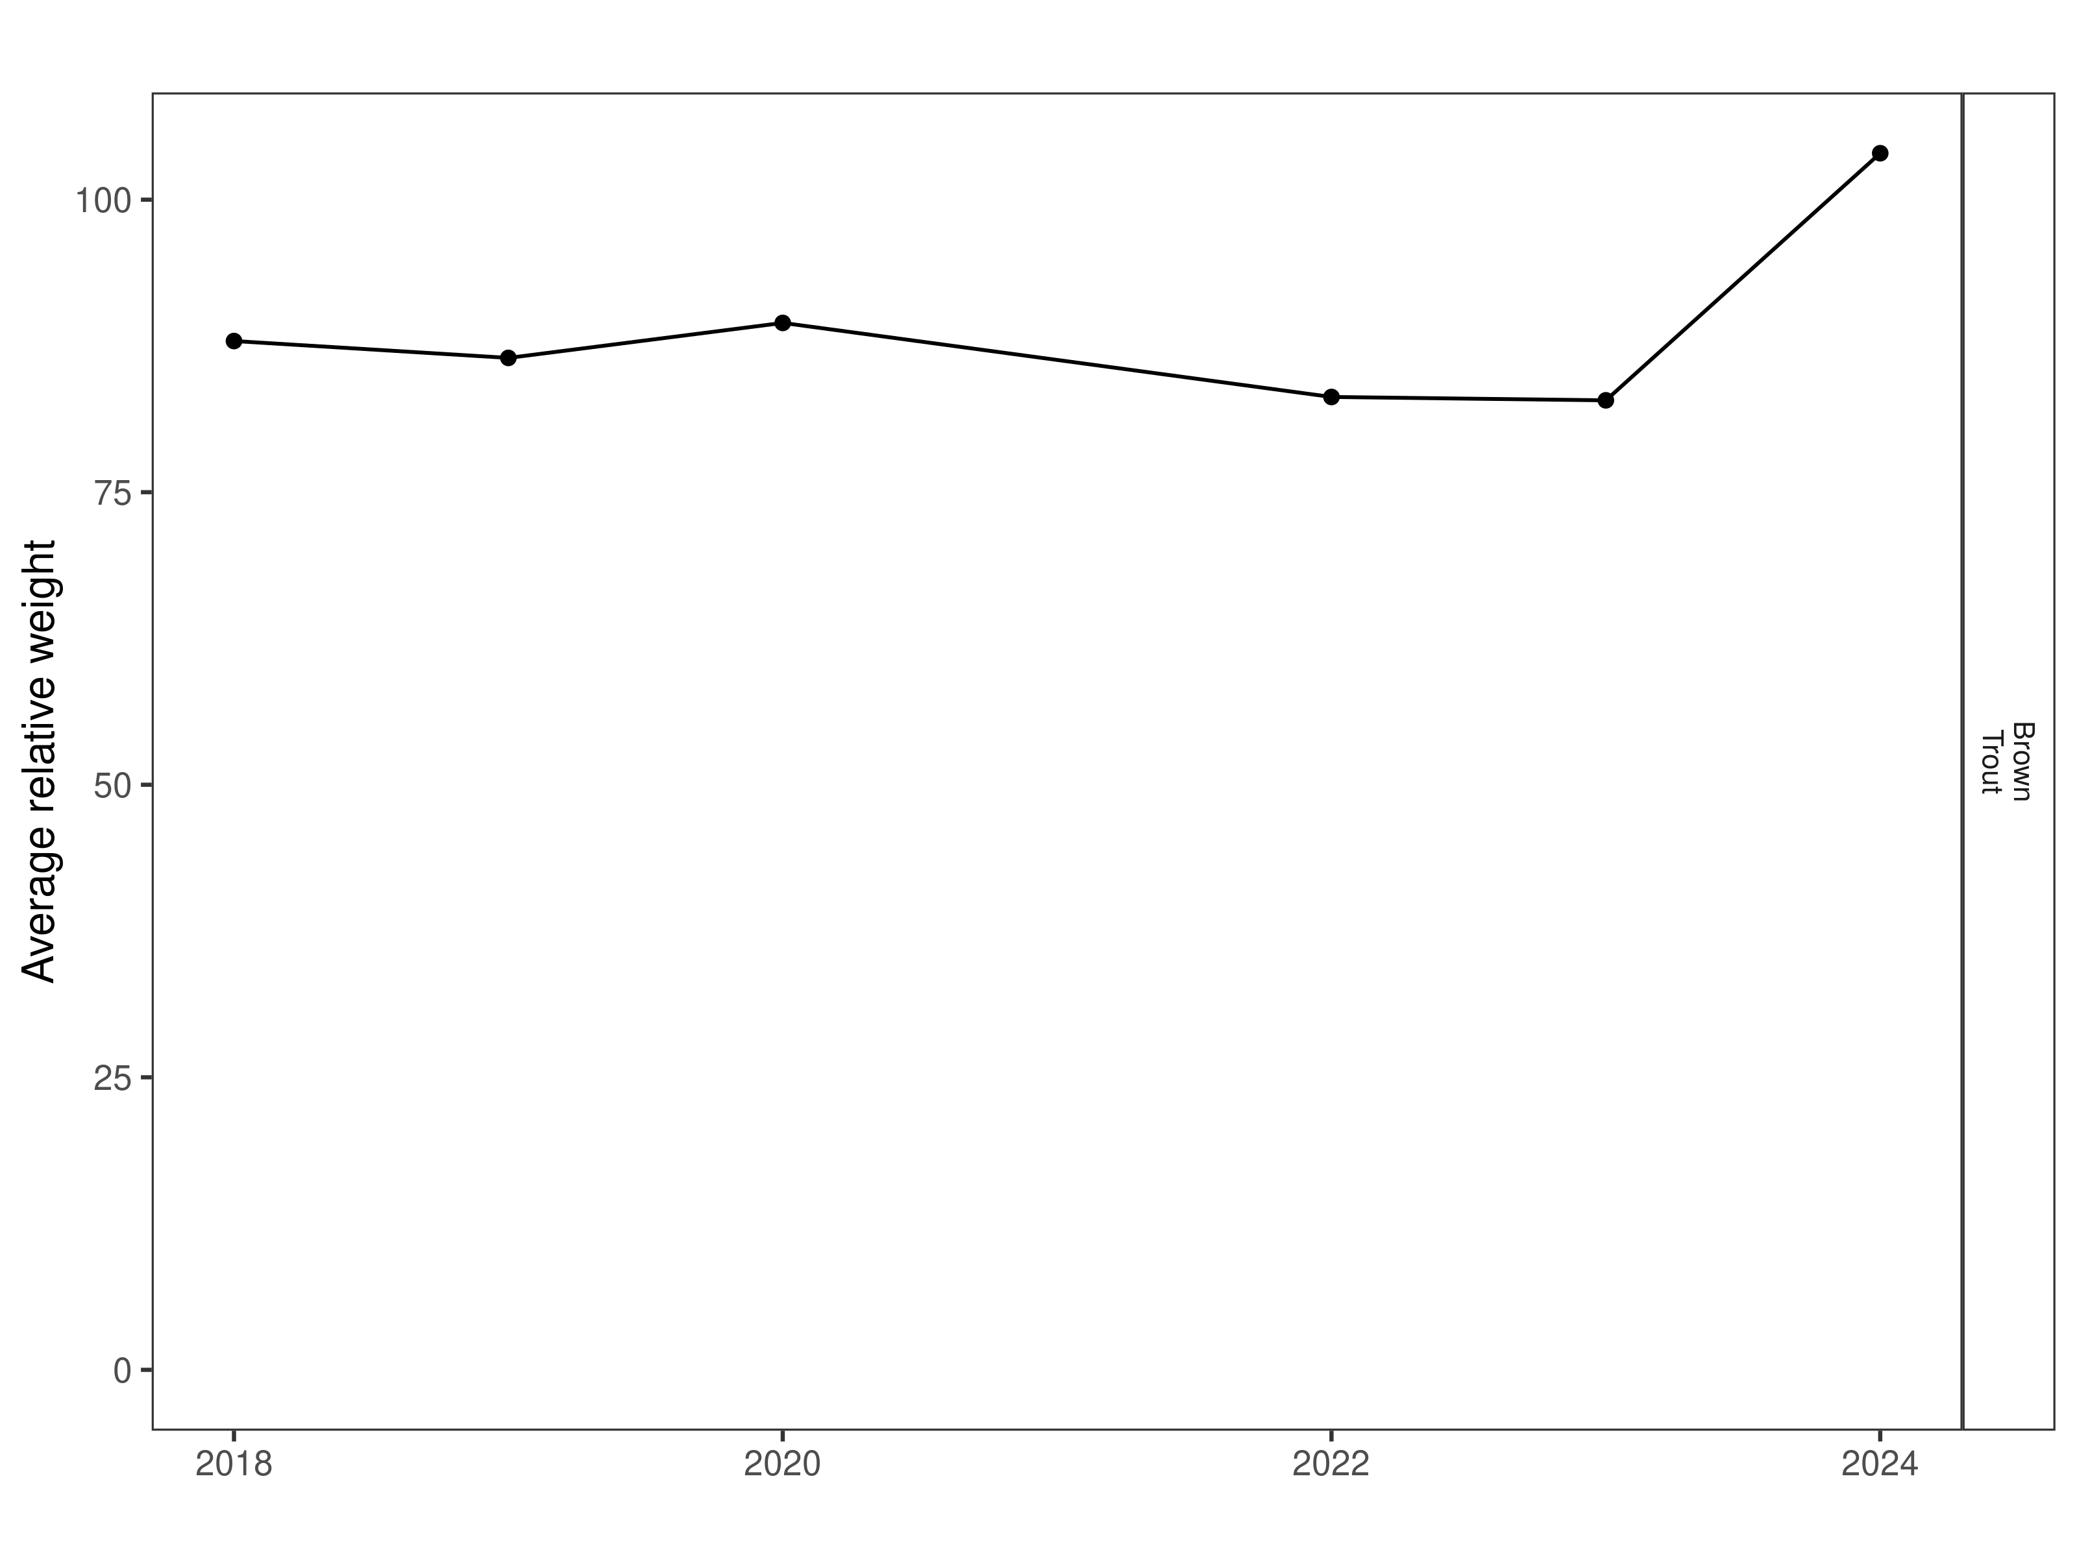
Figure 16. Half Pipe relative weight through time.

Size Structure
Distributions of Brown Trout lengths in 2024 were slightly higher than most previous years (Figure 17). Most Brown Trout were above average length in 2024, and the population experienced a slight increase in median length when compared to previous years (Figure 18). Most of the Brown Trout sampled in this section in 2024 were between 400 and 500 mm (Figure 18).

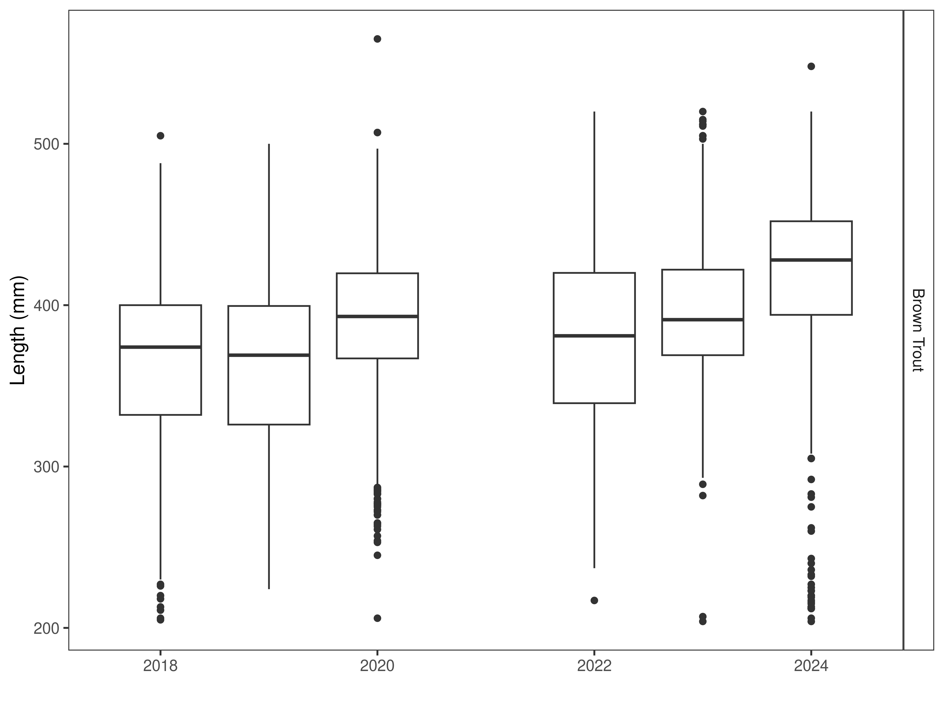
Figure 17. Half Pipe distribution of lengths through time. The box-and-whisker plots divide the distribution of the data into the first quartile (the lower limit of the box), the median (heavy black line), and third quartile (the upper limit of the box). The whiskers denote data points within 1.5 * the interquartile range (the difference between the first and third quartiles). Dots denote data points further than 1.5 * the interquartile range from the box.
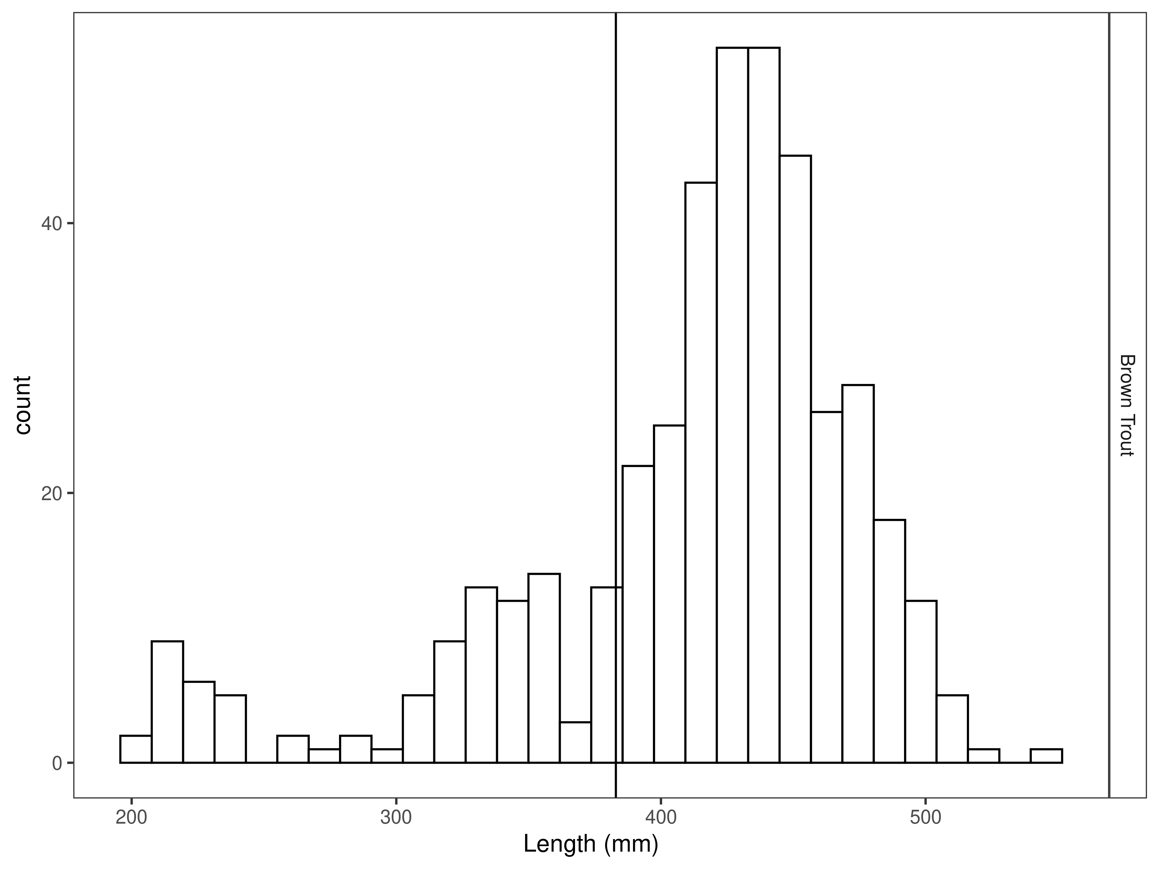
Figure 18. Half Pipe length distribution by species for latest year, with long-term species-averages indicated by the vertical black line.

Mark-recapture abundance estimates
Recapture rates were highest for Brown Trout larger than 330 mm (Figure 19) and capture efficiency was best for fish that ranged in size from 300 to 480 mm (Figure 20). Capture efficiency was relatively stable across most sizes of fish encountered (Figure 20). The estimated Brown trout abundance per km increased from 455 per km in 2023 to 752 per km in 2024. Although the 2024 abundance estimate was higher than the 2023 estimate, it overlaps or is slightly less than estimates from 2020-2022 (Figure 21). Length based models outperformed the null model (Table 10).

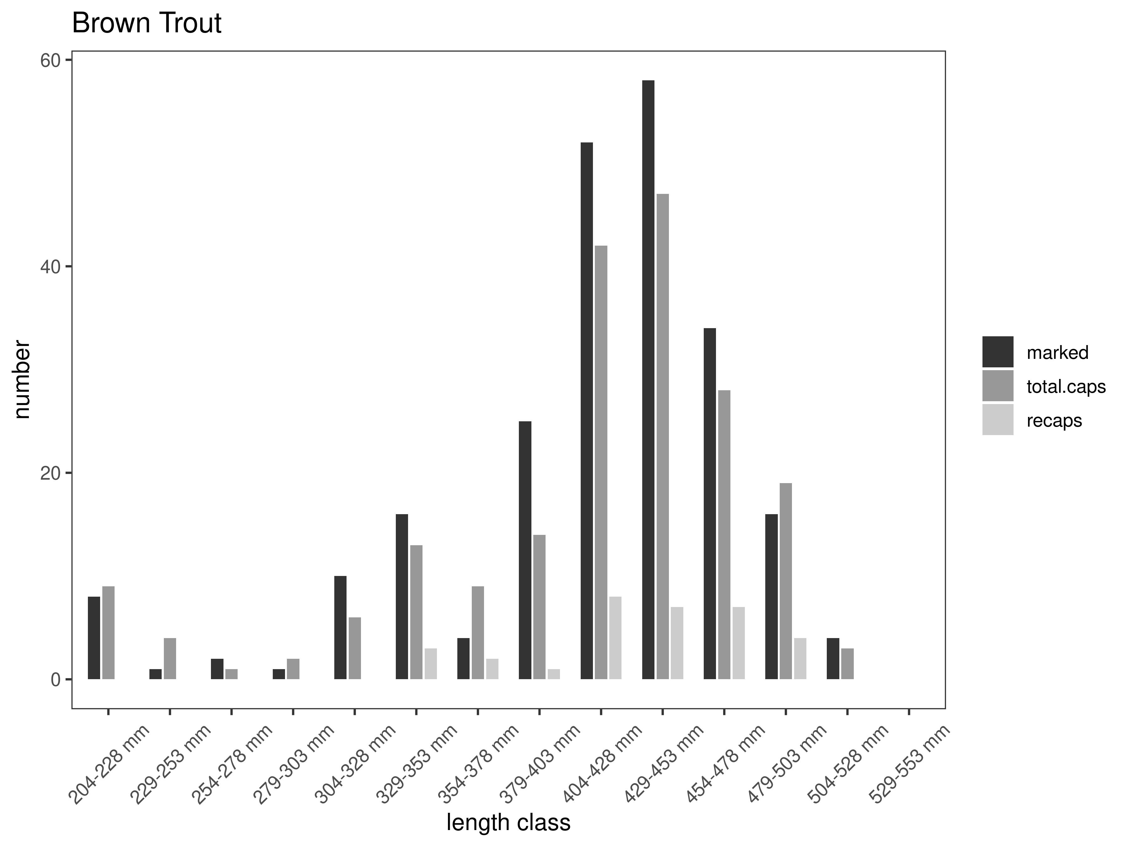
Figure 19. Half Pipe capture-recapture summary across length groups for brown trout in latest year. marked= number of fish marked on initial pass, total.caps = number of fish caught on second pass, and recaps = number of marked fish caught on the second pass.
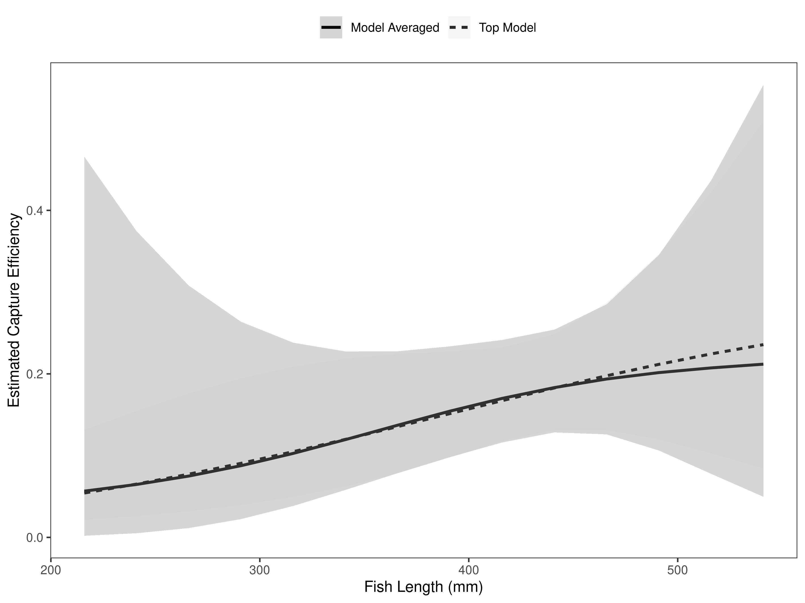
Figure 20. Half Pipe model-averaged estimates of capture efficiency of brown trout in latest year.
Table 10. Model selection results from four models used for two-pass abundance estimation of brown trout in latest year. Models: `Len` = capture efficiency modeled as a function of length class, `Len.sq` = capture efficiency modeled as a quadratic function of length class with the intercept estimated, `FA+` = capture efficiency modeled as a quadratic function of length class with intercept fixed, `Null` = constant capture efficiency.
Model | K | AICc | deltaAICc | ModLik | AICcWt | LnLik | CumWt
FA+ | 2 | 174.79 | 0.0000000 | 1.00 | 0.35 | -85.36269 | 0.35
Len | 2 | 175.22 | 0.4280569 | 0.81 | 0.28 | -85.57672 | 0.63
Len.sq | 3 | 175.48 | 0.6964565 | 0.71 | 0.25 | -84.67950 | 0.87
Null | 1 | 176.83 | 2.0461262 | 0.36 | 0.13 | -87.40658 | 1.00

There were 752 Brown Trout estimated per km in the Half Pipe Section in 2024 (Table 11). Estimate precision was relatively good, but not as precise as Hildreth because the habitat consists of more wide deep pools which negatively affects capture efficiency, thus creating larger confidence intervals (Figure 21). Brown Trout abundance was estimated to within ±174 fish. (Table 11). Biomass increased from around 500 kg in 2023 to just over 1100 kg in 2024 (Figure 22).

Table 11. Model averaged abundance estimates of fish per kilometer (Pop. Estimate) across length groups and estimated biomass (Biomass Estimate, kg) for the latest year.
 |  | Pop. Estimate | 2.5% | 97.5% | Biomass Estimate | 2.5% | 97.5%
Brown Trout | 2024 | 752 | 578 | 926 | 1,114.1 | 926.3 | 1,301.9

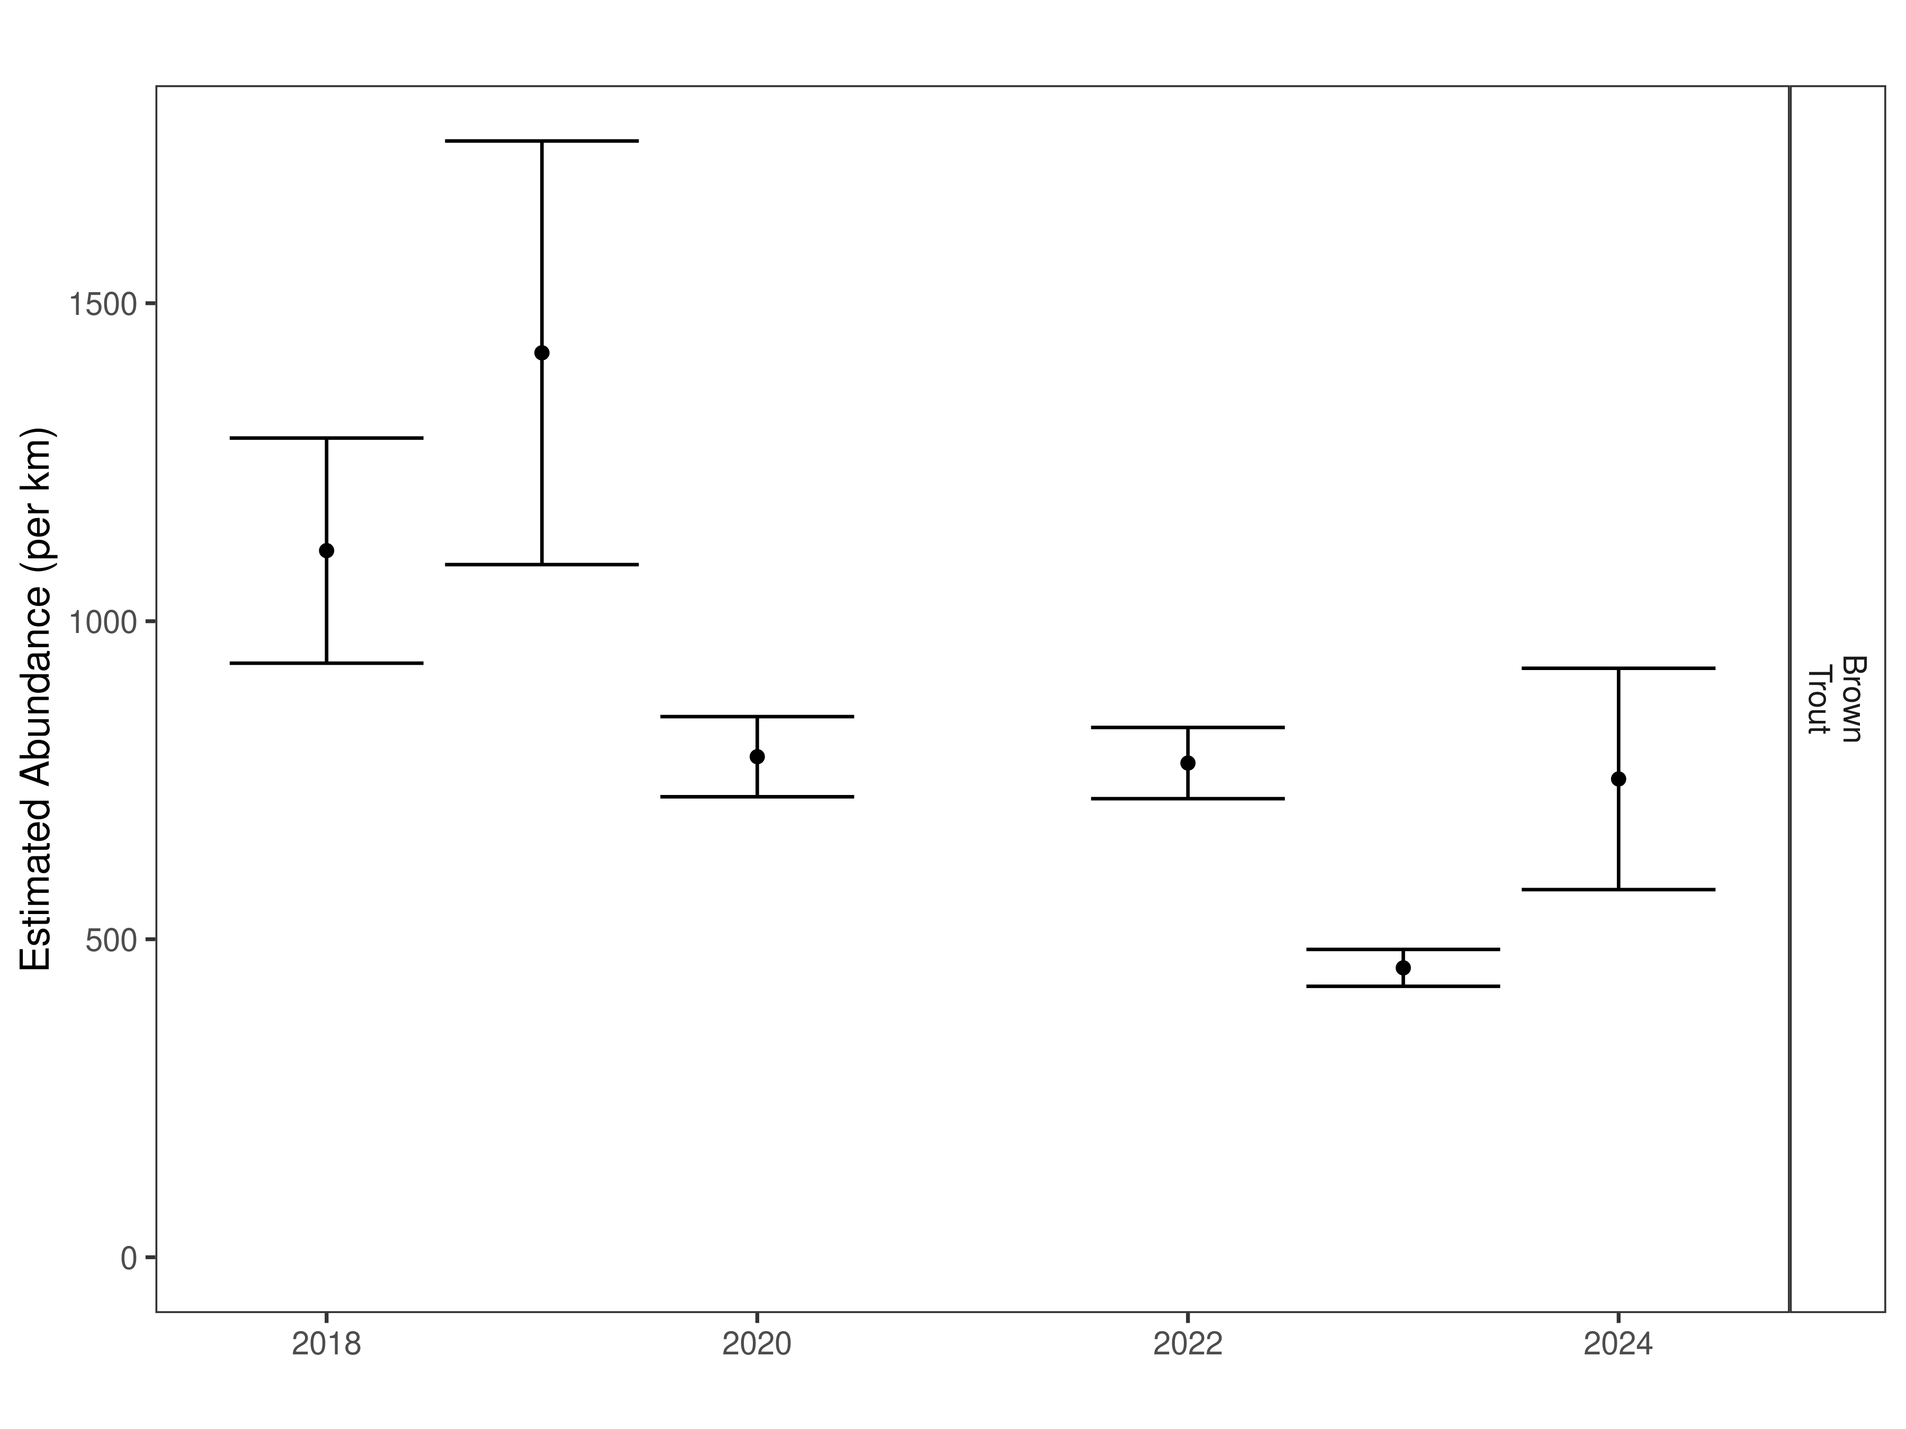
Figure 21. Half Pipe mark-recapture abundance estimates (fish per kilometer) through time using the maximum likelihood method. These estimates (mean and 95% confidence intervals) represent the model-averaged estimates across all length groups.
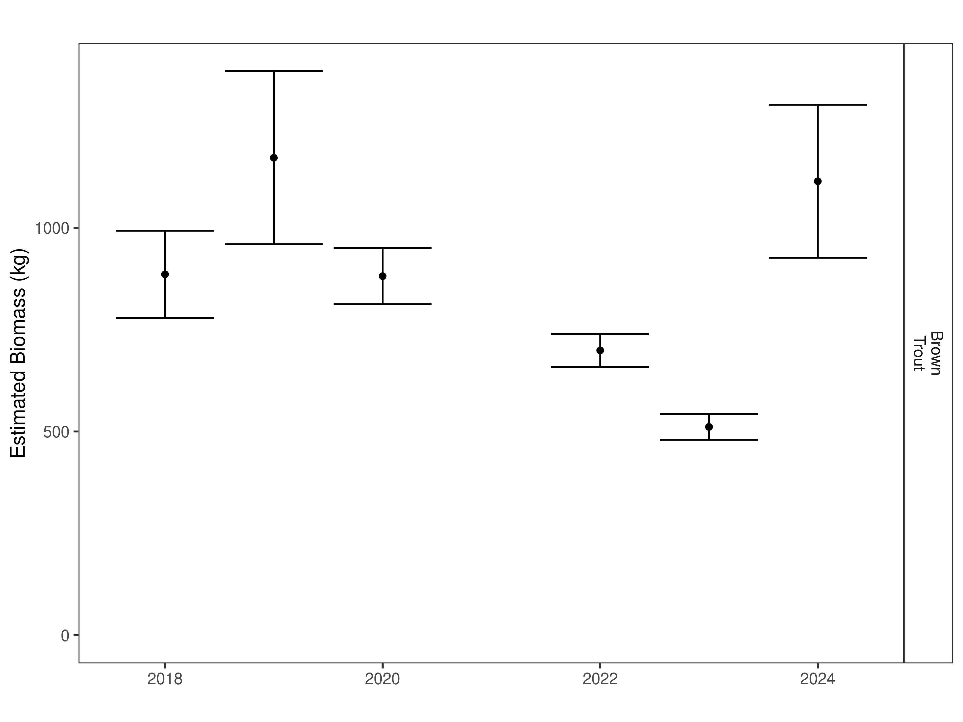
Figure 22. Half Pipe estimates of biomass through time.

Fish and Game section:
Data Summary
In 2024, 601 Brown Trout were captured in the Fish and Game Section of the Beaverhead River and compared to a long-term dataset comprised of 32,967 Brown Trout. Brown Trout in the Fish and Game Section average 395 mm (Table 12). Brown Trout were longer and heavier in 2024 than the long-term average and Brown Trout condition was above average (Table 13). Brown Trout relative weight showed a sharp increase in 2024 after trending downward in each of the four previous years (Figure 23).

Table 12. Fish and Game data summary.
 |  |  |  | Length |  |  |  |  | Weight |  |  | Condition |  |  | Relative Weight
 |  | n |  | Min | Max | Avg | SD |  | Avg | SD |  | Avg | SD |  | Avg | SD
Brown Trout |  | 32967 |  | 40.6 | 815 | 367.9 | 65.9 |  | 501.3 | 249.4 |  | 34.6 | 4.7 |  | 89.2 | 11.8

Table 13. Fish and Game data summary for the latest year.
 |  |  |  | Length |  |  |  |  | Weight |  |  | Condition |  |  | Relative Weight
 |  | n |  | Min | Max | Avg | SD |  | Avg | SD |  | Avg | SD |  | Avg | SD
Brown Trout |  | 601 |  | 200 | 595 | 395.2 | 81.2 |  | 661 | 345.8 |  | 36.8 | 4.3 |  | 95 | 10.6

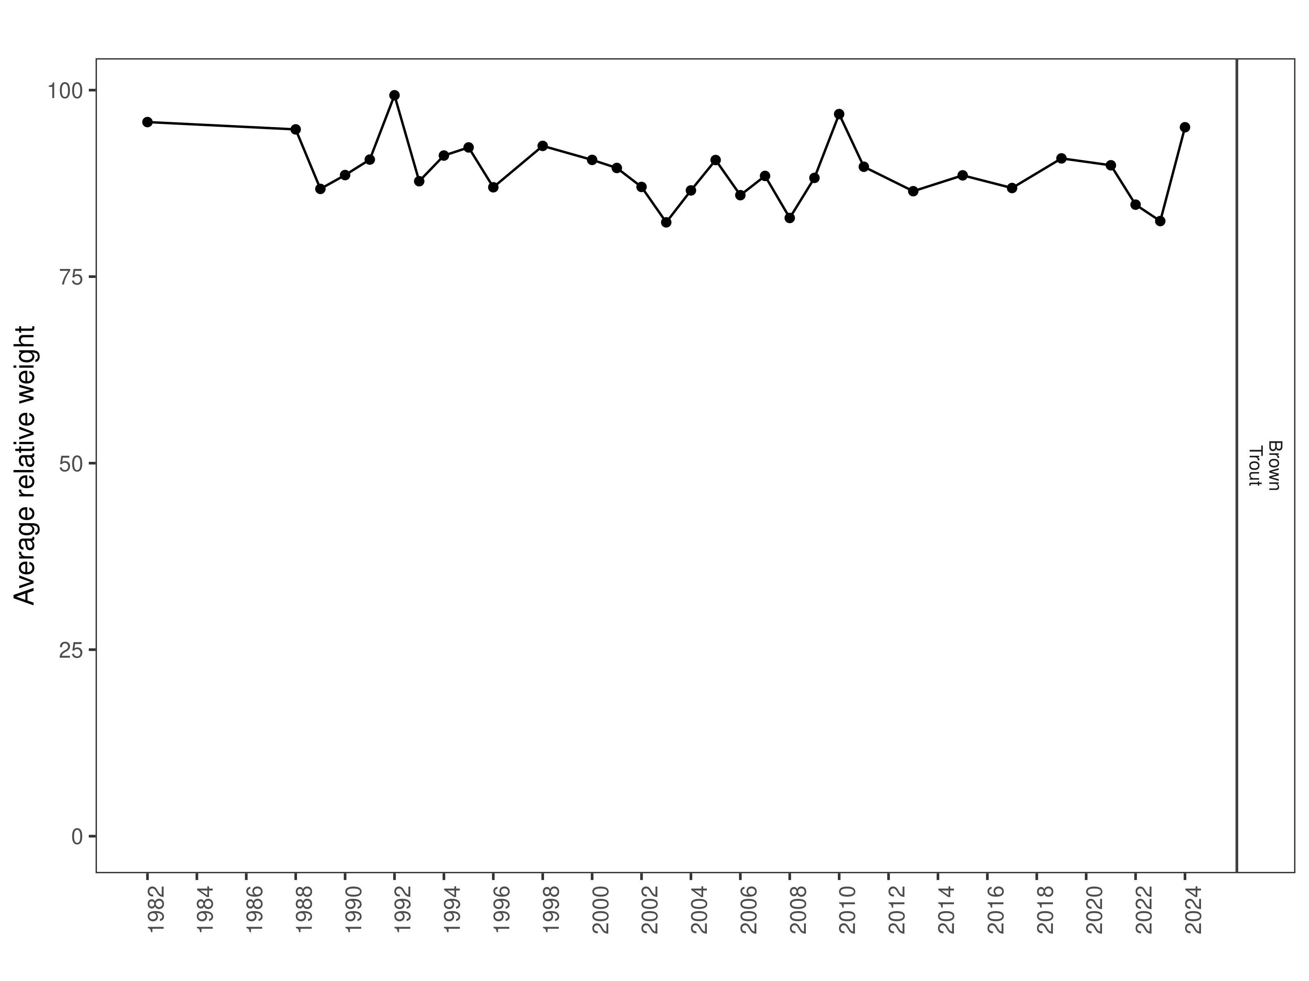
Figure 23. Fish and Game relative weight through time.

Size Structure
Distributions of Brown Trout lengths in 2024 show a decrease in median length when compared to the three previous years (Figure 24). Most Brown Trout were above average length in 2024, and the population showed an increase in distribution of lengths when compared to previous years (Figure 24). There appears to be a strong cohort of 2-year-old fish that range from 280 to 350 mm in length (Figure 25).
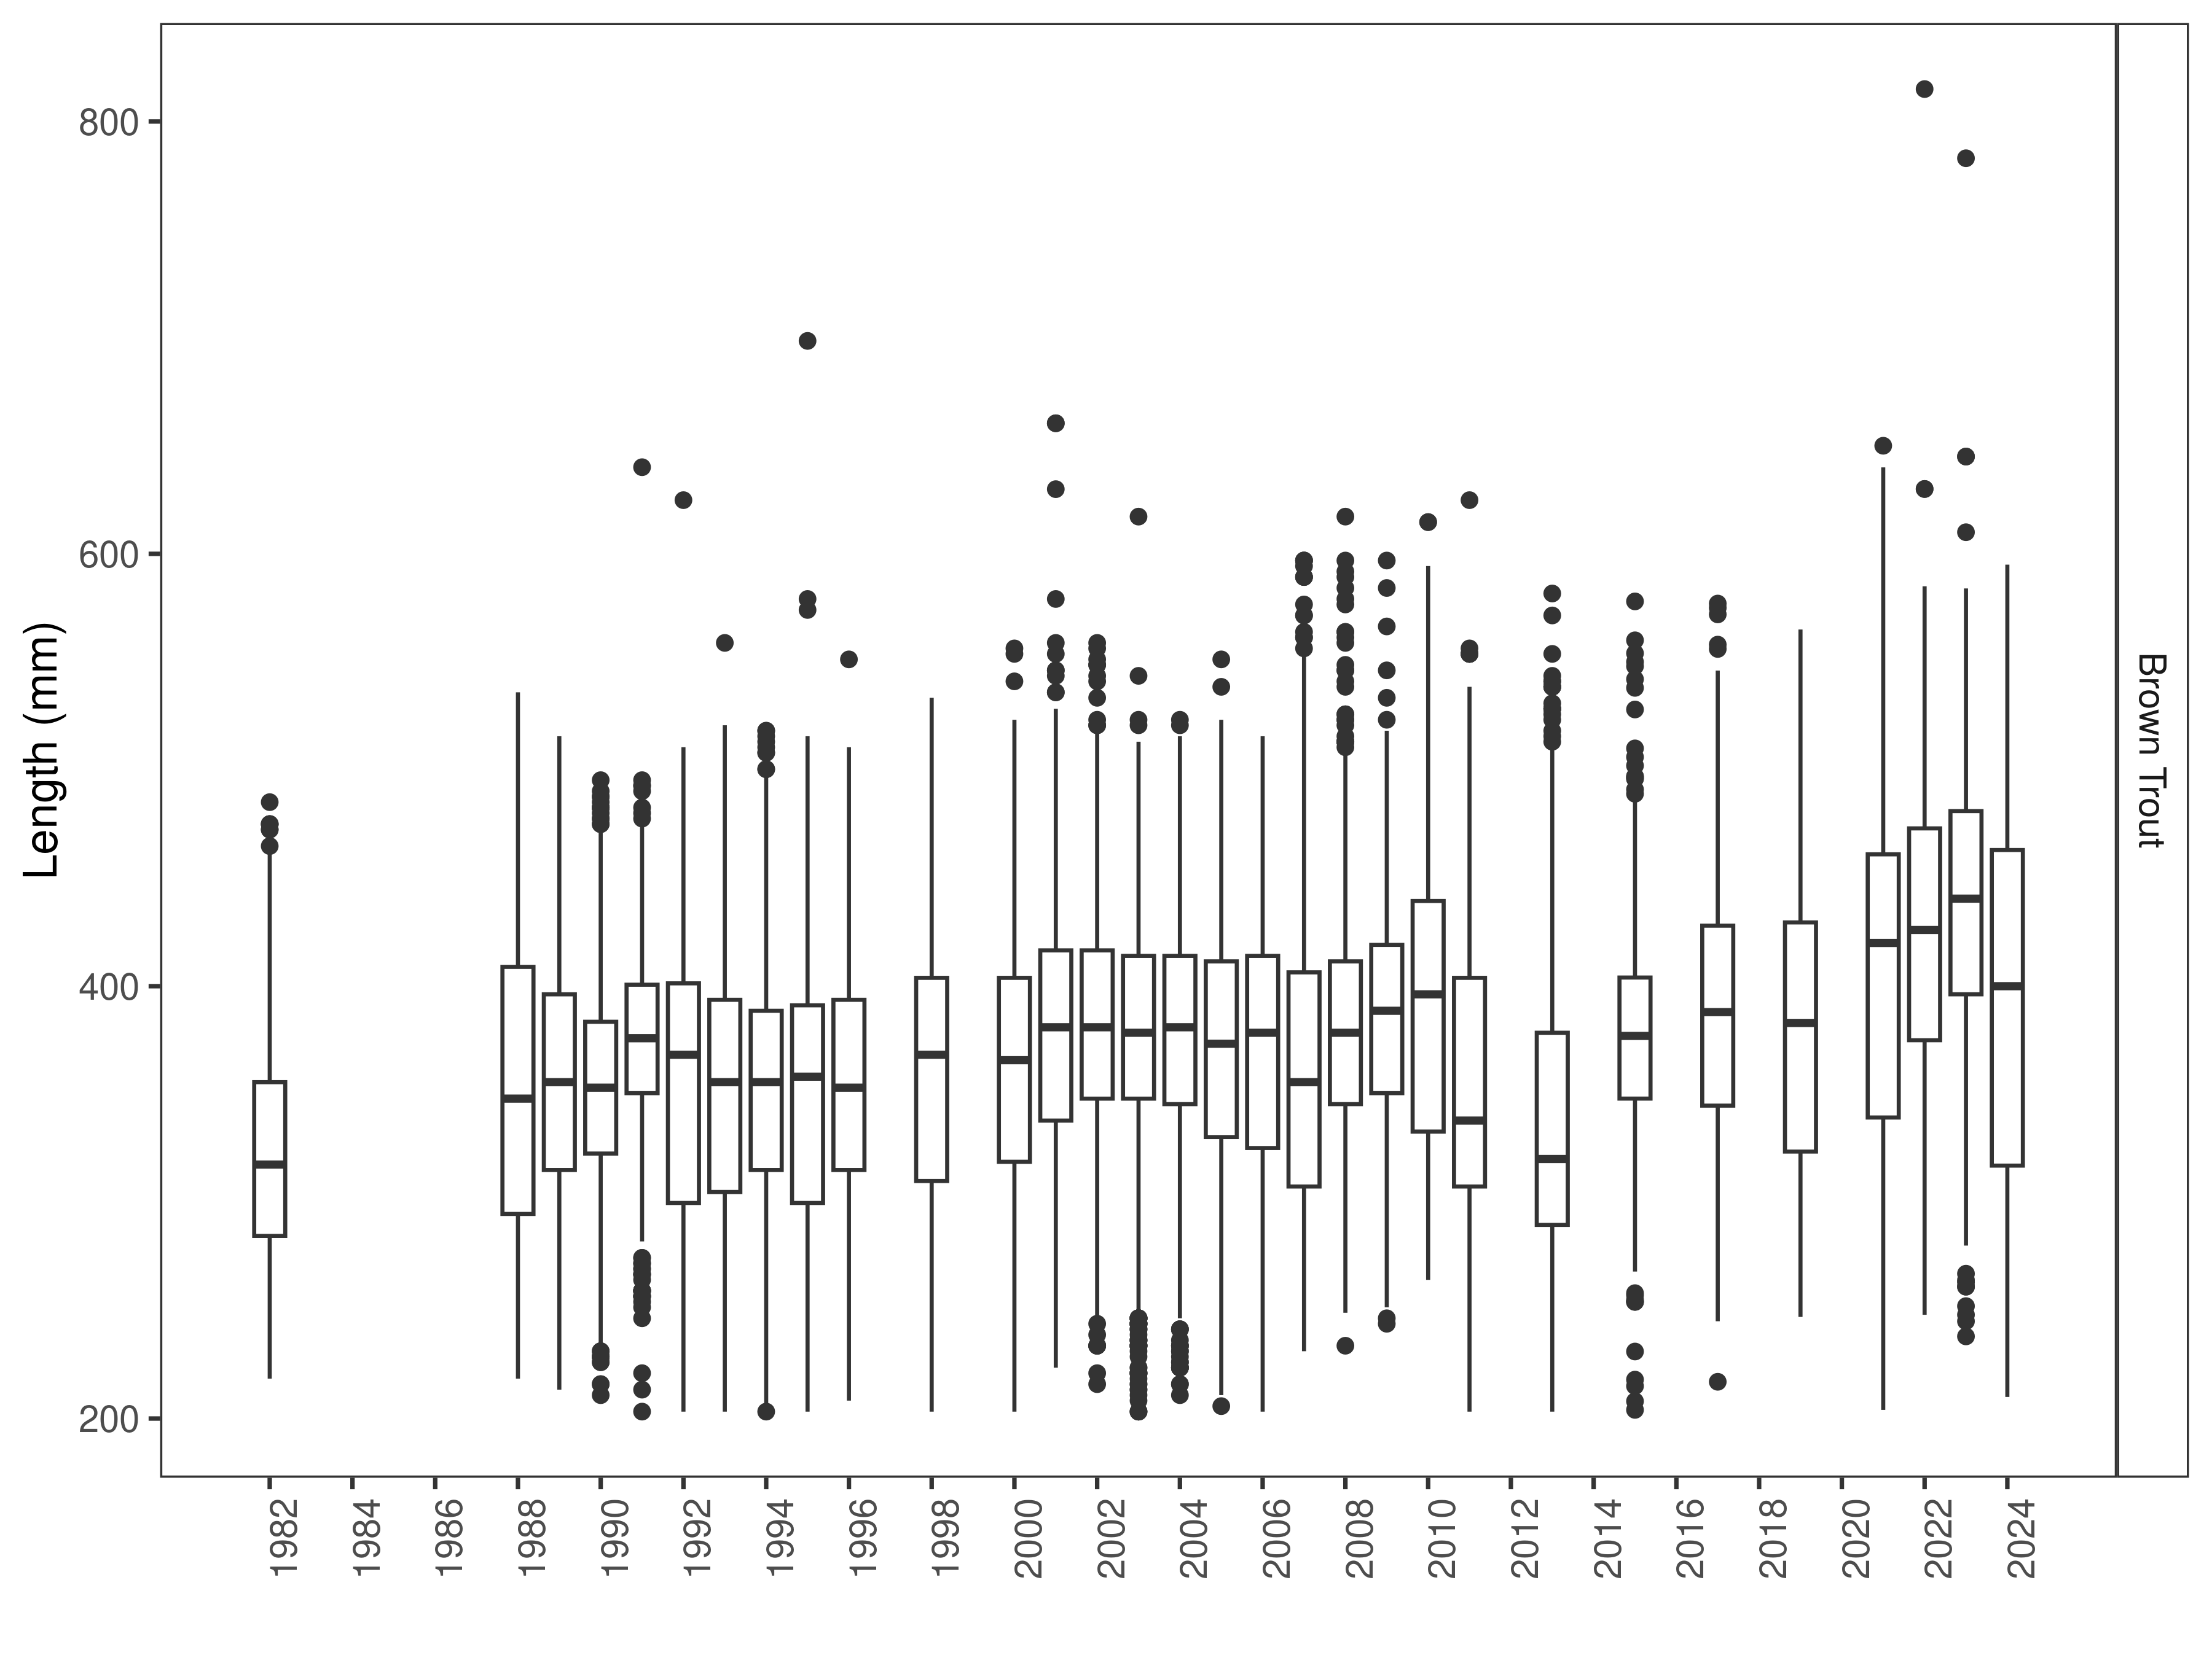
Figure 24. Fish and Game distribution of lengths through time. The box-and-whisker plots divide the distribution of the data into the first quartile (the lower limit of the box), the median (heavy black line), and third quartile (the upper limit of the box). The whiskers denote data points within 1.5 * the interquartile range (the difference between the first and third quartiles). Dots denote data points further than 1.5 * the interquartile range from the box.
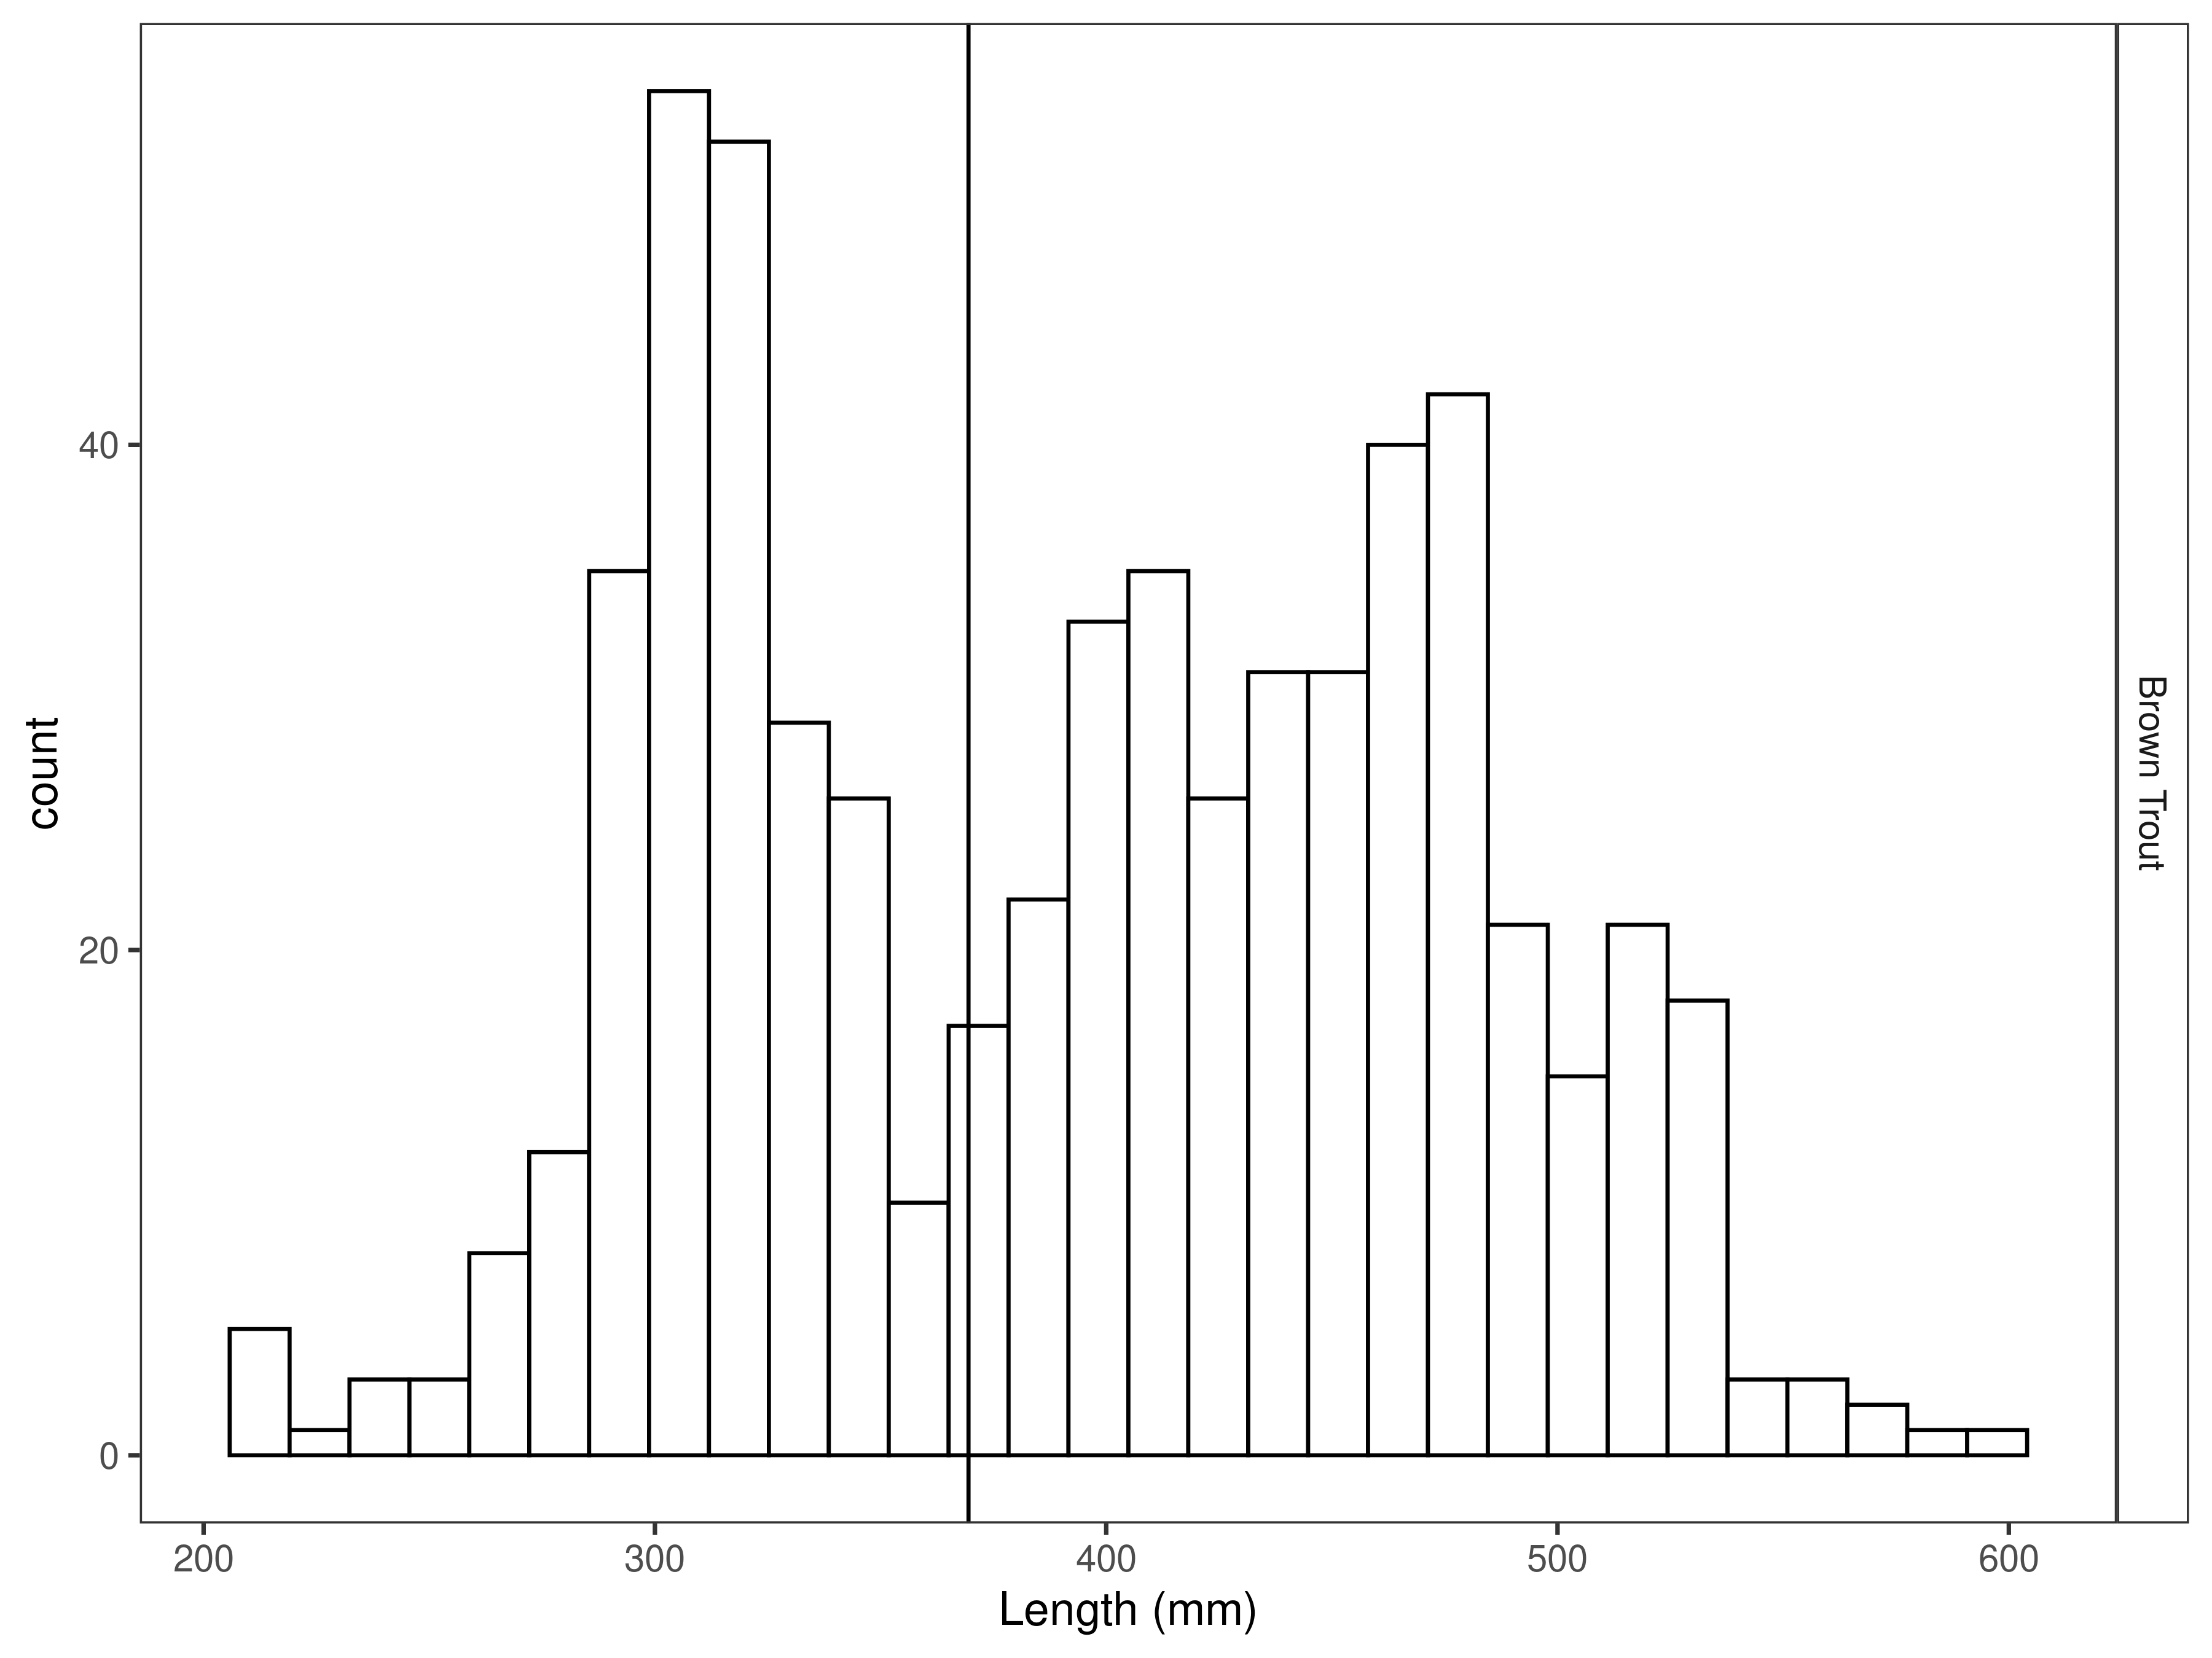
Figure 25. Fish and Game length distribution by species for latest year, with long-term species-averages indicated by the vertical black line.

Mark-recapture abundance estimates
Recapture rates were consistent for Brown Trout between 275 and 550 mm (Figure 26). Capture efficiency was best for fish that ranged from 300 to 500 mm and was relatively stable across most sizes of fish encountered (Figure 27). Length based models outperformed the null model (Table 14).

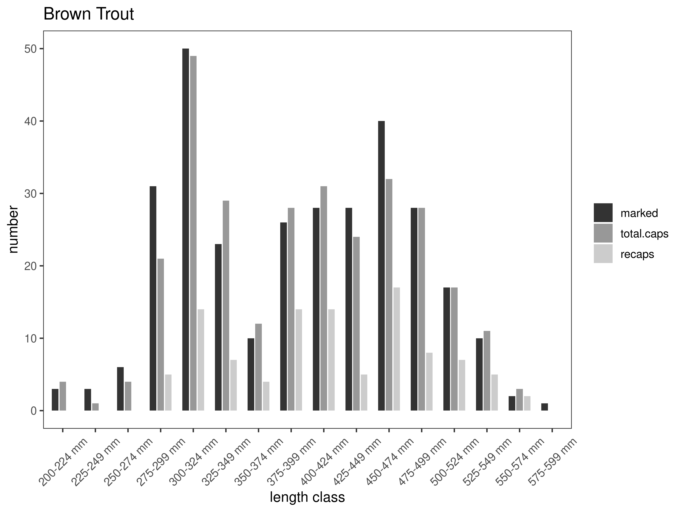
Figure 26. Fish and Game capture-recapture summary across length groups for brown trout in latest year. marked= number of fish marked on initial pass, total.caps = number of fish caught on second pass, and recaps = number of marked fish caught on the second pass.
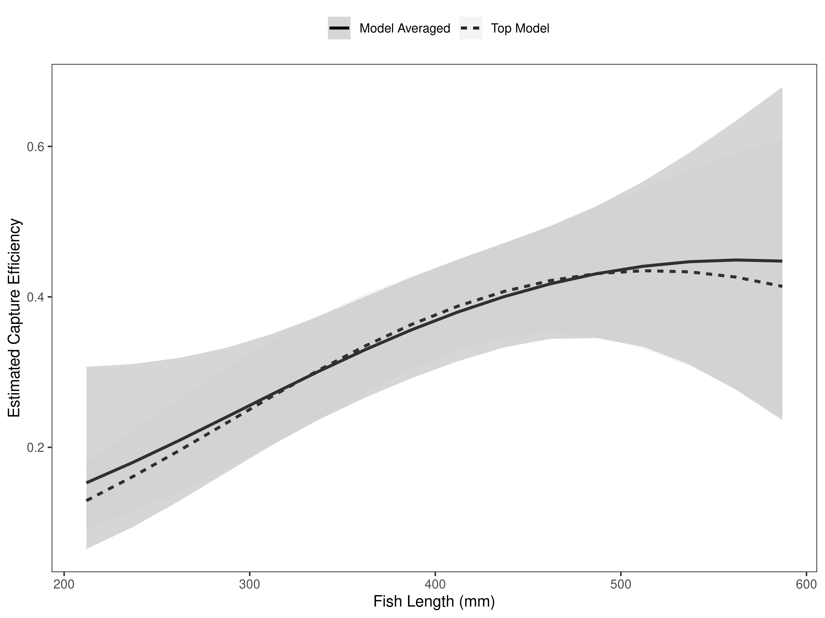
Figure 27. Fish and Game model-averaged estimates of capture efficiency of brown trout in latest year.
Table 14. Model selection results from four models used for two-pass abundance estimation of brown trout in latest year. Models: `Len` = capture efficiency modeled as a function of length class, `Len.sq` = capture efficiency modeled as a quadratic function of length class with the intercept estimated, `FA+` = capture efficiency modeled as a quadratic function of length class with intercept fixed, `Null` = constant capture efficiency.
Model | K | AICc | deltaAICc | ModLik | AICcWt | LnLik | CumWt
FA+ | 2 | 376.80 | 0.000000 | 1.00 | 0.50 | -186.3805 | 0.50
Len | 2 | 377.80 | 1.002452 | 0.61 | 0.30 | -186.8818 | 0.80
Len.sq | 3 | 378.83 | 2.028759 | 0.36 | 0.18 | -186.3742 | 0.98
Null | 1 | 383.70 | 6.894416 | 0.03 | 0.02 | -190.8415 | 1.00

Brown trout were estimated at 282 per km during the 2024 mark-recapture estimate. This was a very precise abundance estimate that was within ±25 fish (Table 15). The estimated abundance of Brown Trout per km increased from 190 per km in 2023 and overlaps or is slightly higher than from 2019 through 2022 (Figure 28). Biomass increased when compared to the previous year but has remained relatively constant since 2019 (Figure 29)

Table 15. Model averaged abundance estimates of fish per kilometer (Pop. Estimate) across length groups and estimated biomass (Biomass Estimate, kg) for the latest year.
 |  | Pop. Estimate | 2.5% | 97.5% | Biomass Estimate | 2.5% | 97.5%
Brown Trout | 2024 | 282 | 257 | 307 | 553.3 | 514.8 | 591.8

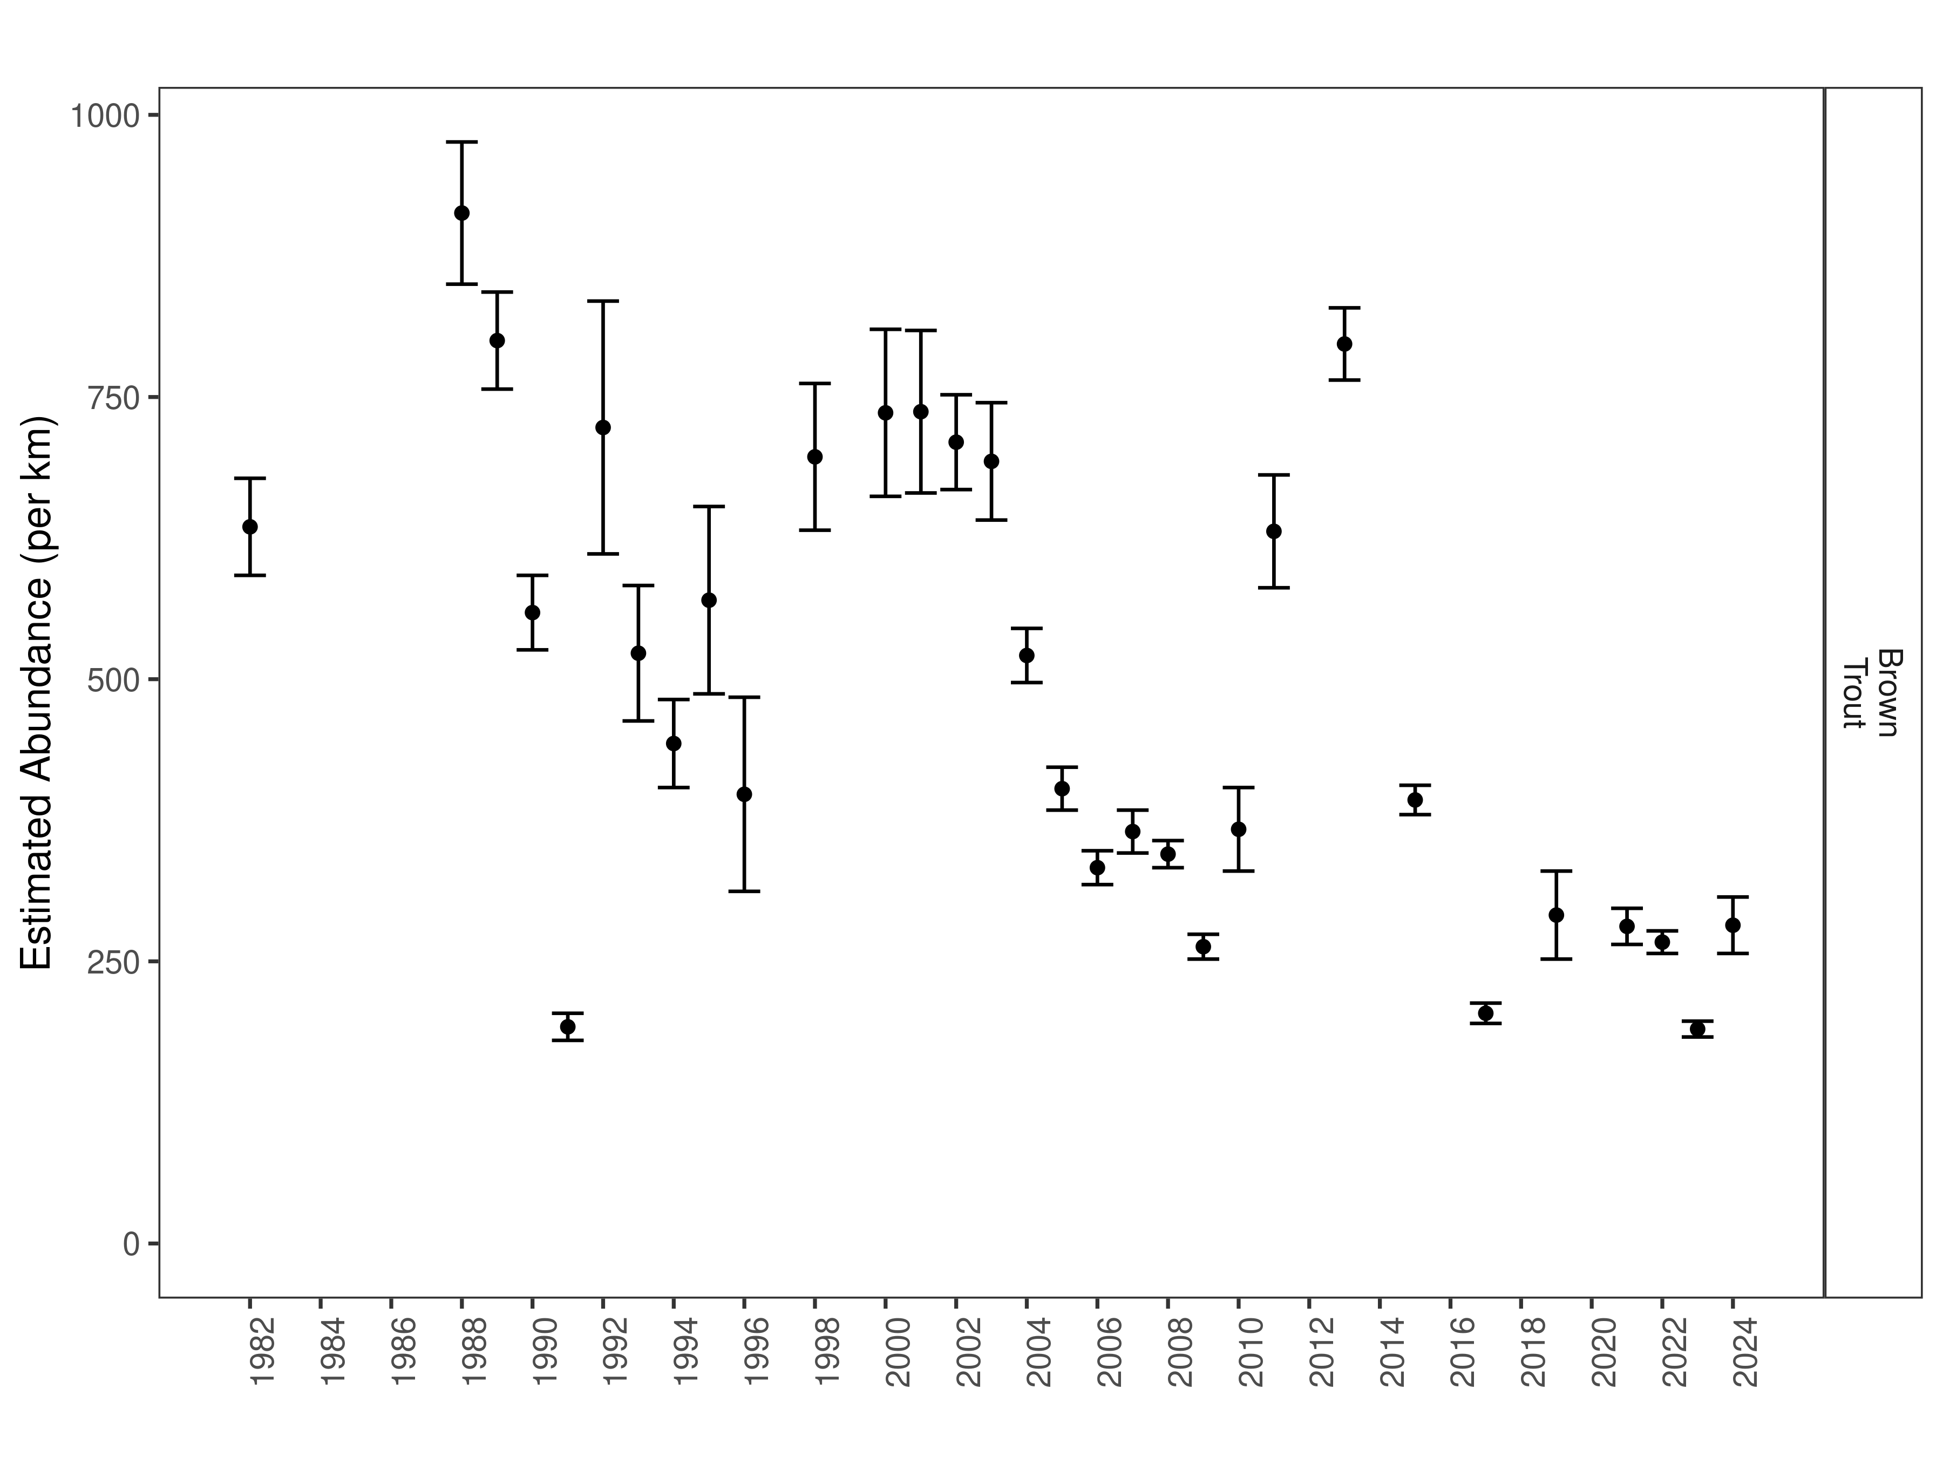
Figure 28. Fish and Game mark-recapture abundance estimates (fish per kilometer) through time using the maximum likelihood method. These estimates (mean and 95% confidence intervals) represent the model-averaged estimates across all length groups.
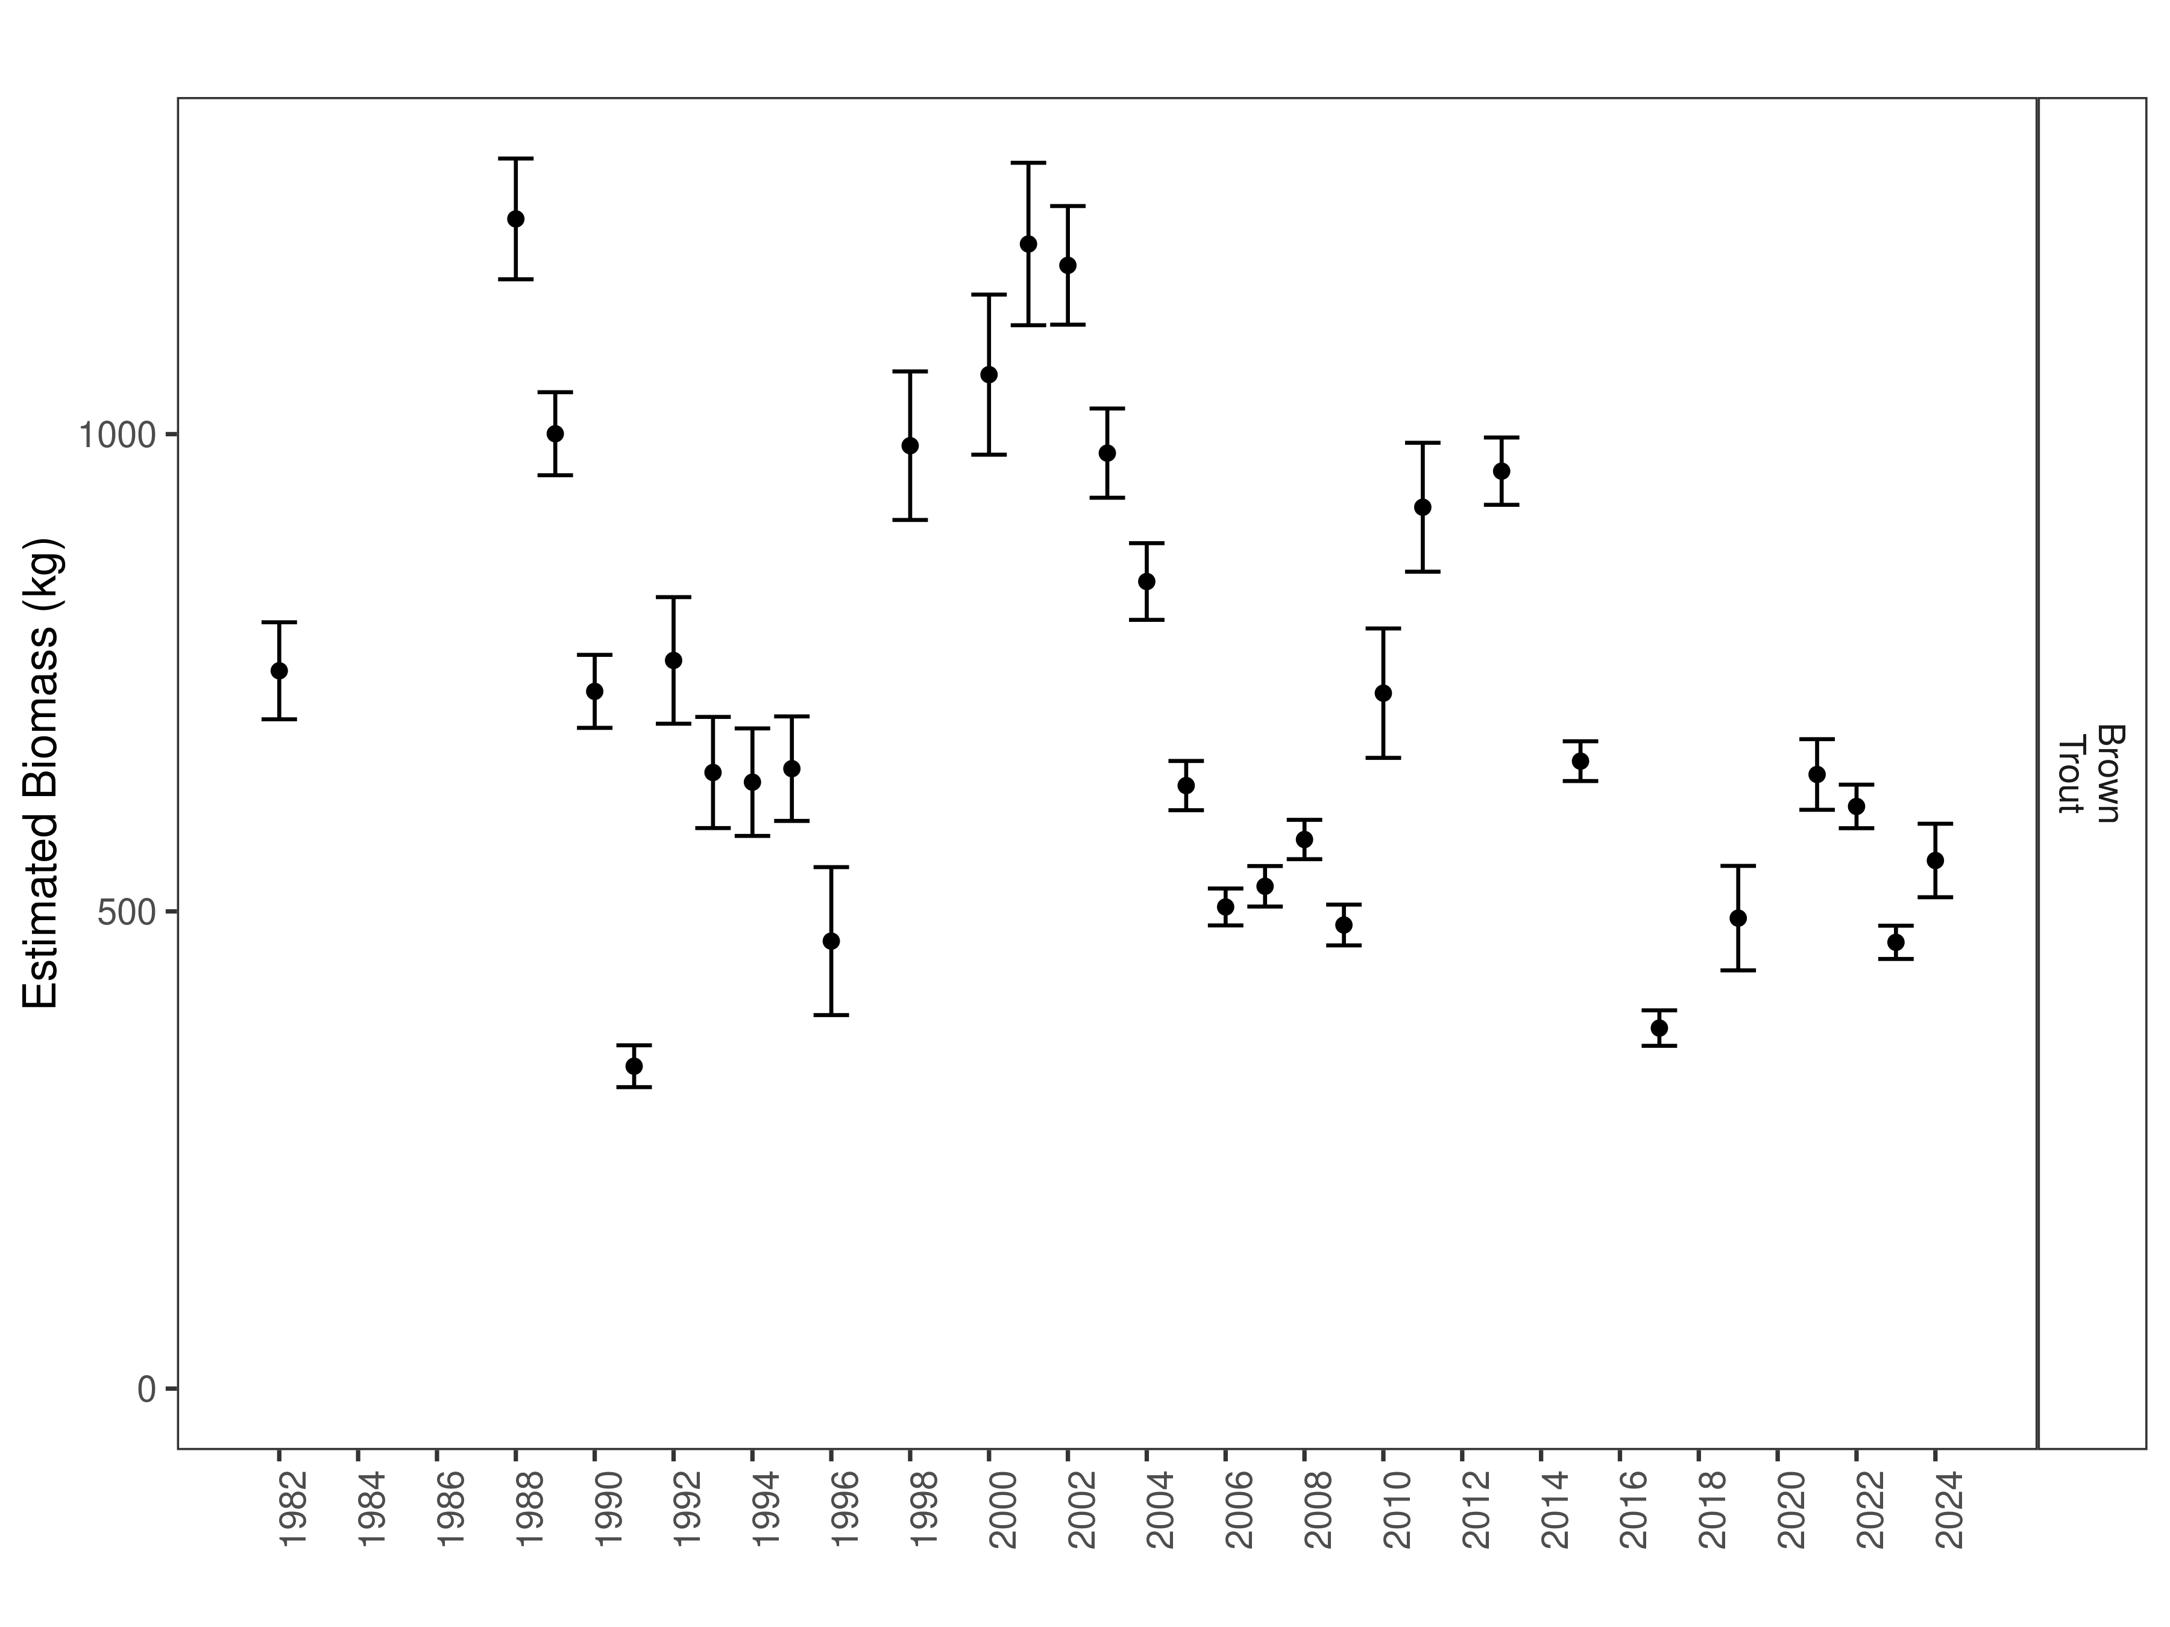
Figure 29. Fish and Game estimates of biomass through time.

Anderson Section:
Data Summary
In 2024, 315 Brown Trout were captured in the Anderson Section of the Beaverhead River and compared to a long-term dataset comprised of 10,902 Brown Trout. Brown Trout in the Anderson Section average 382 mm (Table 16). Brown Trout were slightly longer and heavier in 2024 than the long-term average and condition was similar to the long-term average (Table 17). Brown Trout relative weight showed a decrease in 2024 and it has decreased each of the past four years; however it has remained similar to previous years (Figures 30).

Table 16. Anderson data summary.
 |  |  |  | Length |  |  |  |  | Weight |  |  | Condition |  |  | Relative Weight
 |  | n |  | Min | Max | Avg | SD |  | Avg | SD |  | Avg | SD |  | Avg | SD
Brown Trout |  | 10902 |  | 114.3 | 750 | 382.5 | 82.1 |  | 587 | 346.2 |  | 34.9 | 4 |  | 90 | 10

Table 17. Anderson data summary for the latest year.
 |  |  |  | Length |  |  |  |  | Weight |  |  | Condition |  |  | Relative Weight
 |  | n |  | Min | Max | Avg | SD |  | Avg | SD |  | Avg | SD |  | Avg | SD
Brown Trout |  | 315 |  | 189 | 595 | 402.2 | 93.1 |  | 637.7 | 409 |  | 32.4 | 3.3 |  | 83.8 | 8.4

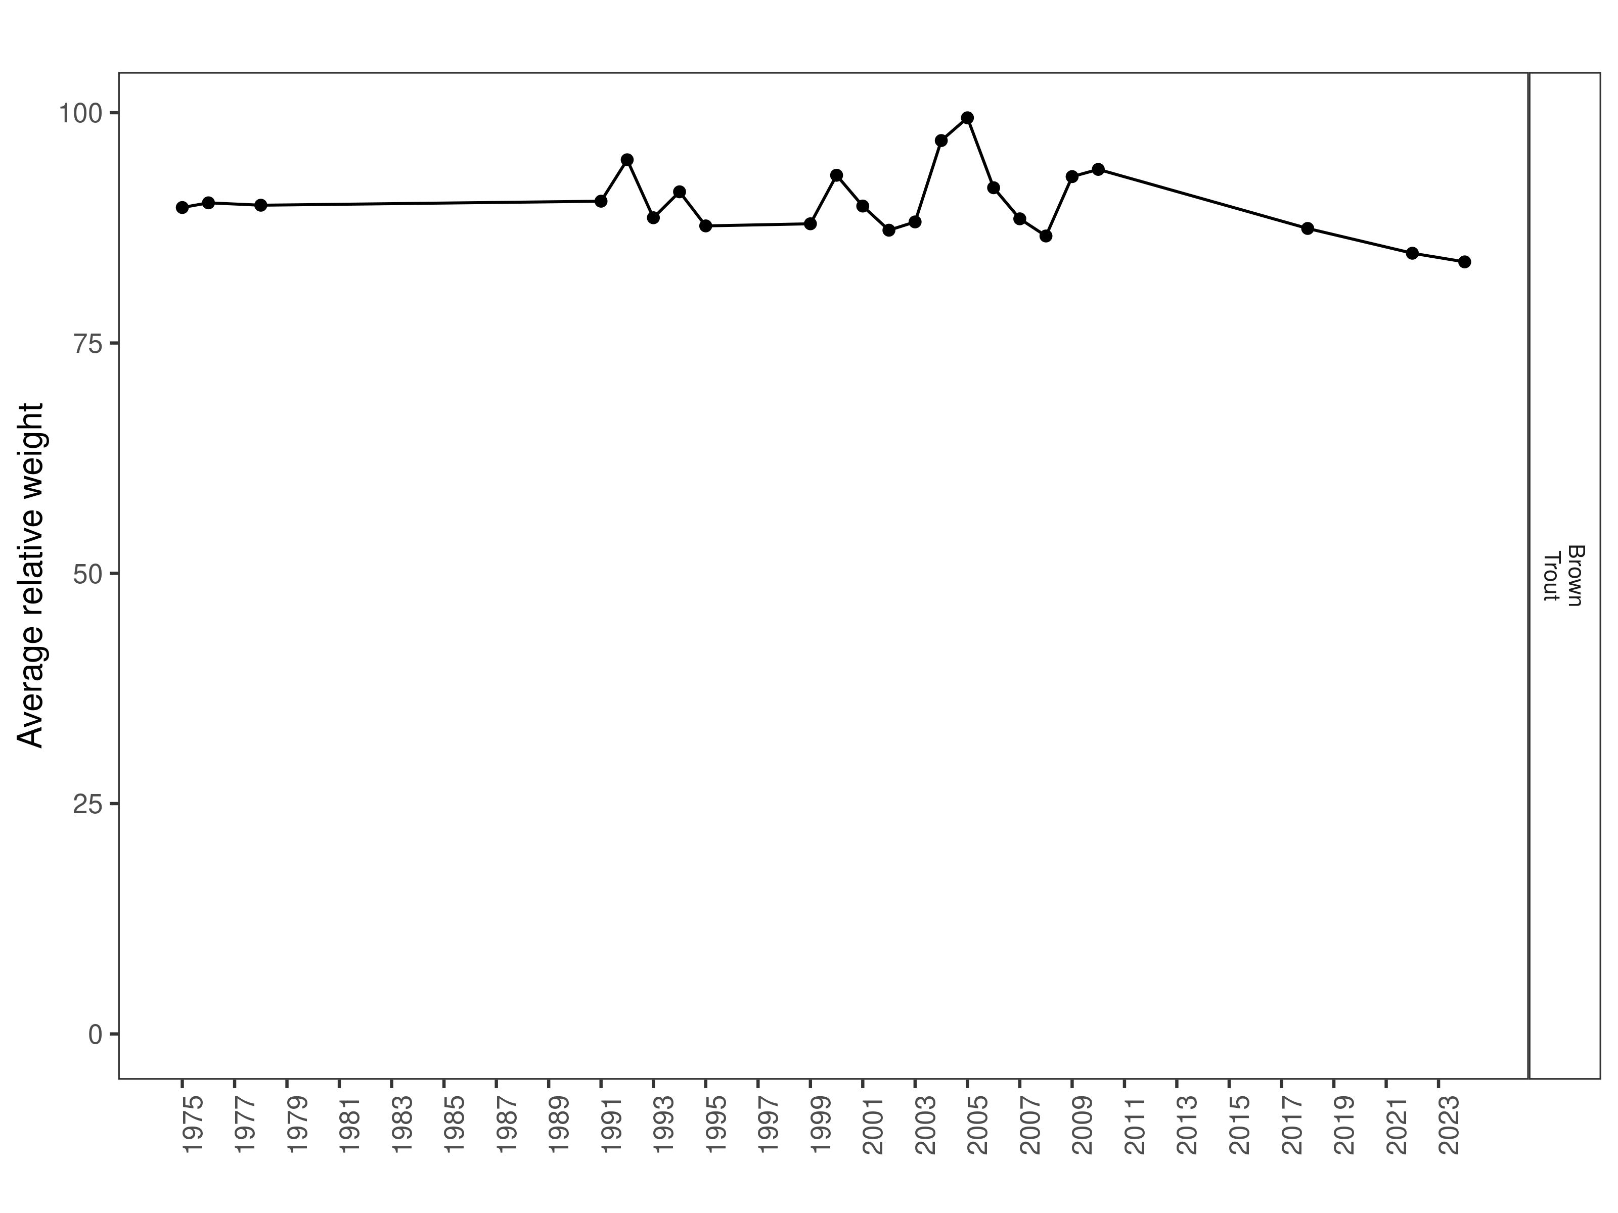
Figure 30. Anderson relative weight through time.

Size Structure
Distributions of Brown Trout lengths in 2024 showed a decrease in median length when compared to the previous year; however, overall distribution of lengths overlap with 2018 and 2022 (Figure 31). There appears to be a strong cohort of 2-year-old fish that range from 280 to 350 mm in length (Figure 32).

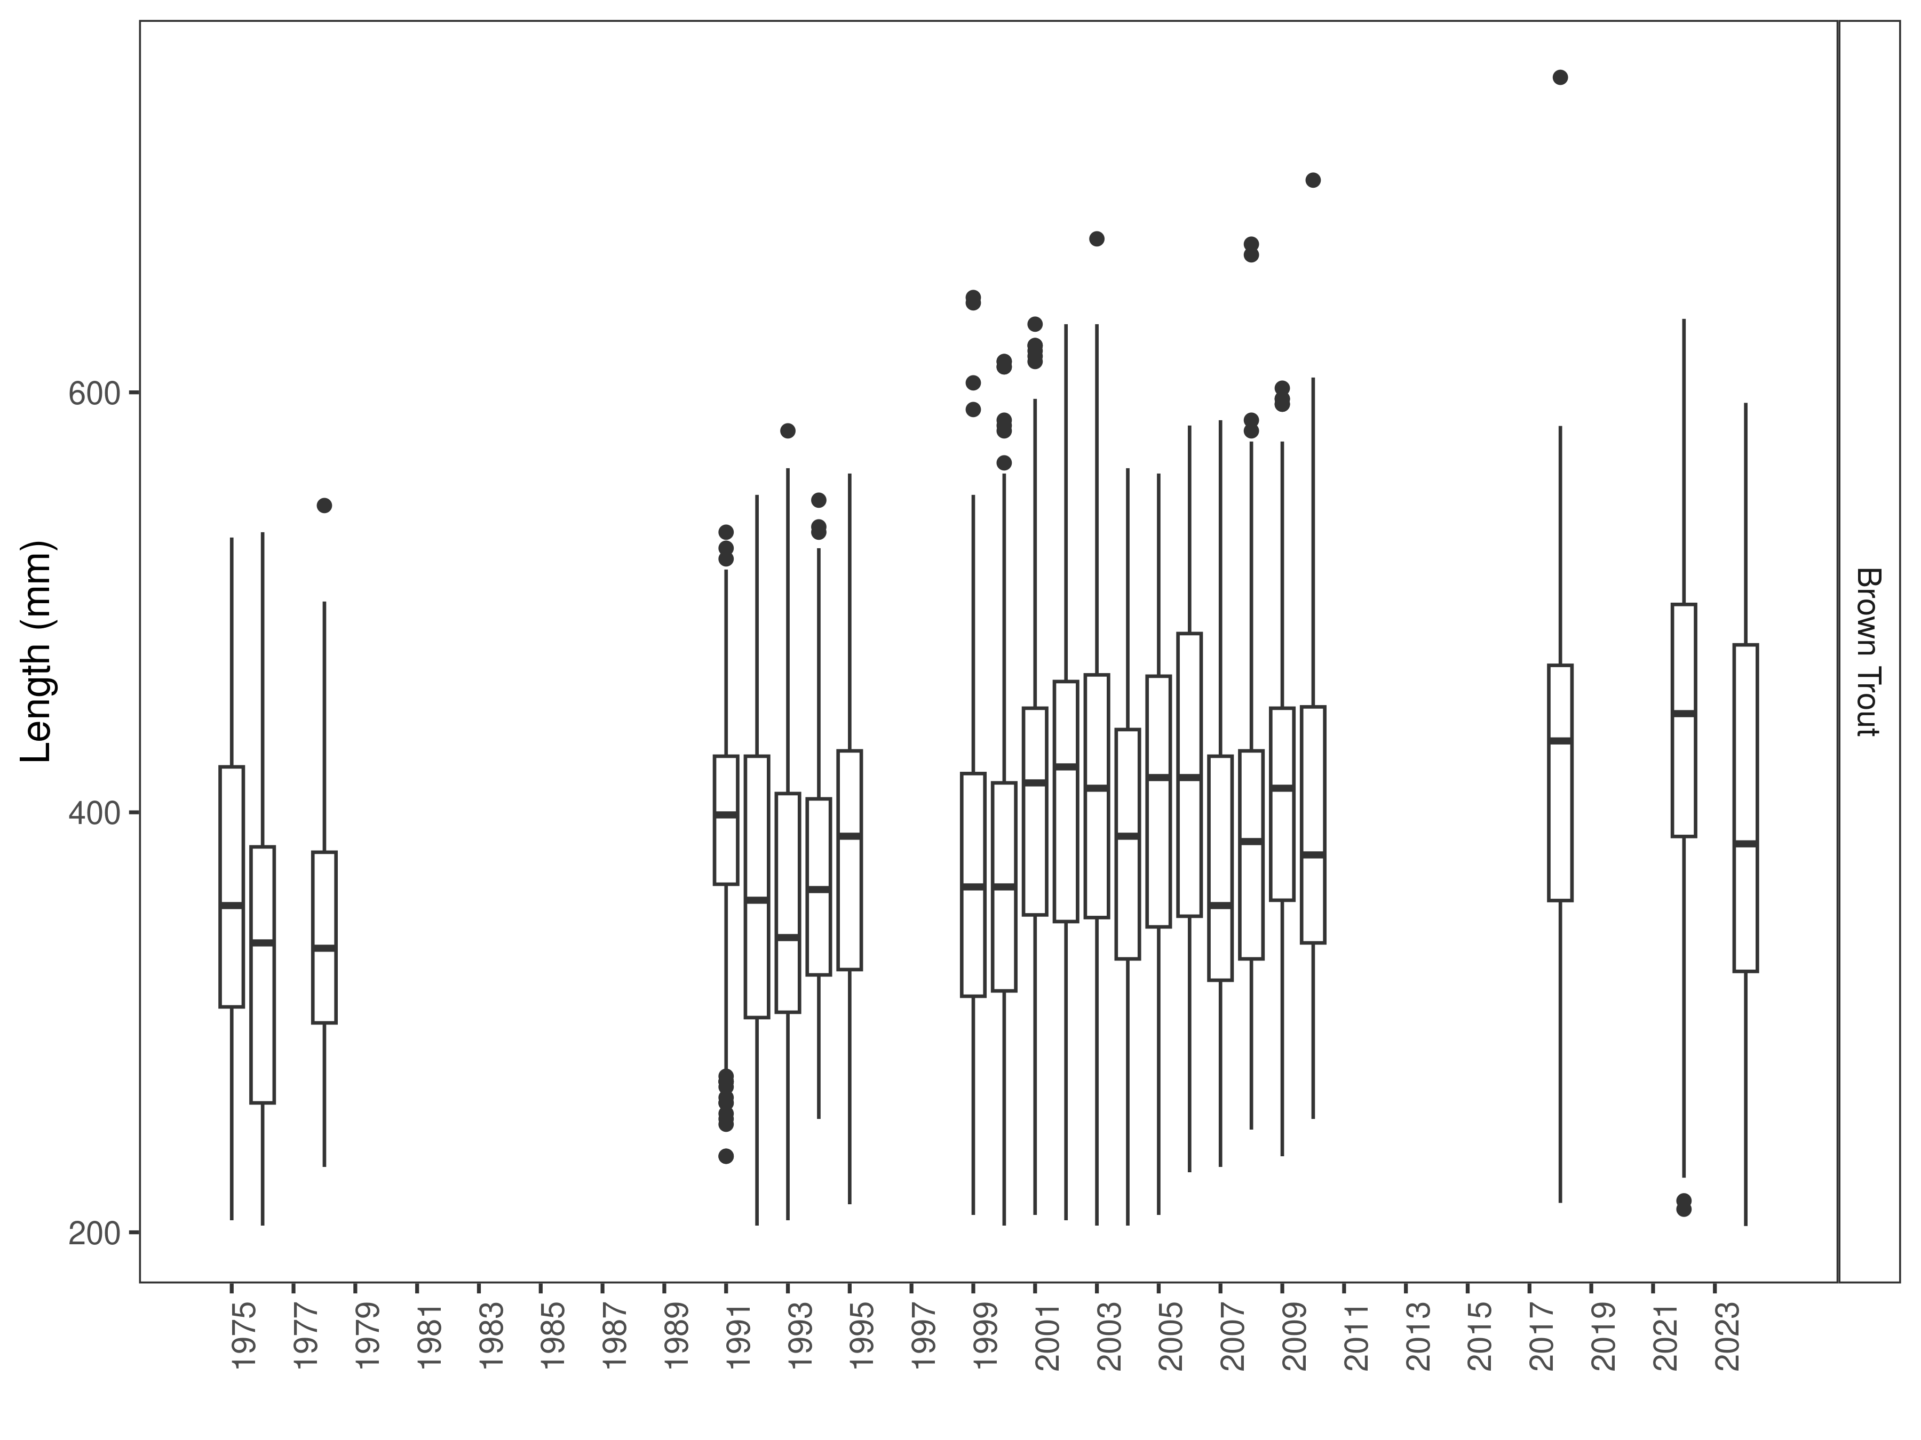
Figure 31. Anderson distribution of lengths through time. The box-and-whisker plots divide the distribution of the data into the first quartile (the lower limit of the box), the median (heavy black line), and third quartile (the upper limit of the box). The whiskers denote data points within 1.5 * the interquartile range (the difference between the first and third quartiles). Dots denote data points further than 1.5 * the interquartile range from the box.
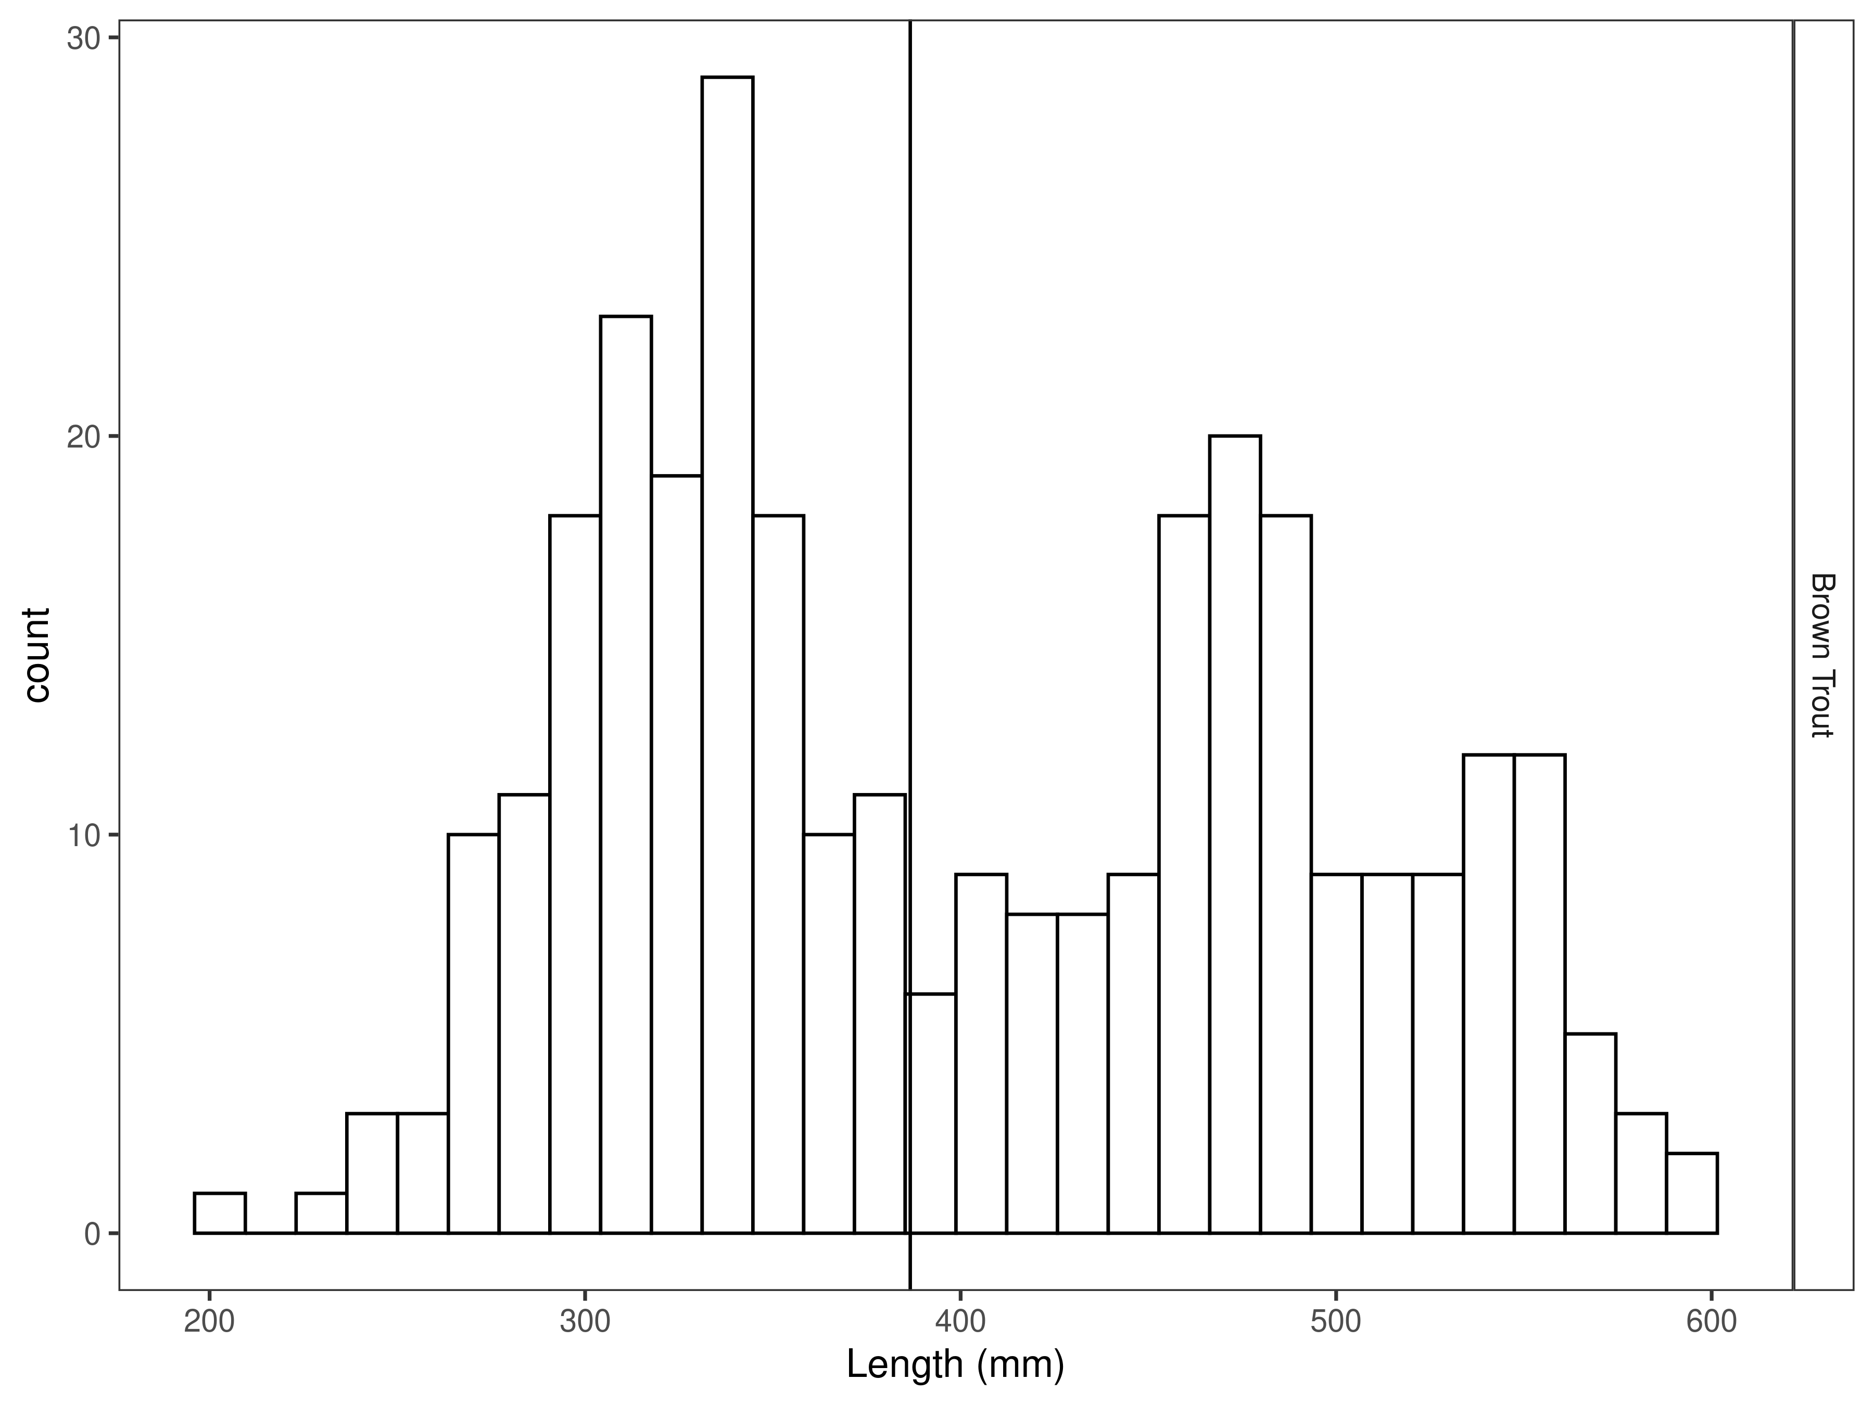
Figure 32. Anderson length distribution by species for latest year, with long-term species-averages indicated by the vertical black line.

Mark-recapture abundance estimates
Recapture rates were consistent for Brown Trout between 320 and 500 mm (Figure 33). Capture efficiency was best for fish that ranged in size from 380 to 540 mm and was relatively stable across all but the largest sizes of fish encountered (Figure 34). Length based models outperformed the null model (Table 18).

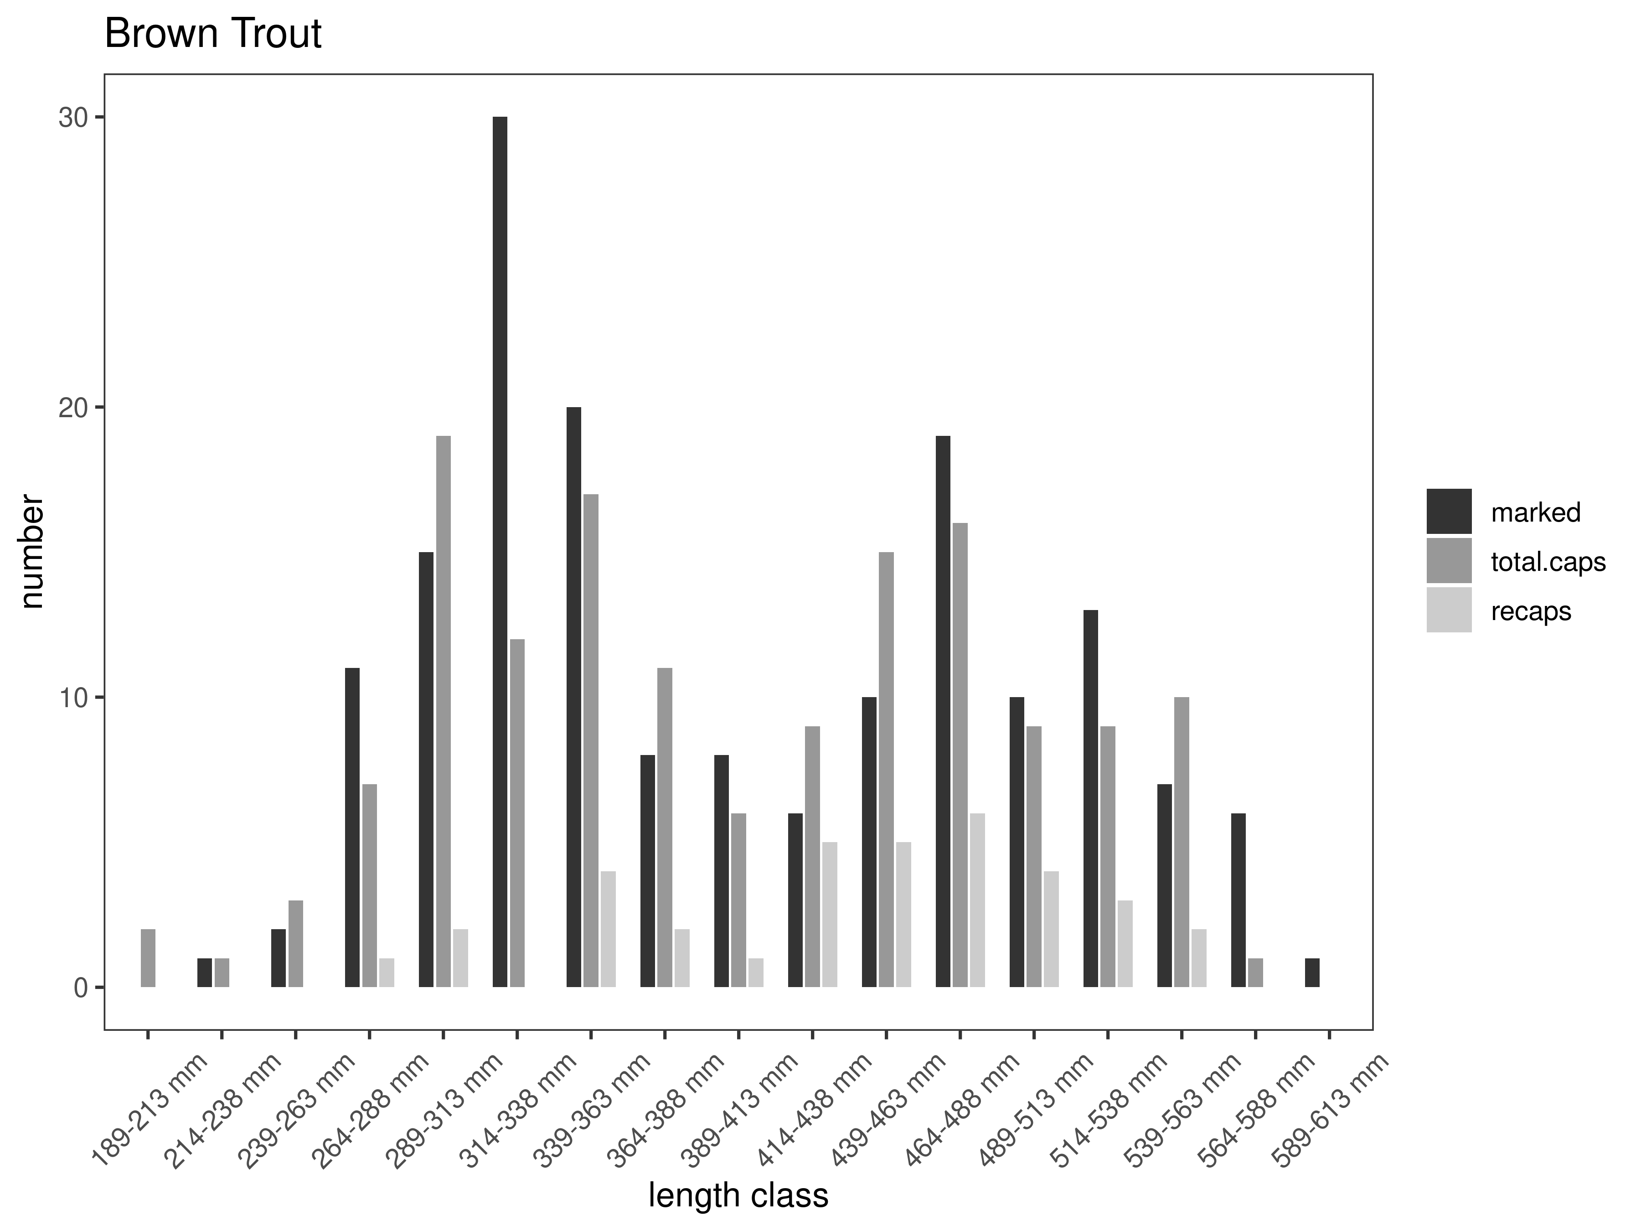
Figure 33. Anderson capture-recapture summary across length groups for brown trout in latest year. marked= number of fish marked on initial pass, total.caps = number of fish caught on second pass, and recaps = number of marked fish caught on the second pass.
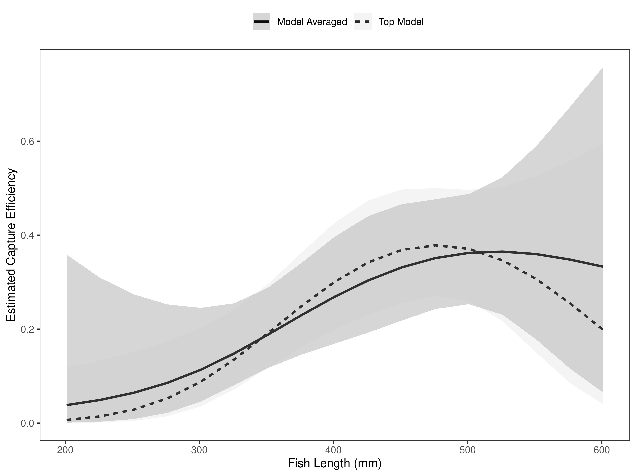
Figure 34. Anderson model-averaged estimates of capture efficiency of brown trout in latest year.
Table 18. Model selection results from four models used for two-pass abundance estimation of brown trout in latest year. Models: `Len` = capture efficiency modeled as a function of length class, `Len.sq` = capture efficiency modeled as a quadratic function of length class with the intercept estimated, `FA+` = capture efficiency modeled as a quadratic function of length class with intercept fixed, `Null` = constant capture efficiency.
Model | K | AICc | deltaAICc | ModLik | AICcWt | LnLik | CumWt
Len.sq | 3 | 156.86 | 0.0000000 | 1.00 | 0.49 | -75.34810 | 0.49
FA+ | 2 | 157.73 | 0.8672234 | 0.65 | 0.32 | -76.82396 | 0.81
Len | 2 | 158.79 | 1.9293796 | 0.38 | 0.19 | -77.35503 | 1.00
Null | 1 | 166.25 | 9.3810963 | 0.01 | 0.00 | -82.10886 | 1.00

The estimated abundance per km was 153 per km in 2024 (Table 19). The estimated abundance per km has increased from 107 Brown trout per km in 2023 to 153 per km in 2024 (Figure 35). This was a precise abundance estimate that was within ±39 fish (Table 19). Brown Trout abundance increased from 2023 and resembles past estimates for 2006-2008 (Figure 35). The Anderson section typically has lower trout abundances, and this trend continues downstream to the mouth of the Beaverhead River. The trout populations from Anderson bridge downstream are strongly influenced by low flows, high water temperatures, and fine sediment. Biomass slightly decreased from the previous year (Figure 36).

Table 19. Model averaged abundance estimates of fish per kilometer (Pop. Estimate) across length groups and estimated biomass (Biomass Estimate, kg) for the latest year.
 |  | Pop. Estimate | 2.5% | 97.5% | Biomass Estimate | 2.5% | 97.5%
Brown Trout | 2024 | 153 | 114 | 192 | 426.8 | 355.9 | 497.7

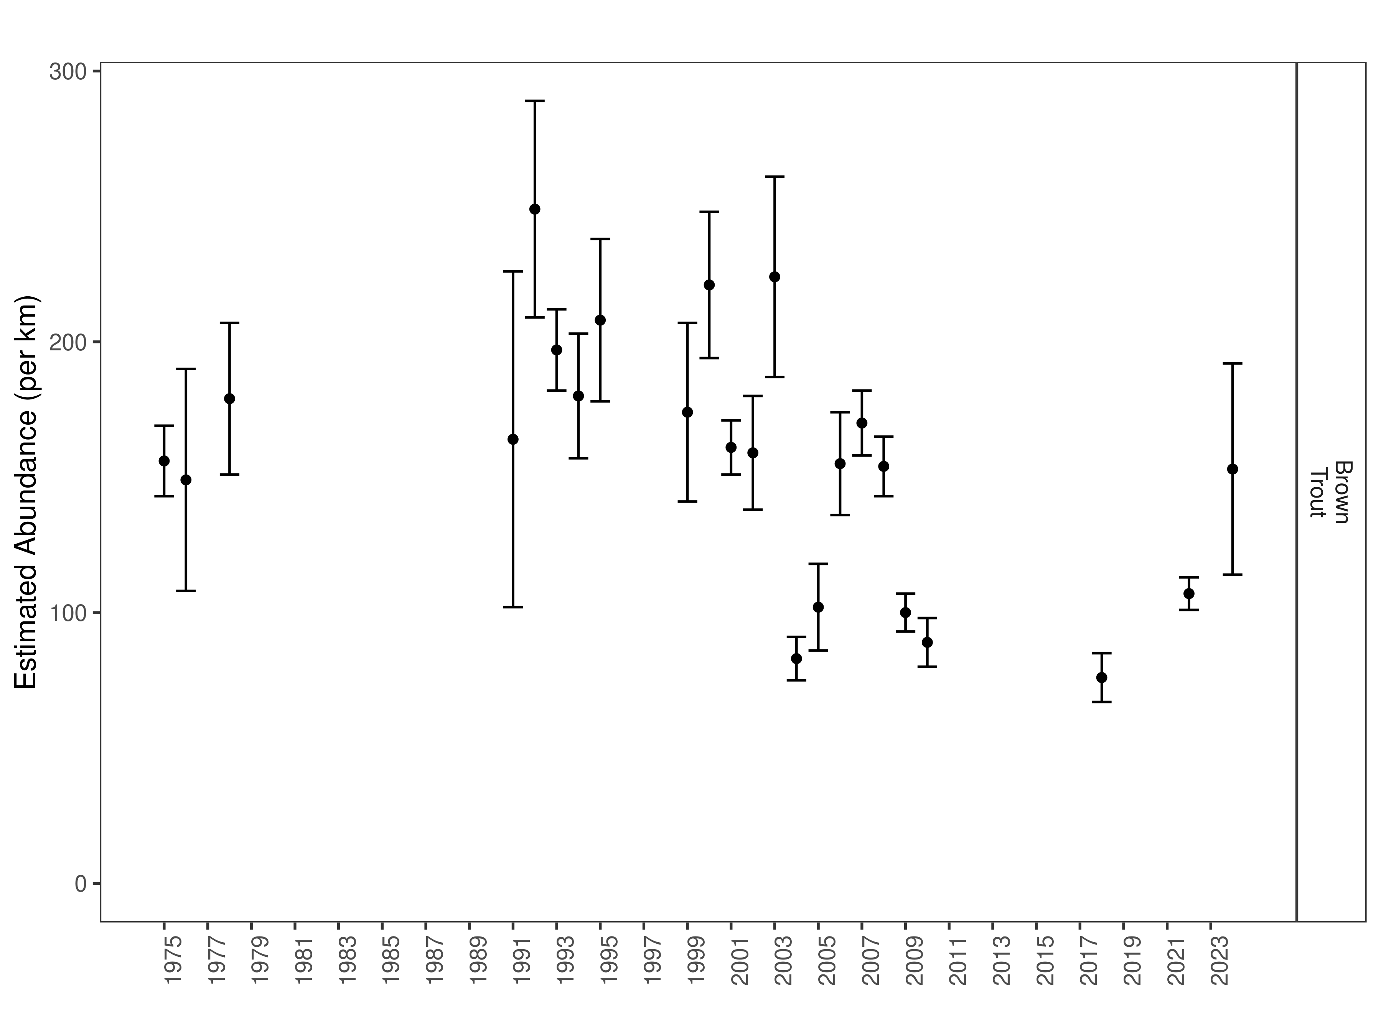
Figure 35. Anderson mark-recapture abundance estimates (fish per kilometer) through time using the maximum likelihood method. These estimates (mean and 95% confidence intervals) represent the model-averaged estimates across all length groups.
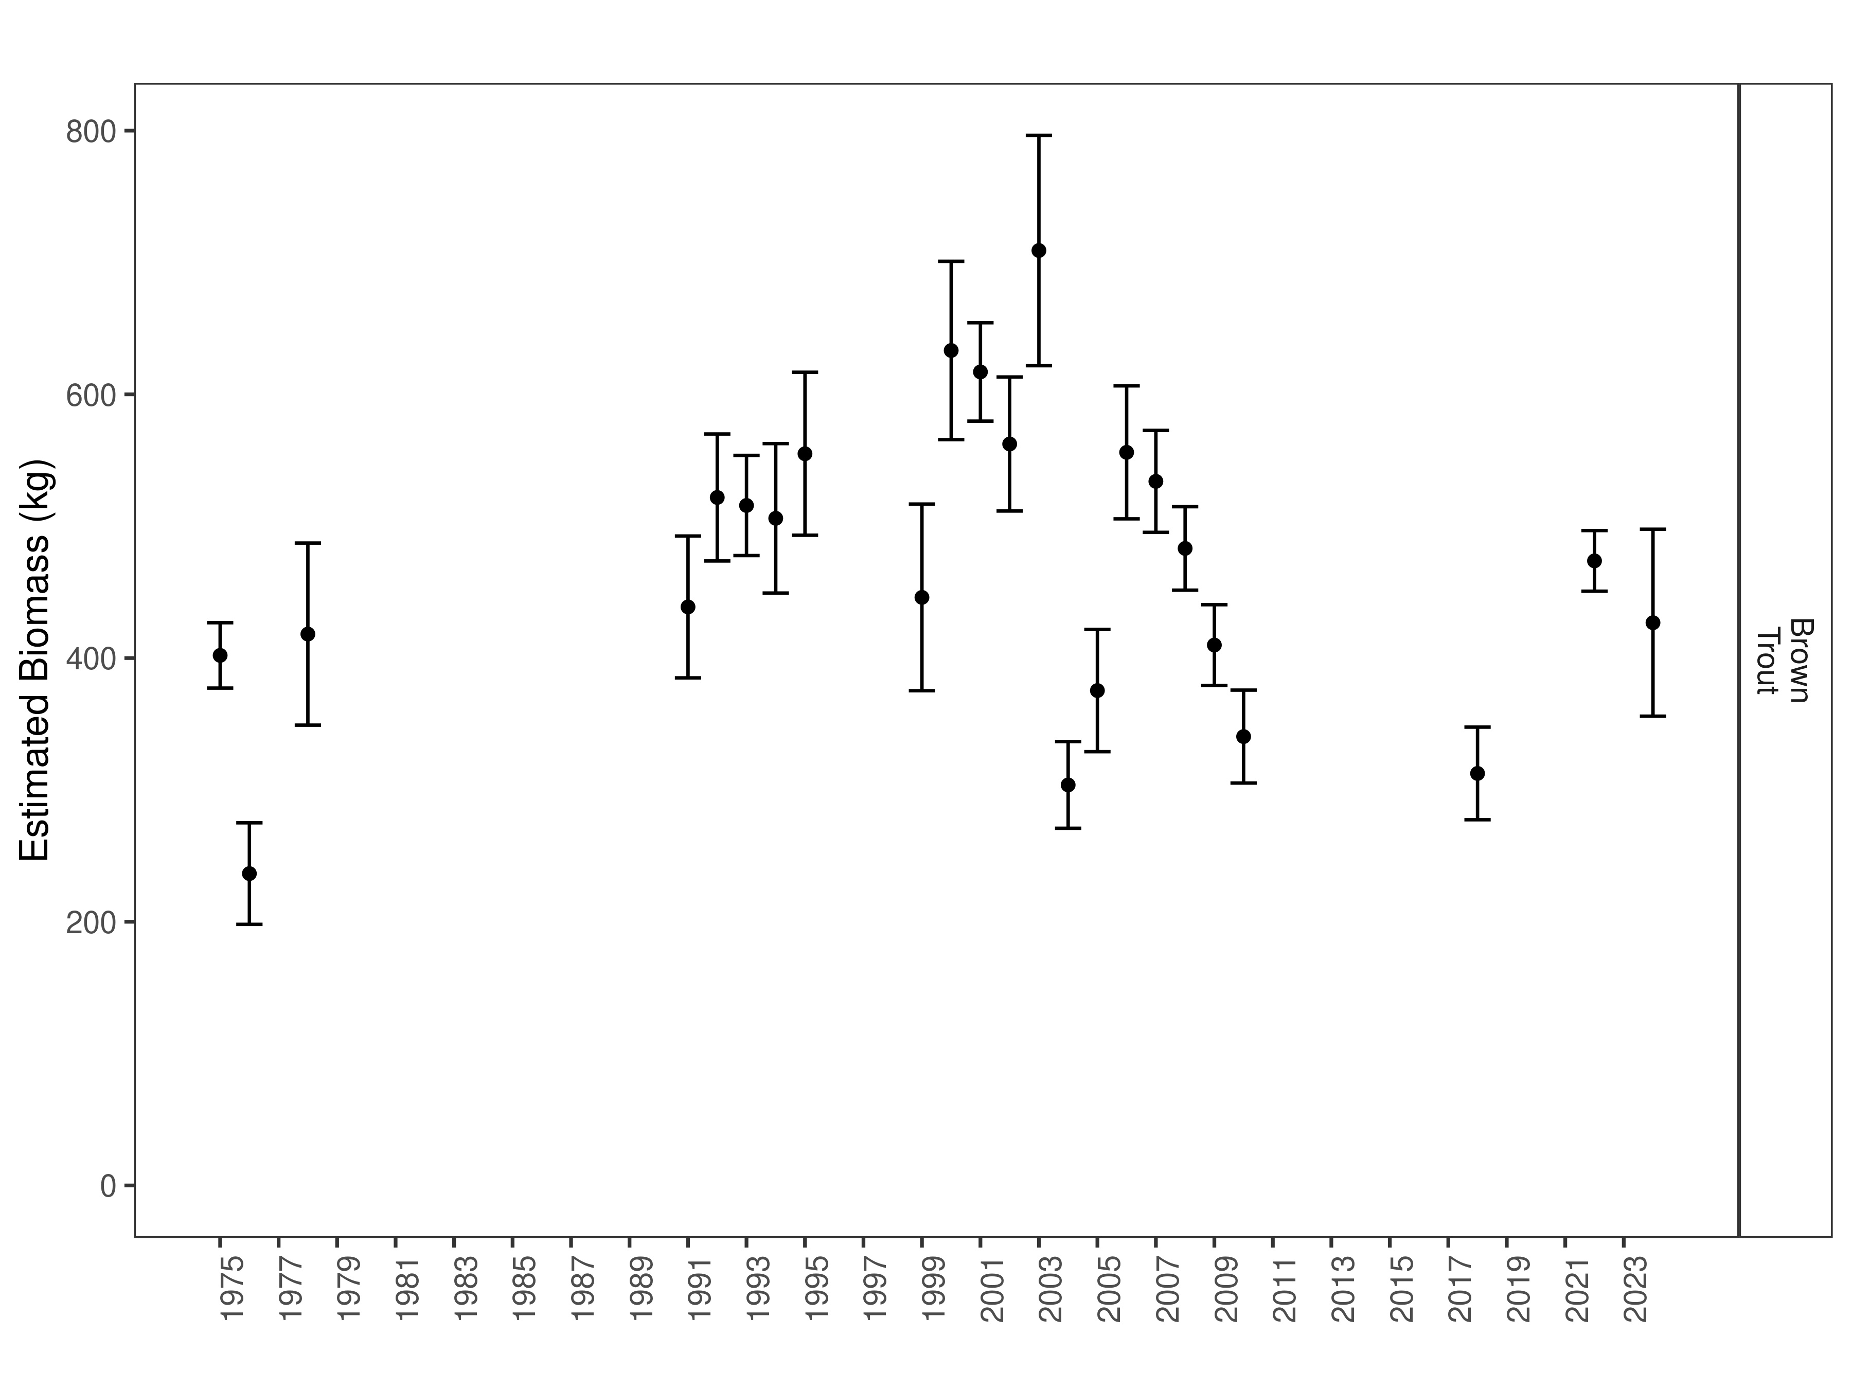
Figure 36. Anderson estimates of biomass through time.

Poindexter Section:
Data Summary
Poindexter Slough is a large side-channel of the Beaverhead River that provides a recreational fishery and acts as a spawning tributary and provides juvenile trout rearing habitat for the Beaverhead River. In 2024, 745 Brown Trout were captured in the Poindexter Section of the Beaverhead River and compared to a long-term dataset comprised of 49,242 Brown Trout. Brown Trout in the Poindexter Section average 272 mm (Table 20). Brown Trout were slightly shorter and heavier in 2024 compared to the long-term average and condition was similar to the long-term average (Table 21). Brown Trout relative weight has trended up and down over the last ten years and in 2024 there was a slight increase in relative weight within the population, but it remained consistent with past sampling years (Figure 37).

Table 20. Poindexter data summary.
 |  |  |  | Length |  |  |  |  | Weight |  |  | Condition |  |  | Relative Weight
 |  | n |  | Min | Max | Avg | SD |  | Avg | SD |  | Avg | SD |  | Avg | SD
Brown Trout |  | 49242 |  | 25.4 | 690.9 | 271.9 | 94.8 |  | 249.5 | 225 |  | 36.8 | 21.8 |  | 93.3 | 53.5

Table 21. Poindexter data summary for the latest year.
 |  |  |  | Length |  |  |  |  | Weight |  |  | Condition |  |  | Relative Weight
 |  | n |  | Min | Max | Avg | SD |  | Avg | SD |  | Avg | SD |  | Avg | SD
Brown Trout |  | 745 |  | 88 | 545 | 255.4 | 127.9 |  | 262.2 | 315.6 |  | 36.3 | 6.6 |  | 91.8 | 16.3

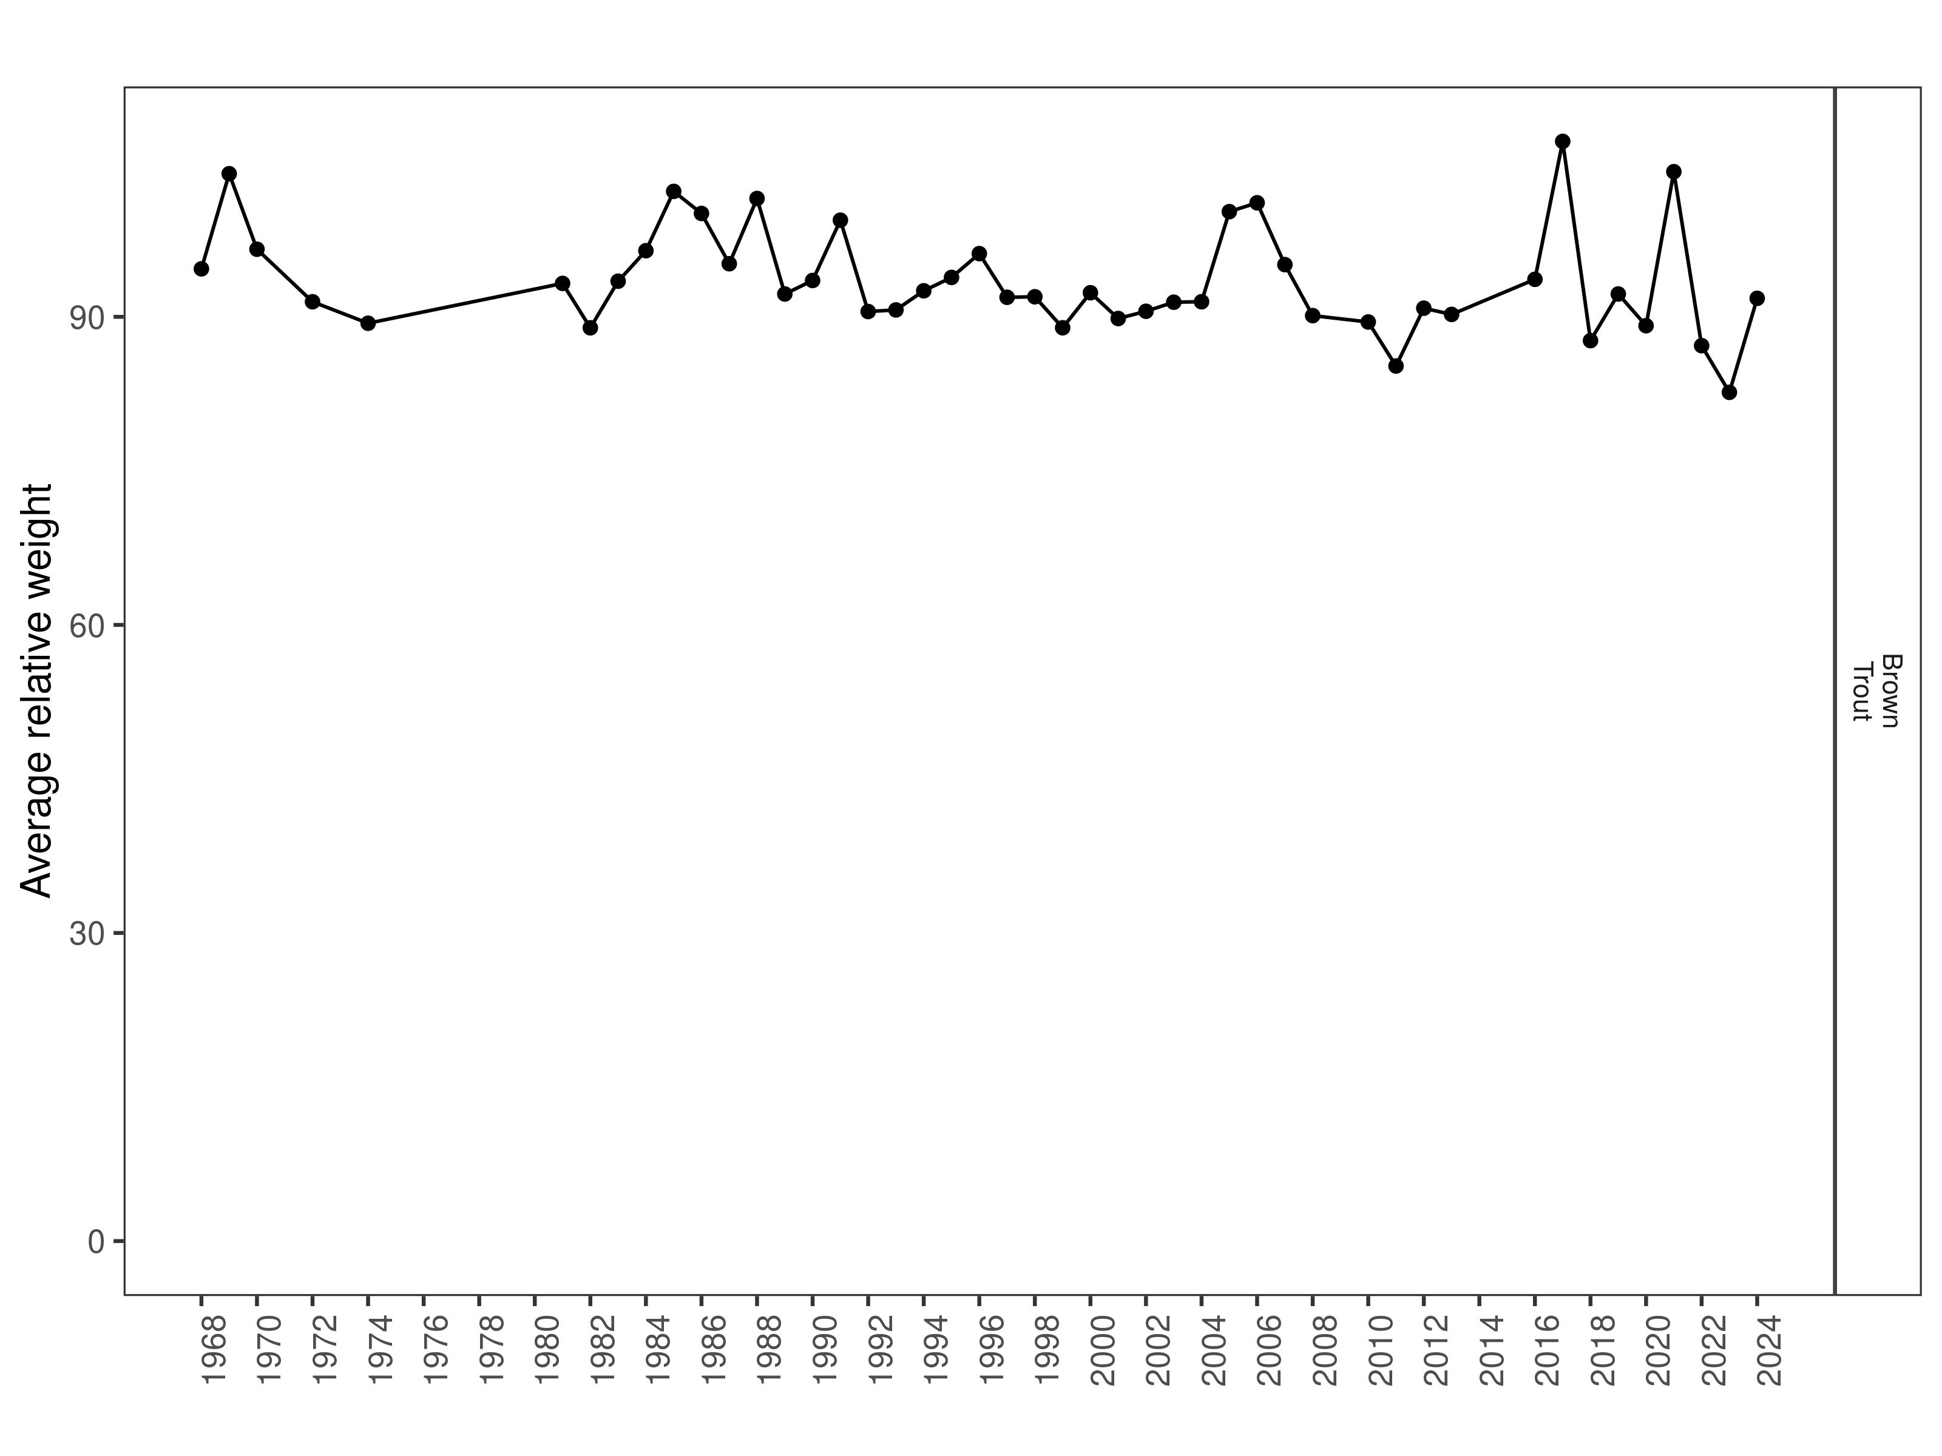
Figure 37. Poindexter relative weight through time.

Size Structure
Distributions of Brown Trout lengths declined in 2024 and median length was significantly lower when compared to the previous year (Figure 38). The shift in length distribution was driven by strong recruitment of Age 1 fish (Figure 39).

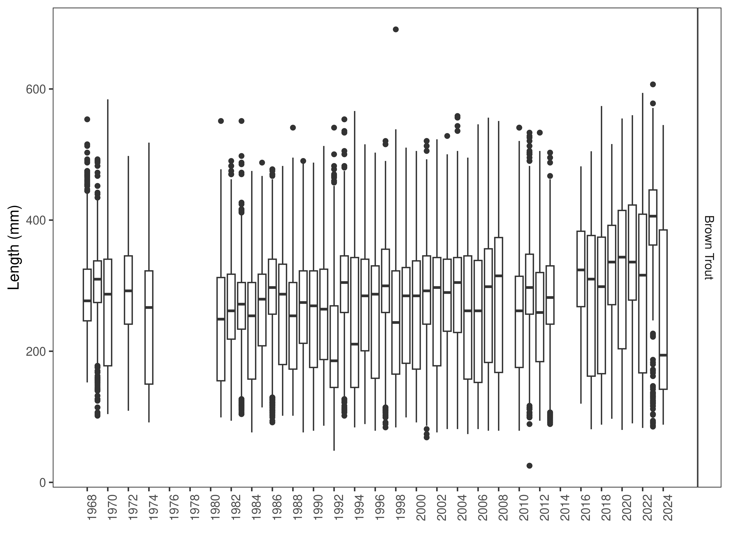
Figure 38. Poindexter distribution of lengths through time. The box-and-whisker plots divide the distribution of the data into the first quartile (the lower limit of the box), the median (heavy black line), and third quartile (the upper limit of the box). The whiskers denote data points within 1.5 * the interquartile range (the difference between the first and third quartiles). Dots denote data points further than 1.5 * the interquartile range from the box.
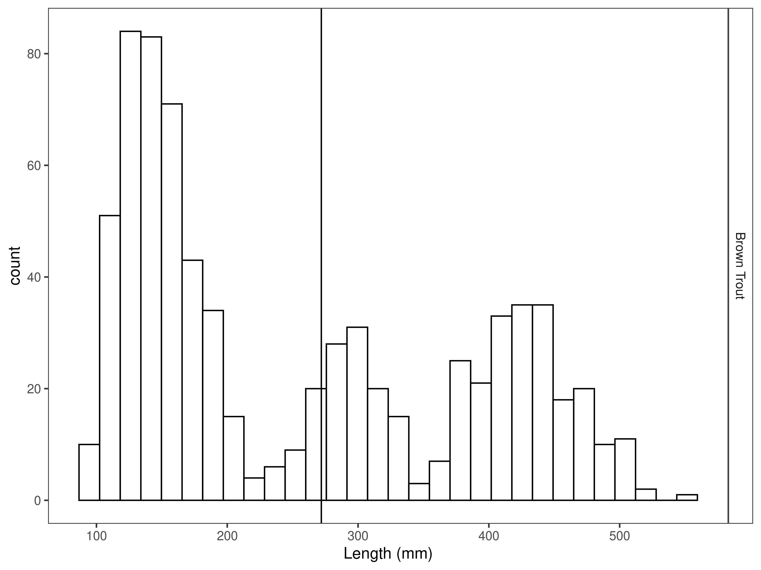
Figure 39. Poindexter length distribution by species for latest year, with long-term species-averages indicated by the vertical black line.

Mark-recapture abundance estimates
Recapture rates were consistent across size groups (Figure 40). Capture efficiency was better for fish that ranged in size from 100 to 460 mm and was relatively stable across all but the largest fish encountered (Figure 41). Length based models outperformed the null model (Table 22).
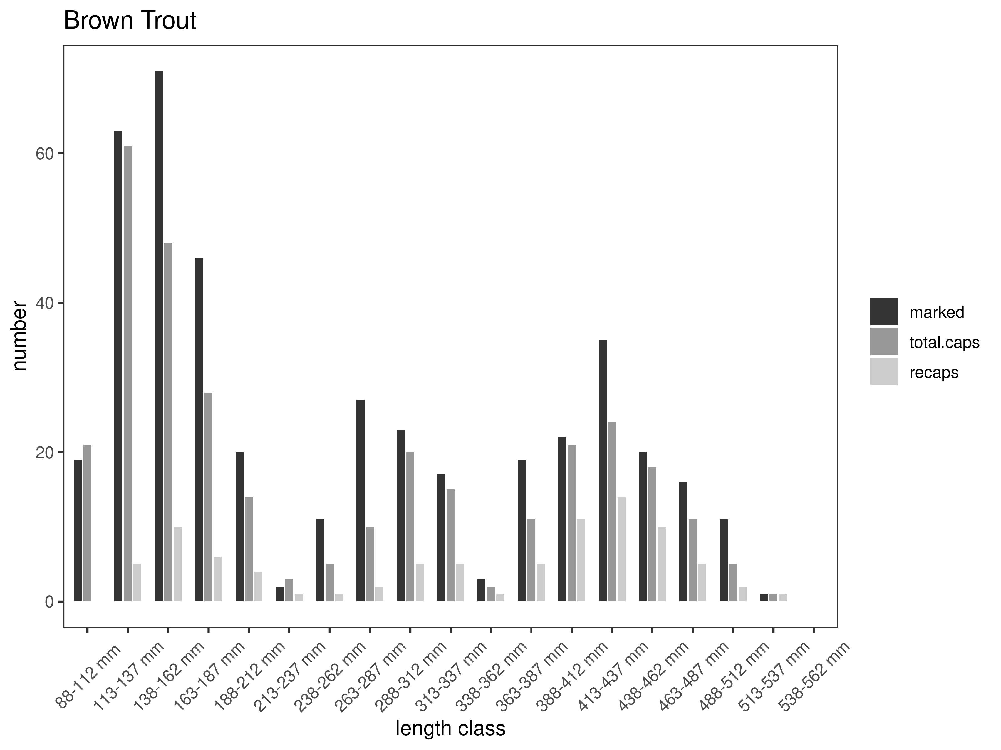
Figure 40. Poindexter capture-recapture summary across length groups for brown trout in latest year. marked= number of fish marked on initial pass, total.caps = number of fish caught on second pass, and recaps = number of marked fish caught on the second pass.

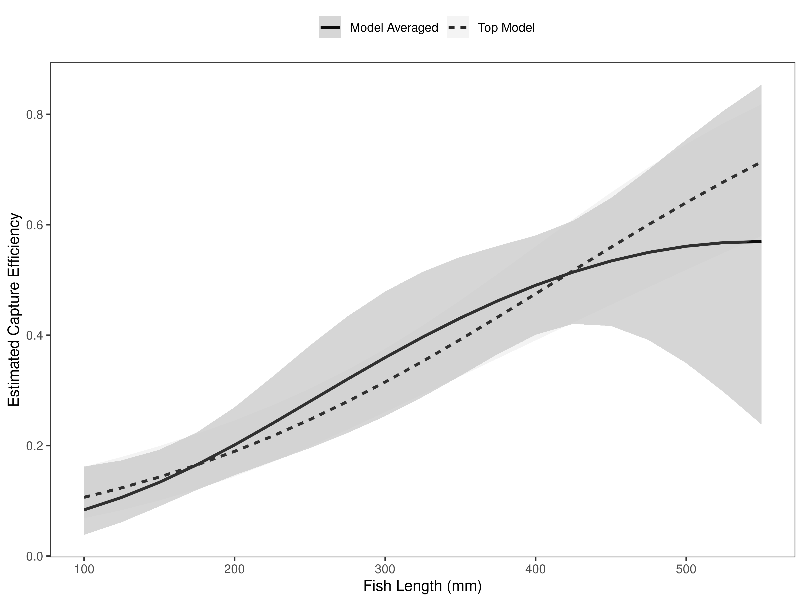
Figure 42. Poindexter model-averaged estimates of capture efficiency of brown trout in latest year.
Table 22. Model selection results from four models used for two-pass abundance estimation of brown trout in latest year. Models: `Len` = capture efficiency modeled as a function of length class, `Len.sq` = capture efficiency modeled as a quadratic function of length class with the intercept estimated, `FA+` = capture efficiency modeled as a quadratic function of length class with intercept fixed, `Null` = constant capture efficiency.
Model | K | AICc | deltaAICc | ModLik | AICcWt | LnLik | CumWt
Len | 2 | 332.67 | 0.0000000 | 1.00 | 0.41 | -164.3155 | 0.41
FA+ | 2 | 333.26 | 0.5865775 | 0.75 | 0.30 | -164.6088 | 0.71
Len.sq | 3 | 333.34 | 0.6668323 | 0.72 | 0.29 | -163.6297 | 1.00
Null | 1 | 377.15 | 44.4802859 | 0.00 | 0.00 | -187.5685 | 1.00

The estimated Brown trout abundance per km has more than doubled since 2023, increasing from 684 per km to 2,293 per km in 2024 (Table 23, Figure 43). Poindexter Slough trout abundance varies greatly from year to year depending on spawning success, although biomass appears to be more directly driven by years with favorable flows (Figure 44).

Table 23. Model averaged abundance estimates of fish per kilometer (Pop. Estimate) across length groups and estimated biomass (Biomass Estimate, kg) for the latest year.
 |  | Pop. Estimate | 2.5% | 97.5% | Biomass Estimate | 2.5% | 97.5%
Brown Trout | 2024 | 2,293 | 1,863 | 2,723 | 298.7 | 275.7 | 321.6

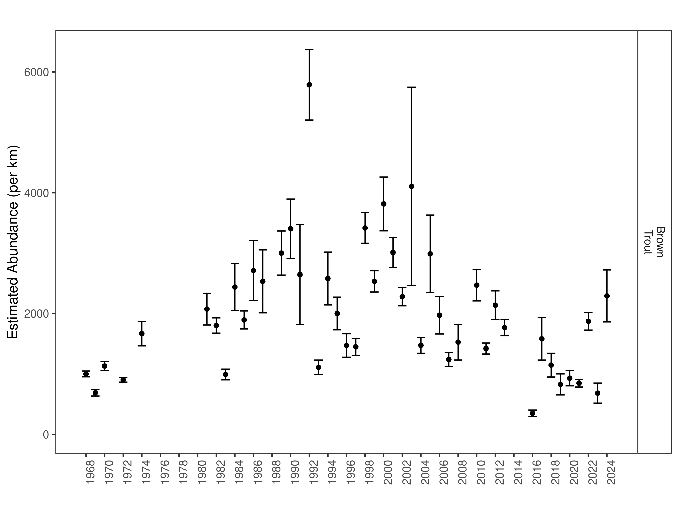
Figure 43. Poindexter mark-recapture abundance estimates (fish per kilometer) through time using the maximum likelihood method. These estimates (mean and 95% confidence intervals) represent the model-averaged estimates across all length groups.
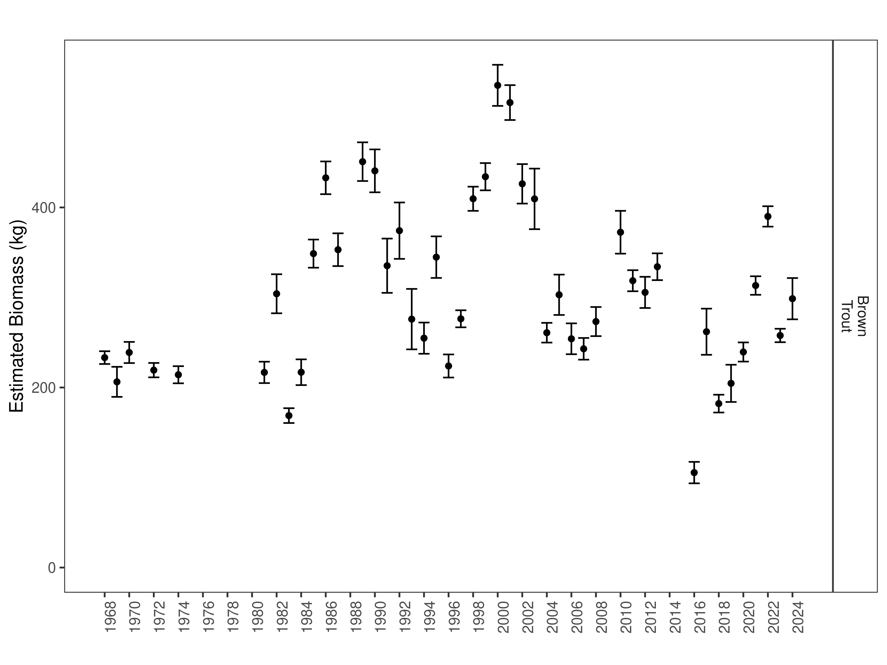
Figure 44. Estimates of biomass through time.

Discussion
Standard Central District regulations for Brown Trout are warranted throughout the Beaverhead River based on 2024 abundance estimates. Brown Trout abundances in tailwater sections (Hildreth, Half Pipe) have consistently been between the 25th and 75th percentiles in recent years. However, abundances in lower sections (Fish and Game, Anderson Lane) were near historic lows and only rebounded to above the 25th percentile in 2024. A robust adaptive management approach is presently being developed for the Beaverhead River that will use historic data to model limiting factors and identify potential management actions that can be implemented in addition to angling regulations to more regularly meet population goals within each section.

References
Akaike, Hirotogu. 1998. “Information Theory and an Extension of the Maximum Likelihood Principle.” In Selected Papers of Hirotugu Akaike, 199–213. Springer.
Gabelhouse, Donald W. 1984. “A Length-Categorization System to Assess Fish Stocks.” North American Journal of Fisheries Management 4 (3): 273–85.
Neumann, R. M., and M. S. Allen. 2007. “Size Structure.” Analysis and Interpretation of Freshwater Fisheries Data. American Fisheries Society, Bethesda, Maryland, 375–421.
R Core Team. 2018. R: A Language and Environment for Statistical Computing. Vienna, Austria: R Foundation for Statistical Computing.
Wege, Gary J., and Richard O. Anderson. 1978. “Relative Weight (Wr): A New Index of Condition for Largemouth Bass.” New Approaches to the Management of Small Impoundments. American Fisheries Society, North Central Division, Special Publication 5: 79–91.
Williams, Byron K., James D. Nichols, and Michael J. Conroy. 2002. Analysis and Management of Animal Populations. Academic Press.

Supporting information
Mark-recapture abundance estimates
Table S1. Hildreth model-averaged estimates of abundance (fish per kilometer) and biomass (kg) for species and year.
 |  | Pop. Estimate | 2.5% | 97.5% | Biomass Estimate | 2.5% | 97.5%
Brown Trout | 1967 | 393 | 348 | 438 | 676.4 | 597.0 | 755.8
Brown Trout | 1968 | 343 | 284 | 402 | 361.7 | 308.4 | 414.9
Brown Trout | 1969 | 481 | 411 | 551 | 468.3 | 365.9 | 570.7
Brown Trout | 1970 | 273 | 250 | 296 | 427.9 | 382.6 | 473.2
Brown Trout | 1971 | 363 | 301 | 425 | 427.7 | 377.9 | 477.4
Brown Trout | 1972 | 206 | 187 | 225 | 407.4 | 361.5 | 453.3
Brown Trout | 1974 | 385 | 362 | 408 | 933.7 | 871.9 | 995.5
Brown Trout | 1975 | 1,372 | 1,291 | 1,453 | 1,682.3 | 1,586.0 | 1,778.7
Brown Trout | 1976 | 2,597 | 2,226 | 2,968 | 2,145.5 | 1,865.8 | 2,425.2
Brown Trout | 1977 | 1,097 | 974 | 1,220 | 1,165.1 | 980.9 | 1,349.4
Brown Trout | 1978 | 869 | 764 | 974 | 1,166.7 | 1,006.9 | 1,326.6
Brown Trout | 1979 | 993 | 773 | 1,213 | 1,109.6 | 933.8 | 1,285.5
Brown Trout | 1980 | 916 | 806 | 1,026 | 1,142.7 | 1,031.2 | 1,254.2
Brown Trout | 1983 | 799 | 564 | 1,034 | 1,070.2 | 972.1 | 1,168.2
Brown Trout | 1984 | 871 | 817 | 925 | 1,236.9 | 1,158.6 | 1,315.1
Brown Trout | 1985 | 751 | 698 | 804 | 1,121.8 | 1,047.4 | 1,196.2
Brown Trout | 1986 | 601 | 461 | 741 | 919.4 | 861.7 | 977.1
Brown Trout | 1987 | 530 | 507 | 553 | 914.5 | 870.1 | 958.8
Brown Trout | 1988 | 893 | 857 | 929 | 1,331.3 | 1,276.9 | 1,385.6
Brown Trout | 1989 | 1,025 | 965 | 1,085 | 1,216.9 | 1,155.8 | 1,278.0
Brown Trout | 1990 | 1,167 | 1,087 | 1,247 | 1,380.1 | 1,300.5 | 1,459.8
Brown Trout | 1991 | 857 | 791 | 923 | 1,007.3 | 949.5 | 1,065.0
Brown Trout | 1992 | 842 | 777 | 907 | 1,270.6 | 1,191.4 | 1,349.9
Brown Trout | 1993 | 950 | 893 | 1,007 | 1,203.1 | 1,132.8 | 1,273.4
Brown Trout | 1994 | 747 | 711 | 783 | 814.9 | 769.4 | 860.3
Brown Trout | 1995 | 1,073 | 1,017 | 1,129 | 1,435.0 | 1,362.4 | 1,507.7
Brown Trout | 1996 | 1,021 | 920 | 1,122 | 1,109.5 | 1,011.5 | 1,207.4
Brown Trout | 1998 | 1,268 | 1,167 | 1,369 | 1,933.2 | 1,788.3 | 2,078.1
Brown Trout | 1999 | 1,254 | 1,179 | 1,329 | 1,726.3 | 1,607.1 | 1,845.6
Brown Trout | 2000 | 971 | 900 | 1,042 | 1,562.1 | 1,443.5 | 1,680.8
Brown Trout | 2001 | 994 | 933 | 1,055 | 1,223.9 | 1,143.2 | 1,304.5
Brown Trout | 2002 | 1,010 | 943 | 1,077 | 1,362.1 | 1,271.5 | 1,452.8
Brown Trout | 2003 | 939 | 880 | 998 | 1,058.4 | 987.5 | 1,129.3
Brown Trout | 2004 | 1,054 | 996 | 1,112 | 1,162.0 | 1,093.6 | 1,230.4
Brown Trout | 2005 | 988 | 943 | 1,033 | 985.0 | 933.6 | 1,036.4
Brown Trout | 2006 | 578 | 502 | 654 | 442.0 | 404.7 | 479.3
Brown Trout | 2007 | 1,463 | 1,362 | 1,564 | 1,075.4 | 1,007.7 | 1,143.1
Brown Trout | 2008 | 1,873 | 1,758 | 1,988 | 1,635.9 | 1,544.9 | 1,726.8
Brown Trout | 2009 | 1,221 | 1,166 | 1,276 | 1,419.0 | 1,355.9 | 1,482.1
Brown Trout | 2010 | 452 | 419 | 485 | 520.8 | 477.7 | 563.9
Brown Trout | 2011 | 1,334 | 1,173 | 1,495 | 1,185.5 | 1,075.6 | 1,295.3
Brown Trout | 2012 | 878 | 800 | 956 | 980.0 | 899.6 | 1,060.5
Brown Trout | 2013 | 1,826 | 1,732 | 1,920 | 1,900.3 | 1,811.7 | 1,988.8
Brown Trout | 2014 | 1,762 | 1,680 | 1,844 | 1,791.7 | 1,706.7 | 1,876.7
Brown Trout | 2015 | 1,409 | 1,328 | 1,490 | 1,358.9 | 1,280.9 | 1,436.9
Brown Trout | 2016 | 1,233 | 1,181 | 1,285 | 1,158.0 | 1,107.7 | 1,208.3
Brown Trout | 2017 | 788 | 752 | 824 | 772.0 | 737.4 | 806.6
Brown Trout | 2018 | 573 | 517 | 629 | 631.4 | 579.7 | 683.2
Brown Trout | 2019 | 567 | 522 | 612 | 641.9 | 599.6 | 684.2
Brown Trout | 2020 | 705 | 657 | 753 | 923.3 | 872.8 | 973.9
Brown Trout | 2021 | 944 | 888 | 1,000 | 1,108.6 | 1,059.3 | 1,157.8
Brown Trout | 2022 | 1,090 | 1,037 | 1,143 | 1,286.6 | 1,231.6 | 1,341.6
Brown Trout | 2023 | 980 | 935 | 1,025 | 1,231.8 | 1,176.0 | 1,287.7
Brown Trout | 2024 | 728 | 653 | 803 | 1,135.4 | 1,009.9 | 1,261.0
Rainbow Trout | 1967 | 48 | 22 | 74 | 99.8 | 38.3 | 161.3
Rainbow Trout | 1968 | 173 | 123 | 223 | 240.6 | 134.2 | 347.0
Rainbow Trout | 1969 | 264 | 173 | 355 | 263.3 | 206.6 | 320.0
Rainbow Trout | 1970 | 134 | 101 | 167 | 213.8 | 171.4 | 256.2
Rainbow Trout | 1971 | 132 | 112 | 152 | 311.4 | 256.6 | 366.3
Rainbow Trout | 1972 | 1,699 | -6,456 | 9,854 | 2,570.7 | -11,394.6 | 16,536.0
Rainbow Trout | 1974 | 346 | 312 | 380 | 727.8 | 653.1 | 802.4
Rainbow Trout | 1975 | 1,039 | 978 | 1,100 | 1,740.1 | 1,615.8 | 1,864.4
Rainbow Trout | 1976 | 1,889 | 1,654 | 2,124 | 2,540.0 | 2,104.0 | 2,976.0
Rainbow Trout | 1977 | 712 | 641 | 783 | 1,231.7 | 1,100.4 | 1,363.0
Rainbow Trout | 1978 | 777 | 552 | 1,002 | 770.6 | 680.8 | 860.4
Rainbow Trout | 1979 | 821 | 706 | 936 | 894.4 | 748.4 | 1,040.4
Rainbow Trout | 1980 | 621 | 568 | 674 | 1,053.8 | 950.1 | 1,157.4
Rainbow Trout | 1983 | 556 | 506 | 606 | 1,271.2 | 1,148.8 | 1,393.6
Rainbow Trout | 1985 | 879 | 795 | 963 | 1,442.8 | 1,327.9 | 1,557.8
Rainbow Trout | 1986 | 577 | 544 | 610 | 1,058.5 | 996.5 | 1,120.4
Rainbow Trout | 1987 | 604 | 557 | 651 | 1,303.5 | 1,180.5 | 1,426.5
Rainbow Trout | 1988 | 573 | 529 | 617 | 1,095.7 | 1,007.2 | 1,184.3
Rainbow Trout | 1989 | 549 | 455 | 643 | 1,045.0 | 810.4 | 1,279.7
Rainbow Trout | 1990 | 392 | 333 | 451 | 667.9 | 555.0 | 780.8
Rainbow Trout | 1991 | 316 | 273 | 359 | 464.0 | 395.1 | 533.0
Rainbow Trout | 1992 | 244 | 204 | 284 | 451.7 | 372.1 | 531.4
Rainbow Trout | 1993 | 262 | 223 | 301 | 403.5 | 338.6 | 468.5
Rainbow Trout | 1994 | 166 | 146 | 186 | 236.1 | 204.3 | 268.0
Rainbow Trout | 1995 | 248 | 209 | 287 | 421.5 | 351.0 | 492.0
Rainbow Trout | 1996 | 211 | 129 | 293 | 297.5 | 196.6 | 398.4
Rainbow Trout | 1998 | 348 | 261 | 435 | 655.9 | 491.2 | 820.5
Rainbow Trout | 1999 | 342 | 253 | 431 | 745.3 | 518.7 | 972.0
Rainbow Trout | 2000 | 465 | 331 | 599 | 969.5 | 658.7 | 1,280.3
Rainbow Trout | 2001 | 488 | 348 | 628 | 856.5 | 596.6 | 1,116.3
Rainbow Trout | 2002 | 1,069 | -849 | 2,987 | 1,657.8 | -1,330.8 | 4,646.3
Rainbow Trout | 2003 | 354 | 206 | 502 | 643.2 | 365.0 | 921.4
Rainbow Trout | 2004 | 631 | 187 | 1,075 | 1,143.3 | 275.9 | 2,010.7
Rainbow Trout | 2005 | 314 | 176 | 452 | 571.8 | 326.1 | 817.5
Rainbow Trout | 2006 | 186 | 13 | 359 | 178.4 | 94.2 | 262.6
Rainbow Trout | 2007 | 418 | 235 | 601 | 532.6 | 253.7 | 811.4
Rainbow Trout | 2008 | 450 | 236 | 664 | 485.6 | 295.5 | 675.7
Rainbow Trout | 2009 | 278 | 184 | 372 | 403.7 | 268.2 | 539.2
Rainbow Trout | 2010 | 152 | 35 | 269 | 224.8 | 90.1 | 359.5
Rainbow Trout | 2011 | 281 | 244 | 318 | 397.8 | 326.2 | 469.5
Rainbow Trout | 2012 | 302 | 258 | 346 | 519.9 | 437.8 | 602.1
Rainbow Trout | 2013 | 444 | 383 | 505 | 726.7 | 645.6 | 807.9
Rainbow Trout | 2014 | 430 | 391 | 469 | 664.4 | 593.7 | 735.1
Rainbow Trout | 2015 | 310 | 283 | 337 | 475.5 | 432.8 | 518.3
Rainbow Trout | 2016 | 292 | 260 | 324 | 454.8 | 403.0 | 506.6
Rainbow Trout | 2017 | 186 | 166 | 206 | 286.8 | 254.8 | 318.8
Rainbow Trout | 2018 | 163 | 134 | 192 | 277.6 | 227.4 | 327.9
Rainbow Trout | 2019 | 123 | 102 | 144 | 230.2 | 186.9 | 273.6
Rainbow Trout | 2020 | 135 | 117 | 153 | 267.8 | 227.1 | 308.6
Rainbow Trout | 2021 | 144 | 129 | 159 | 244.4 | 220.1 | 268.8
Rainbow Trout | 2022 | 204 | 173 | 235 | 385.8 | 298.4 | 473.2
Rainbow Trout | 2023 | 129 | 118 | 140 | 229.8 | 209.9 | 249.7
Rainbow Trout | 2024 | 136 | 95 | 177 | 265.1 | 182.5 | 347.6

Table S2. Half Pipe model-averaged estimates of abundance (fish per kilometer) and biomass (kg) for species and year.
 |  | Pop. Estimate | 2.5% | 97.5% | Biomass Estimate | 2.5% | 97.5%
Brown Trout | 2018 | 1,111 | 934 | 1,288 | 885.6 | 778.6 | 992.6
Brown Trout | 2019 | 1,422 | 1,089 | 1,755 | 1,171.7 | 959.4 | 1,384.0
Brown Trout | 2020 | 787 | 724 | 850 | 881.2 | 812.4 | 950.0
Brown Trout | 2022 | 777 | 721 | 833 | 699.0 | 658.4 | 739.5
Brown Trout | 2023 | 455 | 426 | 484 | 511.2 | 479.7 | 542.7
Brown Trout | 2024 | 752 | 578 | 926 | 1,114.1 | 926.3 | 1,301.9
Table S3. Fish and Game model-averaged estimates of abundance (fish per kilometer) and biomass (kg) for species and year.
 |  | Pop. Estimate | 2.5% | 97.5% | Biomass Estimate | 2.5% | 97.5%
Brown Trout | 1982 | 635 | 592 | 678 | 752.1 | 701.2 | 802.9
Brown Trout | 1988 | 913 | 850 | 976 | 1,225.5 | 1,162.2 | 1,288.8
Brown Trout | 1989 | 800 | 757 | 843 | 1,000.4 | 956.9 | 1,043.9
Brown Trout | 1990 | 559 | 526 | 592 | 730.5 | 692.3 | 768.8
Brown Trout | 1991 | 192 | 180 | 204 | 337.8 | 315.8 | 359.7
Brown Trout | 1992 | 723 | 611 | 835 | 762.9 | 696.6 | 829.2
Brown Trout | 1993 | 523 | 463 | 583 | 645.5 | 587.3 | 703.7
Brown Trout | 1994 | 443 | 404 | 482 | 635.4 | 579.1 | 691.7
Brown Trout | 1995 | 570 | 487 | 653 | 649.5 | 594.8 | 704.3
Brown Trout | 1996 | 398 | 312 | 484 | 468.8 | 391.4 | 546.3
Brown Trout | 1998 | 697 | 632 | 762 | 987.9 | 910.1 | 1,065.7
Brown Trout | 2000 | 736 | 662 | 810 | 1,062.3 | 978.5 | 1,146.2
Brown Trout | 2001 | 737 | 665 | 809 | 1,199.2 | 1,114.1 | 1,284.3
Brown Trout | 2002 | 710 | 668 | 752 | 1,176.9 | 1,114.7 | 1,239.0
Brown Trout | 2003 | 693 | 641 | 745 | 980.1 | 933.4 | 1,026.9
Brown Trout | 2004 | 521 | 497 | 545 | 845.6 | 805.4 | 885.8
Brown Trout | 2005 | 403 | 384 | 422 | 631.8 | 606.0 | 657.6
Brown Trout | 2006 | 333 | 318 | 348 | 504.6 | 485.3 | 524.0
Brown Trout | 2007 | 365 | 346 | 384 | 526.3 | 505.1 | 547.5
Brown Trout | 2008 | 345 | 333 | 357 | 575.3 | 554.7 | 595.9
Brown Trout | 2009 | 263 | 252 | 274 | 485.7 | 464.4 | 507.1
Brown Trout | 2010 | 367 | 330 | 404 | 728.6 | 660.8 | 796.4
Brown Trout | 2011 | 631 | 581 | 681 | 923.4 | 855.9 | 991.0
Brown Trout | 2013 | 797 | 765 | 829 | 961.2 | 926.0 | 996.5
Brown Trout | 2015 | 393 | 380 | 406 | 657.4 | 636.6 | 678.2
Brown Trout | 2017 | 204 | 195 | 213 | 377.7 | 359.1 | 396.3
Brown Trout | 2019 | 291 | 252 | 330 | 492.9 | 438.2 | 547.6
Brown Trout | 2021 | 281 | 265 | 297 | 643.4 | 606.4 | 680.4
Brown Trout | 2022 | 267 | 257 | 277 | 610.0 | 587.2 | 632.8
Brown Trout | 2023 | 190 | 183 | 197 | 467.6 | 450.1 | 485.0
Brown Trout | 2024 | 282 | 257 | 307 | 553.3 | 514.8 | 591.8

Table S4. Anderson model-averaged estimates of abundance (fish per kilometer) and biomass (kg) for species and year.
 |  | Pop. Estimate | 2.5% | 97.5% | Biomass Estimate | 2.5% | 97.5%
Brown Trout | 1975 | 156 | 143 | 169 | 402.0 | 377.2 | 426.8
Brown Trout | 1976 | 149 | 108 | 190 | 236.5 | 198.0 | 275.0
Brown Trout | 1978 | 179 | 151 | 207 | 418.2 | 349.1 | 487.2
Brown Trout | 1991 | 164 | 102 | 226 | 438.8 | 385.0 | 492.6
Brown Trout | 1992 | 249 | 209 | 289 | 521.8 | 473.6 | 569.9
Brown Trout | 1993 | 197 | 182 | 212 | 515.7 | 477.7 | 553.7
Brown Trout | 1994 | 180 | 157 | 203 | 506.0 | 449.3 | 562.6
Brown Trout | 1995 | 208 | 178 | 238 | 554.9 | 493.1 | 616.7
Brown Trout | 1999 | 174 | 141 | 207 | 446.0 | 375.2 | 516.8
Brown Trout | 2000 | 221 | 194 | 248 | 633.3 | 565.6 | 700.9
Brown Trout | 2001 | 161 | 151 | 171 | 617.0 | 579.7 | 654.3
Brown Trout | 2002 | 159 | 138 | 180 | 562.3 | 511.5 | 613.2
Brown Trout | 2003 | 224 | 187 | 261 | 709.1 | 621.7 | 796.4
Brown Trout | 2004 | 83 | 75 | 91 | 303.8 | 270.9 | 336.6
Brown Trout | 2005 | 102 | 86 | 118 | 375.3 | 329.0 | 421.7
Brown Trout | 2006 | 155 | 136 | 174 | 556.0 | 505.6 | 606.4
Brown Trout | 2007 | 170 | 158 | 182 | 534.0 | 495.3 | 572.6
Brown Trout | 2008 | 154 | 143 | 165 | 483.1 | 451.5 | 514.8
Brown Trout | 2009 | 100 | 93 | 107 | 409.9 | 379.2 | 440.5
Brown Trout | 2010 | 89 | 80 | 98 | 340.4 | 305.2 | 375.7
Brown Trout | 2018 | 76 | 67 | 85 | 312.5 | 277.4 | 347.6
Brown Trout | 2022 | 107 | 101 | 113 | 473.7 | 450.7 | 496.7
Brown Trout | 2024 | 153 | 114 | 192 | 426.8 | 355.9 | 497.7

Table S5. Poindexter model-averaged estimates of abundance (fish per kilometer) and biomass (kg) for species and year.
 |  | Pop. Estimate | 2.5% | 97.5% | Biomass Estimate | 2.5% | 97.5%
Brown Trout | 1968 | 1,001 | 953 | 1,049 | 233.2 | 226.1 | 240.3
Brown Trout | 1969 | 688 | 636 | 740 | 206.3 | 189.6 | 223.0
Brown Trout | 1970 | 1,132 | 1,055 | 1,209 | 238.9 | 227.2 | 250.7
Brown Trout | 1972 | 903 | 866 | 940 | 219.3 | 211.3 | 227.3
Brown Trout | 1974 | 1,669 | 1,466 | 1,872 | 214.2 | 204.7 | 223.7
Brown Trout | 1981 | 2,074 | 1,812 | 2,336 | 216.8 | 204.9 | 228.7
Brown Trout | 1982 | 1,803 | 1,677 | 1,929 | 304.1 | 282.5 | 325.8
Brown Trout | 1983 | 992 | 903 | 1,081 | 168.8 | 160.6 | 177.0
Brown Trout | 1984 | 2,439 | 2,049 | 2,829 | 217.0 | 202.7 | 231.3
Brown Trout | 1985 | 1,895 | 1,746 | 2,044 | 348.7 | 333.1 | 364.4
Brown Trout | 1986 | 2,712 | 2,215 | 3,209 | 432.9 | 414.8 | 451.1
Brown Trout | 1987 | 2,534 | 2,013 | 3,055 | 353.1 | 334.9 | 371.3
Brown Trout | 1989 | 3,002 | 2,637 | 3,367 | 450.9 | 429.4 | 472.3
Brown Trout | 1990 | 3,404 | 2,912 | 3,896 | 440.7 | 416.8 | 464.5
Brown Trout | 1991 | 2,645 | 1,818 | 3,472 | 335.3 | 305.1 | 365.4
Brown Trout | 1992 | 5,787 | 5,204 | 6,370 | 374.2 | 342.9 | 405.5
Brown Trout | 1993 | 1,110 | 989 | 1,231 | 275.9 | 242.4 | 309.5
Brown Trout | 1994 | 2,581 | 2,144 | 3,018 | 254.8 | 237.5 | 272.2
Brown Trout | 1995 | 2,002 | 1,731 | 2,273 | 344.8 | 321.7 | 367.9
Brown Trout | 1996 | 1,472 | 1,278 | 1,666 | 223.9 | 211.1 | 236.7
Brown Trout | 1997 | 1,450 | 1,310 | 1,590 | 276.3 | 266.9 | 285.8
Brown Trout | 1998 | 3,418 | 3,165 | 3,671 | 409.7 | 396.2 | 423.1
Brown Trout | 1999 | 2,534 | 2,358 | 2,710 | 434.2 | 419.0 | 449.3
Brown Trout | 2000 | 3,815 | 3,370 | 4,260 | 535.6 | 512.8 | 558.5
Brown Trout | 2001 | 3,012 | 2,764 | 3,260 | 516.5 | 497.1 | 535.9
Brown Trout | 2002 | 2,280 | 2,129 | 2,431 | 426.2 | 404.3 | 448.2
Brown Trout | 2003 | 4,106 | 2,464 | 5,748 | 409.5 | 375.9 | 443.2
Brown Trout | 2004 | 1,475 | 1,343 | 1,607 | 260.9 | 249.9 | 271.8
Brown Trout | 2005 | 2,989 | 2,347 | 3,631 | 303.0 | 280.6 | 325.4
Brown Trout | 2006 | 1,974 | 1,663 | 2,285 | 254.1 | 237.0 | 271.3
Brown Trout | 2007 | 1,241 | 1,125 | 1,357 | 243.0 | 230.9 | 255.0
Brown Trout | 2008 | 1,527 | 1,232 | 1,822 | 273.3 | 257.1 | 289.4
Brown Trout | 2010 | 2,471 | 2,210 | 2,732 | 372.5 | 348.7 | 396.2
Brown Trout | 2011 | 1,422 | 1,331 | 1,513 | 318.6 | 306.9 | 330.3
Brown Trout | 2012 | 2,140 | 1,904 | 2,376 | 305.7 | 288.3 | 323.0
Brown Trout | 2013 | 1,768 | 1,634 | 1,902 | 334.2 | 319.3 | 349.0
Brown Trout | 2016 | 351 | 299 | 403 | 105.5 | 93.6 | 117.4
Brown Trout | 2017 | 1,583 | 1,231 | 1,935 | 262.0 | 236.3 | 287.6
Brown Trout | 2018 | 1,147 | 951 | 1,343 | 182.1 | 172.2 | 192.0
Brown Trout | 2019 | 828 | 654 | 1,002 | 204.6 | 183.9 | 225.3
Brown Trout | 2020 | 931 | 804 | 1,058 | 239.4 | 228.8 | 250.1
Brown Trout | 2021 | 847 | 785 | 909 | 313.3 | 303.0 | 323.6
Brown Trout | 2022 | 1,874 | 1,727 | 2,021 | 390.0 | 378.7 | 401.4
Brown Trout | 2023 | 684 | 518 | 850 | 257.8 | 250.3 | 265.3
Brown Trout | 2024 | 2,293 | 1,863 | 2,723 | 298.7 | 275.7 | 321.6

