Introduction
The lower Ruby River can provide a unique high-quality wading-accessible trout fishery; however, trout abundances have fluctuated through time and are presently at historic lows.
All flowing waters in this drainage that support trout are managed as wild trout fisheries, emphasizing habitat protection and natural reproduction. Tributaries and their connectivity with the Ruby River are critical for supporting natural reproduction, providing rearing habitats for juvenile trout, and delivering cool summer stream flows. Management of tributary connectivity for non-native Brown Trout and Rainbow Trout recruitment is balanced with occasional tributary isolation from the mainstem river to promote Westslope Cutthroat Trout conservation.
The current wild trout management strategy replaced hatchery-based management of trout over 50 years ago. Maintenance of healthy fish habitats for all life stages is needed for this strategy to succeed, and the predicted changes in streamflow and water temperatures are high priorities for fisheries management in this drainage. The Ruby Valley Water Users voluntary drought management plan dictates instream flows in the Ruby River. FWP partners with water users, the Ruby Valley Conservation District, and other stakeholders to maintain and improve instream flow, habitat, and connectivity. Over 50 stream permits (310 and 124s) are issued annually by the Ruby Valley Conservation Districts or FWP to minimize impacts of proposed manipulations to the bed or banks of streams. The Ruby Valley Conservation District's Watershed Restoration Plan and focus on alleviating habitat degradation or pollution issues through on-the-ground projects and improved land use practices are critical in managing fish habitats.
The Ruby River basin contains fish species common to southwestern Montana. These species include Rainbow Trout, Brown Trout, Brook Trout, Westslope Cutthroat Trout (primarily in isolated tributaries), Mountain Whitefish, Arctic Grayling, hybrid cutthroat trout, Longnose Dace, Longnose Sucker, Rocky Mountain Sculpin, and White Sucker. Arctic Graying are historically native to the drainage but were extirpated. Although the Ruby River basin was historically stocked with hatchery fish, stocking in rivers and streams was discontinued by the early 1970s when wild trout management philosophies were initiated.
The Ruby River from the reservoir to the mouth will be managed to maximize densities of wild Brown Trout in the tailwater and as a recreational wild Brown Trout and Mountain Whitefish fishery in lower reaches. Ruby River tailwater (Ruby Dam to Alder) Brown trout densities average about 1,350 fish per mile and typically range between 750 and 2,000 fish per mile, with about 6% being over 18 inches. Rainbow Trout are rare below the reservoir. Historic drivers of the trout population and size structure in the tailwater are flows and trout densities. Limnological issues, such as summertime turbidity in Ruby River Reservoir, also influences the fishery. In the lower Ruby River, Brown Trout densities average about 650 fish per mile and typically range from 200 to 1,350 fish per mile. Primary population drivers in the lower river are summertime instream flows and temperatures, with riparian health, floodplain connectivity, and sediment and nutrient input likely serving as secondary drivers. Recommended Ruby River angling regulations will be adaptively managed in both reaches in response to population densities. Partnering with water users to deliver varied flow regimes for channel maintenance and fish habitat needs and to avoid chronic dewatering is a primary management strategy. Seasonal closures to reduce angling-related mortality during low flows and high temperatures are common on the lower Ruby River and will be implemented as described by FWP policy. Angling pressure is relatively high on the Ruby River downstream of the reservoir, with most use occurring in the tailwater. Angling effort has varied from 3,828 angler-days in 1993 to 16,030 angler-days in 2009 but has generally increased through time; average angler use between 1982 and 2001 was about 7,500 angler-days and between 2001 and 2020 was about 13,000 angler-days. About half of the angler-days logged on the Ruby River are from nonresident anglers. Angler use of the Ruby River results in over $10,000,000 of direct expenditures.
The purpose of this report is to update the characteristics of the fish populations in different long-term monitoring sections to provide time series datasets that can be used to develop or evaluate management actions pursuant to regularly achieving fisheries management goals for the Ruby River.
Study Area
The Ruby River arises from tributaries (East, West and Middle forks) located in the Gravelly and Snowcrest mountains of southwest Montana and flows in a northwesterly direction for 41 miles through a narrow valley to the Ruby Reservoir. Ruby Reservoir, built in 1939, is used for the storage of irrigation water. Downstream from Ruby Dam, the river meanders for about 48 miles through an agricultural valley to its confluence with the Beaverhead River. The river drains an area of about 935 square miles.
The Vigilante FAS section is the most upstream annual monitoring section on the Ruby River and is representative of the tailwater reach. The Vigilante section is the 0.62 miles between the irrigation diversion on and downstream property boundary of the Montana Fish, Wildlife & Parks Vigilante Fishing Access Site. The Silver Springs section, which characterizes the middle-valley fishery, starts at a ranch bridge on private property and continues downstream 1.36 miles to near the Silver Springs bridge. In 2012 the channel of the Silver Springs Section cutoff a large bend in the river that shortened the section length by 0.4 miles, this redefined the section moving forward. The section changed from a long meandering channel with long deep pools to a shorter straighter channel with more gradient and riffles. Since 2012 this part of the Ruby River has been recruiting new gravels, sorting fine material and steadily rebuilding its floodplain. The Seyler section characterizes the lowest reach of the Ruby River and runs 1.84 miles from a diversion on private property 0.2 miles below Seyler Lane to within a quarter mile above the mouth of the Ruby River. In 2017 a new Seyler Section was created following the completion of a large-scale river restoration project, which redefined section length moving forward.

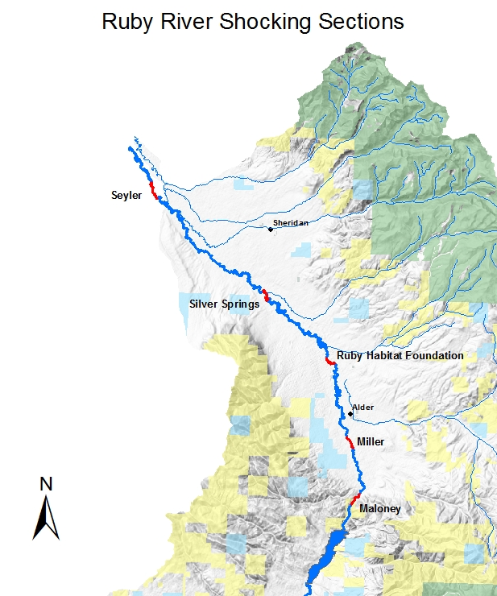
Figure 1. Long-term Ruby River sampling sections. The Maloney Section on the above map has been renamed as Vigilante Section.

Methods
Sampling Methods
The fisheries data analyzed in this report were collected the during spring mark-recapture abundance surveys on three different river sections that represent the entire Ruby River trout fishery. The Vigilante section is comprised of data collected over last 27 years (1998-2025). The Seyler section has been monitored for the last 8 years from (2017-2025). Sampling did not occur during some years or periods of years in each section. Trout were collected from a drift boat by mobile anode electrofishing each March or April during single pass marking and recapture runs 7 to 14 days apart (Vincent 1971). All captured trout >203 mm (8 inches) were measured to the nearest mm or tenth of an inch and weighed to the nearest gram or hundredth of a pound. The study section and data collection methods are described in more detail by Oswald (2009).

Relative weight
Relative weights ($W_{r}$) were calculated as per (Wege and Anderson 1978):
$$W_{r}=\frac{W}{W_{s}}*100,$$
where $W$ is the weight of an individual fish and $W_{s}$ is the “standard weight” of a fish of the same length, derived from published length-weight relationships.

Condition
Fulton’s condition factor ($K$) was used to calculate the condition of fish:
$$K=\frac{W}{L^{3}}*c,$$
where $W$ was the weight of an individual fish, $L$ the length, and the constant $c$ a simple scaling factor.

Size Structure
The size structure of a fish population reflects a complex interplay of environmental drivers and population dynamics (Neumann and Allen 2007), and the relative frequencies of size classes provide a glimpse into these processes. We used two methods to describe the size structure of this fishery: 1) descriptive statistics of lengths through time, and 2) proportional stock density. Proportional stock density is the percentage of fish in each of set of length classes specific to each species of fish. We used the Gabelhouse classification scheme to partition fish into one of six classes: 1) sub-stock, 2) stock, 3) quality, 4) preferred, 5) memorable, and 6) trophy (Gabelhouse 1984). We then calculated the proportional stock density (PSD) of each class as:
$${\text{PSD}}_{\text{class}}=100\left(\frac{\text{number of fish in class}}{\text{total number of fish}}\right).$$
We used the FSA package (Ogle et al. 2018) in the R programming environment to calculate relative weights (R Core Team 2018).

Mark-recapture abundance estimates
Abundance was estimated using maximum likelihood estimation to allow the effects of covariates such as age class and/or length to be included on the probability of detection. This method assumes that the population is closed. We used the glm function from the stats package in the R programming environment to estimate the effects of length on the probability of detection, and to then calculate abundance (R Core Team 2018). Reported abundance estimates are based on model-averaged estimates. Chi-square goodness-of-fit tests were used to evaluate the adequacy of model fit (Williams, Nichols, and Conroy 2002). The Akaike Information Criterion was used to assess the best predictive model, and the single top model was used to make predictions and inference on abundance (Akaike 1998).

Results
Vigilante FAS Section:

Data summary
In 2025, 488 Brown Trout were captured in the Vigilante FAS Section of the Ruby River and compared to a long-term dataset comprised of 22,621 Brown Trout. Brown Trout in the Vigilante FAS Section average 372 mm (Table 1). Brown Trout were longer and heavier in 2025 when compared to the long-term average. Both Brown Trout condition and relative weight were above average in 2025 (Table 2). Brown Trout relative weight has remained relatively stable for the last 15 years (Figure 2).
Table 1. Vigilante FAS data summary.
 |  |  |  | Length |  |  |  |  | Weight |  |  | Condition |  |  | Relative Weight
 |  | n |  | Min | Max | Avg | SD |  | Avg | SD |  | Avg | SD |  | Avg | SD
Brown Trout |  | 22621 |  | 157.5 | 635 | 371.8 | 64.2 |  | 483.2 | 215.6 |  | 28.2 | 12.1 |  | 72.8 | 31

Table 2. Vigilante FAS data summary for the latest year.
 |  |  |  | Length |  |  |  |  | Weight |  |  | Condition |  |  | Relative Weight
 |  | n |  | Min | Max | Avg | SD |  | Avg | SD |  | Avg | SD |  | Avg | SD
Brown Trout |  | 488 |  | 263 | 540 | 423.2 | 45.1 |  | 674.5 | 190 |  | 31.6 | 3 |  | 81.9 | 7.7

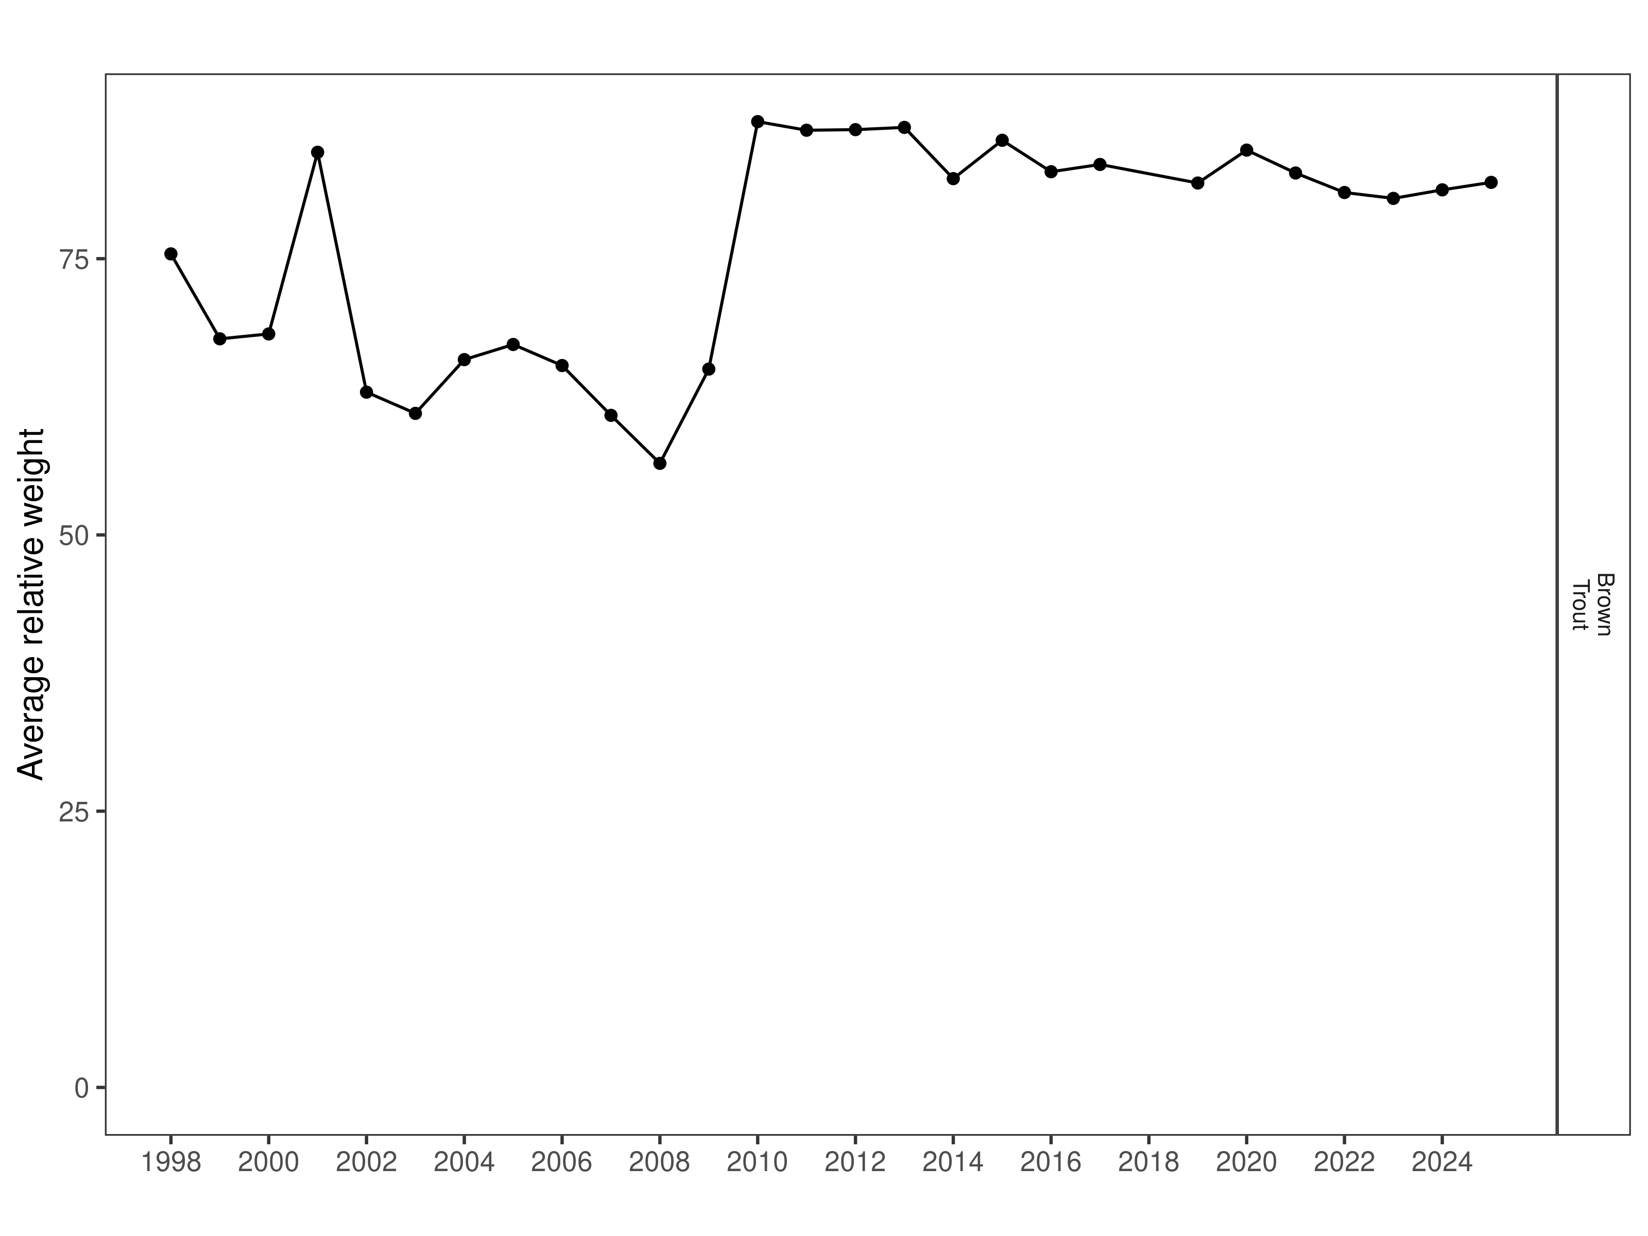
Figure 2. Vigilante FAS relative weight through time.

Size Structure
Brown Trout distribution of lengths in 2025 had the highest median value on record and the overall distribution of lengths consists of mostly larger fish (Figure 3). Most of the Brown Trout sampled in this section in 2025 were between 380 and 480 mm and juvenile recruitment appears to have been low the previous year (Figure 4).

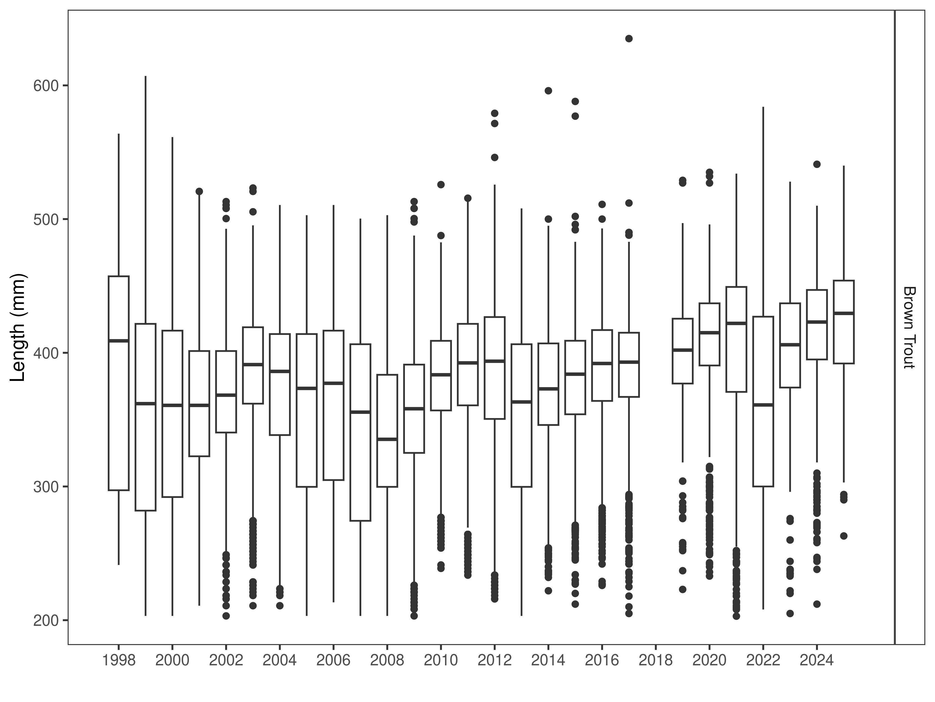
Figure 3. Vigilante FAS distribution of lengths through time. The box-and-whisker plots divide the distribution of the data into the first quartile (the lower limit of the box), the median (heavy black line), and third quartile (the upper limit of the box). The whiskers denote data points within 1.5 * the interquartile range (the difference between the first and third quartiles). Dots denote data points further than 1.5 * the interquartile range from the box.
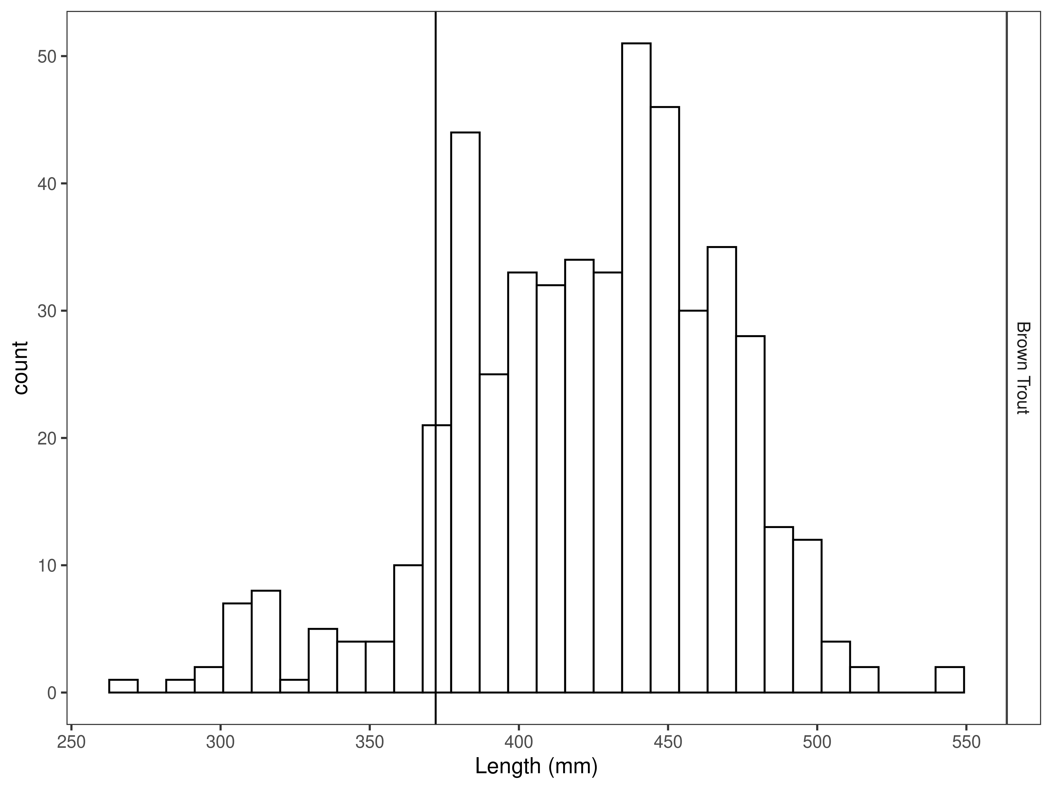
Figure 4. Vigilante FAS length distribution by species for latest year, with long-term species-averages indicated by the vertical black line.

Mark-recapture abundance estimates
Recapture rates were similar for Brown Trout across lengths (Figures 5). Capture efficiency was low for small and large fish but better for fish that ranged in size from 380 to 480 mm (Figure 6), resulting in better support for length-based models (Table 3). The estimated Brown trout abundance per km was 386 per km +19 fish in 2025 (Table 4). The 2025 abundance estimate decreased from the 2024 estimate and was the lowest estimate on record however, this lines up with all estimates conducted since 2019 (Figure 7). Brown Trout Biomass has also remained relatively constant since 2019 (Figure 8).

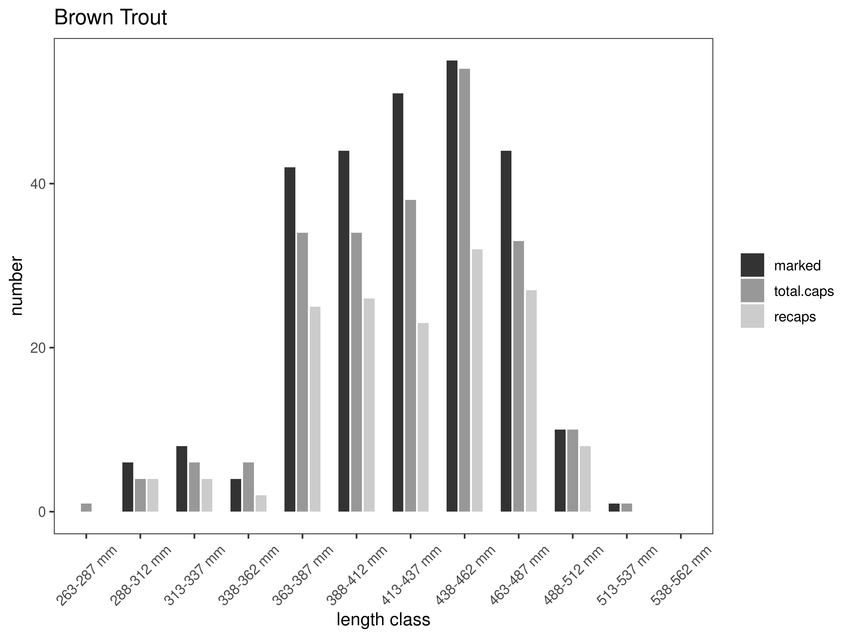
Figure 5. Vigilante FAS capture-recapture summary across length groups for brown trout in latest year. marked= number of fish marked on initial pass, total.caps = number of fish caught on second pass, and recaps = number of marked fish caught on the second pass.
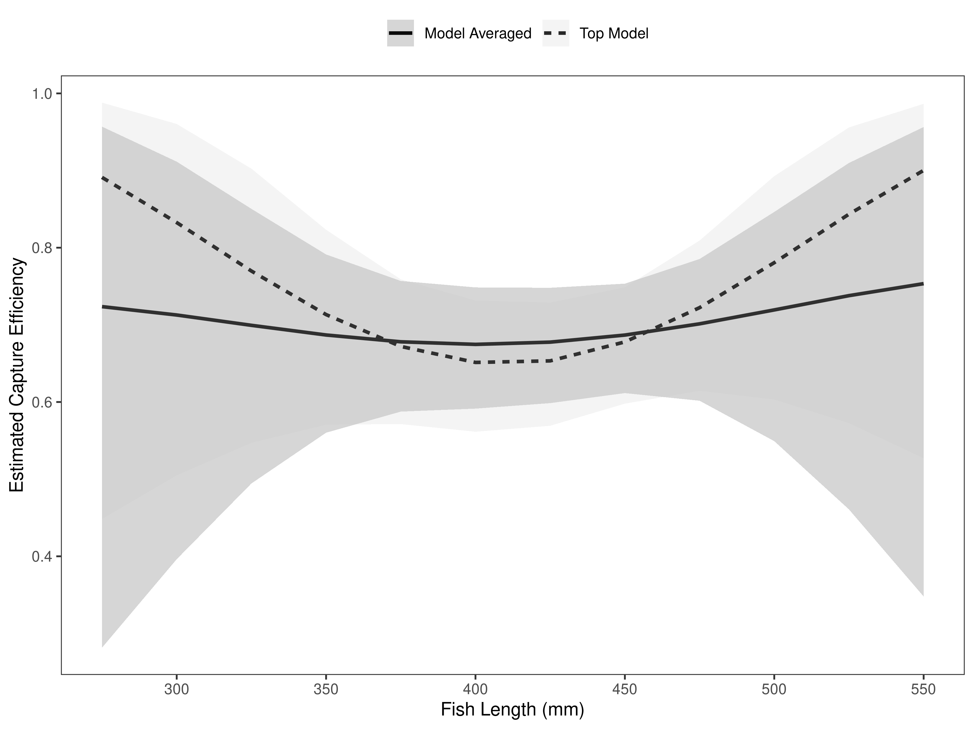

Figure 6. Vigilante FAS model-averaged estimates of capture efficiency of brown trout in latest year.
Table 3. Model selection results from four models used for two-pass abundance estimation of brown trout in latest year. Models: `Len` = capture efficiency modeled as a function of length class, `Len.sq` = capture efficiency modeled as a quadratic function of length class with the intercept estimated, `FA+` = capture efficiency modeled as a quadratic function of length class with intercept fixed, `Null` = constant capture efficiency.
Model | K | AICc | deltaAICc | ModLik | AICcWt | LnLik | CumWt
Len.sq | 3 | 278.39 | 0.00000000 | 1.00 | 0.32 | -136.1379 | 0.32
Len | 2 | 278.42 | 0.03597466 | 0.98 | 0.31 | -137.1837 | 0.63
Null | 1 | 278.76 | 0.37151432 | 0.83 | 0.26 | -138.3699 | 0.89
FA+ | 2 | 280.48 | 2.09412768 | 0.35 | 0.11 | -138.2127 | 1.00

Brown Trout were estimated at 386 per km in the Vigilante FAS Section in 2025 (Table 2). Brown Trout abundance was estimated to within ±19 fish (Table 2). This is a very accurate abundance estimate, which is typical for the Vigilante FAS section most years.

Table 4. Model averaged abundance estimates of fish per kilometer (Pop. Estimate) across length groups and estimated biomass (Biomass Estimate, kg) for the latest year.
 |  | Pop. Estimate | 2.5% | 97.5% | Biomass Estimate | 2.5% | 97.5%
Brown Trout | 2025 | 386 | 367 | 405 | 259.5 | 246.3 | 272.7

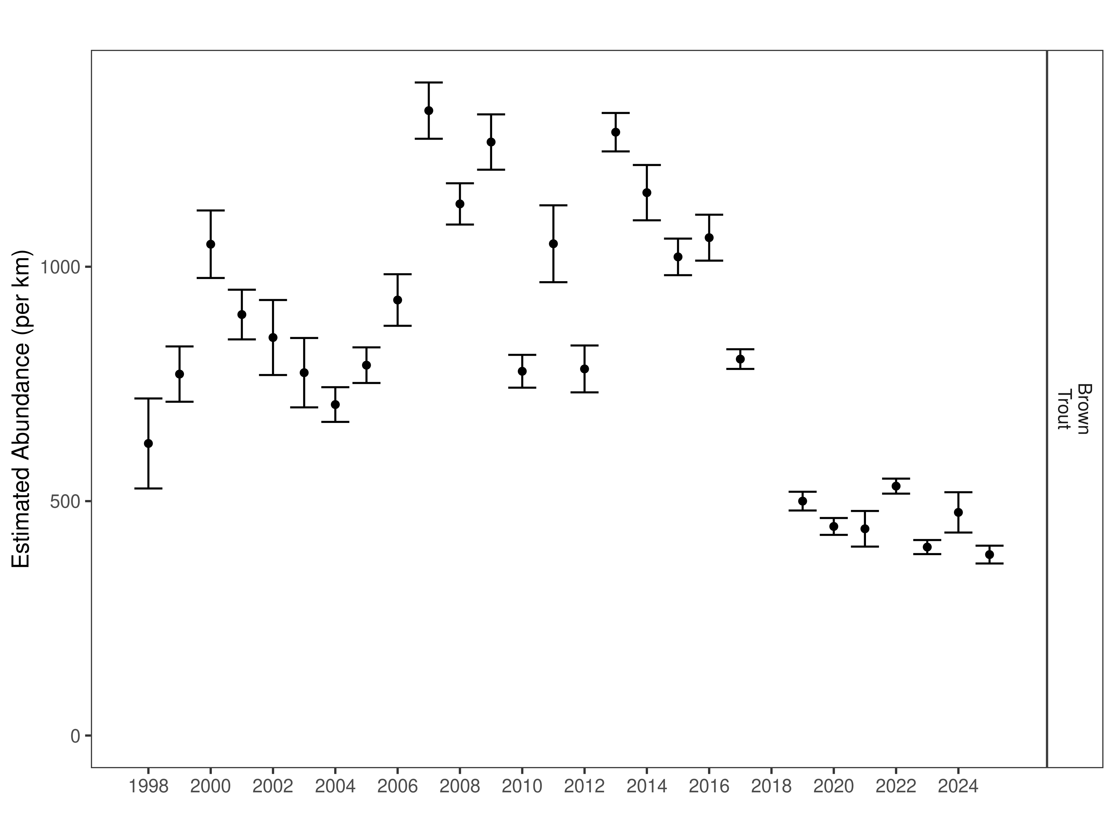
Figure 7. Vigilante FAS mark-recapture abundance estimates (fish per kilometer) through time using the maximum likelihood method. These estimates (mean and 95% confidence intervals) represent the model-averaged estimates across all length groups.
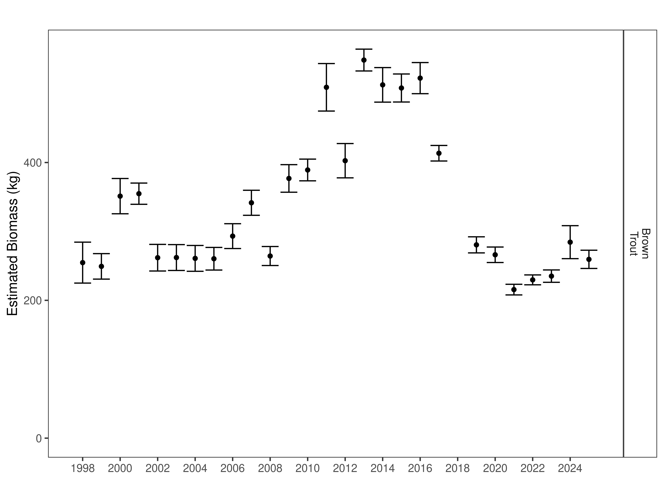
Figure 8. Vigilante FAS estimates of biomass through time.

Silver Springs Section:
Data Summary
In 2025, 128 Brown Trout were captured in the Silver Springs Section of the Ruby River and compared to a long-term dataset comprised of 3,782 Brown Trout. Brown Trout in the Silver Springs Section average 369 mm (Table 5). Brown Trout were longer and heavier in 2025 than the long-term average and both condition and relative weight were slightly above average (Table 6). Brown Trout relative weight has been relatively stable for the last 12 years (Figure 9).

Table 5. Silver Springs data summary.
 |  |  |  | Length |  |  |  |  | Weight |  |  | Condition |  |  | Relative Weight
 |  | n |  | Min | Max | Avg | SD |  | Avg | SD |  | Avg | SD |  | Avg | SD
Brown Trout |  | 3782 |  | 163 | 596 | 369.2 | 69.4 |  | 508.2 | 270.1 |  | 32.4 | 4 |  | 83.6 | 10.2

Table 6. Silver Springs data summary for the latest year.
 |  |  |  | Length |  |  |  |  | Weight |  |  | Condition |  |  | Relative Weight
 |  | n |  | Min | Max | Avg | SD |  | Avg | SD |  | Avg | SD |  | Avg | SD
Brown Trout |  | 128 |  | 236 | 565 | 401.1 | 83.5 |  | 656.6 | 367.6 |  | 33.3 | 2.9 |  | 86.1 | 7.4

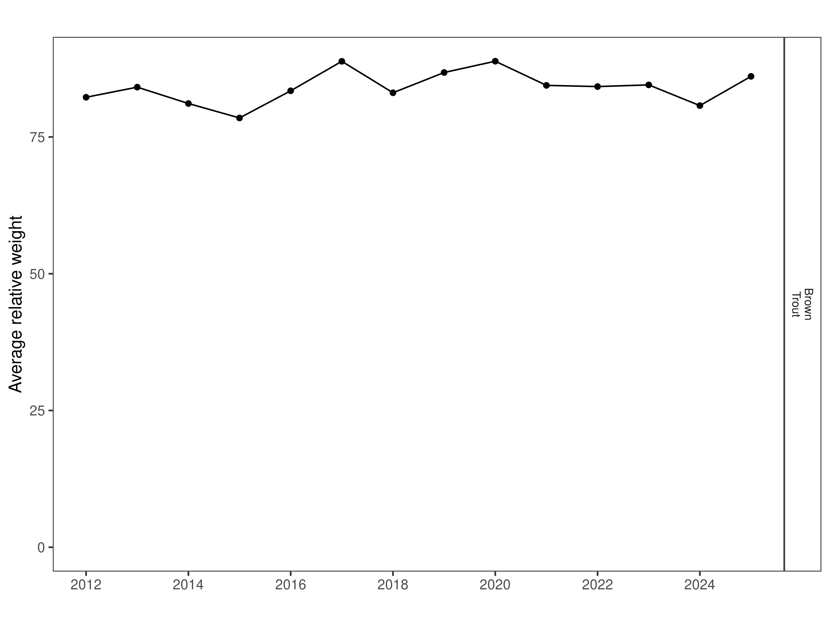
Figure 9. Silver Springs relative weight through time.

Size Structure
Distribution of Brown Trout lengths in 2025 were equal to or slightly lower than the four previous years (Figure 10). Brown Trout were above average length in 2024, and the population experienced a slight decrease in median length when compared to the previous year (Figure 10). There appears to be a strong cohort of 2-year-old Brown Trout sampled in this section that ranged between 203 and 340 mm and most of the larger fish that were sampled were between 360 mm and 480 mm (Figure 11).

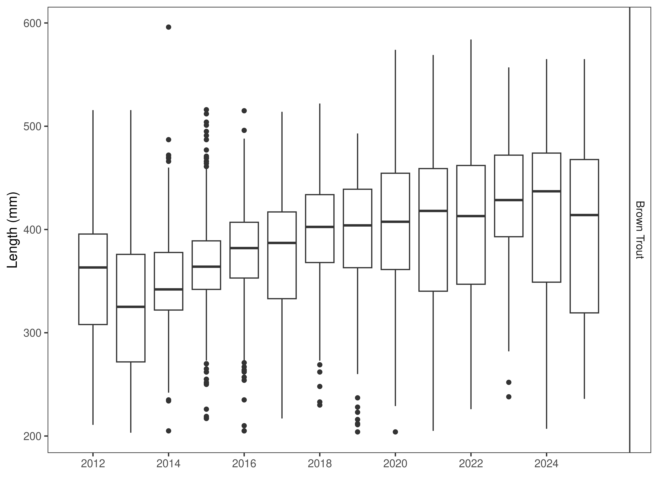
Figure 10. Silver Springs distribution of lengths through time. The box-and-whisker plots divide the distribution of the data into the first quartile (the lower limit of the box), the median (heavy black line), and third quartile (the upper limit of the box). The whiskers denote data points within 1.5 * the interquartile range (the difference between the first and third quartiles). Dots denote data points further than 1.5 * the interquartile range from the box.
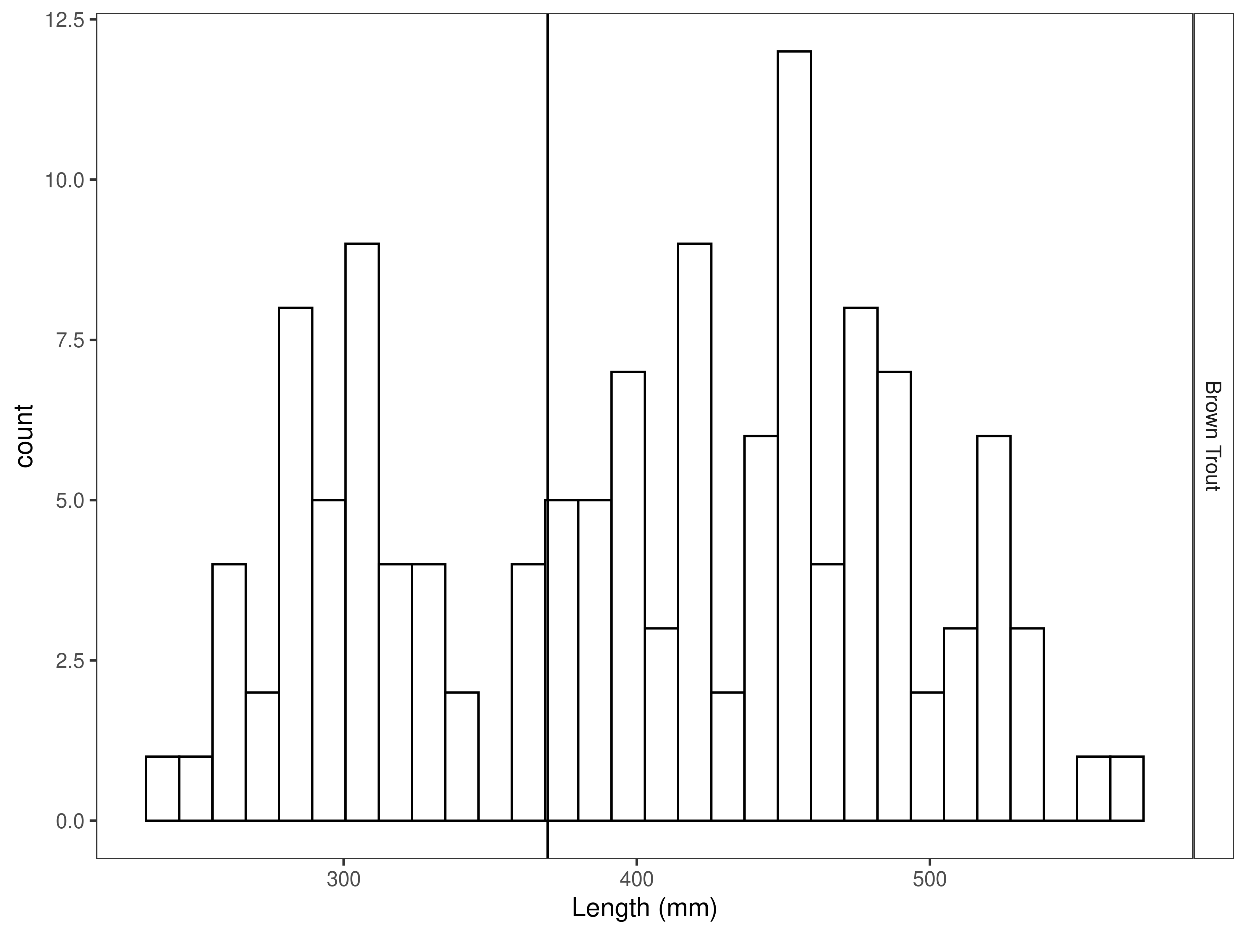
Figure 11. Silver Springs length distribution by species for latest year, with long-term species-averages indicated by the vertical black line.

Mark-recapture abundance estimates
Recapture rates were similar for Brown Trout across lengths (Figure 12), Capture efficiency was similar among sizes of fish captured and the null model outperformed length-based models (Figure 13 and Table 7). Capture efficiency was relatively stable across the sizes of fish encountered (Figure 13). The estimated Brown trout abundance per km was 190 per km +37 fish in 2025 (Table 8). The 2025 abundance estimates slightly increased from the 2024 estimate; however, the estimates are not significantly different from each other (Figure 14). Brown Trout Biomass has been on an increasing trend since 2019 (Figure 15).
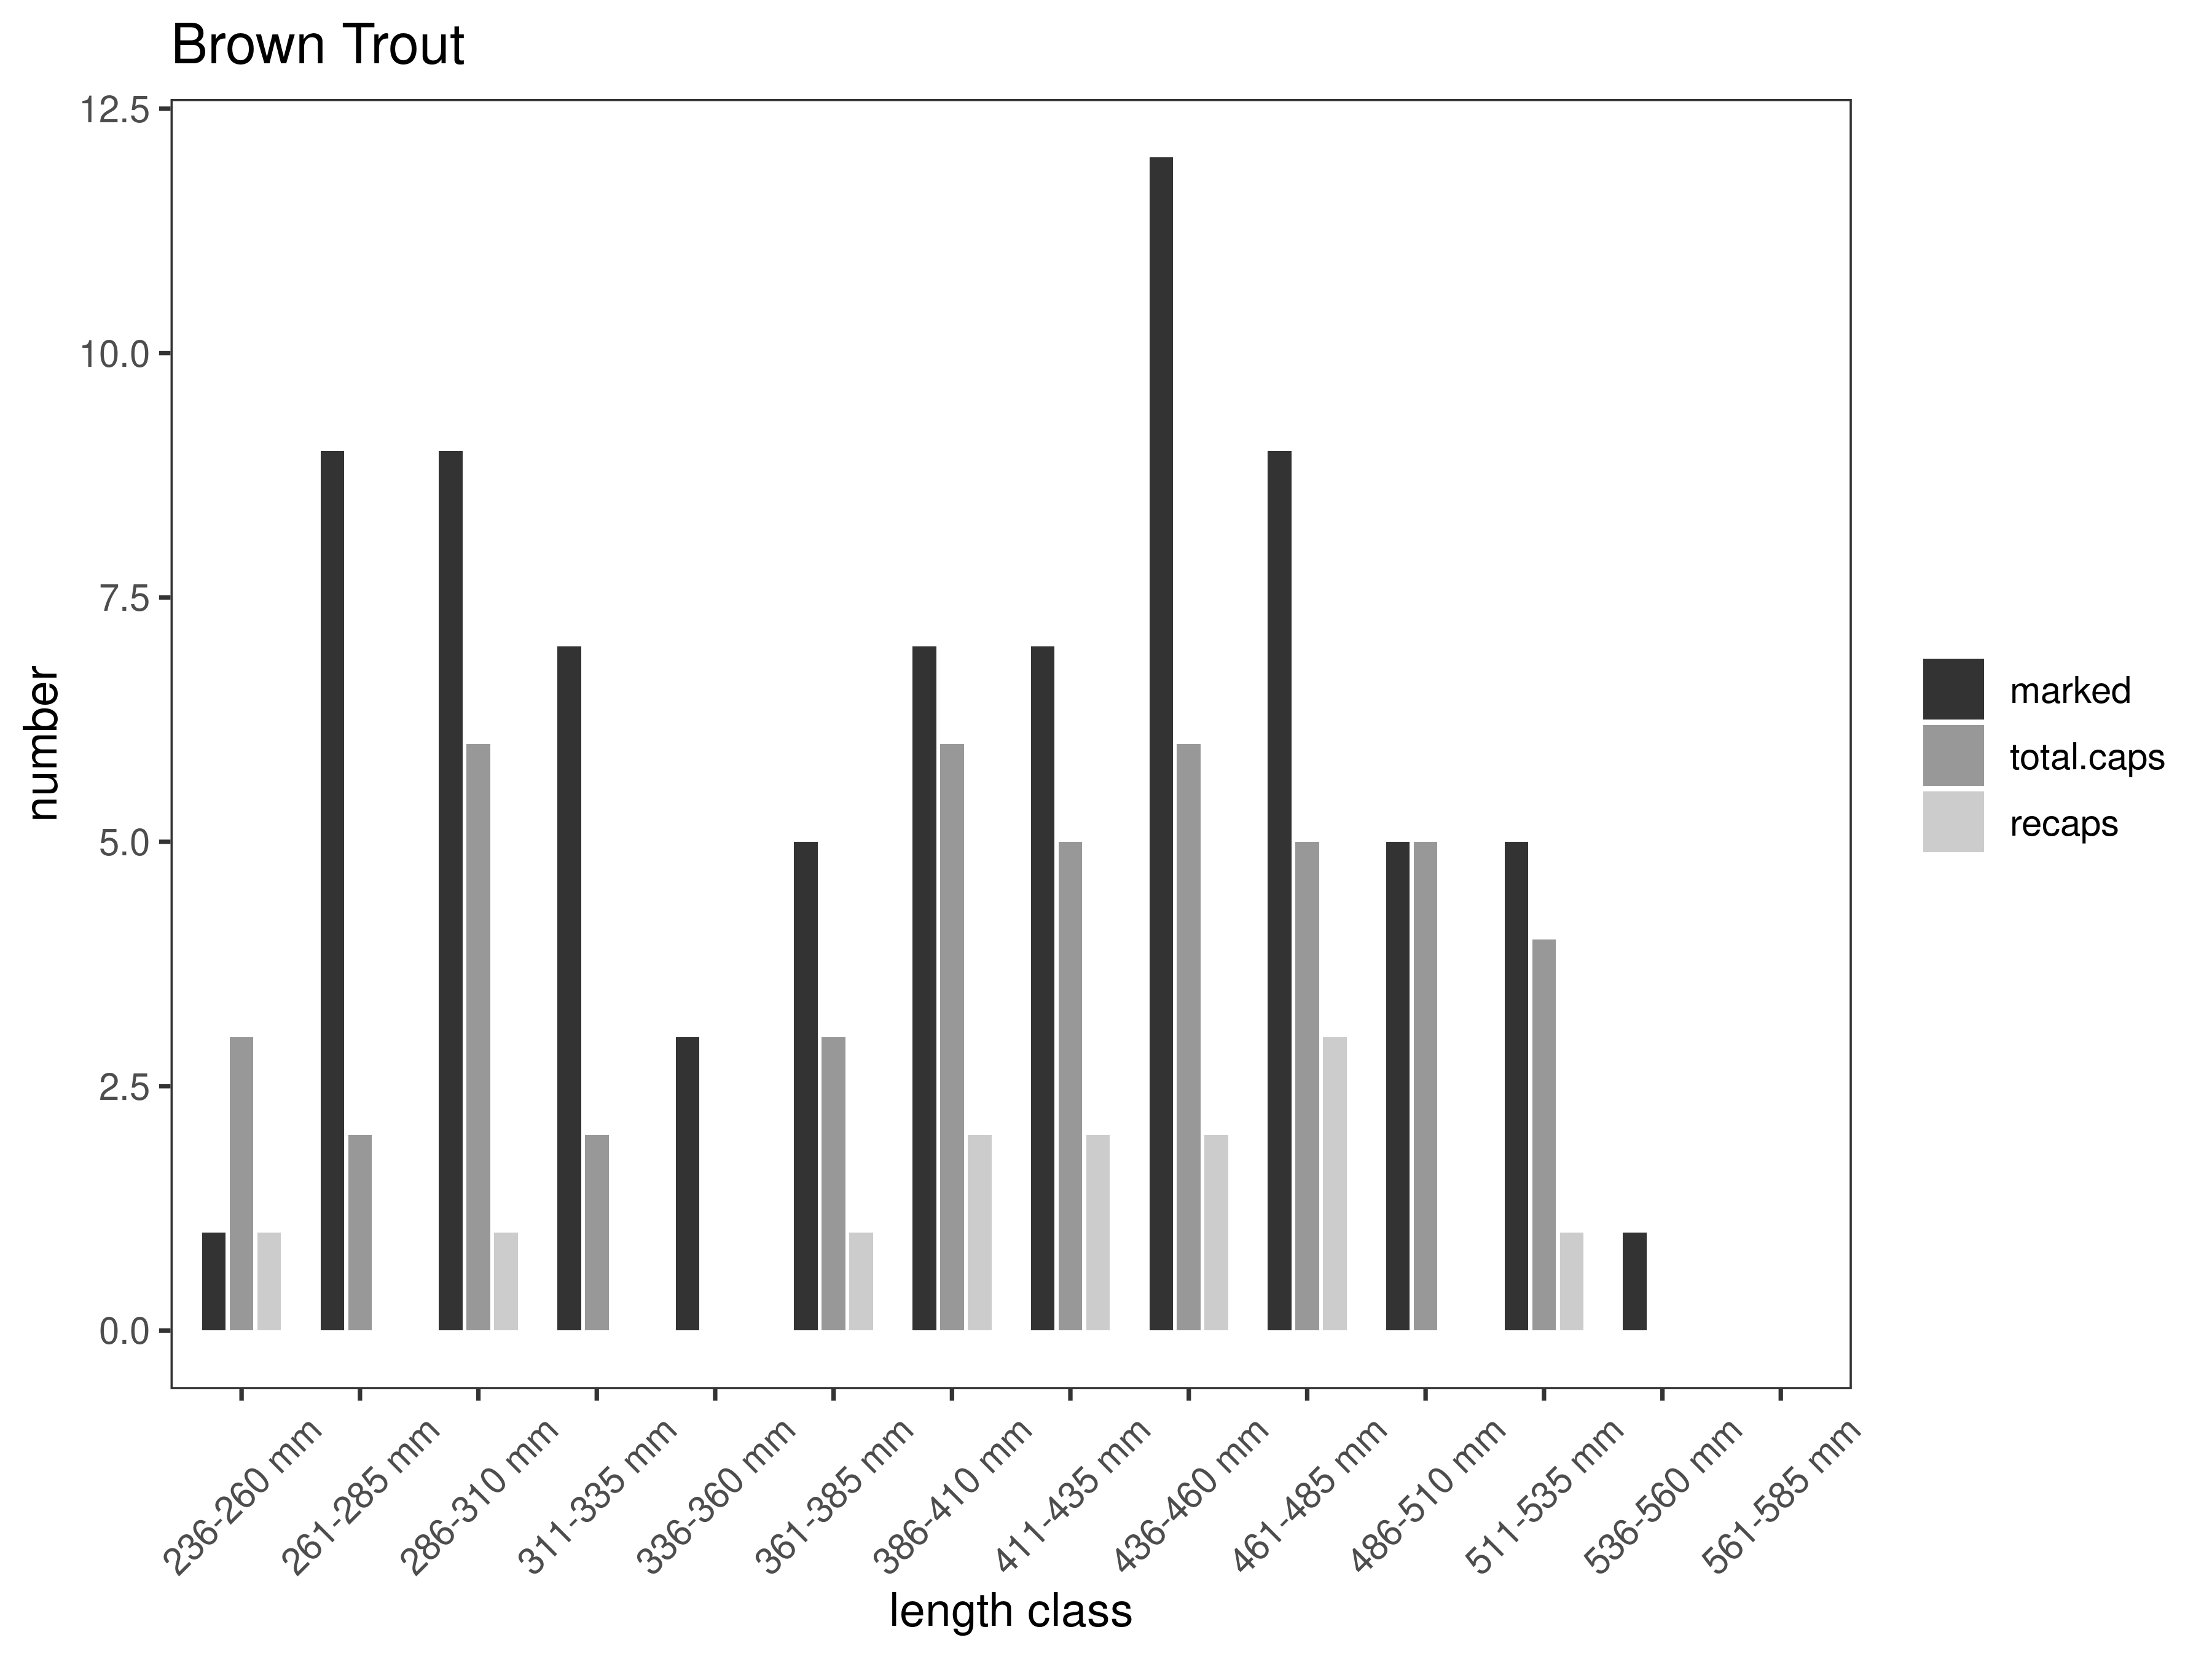
Figure 12. Silver Springs capture-recapture summary across length groups for brown trout in latest year. marked= number of fish marked on initial pass, total.caps = number of fish caught on second pass, and recaps = number of marked fish caught on the second pass.
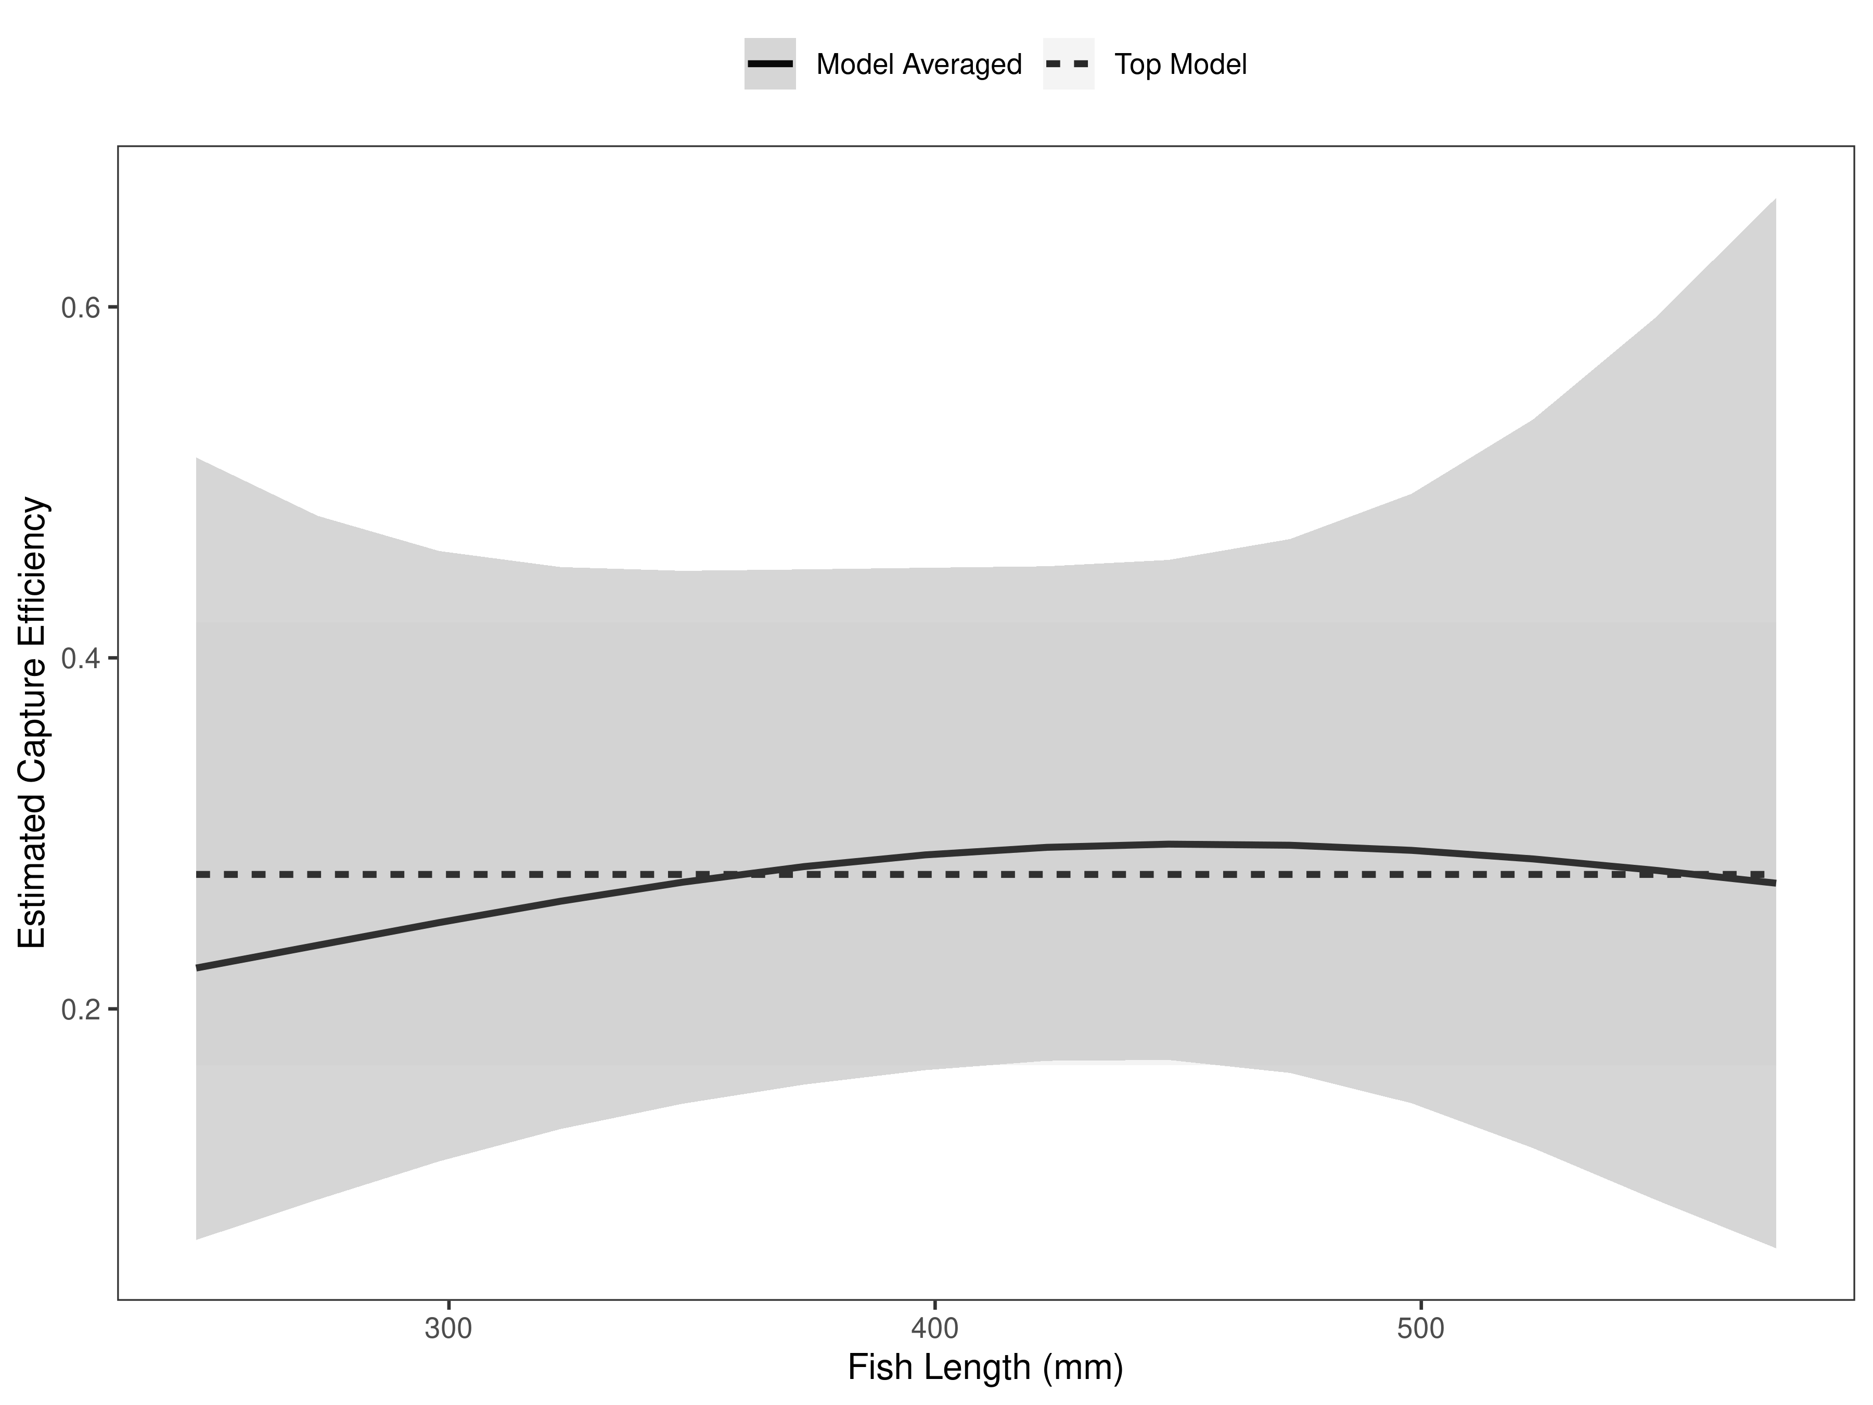
Figure 13. Silver Springs model-averaged estimates of capture efficiency of brown trout in latest year.
Table 7. Model selection results from four models used for two-pass abundance estimation of brown trout in latest year. Models: `Len` = capture efficiency modeled as a function of length class, `Len.sq` = capture efficiency modeled as a quadratic function of length class with the intercept estimated, `FA+` = capture efficiency modeled as a quadratic function of length class with intercept fixed, `Null` = constant capture efficiency.
Model | K | AICc | deltaAICc | ModLik | AICcWt | LnLik | CumWt
Null | 1 | 57.52 | 0.000000 | 1.00 | 0.47 | -27.71634 | 0.47
FA+ | 2 | 58.82 | 1.297932 | 0.52 | 0.25 | -27.27338 | 0.72
Len | 2 | 59.33 | 1.805918 | 0.41 | 0.19 | -27.52738 | 0.91
Len.sq | 3 | 60.91 | 3.391982 | 0.18 | 0.09 | -27.17770 | 1.00

Table 8. Model averaged abundance estimates of fish per kilometer (Pop. Estimate) across length groups and estimated biomass (Biomass Estimate, kg) for the latest year.
 |  | Pop. Estimate | 2.5% | 97.5% | Biomass Estimate | 2.5% | 97.5%
Brown Trout | 2025 | 190 | 153 | 227 | 180.8 | 145.8 | 215.9

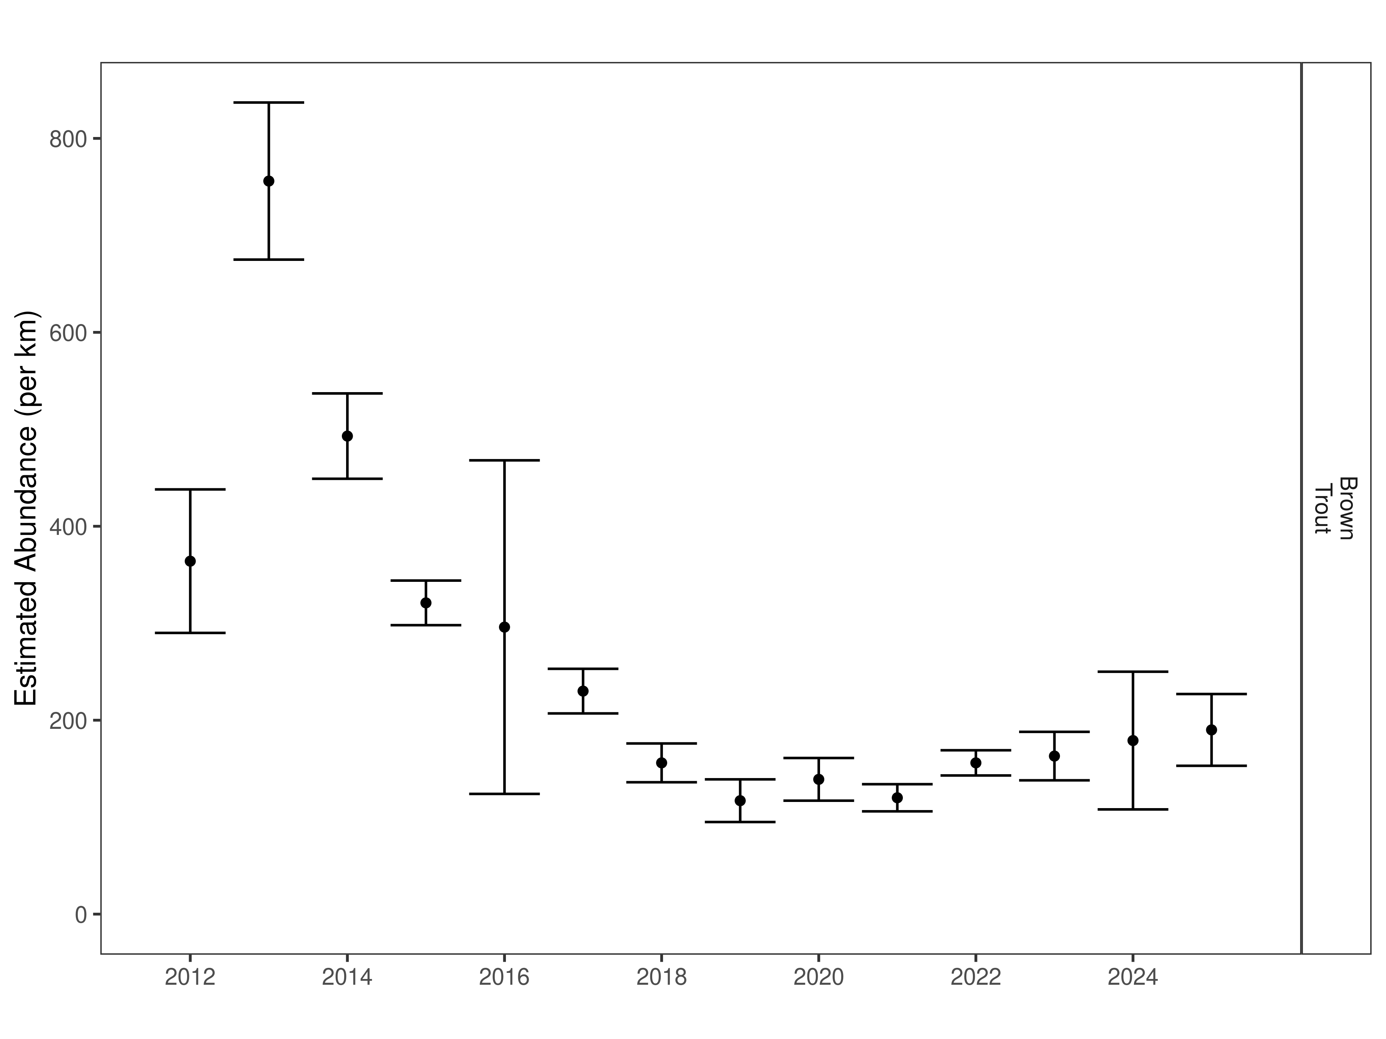
Figure 14. Silver Springs mark-recapture abundance estimates (fish per kilometer) through time using the maximum likelihood method. These estimates (mean and 95% confidence intervals) represent the model-averaged estimates across all length groups.
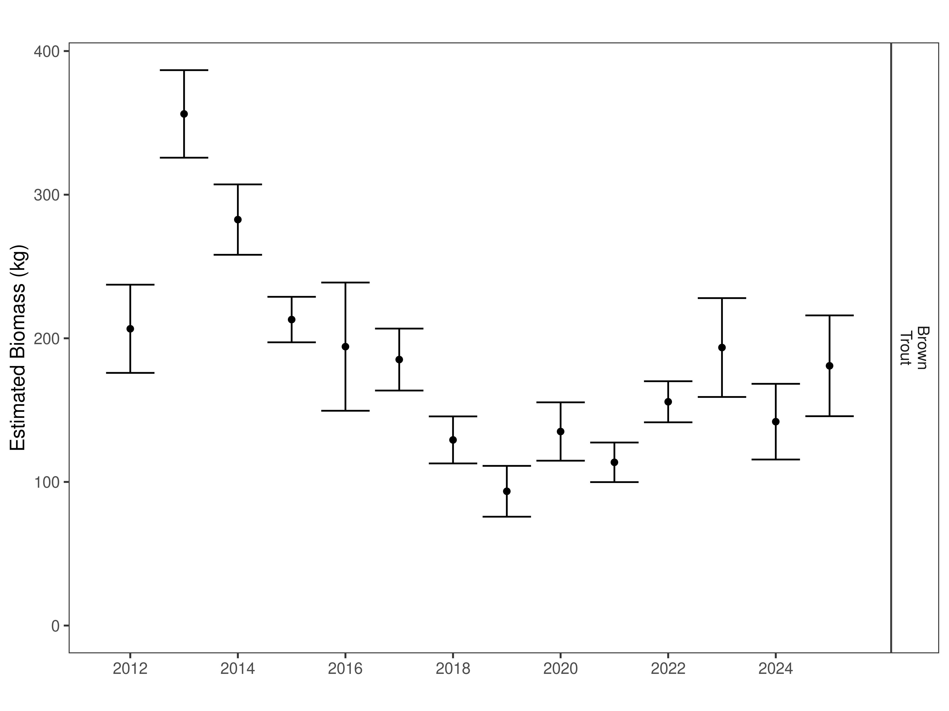
Figure 15. Silver Springs estimates of biomass through time.

Seyler Section:
Data Summary
In 2025, 51 Brown Trout were captured in the Seyler Section of the Ruby River and compared to a long-term dataset comprised of 533 Brown Trout. Brown Trout in the Seyler Section average 328 mm (Table 9). Brown Trout were longer and heavier in 2025 than the long-term average and condition and relative weight were similar to previous years (Table 10). Brown Trout relative weight has been relatively stable for the last 5 years (Figure 16).

Table 9. Data summary.
 |  |  |  | Length |  |  |  |  | Weight |  |  | Condition |  |  | Relative Weight
 |  | n |  | Min | Max | Avg | SD |  | Avg | SD |  | Avg | SD |  | Avg | SD
Brown Trout |  | 533 |  | 83 | 559 | 327.9 | 119 |  | 421.4 | 353.6 |  | 33.9 | 4.3 |  | 86.6 | 10.8

Table 10. Data summary for the latest year.
 |  |  |  | Length |  |  |  |  | Weight |  |  | Condition |  |  | Relative Weight
 |  | n |  | Min | Max | Avg | SD |  | Avg | SD |  | Avg | SD |  | Avg | SD
Brown Trout |  | 51 |  | 241 | 555 | 379.1 | 72.6 |  | 573.8 | 324.5 |  | 34.3 | 3.4 |  | 88.6 | 8.6

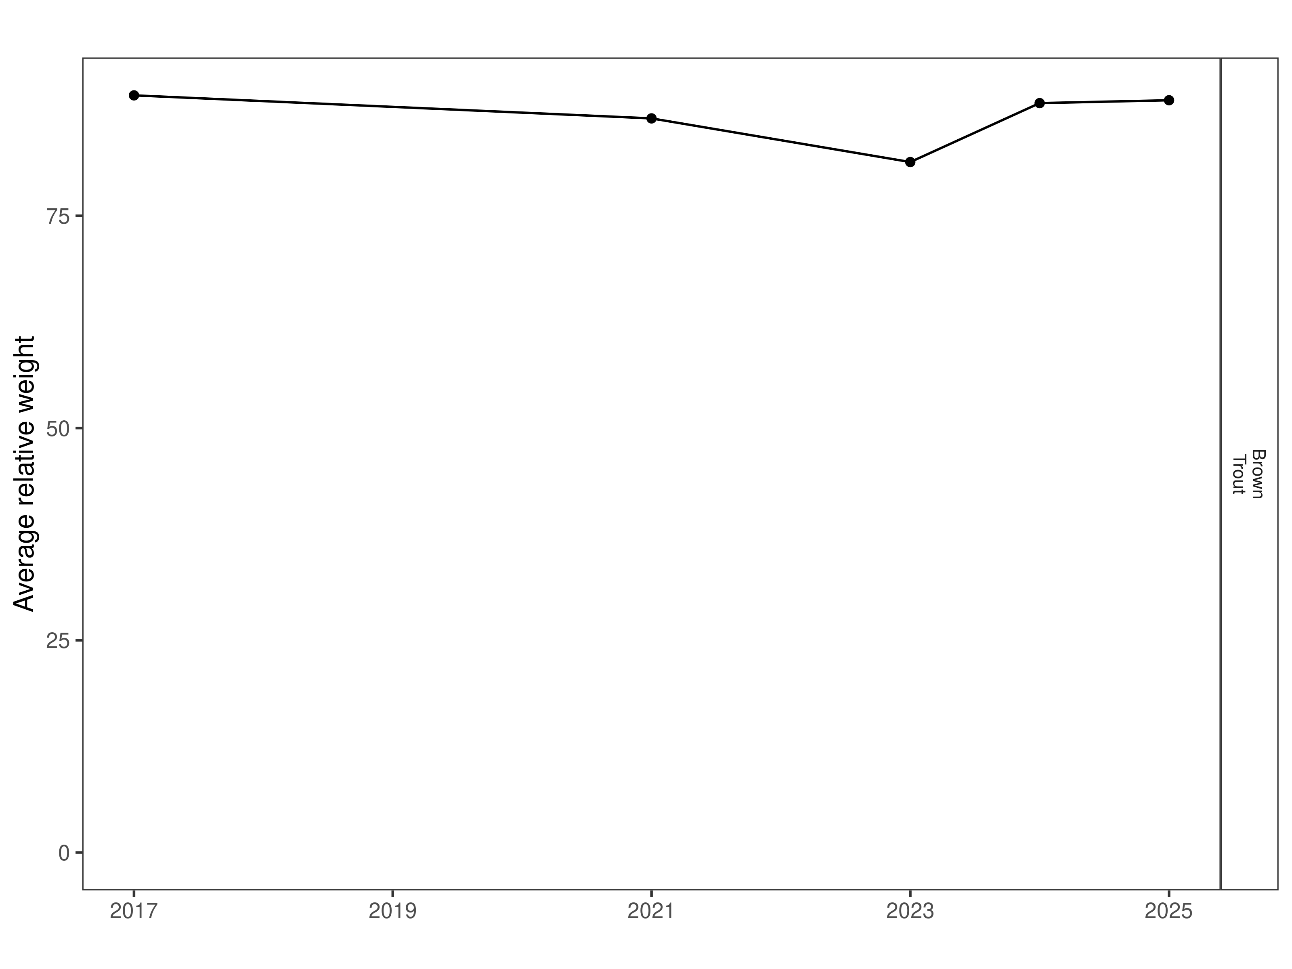
Figure 16. Seyler relative weight through time.

Size Structure
Distribution of Brown Trout lengths in 2025 was similar to 2017 and 2021 and higher than in 2024 (Figure 17) Most fish that were sampled were between 240 mm and 450 mm and there is a strong cohort of 2-year-old fish in the section (Figure 18).

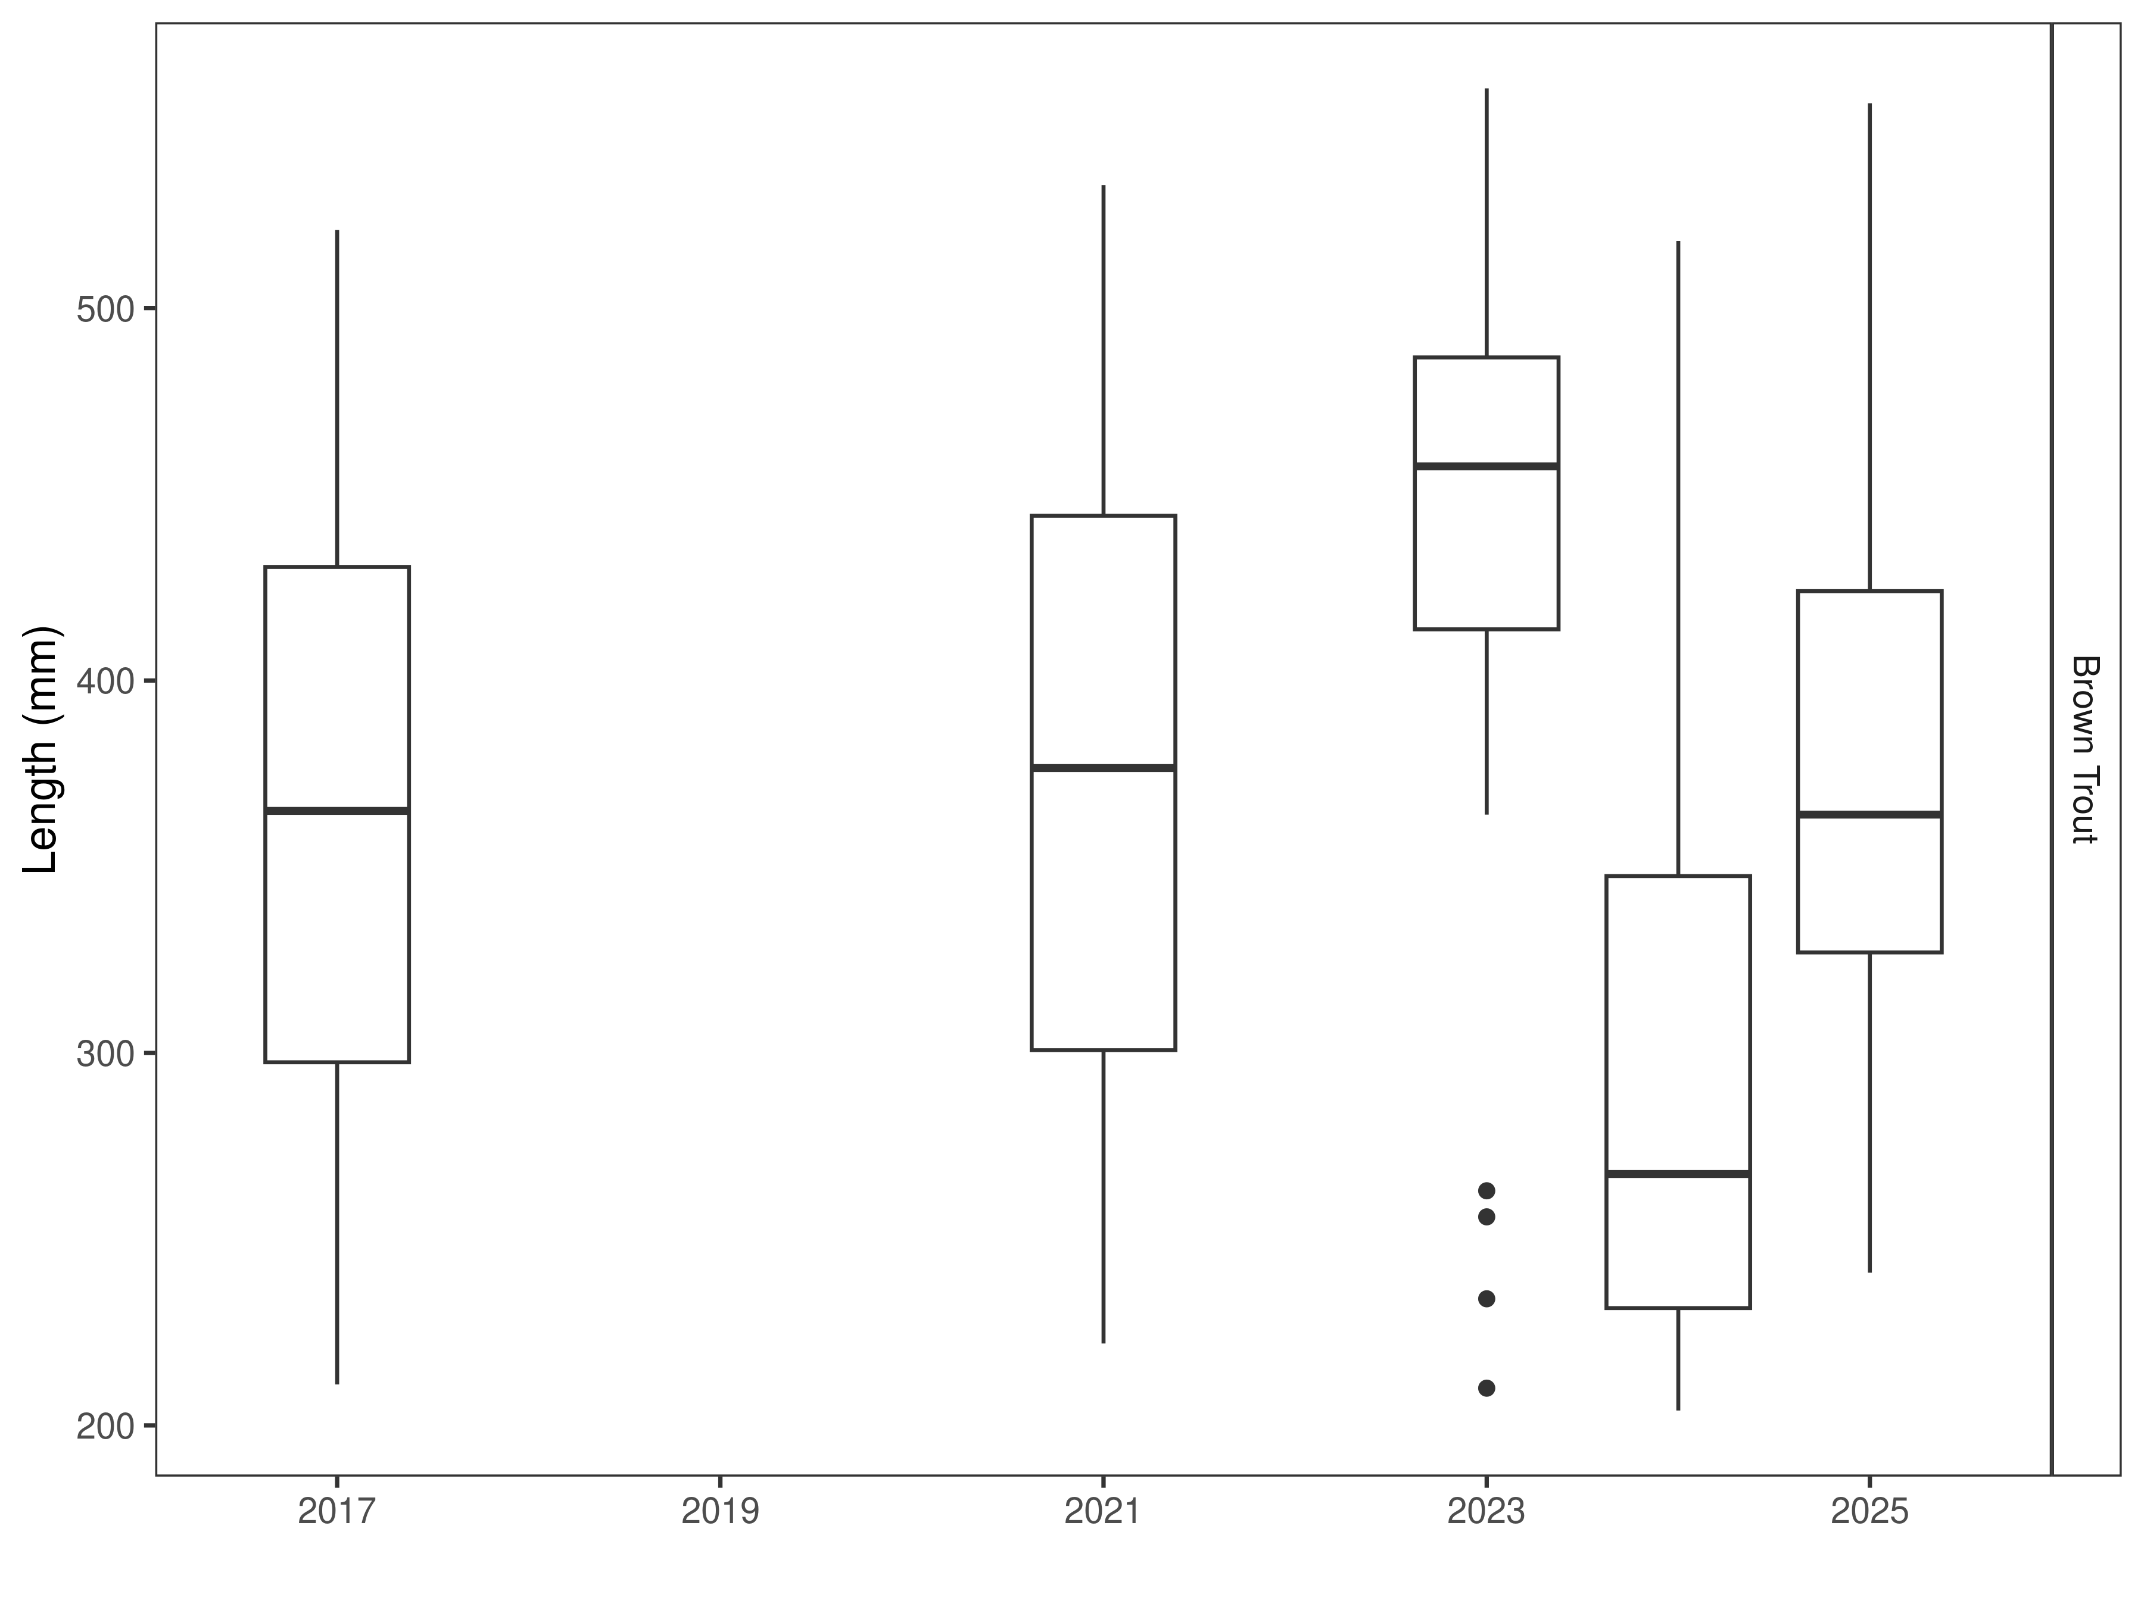
Figure 17. Seyler distribution of lengths through time. The box-and-whisker plots divide the distribution of the data into the first quartile (the lower limit of the box), the median (heavy black line), and third quartile (the upper limit of the box). The whiskers denote data points within 1.5 * the interquartile range (the difference between the first and third quartiles). Dots denote data points further than 1.5 * the interquartile range from the box.
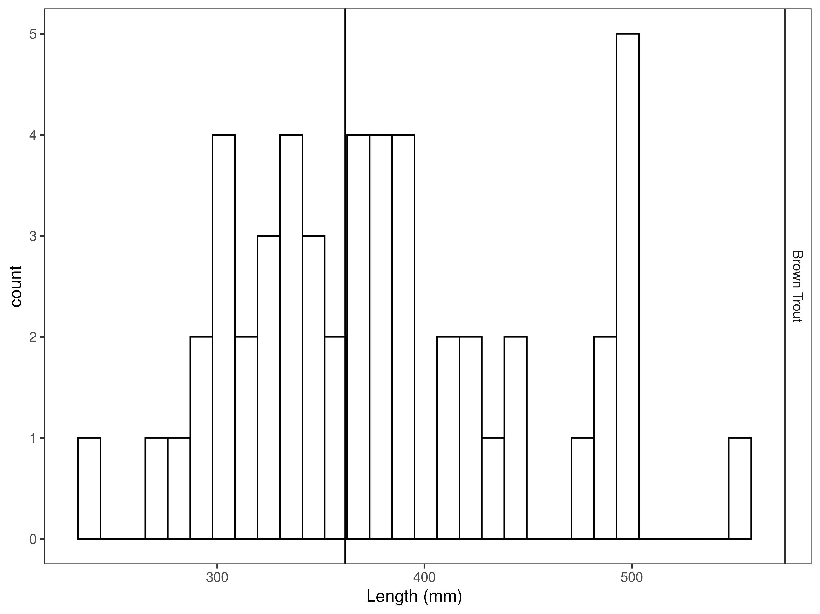
Figure 18. Seyler length distribution by species for latest year, with long-term species-averages indicated by the vertical black line.

Mark-recapture abundance estimates
Recapture rates were similar for Brown Trout across lengths except for fish between 415 mm and 465 mm (Figure 19). Capture efficiency was similar for most lengths (Figure 20) and the null model outperformed length-based models (Table 11). The estimated Brown trout abundance was 29 per km +7 in 2025 (Table 12). Brown Trout abundance decreased in 2025 and now more closely resembles the 2019 estimate (Figure 21). However, Brown Trout biomass was similar to the previous year (Figure 22).

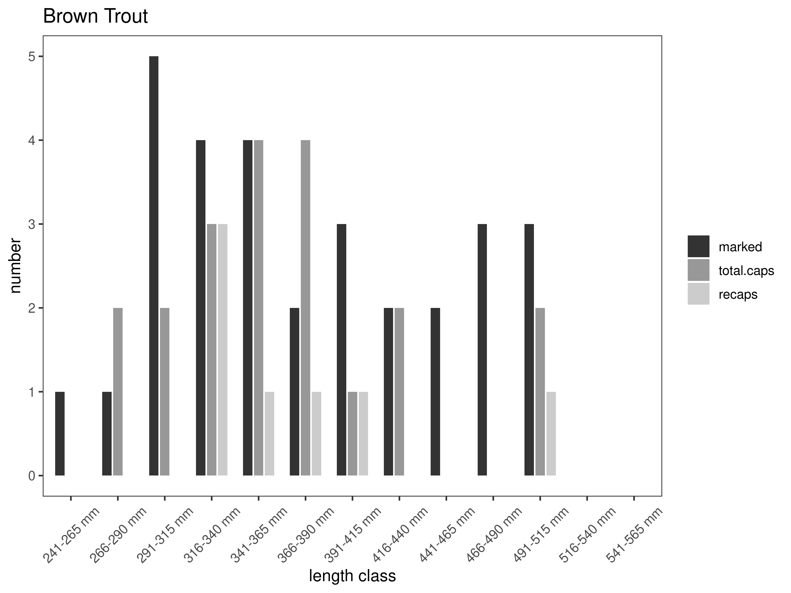
Figure 19. Capture-recapture summary across length groups for brown trout in latest year. marked= number of fish marked on initial pass, total.caps = number of fish caught on second pass, and recaps = number of marked fish caught on the second pass.

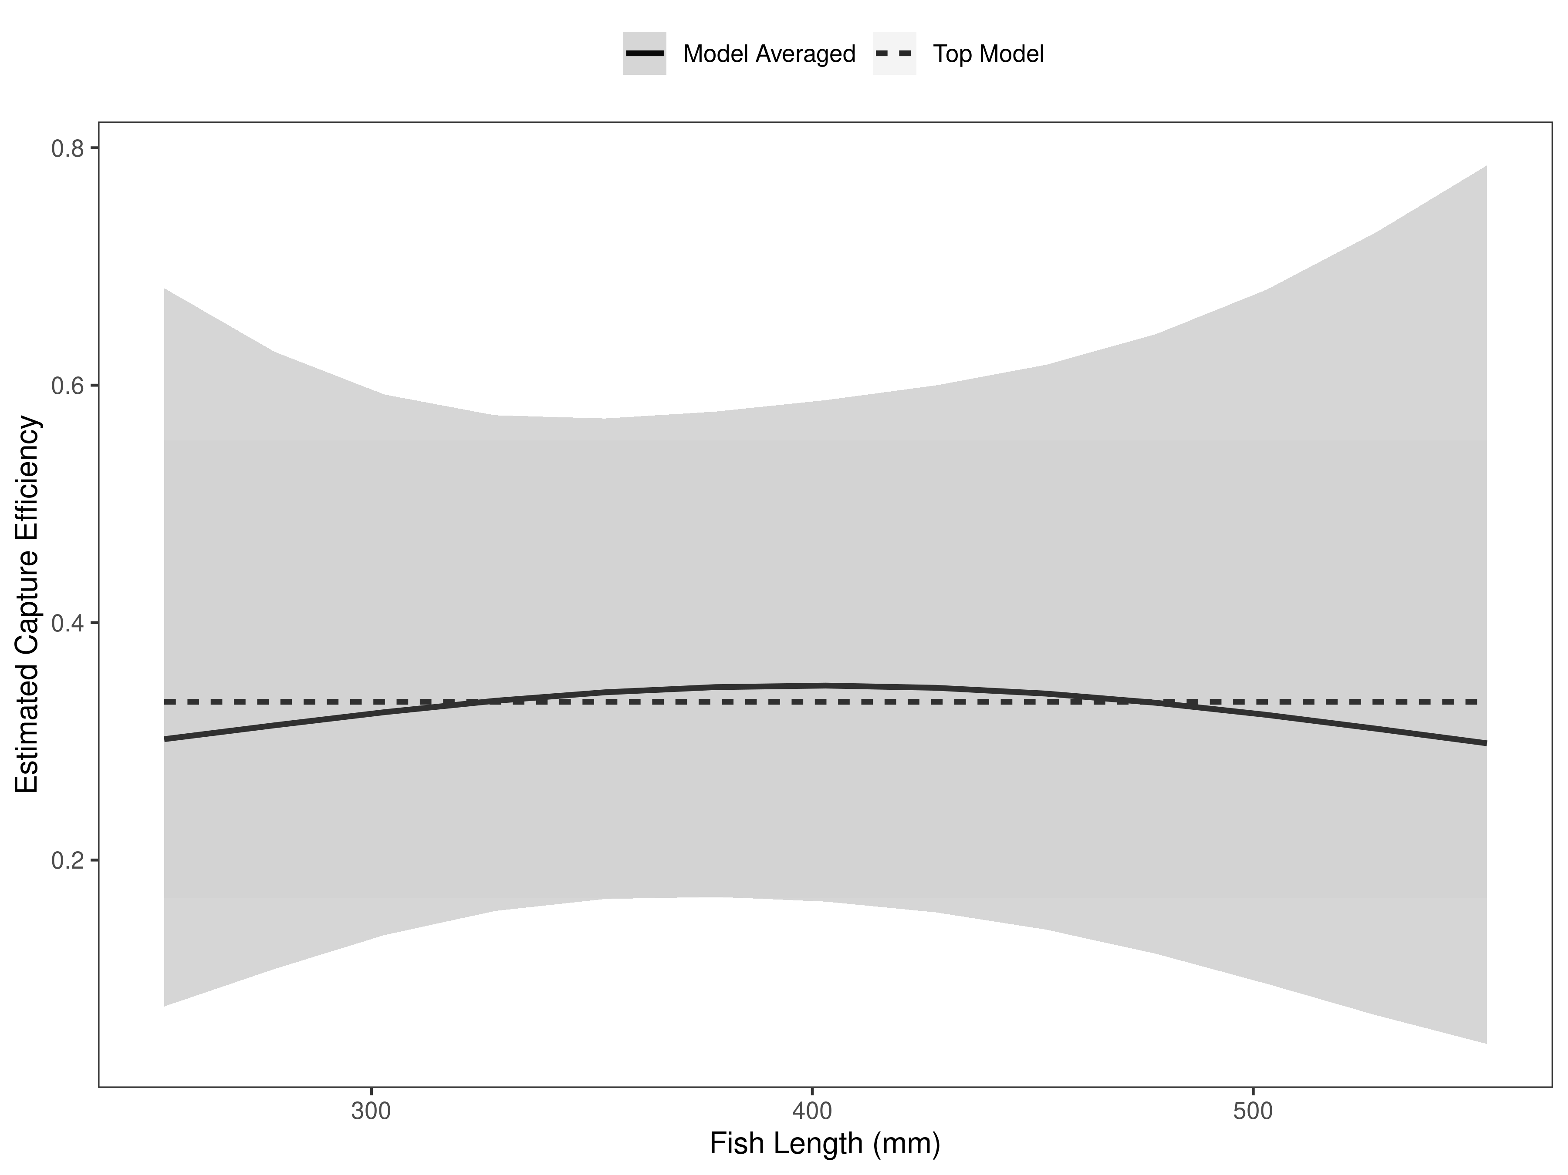
Figure 20. Model-averaged estimates of capture efficiency of brown trout in latest year.
Table 11. Model selection results from four models used for two-pass abundance estimation of brown trout in latest year. Models: `Len` = capture efficiency modeled as a function of length class, `Len.sq` = capture efficiency modeled as a quadratic function of length class with the intercept estimated, `FA+` = capture efficiency modeled as a quadratic function of length class with intercept fixed, `Null` = constant capture efficiency.
Model | K | AICc | deltaAICc | ModLik | AICcWt | LnLik | CumWt
Null | 1 | 28.94 | 0.000000 | 1.00 | 0.56 | -13.36680 | 0.56
FA+ | 2 | 30.91 | 1.963244 | 0.37 | 0.21 | -13.12035 | 0.77
Len | 2 | 31.40 | 2.456140 | 0.29 | 0.16 | -13.36680 | 0.94
Len.sq | 3 | 33.36 | 4.414663 | 0.11 | 0.06 | -12.97351 | 1.00

Brown Trout were estimated at 29 per kilometer in the Seyler Section in 2025 (Table 2). Brown Trout abundance was estimated to within ±7 fish (Table 2). This is an accurate abundance estimate especially when you consider how few fish are in the section.

Table 12. Model averaged abundance estimates of fish per kilometer (Pop. Estimate) across length groups and estimated biomass (Biomass Estimate, kg) for the latest year.
 |  | Pop. Estimate | 2.5% | 97.5% | Biomass Estimate | 2.5% | 97.5%
Brown Trout | 2025 | 29 | 22 | 36 | 51.6 | 36.3 | 66.9

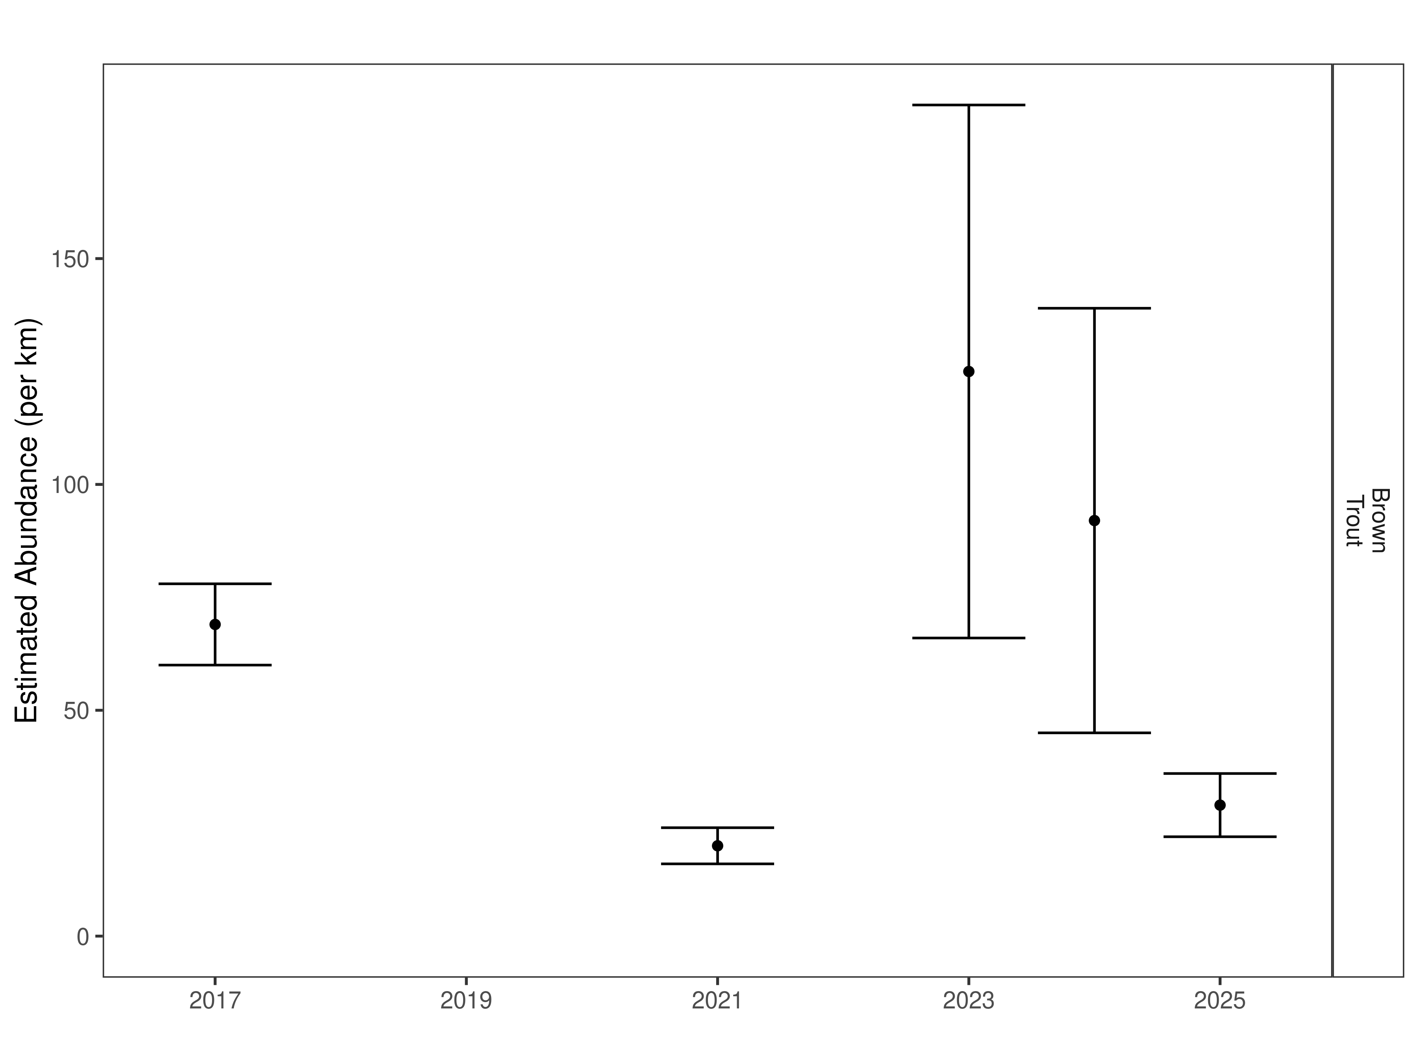
Figure 21. Seyler mark-recapture abundance estimates (fish per kilometer) through time using the maximum likelihood method. These estimates (mean and 95% confidence intervals) represent the model-averaged estimates across all length groups.
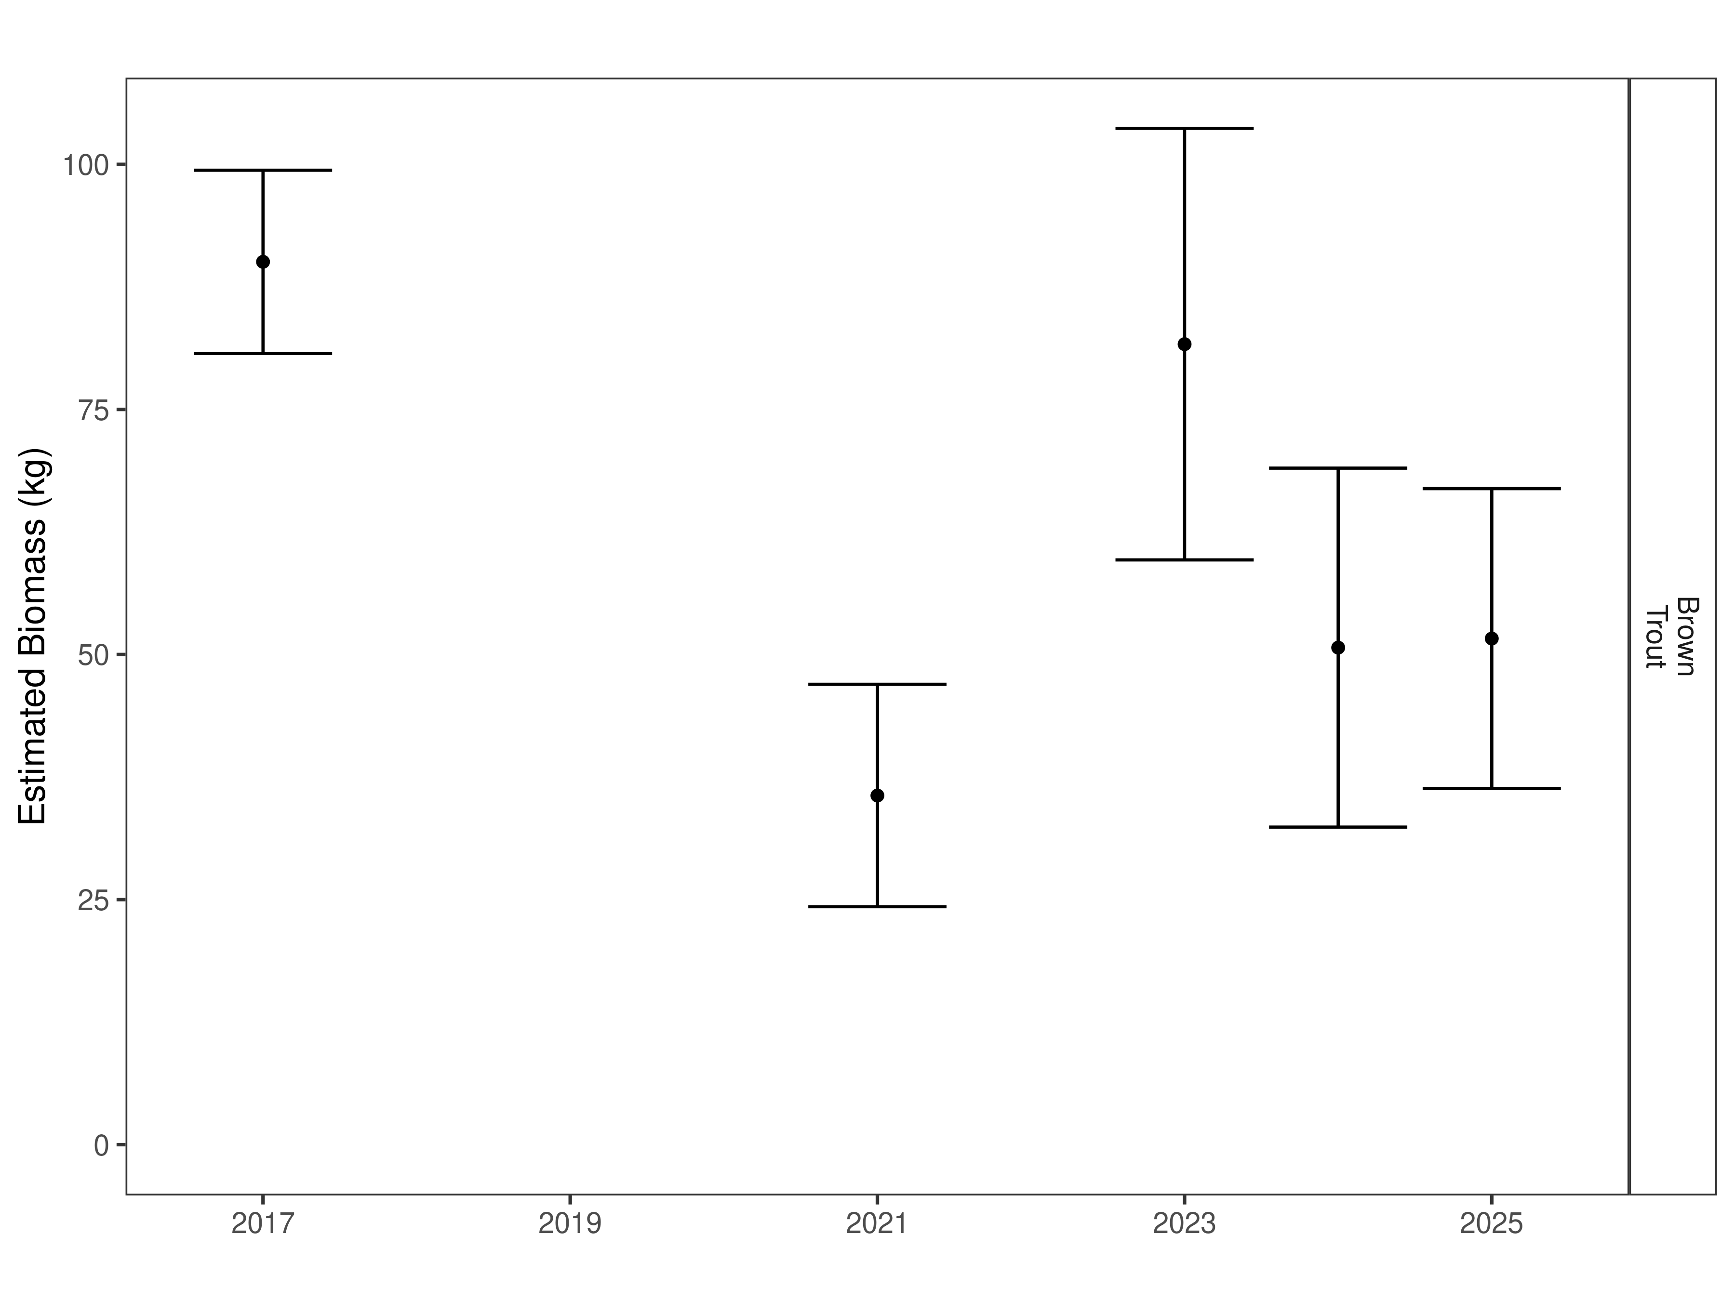
Figure 22. Seyler estimates of biomass through time.

Discussion
Restricted harvest or catch and release and fall-winter spawning closures are warranted for the lower and tailwater sections of the Ruby River, respectively. Trout abundances in the Ruby tailwater have been at historic lows for the past seven years while valley bottom sections have been slightly about the 25th percentile. A robust adaptive management approach is presently being developed for the Ruby River that will use historic data to model limiting factors and identify potential management actions that can be implemented in addition to angling regulations to more regularly meet population goals within each section.

References
Akaike, Hirotogu. 1998. “Information Theory and an Extension of the Maximum Likelihood Principle.” In Selected Papers of Hirotugu Akaike, 199–213. Springer.
Gabelhouse, Donald W. 1984. “A Length-Categorization System to Assess Fish Stocks.” North American Journal of Fisheries Management 4 (3): 273–85.
Neumann, R. M., and M. S. Allen. 2007. “Size Structure.” Analysis and Interpretation of Freshwater Fisheries Data. American Fisheries Society, Bethesda, Maryland, 375–421.
R Core Team. 2018. R: A Language and Environment for Statistical Computing. Vienna, Austria: R Foundation for Statistical Computing.
Wege, Gary J., and Richard O. Anderson. 1978. “Relative Weight (Wr): A New Index of Condition for Largemouth Bass.” New Approaches to the Management of Small Impoundments. American Fisheries Society, North Central Division, Special Publication 5: 79–91.
Williams, Byron K., James D. Nichols, and Michael J. Conroy. 2002. Analysis and Management of Animal Populations. Academic Press.

Supporting Information

Mark-recapture abundance estimates
Table S1. Vigilante FAS model-averaged estimates of abundance (fish per kilometer) and biomass (kg) for species and year.
 |  | Pop. Estimate | 2.5% | 97.5% | Biomass Estimate | 2.5% | 97.5%
Brown Trout | 1998 | 623 | 527 | 719 | 254.7 | 225.0 | 284.4
Brown Trout | 1999 | 771 | 712 | 830 | 249.3 | 230.8 | 267.8
Brown Trout | 2000 | 1,048 | 976 | 1,120 | 351.2 | 325.6 | 376.8
Brown Trout | 2001 | 898 | 845 | 951 | 354.8 | 339.4 | 370.2
Brown Trout | 2002 | 849 | 769 | 929 | 261.9 | 242.6 | 281.2
Brown Trout | 2003 | 774 | 700 | 848 | 262.1 | 243.3 | 280.9
Brown Trout | 2004 | 706 | 669 | 743 | 260.9 | 242.2 | 279.6
Brown Trout | 2005 | 790 | 752 | 828 | 260.4 | 243.9 | 276.8
Brown Trout | 2006 | 929 | 874 | 984 | 293.2 | 275.2 | 311.2
Brown Trout | 2007 | 1,333 | 1,273 | 1,393 | 341.6 | 323.4 | 359.8
Brown Trout | 2008 | 1,134 | 1,090 | 1,178 | 264.3 | 250.5 | 278.1
Brown Trout | 2009 | 1,266 | 1,207 | 1,325 | 376.9 | 356.9 | 396.9
Brown Trout | 2010 | 777 | 742 | 812 | 389.2 | 373.4 | 404.9
Brown Trout | 2011 | 1,049 | 967 | 1,131 | 509.2 | 474.7 | 543.6
Brown Trout | 2012 | 782 | 732 | 832 | 402.6 | 377.7 | 427.5
Brown Trout | 2013 | 1,287 | 1,246 | 1,328 | 548.7 | 532.9 | 564.5
Brown Trout | 2014 | 1,158 | 1,099 | 1,217 | 512.7 | 487.6 | 537.8
Brown Trout | 2015 | 1,021 | 982 | 1,060 | 508.2 | 487.8 | 528.5
Brown Trout | 2016 | 1,062 | 1,013 | 1,111 | 522.5 | 499.9 | 545.1
Brown Trout | 2017 | 803 | 782 | 824 | 413.5 | 402.2 | 424.8
Brown Trout | 2019 | 500 | 480 | 520 | 280.5 | 268.9 | 292.2
Brown Trout | 2020 | 446 | 428 | 464 | 266.1 | 254.9 | 277.4
Brown Trout | 2021 | 441 | 403 | 479 | 215.6 | 207.8 | 223.3
Brown Trout | 2022 | 532 | 516 | 548 | 229.7 | 222.5 | 236.9
Brown Trout | 2023 | 402 | 387 | 417 | 235.1 | 226.2 | 244.1
Brown Trout | 2024 | 476 | 433 | 519 | 284.4 | 260.5 | 308.4
Brown Trout | 2025 | 386 | 367 | 405 | 259.5 | 246.3 | 272.7

Mark-recapture abundance estimates
Table S2. Silver Springs model-averaged estimates of abundance (fish per kilometer) and biomass (kg) for species and year.
 |  | Pop. Estimate | 2.5% | 97.5% | Biomass Estimate | 2.5% | 97.5%
Brown Trout | 2012 | 364 | 290 | 438 | 206.6 | 175.9 | 237.3
Brown Trout | 2013 | 756 | 675 | 837 | 356.2 | 325.8 | 386.7
Brown Trout | 2014 | 493 | 449 | 537 | 282.6 | 258.1 | 307.1
Brown Trout | 2015 | 321 | 298 | 344 | 213.1 | 197.2 | 228.9
Brown Trout | 2016 | 296 | 124 | 468 | 194.2 | 149.6 | 238.8
Brown Trout | 2017 | 230 | 207 | 253 | 185.2 | 163.6 | 206.8
Brown Trout | 2018 | 156 | 136 | 176 | 129.2 | 112.9 | 145.6
Brown Trout | 2019 | 117 | 95 | 139 | 93.5 | 75.8 | 111.2
Brown Trout | 2020 | 139 | 117 | 161 | 135.1 | 114.8 | 155.4
Brown Trout | 2021 | 120 | 106 | 134 | 113.7 | 99.9 | 127.4
Brown Trout | 2022 | 156 | 143 | 169 | 155.8 | 141.5 | 170.1
Brown Trout | 2023 | 163 | 138 | 188 | 193.6 | 159.2 | 228.0
Brown Trout | 2024 | 179 | 108 | 250 | 142.0 | 115.6 | 168.3
Brown Trout | 2025 | 190 | 153 | 227 | 180.8 | 145.8 | 215.9

Mark-recapture abundance estimates
Table S3. Seyler model-averaged estimates of abundance (fish per kilometer) and biomass (kg) for species and year.
 |  | Pop. Estimate | 2.5% | 97.5% | Biomass Estimate | 2.5% | 97.5%
Brown Trout | 2017 | 69 | 60 | 78 | 90.1 | 80.7 | 99.4
Brown Trout | 2021 | 20 | 16 | 24 | 35.6 | 24.3 | 47.0
Brown Trout | 2023 | 125 | 66 | 184 | 81.7 | 59.6 | 103.7
Brown Trout | 2024 | 92 | 45 | 139 | 50.7 | 32.4 | 69.0
Brown Trout | 2025 | 29 | 22 | 36 | 51.6 | 36.3 | 66.9

