Introduction
Fisheries surveys were completed on the Yellowstone River in 2025. This sampling was part of long-term monitoring that has occurred in the Yellowstone River since 1978. Description of these efforts and discussion of the results are presented in this document.

Study Area
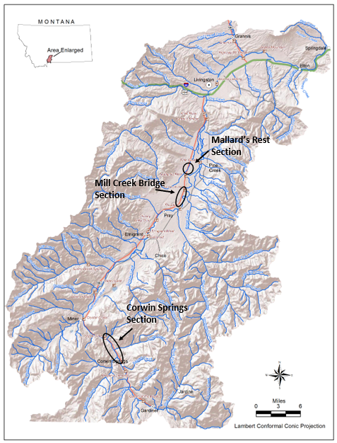
Figure 1. Long-term Yellowstone River sampling sections. The Mallard’s Rest section was not sampled in 2025.

Methods

Sampling methods
The Crowin Springs Section and the Mill Creek Bridge Section are long-term monitoring sections that have been sampled since 1978 and 1981, respectively. In 2025, the sections were sampled using the mark-recapture method to produce population abundance estimates for trout. PIT tagging efforts were also completed in these sections as part of a transition from mark-recapture population estimates to an open model of calculating population abundance. This transition is driven by the inability to complete mark-recapture efforts annually because of changing spring flow regimes in the river.
In 2025, the Mill Creek Bridge Section was marked on April 15 and 22. The recapture effort was completed on April 29. The Corwin Springs Section was marked on April 16 and 23. The recapture effort was completed on April 30.
No sampling occurred in the Mallard’s Rest Section in 2025.

Relative weight
Relative weights ($W_{r}$) were calculated as per (Wege and Anderson 1978):
$$W_{r}=\frac{W}{W_{s}}*100,$$
where $W$ was the weight of an individual fish and $W_{s}$ is the “standard weight” of a fish of the same length, derived from published length-weight relationships.

Condition
Fulton’s condition factor ($K$) was used to calculate the condition of fish:
$$K=\frac{W}{L^{3}}*c,$$
where $W$ was the weight of an individual fish, $L$ the length, and the constant $c$ a simple scaling factor.

Size Structure
The size structure of a fish population reflects a complex interplay of environmental drivers and population dynamics (Neumann and Allen 2007), and the relative frequencies of size classes provide a glimpse into these processes. We used descriptive statistics of lengths through time to describe the size structure of this fishery.
We used the FSA package (Ogle et al. 2018) in the R programming environment to calculate relative weights (R Core Team 2018).

Mark-recapture abundance estimates
Abundance was estimated using the Chapman modification of the Petersen estimator for abundance from a single census. This method assumes that the population is closed. We implemented this method using the FSA package (Ogle 2018) in the R programming environment (R Core Team 2018).

Results
Mill Creek Bridge Section

Data summary
In 2025, one brook trout that was 223.5 mm in length was captured (Table 1). Capture of brook trout in this section is rare. Two hundred seventy-one brown trout were captured with an average length of 332.9 mm. A total of 849 rainbow trout were captured in 2025. Their average length was 237.8 mm. In 2025, 125 trout that were hybrid crosses between rainbow and Yellowstone cutthroat trout were captured. These fish had an average length of 348.3 mm. Lastly, a total of 114 Yellowstone cutthroat with an average length of 293.1 mm trout were captured.
Table 1. Mill Creek Bridge Section Data summary for 2025.
 |  |  |  | Length |  |  |  |  | Weight |  |  | Condition |  |  | Relative Weight
 |  | n |  | Min | Max | Avg | SD |  | Avg | SD |  | Avg | SD |  | Avg | SD
Brook Trout |  | 1 |  | 223.5 | 223.5 | 223.5 | NA |  | 99.8 | NA |  | 32.3 | NA |  | 86.1 | NA
Brown Trout |  | 271 |  | 129.5 | 563.9 | 332.9 | 122.1 |  | 504.3 | 490.7 |  | 35.1 | 20.5 |  | 90.1 | 53.0
Rainbow Trout |  | 849 |  | 78.7 | 538.5 | 237.8 | 71.7 |  | 171.1 | 150.5 |  | 36.2 | 16.8 |  | 92.8 | 43.4
Rainbow X Yellowstone Cutthroat Hybrid |  | 125 |  | 137.2 | 482.6 | 348.3 | 75.7 |  | 453.7 | 239.7 |  | 35.6 | 8.9 |  | NA | NA
Yellowstone Cutthroat Trout |  | 114 |  | 157.5 | 472.4 | 293.1 | 67.7 |  | 293.1 | 221.5 |  | 35.3 | 3.4 |  | 86.1 | 8.0

Relative Weights
In 2025, Relative weights for brown trout were higher than 2023 and 2024 (Figure 2). Relative weights for rainbow trout remained similar for all three years. Relative weights for Yellowstone cutthroat trout were lower in 2025 when compared to 2023 and 2024.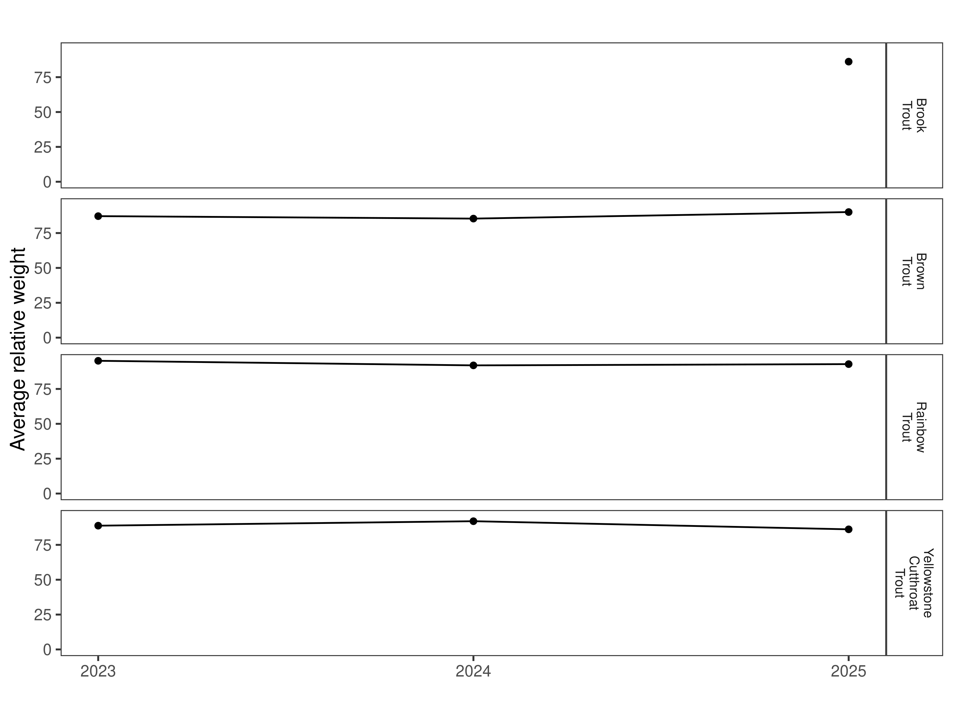
Figure 2. Relative weights of trout species in the Mill Creek Bridge Section for 2023, 2024, and 2025.

Size Structure
Distribution of lengths for brown, rainbow, and Yellowstone cutthroat trout, in 2025, overlapped with the previous two years (Figure 3 and Figure 4). The length distribution for Yellowstone cutthroat was slightly wider than the previous two years.
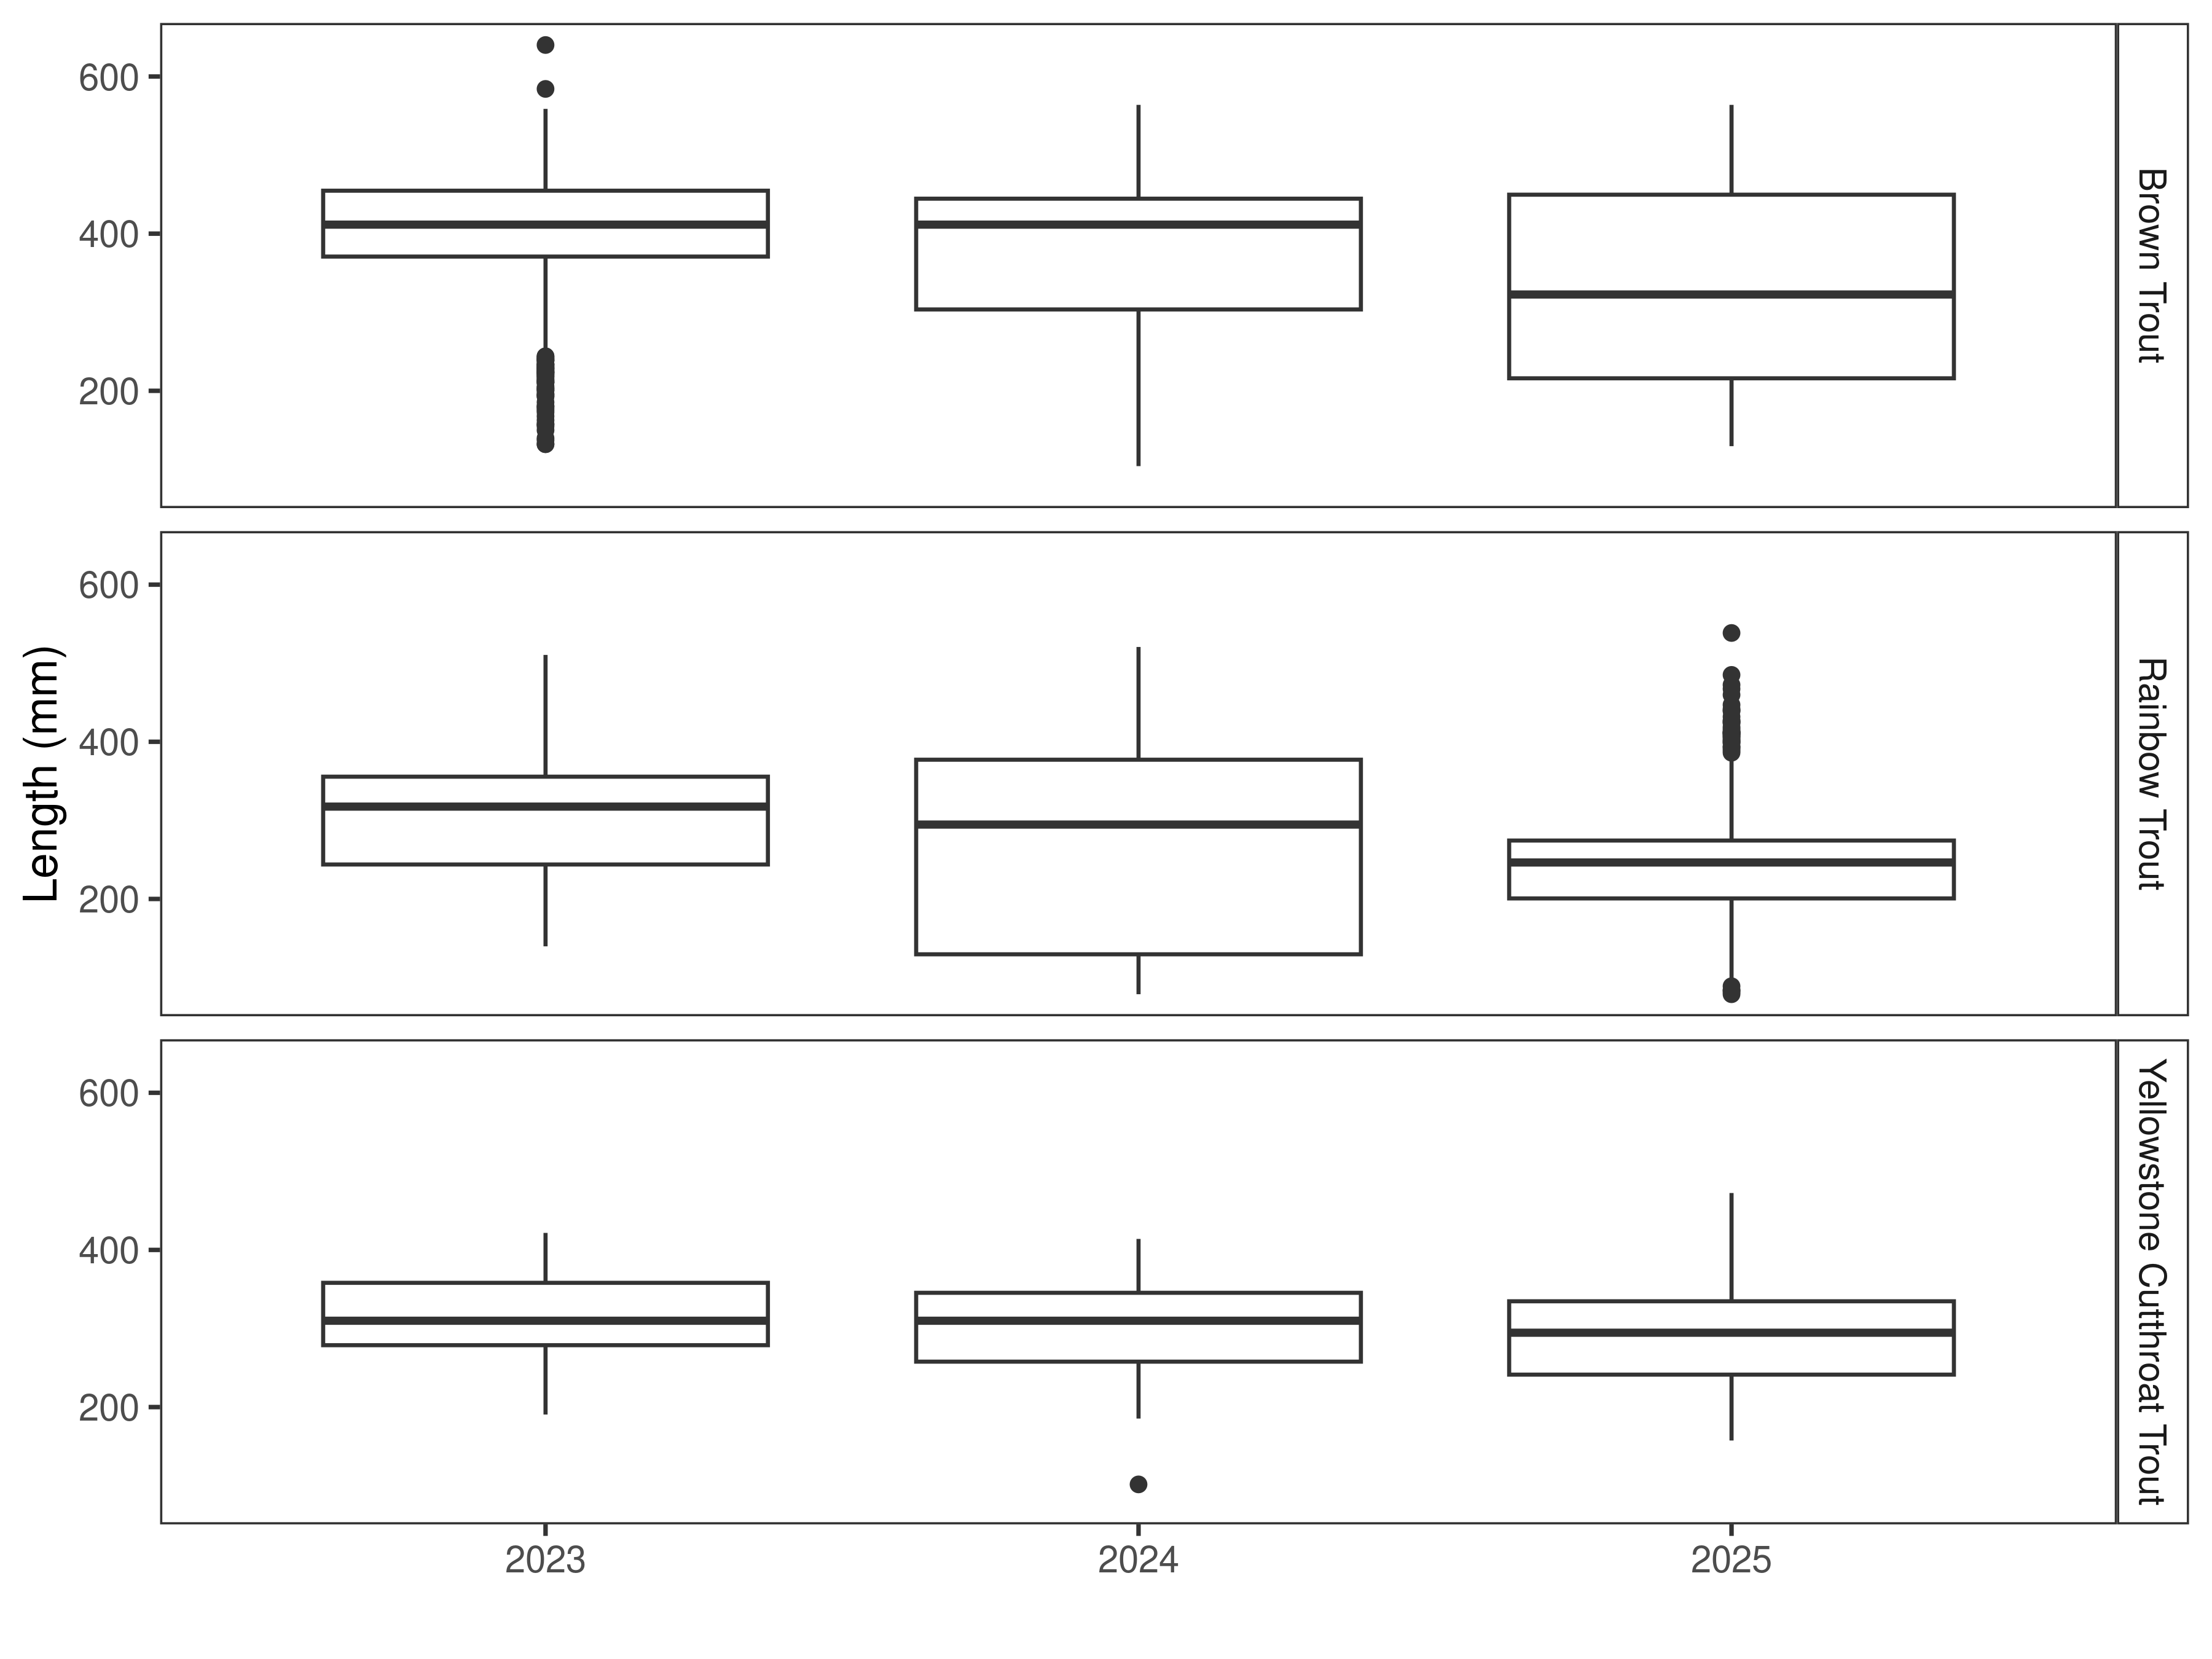
Figure 3. Distribution of lengths for 2023, 2024, and 2025. The box-and-whisker plots divide the distribution of the data into the first quartile (the lower limit of the box), the median (heavy black line), and third quartile (the upper limit of the box). The whiskers denote data points within 1.5 * the interquartile range (the difference between the first and third quartiles). Dots denote data points further than 1.5 * the interquartile range from the box.
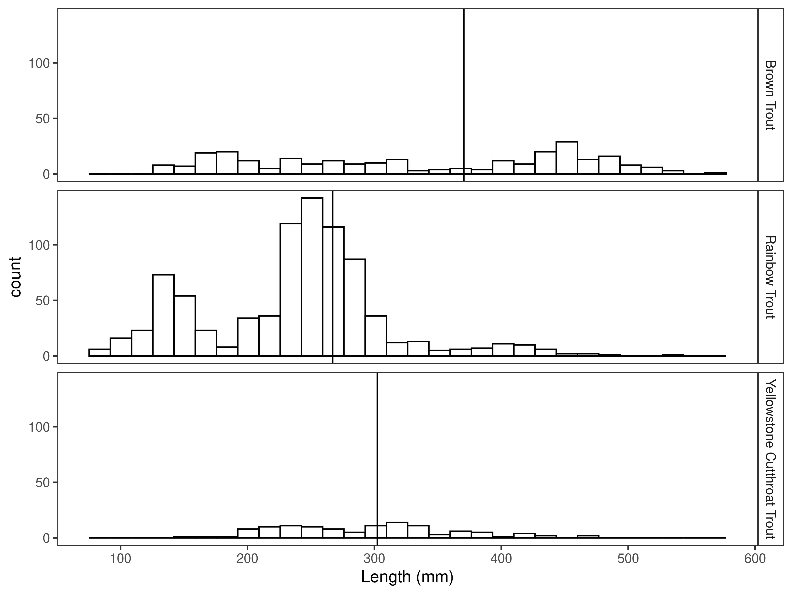
Figure 4. Length distribution by species for 2025, with long-term species-averages indicated by the vertical black line.

Mark-recapture abundance estimates
Abundance estimates for brown trout in the Mill Creek Bridge Section increased from 2004 (103/km) to 2025 (115/km) yet remained lower than the 2023 (150/km) estimate (Figure 5 and Table 2). The biomass estimates for brown trout decreased from 2023 (694.2 kg/km) to 2025 (412.3 kg/km) (Figure 6 and Table 2).
Rainbow trout abundance estimates decreased from 2024 (305/km) to 2025 (229/km) but remained higher than 2023 (180/km). Biomass estimates for rainbow trout increased from 2023(431.3 kg/km) to 2024(766.8 kg/km) and then declined in 2025(279.1 kg/km).
Abundance estimates for Yellowstone cutthroat trout were increased from 2023 (19/km) to 2024 (40/km). In 2025, the abundance decreased to 35/km but remained higher than 2023. Yellowstone cutthroat trout biomass estimates also increased from 2023 (50.3 kg/km) to 2024 (90.3 kg/km) and then decreased to 72.8 kg/km in 2025.
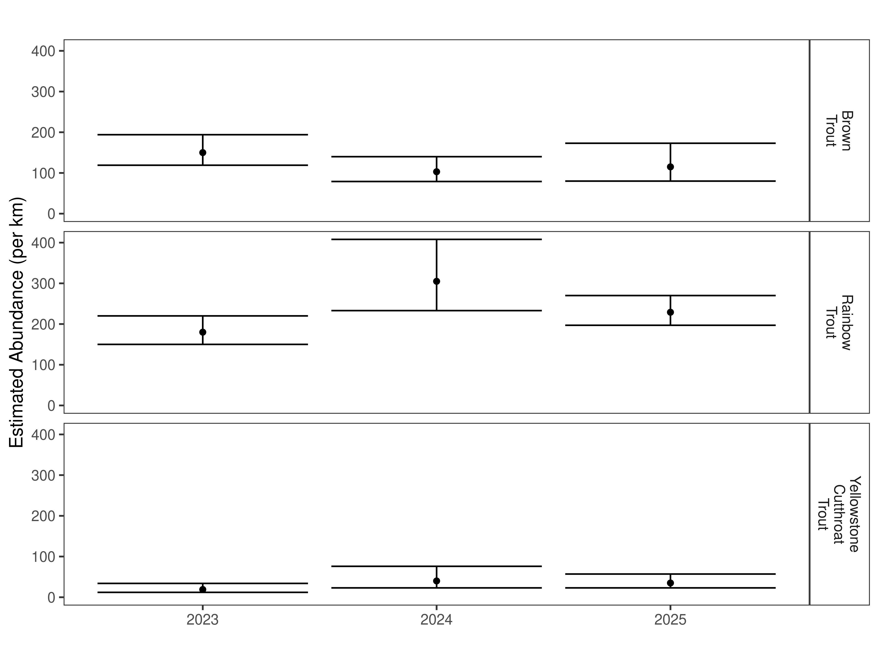
Figure 5. Mark-recapture abundance estimates (fish per kilometer) through time using the Chapman estimator. These estimates (mean and 95% confidence intervals) represent the model-averaged estimates across all length groups.
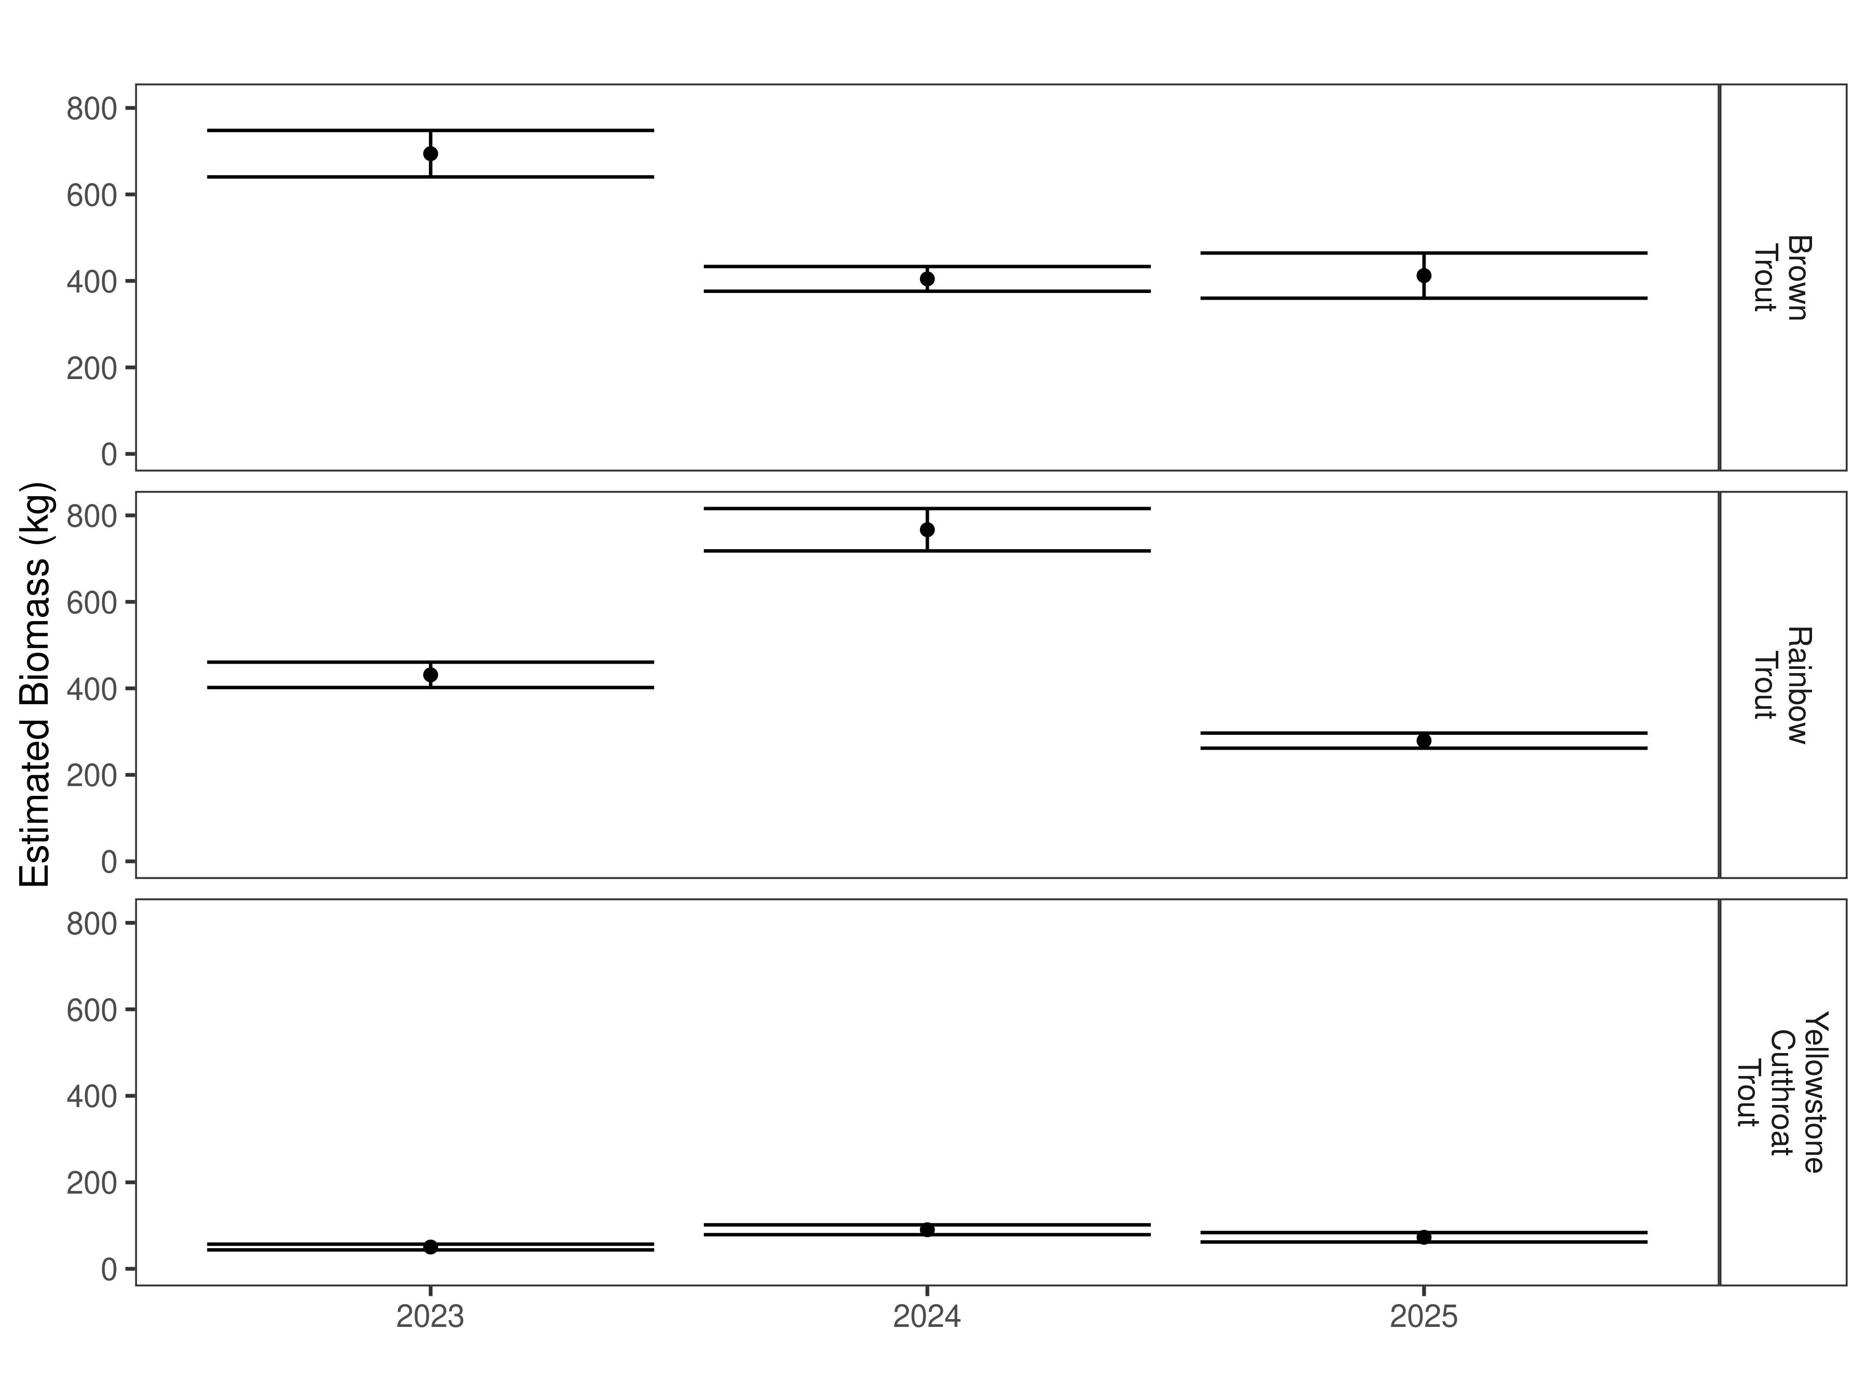
Figure 6. Estimates of biomass for 2023, 2024, and 2025.
Table 2. Abundance estimates of fish per kilometer (Pop. Estimate) across length groups and estimated biomass (Biomass Estimate, kg) for the latest year.
 |  | Pop. Estimate | 2.5% | 97.5% | Biomass Estimate | 2.5% | 97.5%
Brown Trout | 2025 | 115 | 80 | 173 | 412.3 | 360.1 | 464.5
Rainbow Trout | 2025 | 229 | 197 | 270 | 279.1 | 261.7 | 296.6
Rainbow X Yellowstone Cutthroat Hybrid | 2025 | 27 | 19 | 39 | 86.0 | 77.3 | 94.7
Yellowstone Cutthroat Trout | 2025 | 35 | 23 | 57 | 72.8 | 61.9 | 83.7

Corwin Springs Section

Data summary
In 2025, 359 brown trout were captured with an average length of 331.4 mm (Table 1). A total of 508 rainbow trout were captured in 2025. Their average length was 248.8mm. In 2025, 140 trout that were hybrid crosses between rainbow and Yellowstone cutthroat trout were captured. These fish had an average length of 339.9 mm. Lastly, a total of 413 Yellowstone cutthroat with an average length of 297.4 mm trout were captured.
Table 3. Corwin Springs Section data summary for 2025.
 |  |  |  | Length |  |  |  |  | Weight |  |  | Condition |  |  | Relative Weight
 |  | n |  | Min | Max | Avg | SD |  | Avg | SD |  | Avg | SD |  | Avg | SD
Brown Trout |  | 359 |  | 129.5 | 535.9 | 331.4 | 103.7 |  | 437.2 | 322.7 |  | 34.1 | 7.2 |  | 87.6 | 18.3
Rainbow Trout |  | 508 |  | 83.8 | 472.4 | 248.8 | 82.0 |  | 202.4 | 178.2 |  | 37.3 | 22.7 |  | 95.4 | 58.7
Rainbow X Yellowstone Cutthroat Hybrid |  | 140 |  | 137.2 | 523.2 | 339.9 | 70.1 |  | 422.9 | 227.8 |  | 35.6 | 8.4 |  | NA | NA
Yellowstone Cutthroat Trout |  | 413 |  | 157.5 | 472.4 | 297.4 | 53.0 |  | 291.7 | 146.9 |  | 36.6 | 3.9 |  | 89.2 | 9.6

Relative Weights
In 2025, Relative weights for brown, rainbow, and Yellowstone cutthroat trout were all higher than 2023 and 2024 (Figure 7).
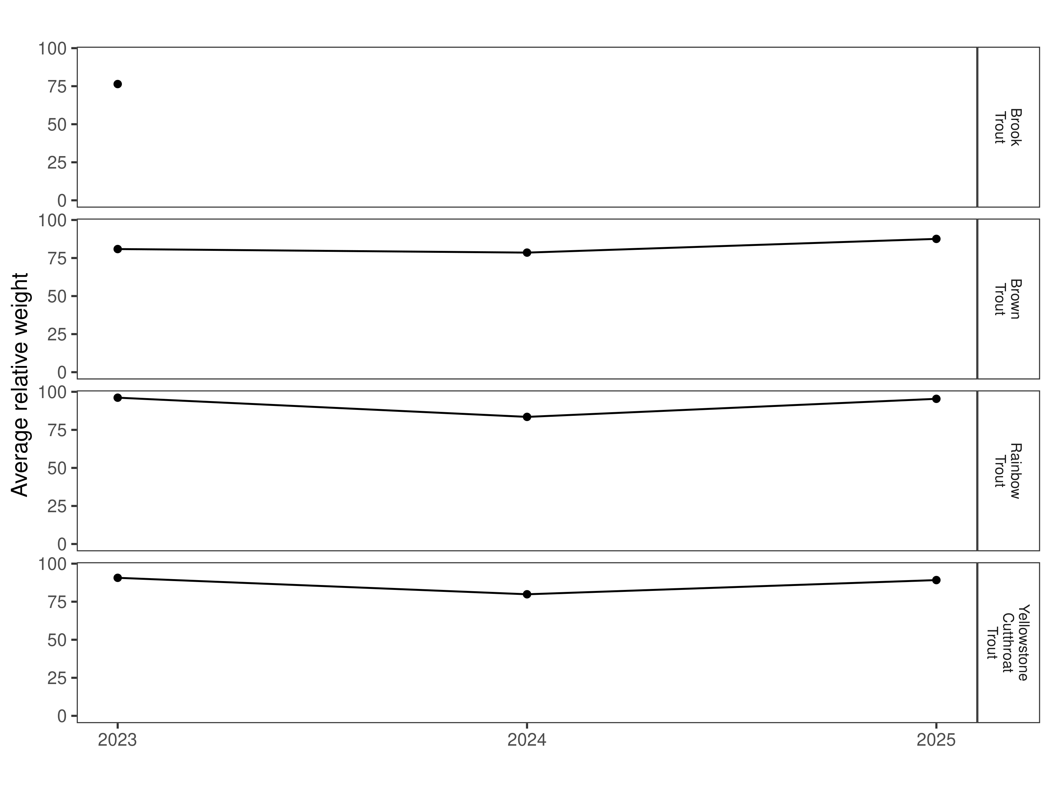
Figure 7. Relative weight through time.

Size Structure
Distribution of lengths for brown, rainbow, and Yellowstone cutthroat trout, in 2025, overlapped with the previous two years (Figure 8 and Figure 9). The length distribution for brown and Yellowstone cutthroat were slightly wider than the previous two years. The rainbow trout length distribution range shifted downward with more small fish and less large fish.

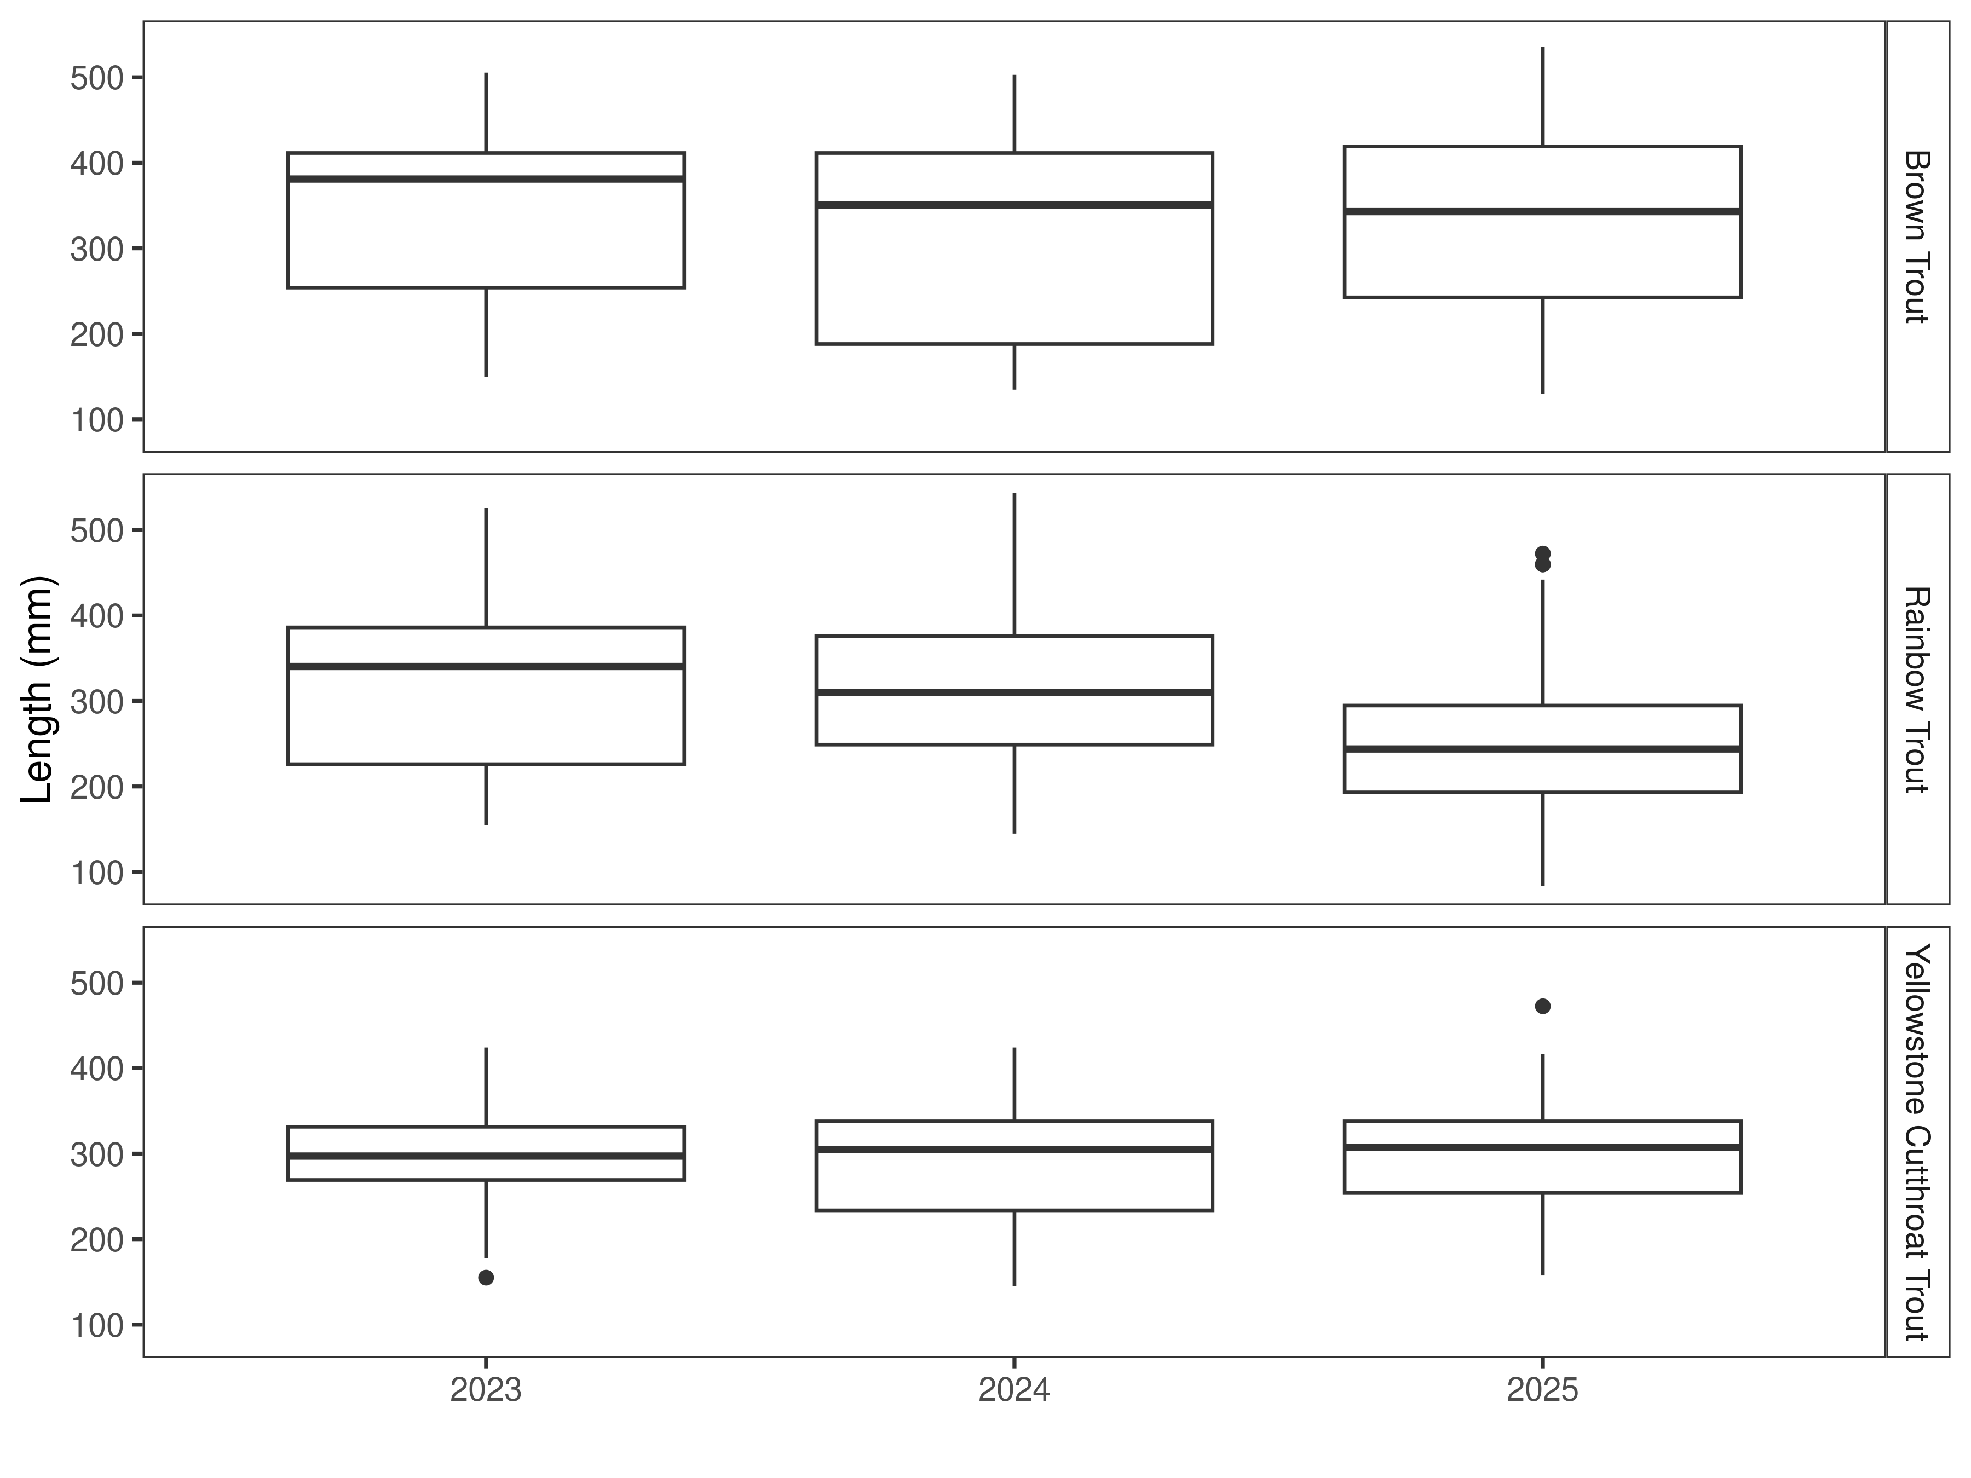
Figure 8. Distribution of lengths through time. The box-and-whisker plots divide the distribution of the data into the first quartile (the lower limit of the box), the median (heavy black line), and third quartile (the upper limit of the box). The whiskers denote data points within 1.5 * the interquartile range (the difference between the first and third quartiles). Dots denote data points further than 1.5 * the interquartile range from the box.
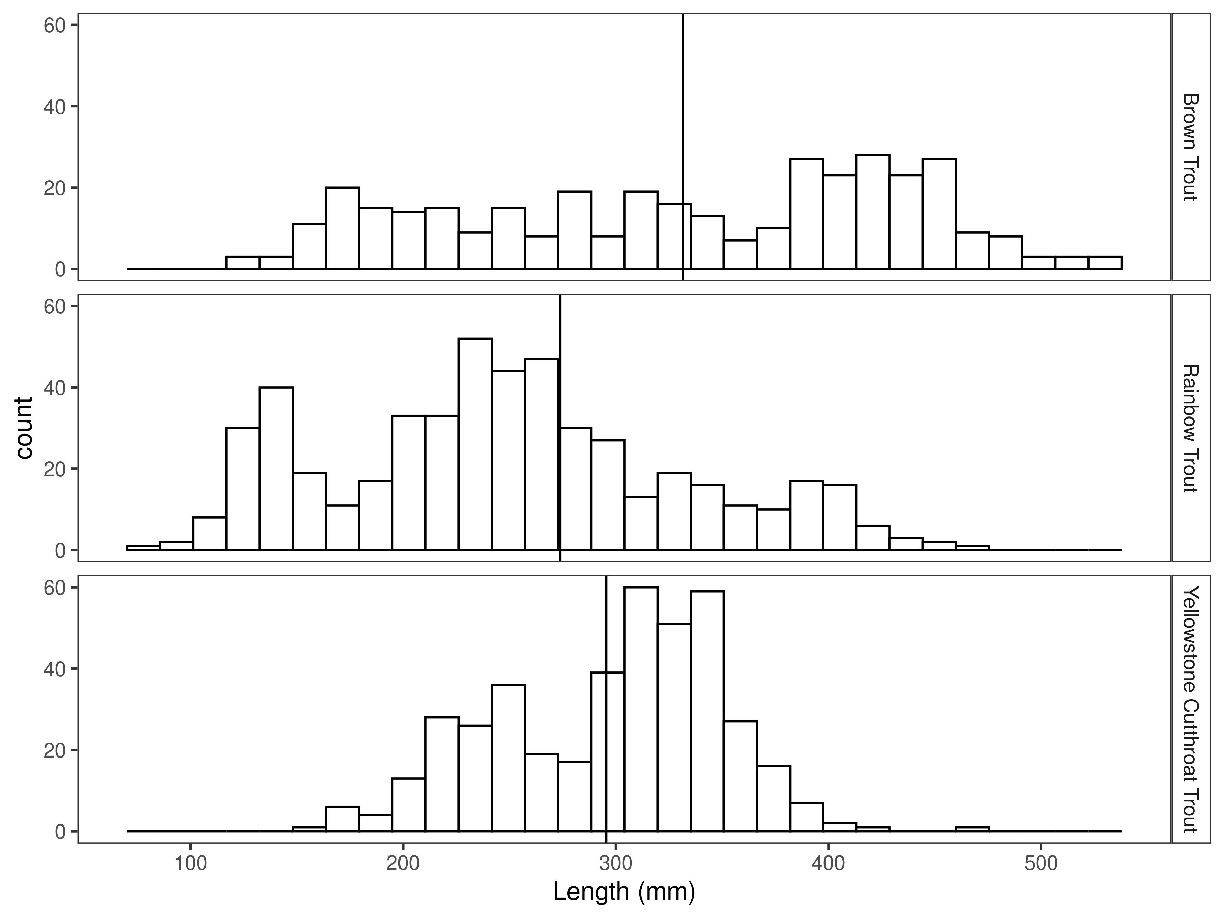
Figure 9. Length distribution by species for latest year, with long-term species-averages indicated by the vertical black line.

Mark-recapture abundance estimates
River conditions prevented enough sampling to complete abundance estimates in 2023 and 2024.
In 2025, the abundance estimates for brown trout in the Corwin Springs Section was (211/km) (Figure 10 and Table 4). The biomass estimate for brown trout was (605.5 kg/km) (Figure 11 and Table 4).
The rainbow trout abundance estimate for 2025 was (431/km) and the biomass estimate was (572.7 kg/km).
The abundance estimate for Yellowstone cutthroat was (163/km) in 2025 and the biomass estimate was 311.8 kg/km.

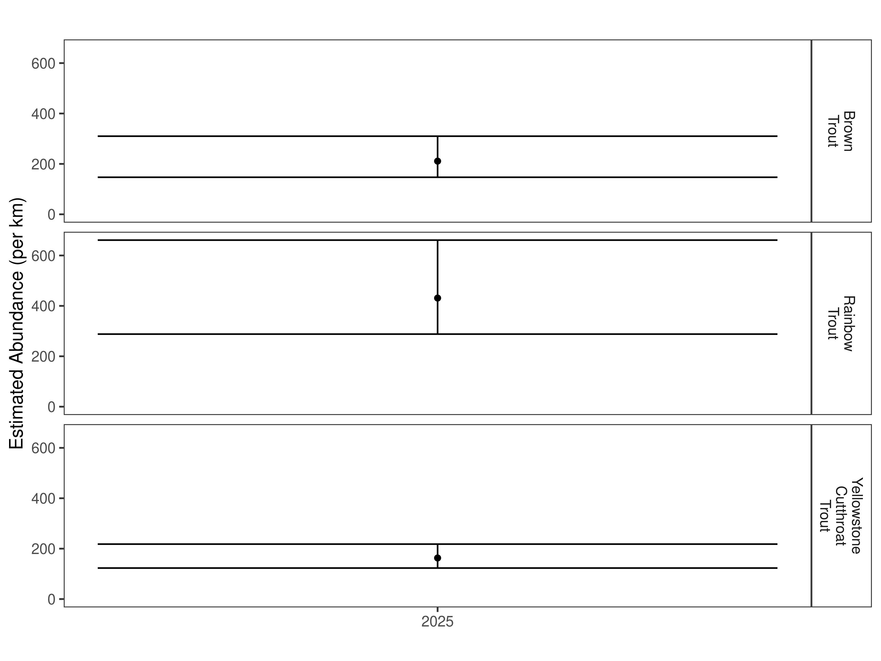
Figure 10. Mark-recapture abundance estimates (fish per kilometer) through time using the Chapman estimator. These estimates (mean and 95% confidence intervals) represent the model-averaged estimates across all length groups.
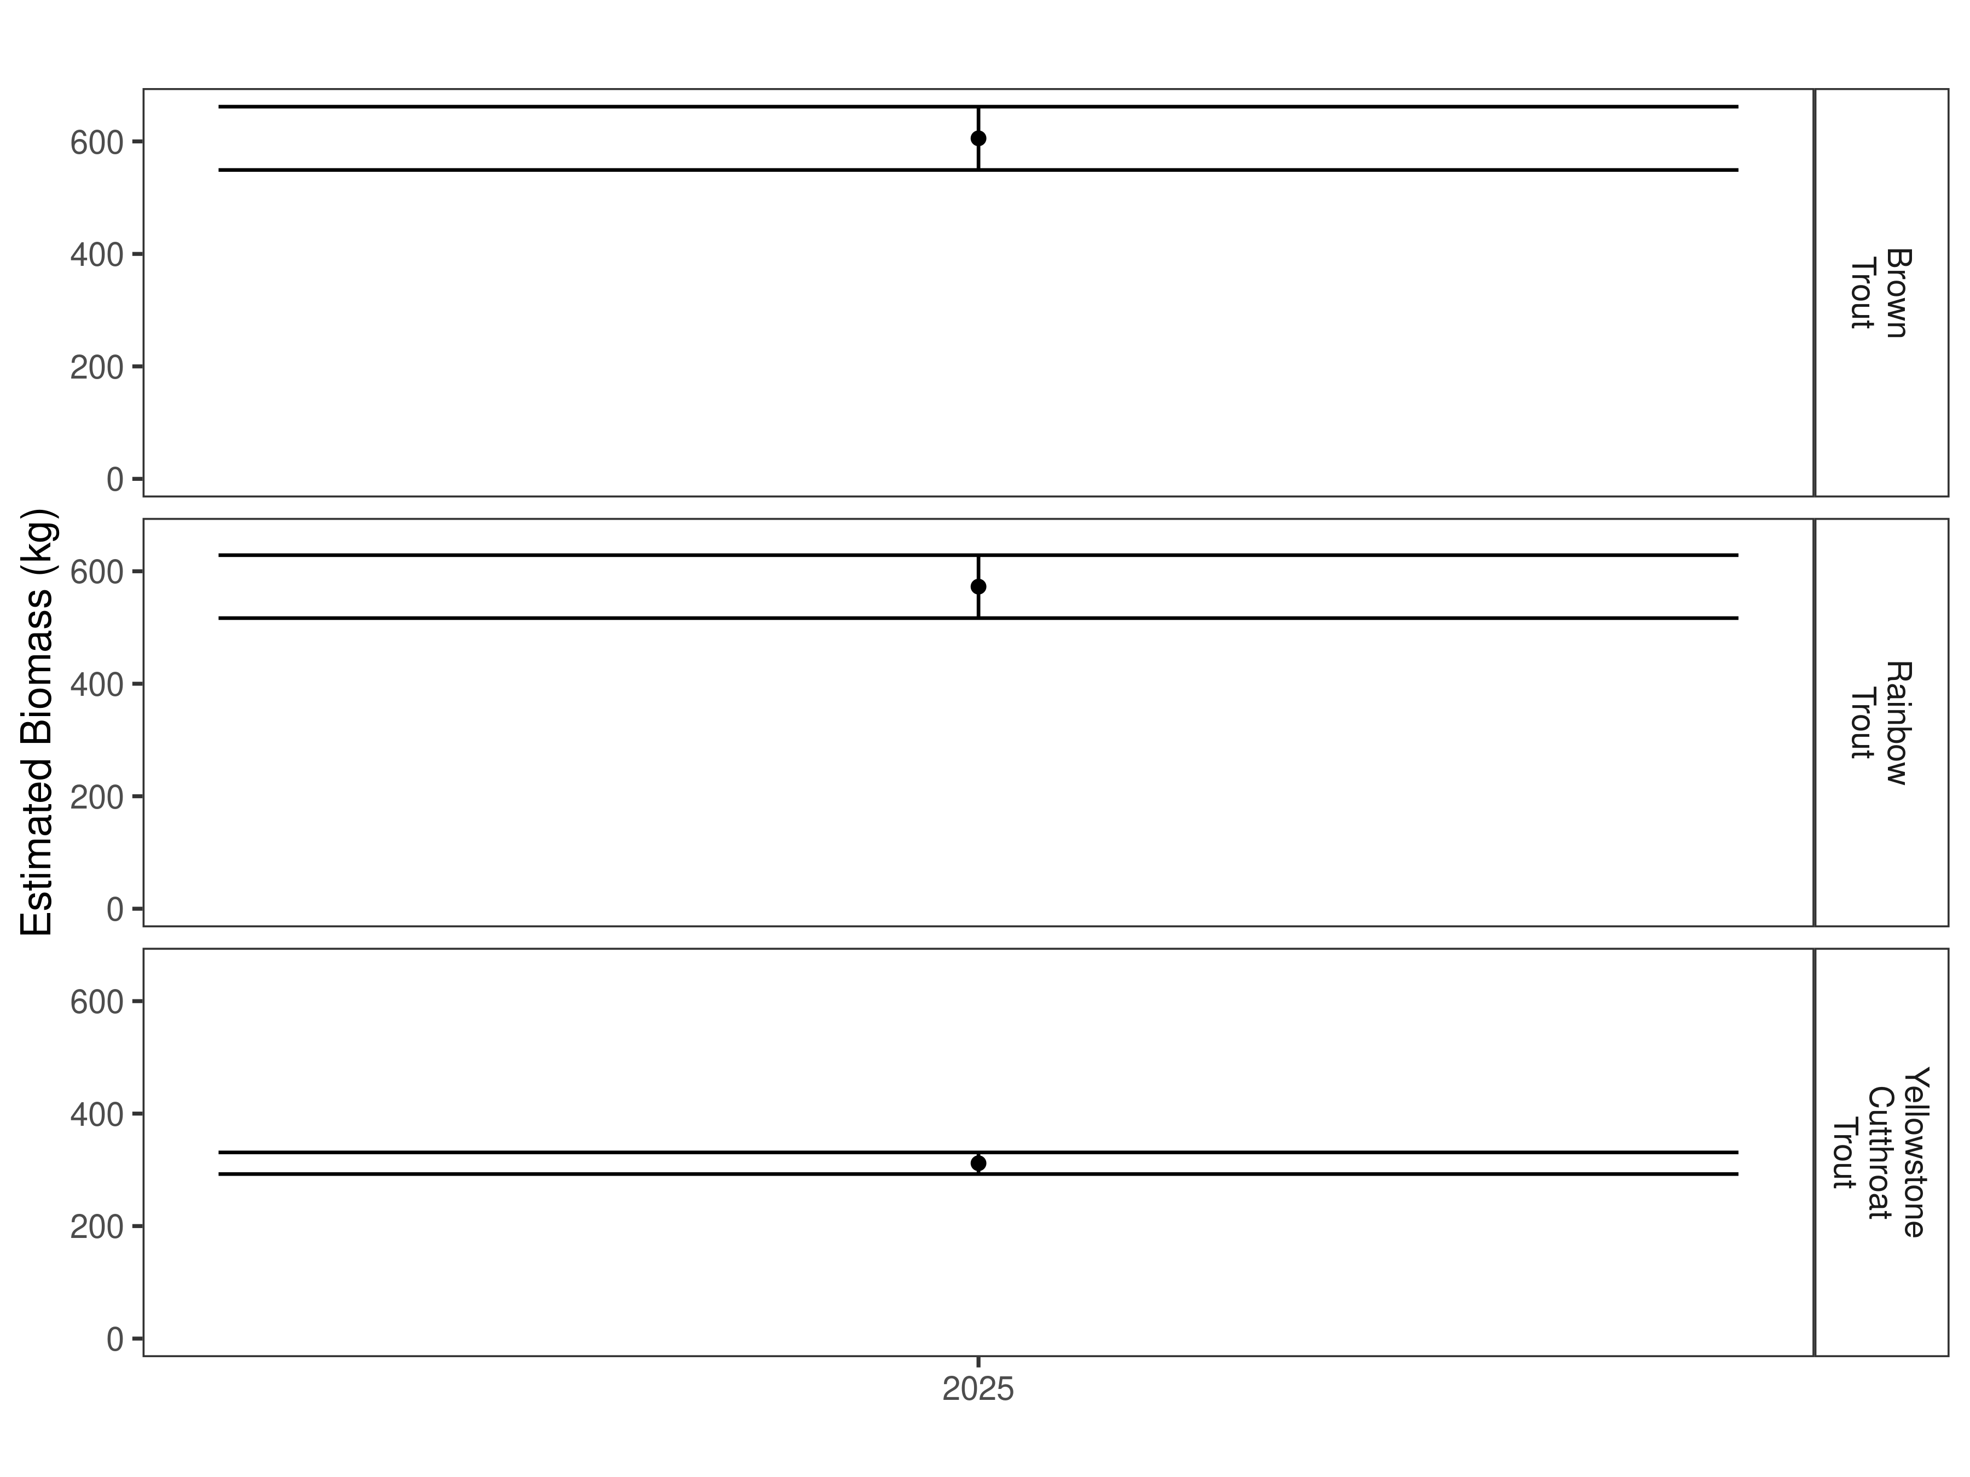
Figure 11. Estimates of biomass through time.
Table 4. Abundance estimates of fish per kilometer (Pop. Estimate) across length groups and estimated biomass (Biomass Estimate, kg) for the latest year.
 |  | Pop. Estimate | 2.5% | 97.5% | Biomass Estimate | 2.5% | 97.5%
Brown Trout | 2025 | 211 | 147 | 310 | 605.5 | 549.2 | 661.8
Rainbow Trout | 2025 | 431 | 288 | 661 | 572.7 | 516.7 | 628.7
Yellowstone Cutthroat Trout | 2025 | 163 | 123 | 218 | 311.8 | 292.5 | 331.0

Discussion
Over the last three years, populations of brown, rainbow, and Yellowstone cutthroat trout in the Mill Creek Bridge Section have been relatively stable with some annual fluctuation. Both brown and rainbow trout have had biomass decreases since 2023. Rainbow trout in the Mill Creek Bridge Section have two strong year classes of younger fish, while brown and Yellowstone cutthroat trout have relatively even distribution of years based on length distribution.
Future sampling in the Corwin Springs Section will provide a better indication of trout population trends in this section. Flow conditions in the Yellowstone River have made sampling under a traditional mark-recapture effort more difficult during the last decade. Efforts are underway to transition to an open model population estimate that would allow for the completion of estimates, especially in years that river conditions are not conducive for traditional mark-recapture efforts.

References
Gabelhouse, Donald W. 1984. “A Length-Categorization System to Assess Fish Stocks.” North American Journal of Fisheries Management 4 (3): 273–85.
Neumann, R. M., and M. S. Allen. 2007. “Size Structure.” Analysis and Interpretation of Freshwater Fisheries Data. American Fisheries Society, Bethesda, Maryland, 375–421.
Ogle, D. H. 2018. FSA: Fisheries Stock Analysis. R Package Version 0.8. 20.9000.
R Core Team. 2018. R: A Language and Environment for Statistical Computing. Vienna, Austria: R Foundation for Statistical Computing.
Wege, Gary J., and Richard O. Anderson. 1978. “Relative Weight (Wr): A New Index of Condition for Largemouth Bass.” New Approaches to the Management of Small Impoundments. American Fisheries Society, North Central Division, Special Publication 5: 79–91.

Supporting Information

Mark-recapture abundance estimates
Table S1. Model-averaged estimates of abundance (fish per kilometer) and biomass (kg) for species and year for the Mill Creek Bridge Section.
 |  | Pop. Estimate | 2.5% | 97.5% | Biomass Estimate | 2.5% | 97.5%
Brown Trout | 2023 | 150 | 119 | 194 | 694.2 | 640.5 | 748.0
Brown Trout | 2024 | 103 | 79 | 140 | 404.7 | 376.1 | 433.3
Brown Trout | 2025 | 115 | 80 | 173 | 412.3 | 360.1 | 464.5
Rainbow Trout | 2023 | 180 | 150 | 220 | 431.3 | 401.9 | 460.6
Rainbow Trout | 2024 | 305 | 233 | 408 | 766.8 | 717.9 | 815.8
Rainbow Trout | 2025 | 229 | 197 | 270 | 279.1 | 261.7 | 296.6
Yellowstone Cutthroat Trout | 2023 | 19 | 12 | 34 | 50.3 | 43.6 | 56.9
Yellowstone Cutthroat Trout | 2024 | 40 | 23 | 76 | 90.3 | 78.9 | 101.6
Yellowstone Cutthroat Trout | 2025 | 35 | 23 | 57 | 72.8 | 61.9 | 83.7

Mark-recapture abundance estimates
Table S2. Model-averaged estimates of abundance (fish per kilometer) and biomass (kg) for species and year for the Corwin Springs Section.
 |  | Pop. Estimate | 2.5% | 97.5% | Biomass Estimate | 2.5% | 97.5%
Brown Trout | 2023 | 150 | 119 | 194 | 694.2 | 640.5 | 748.0
Brown Trout | 2024 | 103 | 79 | 140 | 404.7 | 376.1 | 433.3
Brown Trout | 2025 | 115 | 80 | 173 | 412.3 | 360.1 | 464.5
Rainbow Trout | 2023 | 180 | 150 | 220 | 431.3 | 401.9 | 460.6
Rainbow Trout | 2024 | 305 | 233 | 408 | 766.8 | 717.9 | 815.8
Rainbow Trout | 2025 | 229 | 197 | 270 | 279.1 | 261.7 | 296.6
Rainbow X Yellowstone Cutthroat Hybrid | 2024 | 8 | 4 | 20 | 30.0 | 24.7 | 35.2
Rainbow X Yellowstone Cutthroat Hybrid | 2025 | 27 | 19 | 39 | 86.0 | 77.3 | 94.7
Yellowstone Cutthroat Trout | 2023 | 19 | 12 | 34 | 50.3 | 43.6 | 56.9
Yellowstone Cutthroat Trout | 2024 | 40 | 23 | 76 | 90.3 | 78.9 | 101.6
Yellowstone Cutthroat Trout | 2025 | 35 | 23 | 57 | 72.8 | 61.9 | 83.7

