Introduction
Fisheries surveys were completed on the Shields River in 2025. This electrofishing sampling effort was a combination of long-term monitoring that has occurred since 1975 and the addition of new sections to gain better understanding of the distribution and abundance of fish populations throughout the Shields River. Description of these efforts and discussion of the results are presented in this document.

Study Area
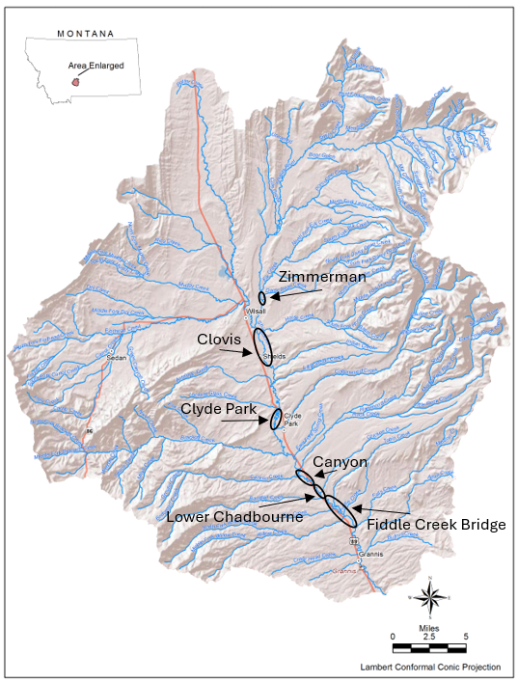
Figure 1. Map displaying the Shields River sampling section for 2025.

Methods

Sampling methods
The Zimmerman Section is a long-term monitoring section that has been sampled since 1975. The Clovis, Clyde Park, Canyon, Lower Chadbourne, and Fiddle Creek Bridge Sections were new in 2025. In 2025, all sections were sampled using the mark-recapture method to produce population abundance estimates for trout. PIT tagging efforts were also completed in these sections as part of an effort to track fish movement with an emphasis on Yellowstone cutthroat trout. Genetic samples were collected for fish that were identified as Yellowstone cutthroat trout, rainbow trout, and rainbow x Yellowstone hybrids.
In 2025, the Zimmerman Section was marked on March 27 and the recapture effort was completed on April 3. The Clyde Park Section was marked on March 26 and recaptured April 2. The Canyon Section was marked on March 1 and recaptured on March 8. The Clovis Section was marked on March 9 and no recapture was completed on this section due to high spring flows. The Lower Chadbourne Section was marked on June 24 and 26 and was recaptured on July 2. The Fiddle Creek Bridge Section was marked on June 25 and recaptured on July 1.

Relative weight
Relative weights ($W_{r}$) were calculated as per (Wege and Anderson 1978):
$$W_{r}=\frac{W}{W_{s}}*100,$$
where $W$ is the weight of an individual fish and $W_{s}$ is the “standard weight” of a fish of the same length, derived from published length-weight relationships.

Condition
Fulton’s condition factor ($K$) was used to calculate the condition of fish:
$$K=\frac{W}{L^{3}}*c,$$
where $W$ was the weight of an individual fish, $L$ the length, and the constant $c$ a simple scaling factor.

Size Structure
The size structure of a fish population reflects a complex interplay of environmental drivers and population dynamics (Neumann and Allen 2007), and the relative frequencies of size classes provide a glimpse into these processes. We used two methods to describe the size structure of this fishery: 1) descriptive statistics of lengths through time, and 2) proportional stock density. Proportional stock density is the percentage of fish in each of set of length classes specific to each species of fish. We used the Gabelhouse classification scheme to partition fish into one of six classes: 1) sub-stock, 2) stock, 3) quality, 4) preferred, 5) memorable, and 6) trophy (Gabelhouse 1984). We then calculated the proportional stock density (PSD) of each class as:
$${\text{PSD}}_{\text{class}}=100\left(\frac{\text{number of fish in class}}{\text{total number of fish}}\right).$$
We used the FSA package (Ogle et al. 2018) in the R programming environment to calculate relative weights (R Core Team 2018).

Mark-recapture abundance estimates
Abundance was estimated using the Chapman modification of the Petersen estimator for abundance from a single census. This method assumes that the population is closed. We implemented this method using the FSA package (Ogle 2018) in the R programming environment (R Core Team 2018).

Results
Zimmerman Section

Data summary
In 2025, a total of five brook trout with an average length of 217.9 mm were captured (Table 1). One hundred forty-nine brown trout were captured with an average length of 333.5 mm. A total of 23 Yellowstone cutthroat trout were captured. Their average length was 330.2 mm. In 2025, 2 trout that were hybrid crosses between rainbow and Yellowstone cutthroat trout were captured. These fish had an average length of 375.9 mm. Lastly, a total of 301 mountain whitefish with an average length of 302.1 mm trout were captured.
No rainbow trout were captured in 2025 but one was captured in this section in 2024.

Table 1. Data summary for the Zimmerman Section in 2025.
 |  |  |  | Length |  |  |  |  | Weight |  |  | Condition |  |  | Relative Weight
 |  | n |  | Min | Max | Avg | SD |  | Avg | SD |  | Avg | SD |  | Avg | SD
Brook Trout |  | 5 |  | 137.2 | 274.3 | 217.9 | 70.5 |  | 108.9 | 99.6 |  | 32.8 | 5.8 |  | 88.0 | 14.4
Brown Trout |  | 149 |  | 109.2 | 439.4 | 333.5 | 46.3 |  | 331.3 | 114.9 |  | 32.1 | 2.7 |  | 82.3 | 6.7
Lake Chub |  | 1 |  | 114.3 | 114.3 | 114.3 | NA |  | NA | NA |  | NA | NA |  | NA | NA
Mountain Whitefish |  | 301 |  | 76.2 | 439.4 | 302.1 | 73.5 |  | 276.7 | 164.8 |  | 31.3 | 3.1 |  | 86.1 | 8.6
Rainbow X Yellowstone Cutthroat Hybrid |  | 2 |  | 363.2 | 388.6 | 375.9 | 18.0 |  | 512.6 | 44.9 |  | 34.9 | 1.9 |  | NA | NA
Yellowstone Cutthroat Trout |  | 23 |  | 182.9 | 492.8 | 330.2 | 63.8 |  | 373.5 | 245.6 |  | 34.5 | 3.1 |  | 83.4 | 8.0

Relative Weights
In 2025, relative weight for brook trout was lower than 2024 and declined from 96.1 to 88.0 (Table 1 and Figure 2). Relative weights for brown trout remained the same as 2024 at 82.3. Relative weight for Yellowstone cutthroat trout increased from 82.0 in 2024 to 83.4 in 2025. Mountain whitefish relative weight was 86.1 in 2025, a decline from 92.3 in 2024. No rainbow trout were captured in 2025.
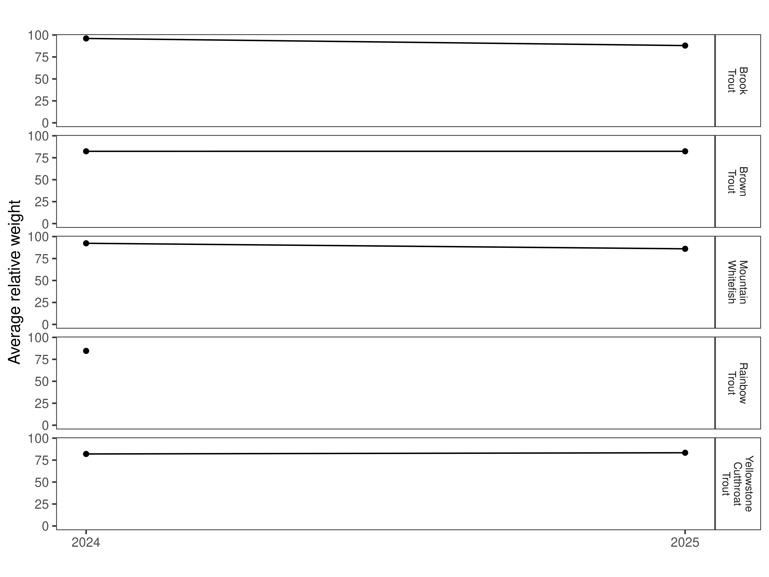
Figure 2. Relative weight for 2024 and 2025 in the Zimmerman Section.

Size Structure
Distribution of lengths for brown, Yellowstone cutthroat trout, and mountain whitefish, in 2025, overlapped with 2024 (Figure 3 and Figure 4). The length distribution for all three species was wider than the previous year. The width increase was result of an increase in the capture of smaller fish of each species.
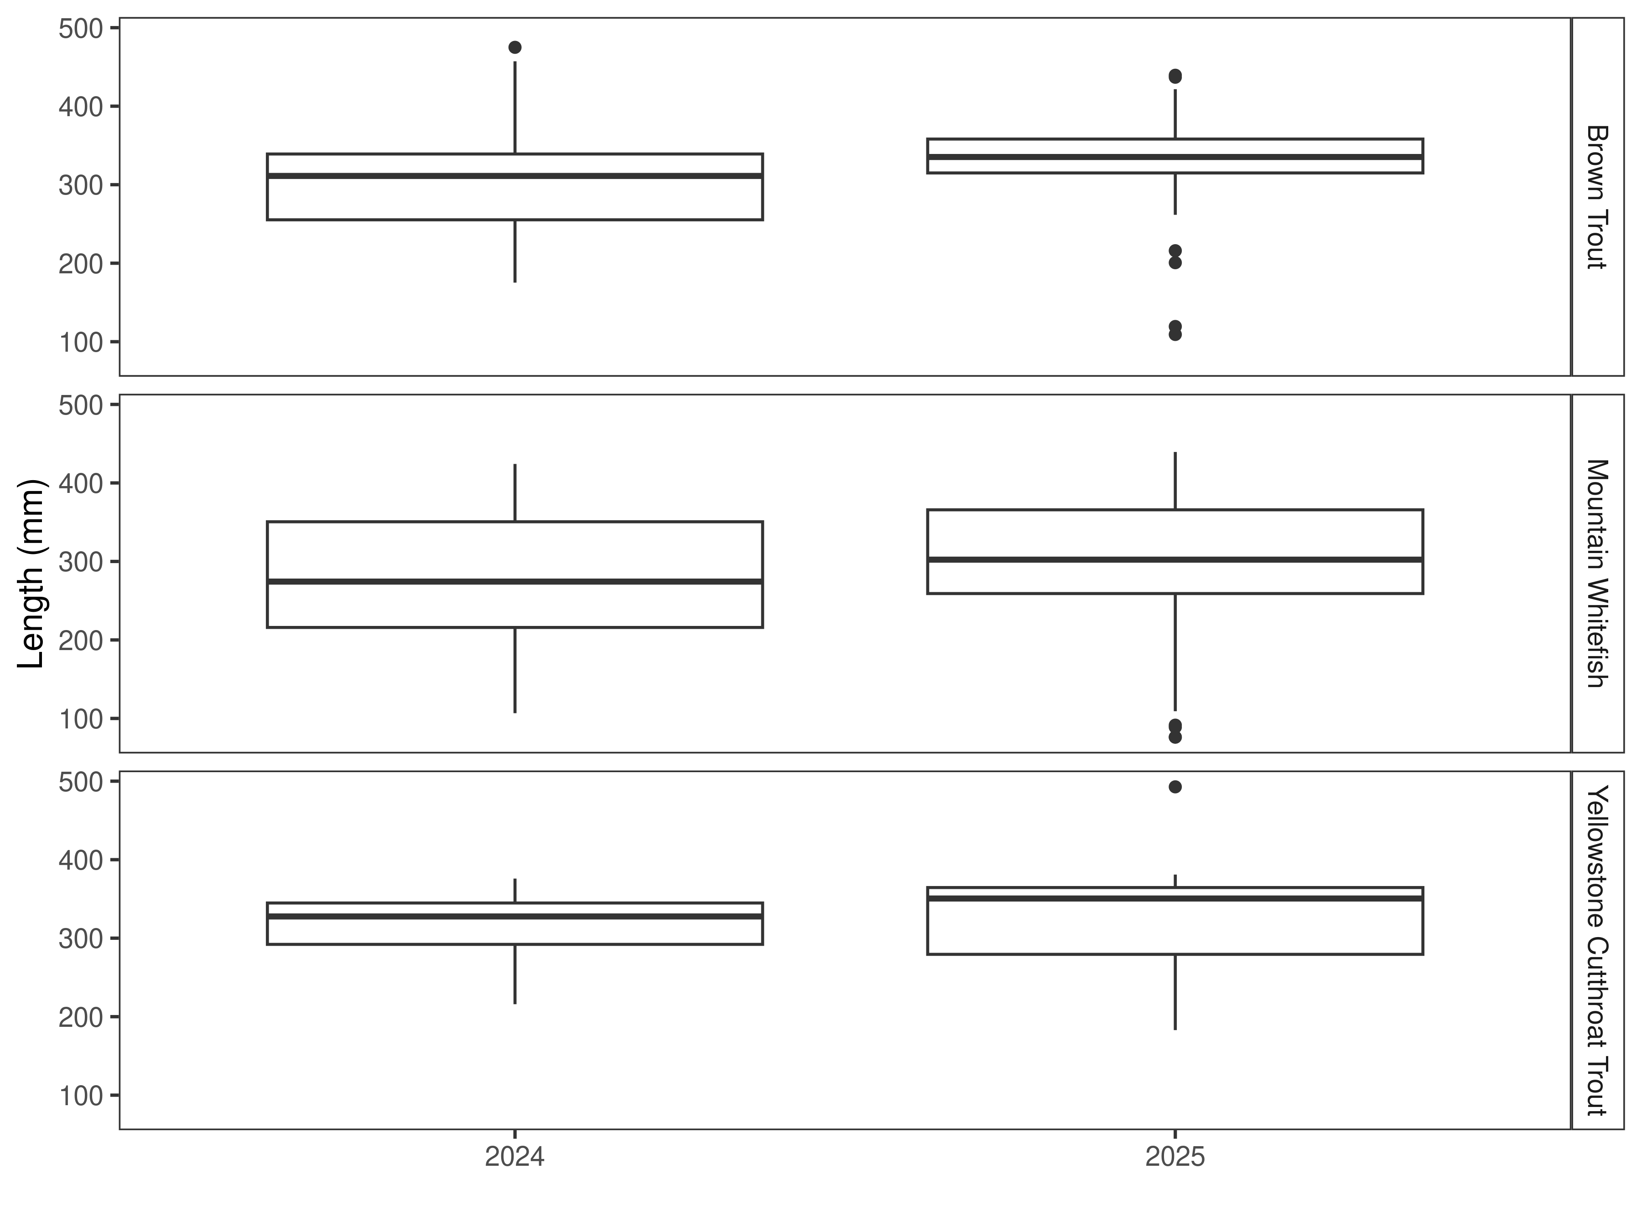
Figure 3. Distribution of lengths for 2024 and 2025 in the Zimmerman Section. The box-and-whisker plots divide the distribution of the data into the first quartile (the lower limit of the box), the median (heavy black line), and third quartile (the upper limit of the box). The whiskers denote data points within 1.5 * the interquartile range (the difference between the first and third quartiles). Dots denote data points further than 1.5 * the interquartile range from the box.
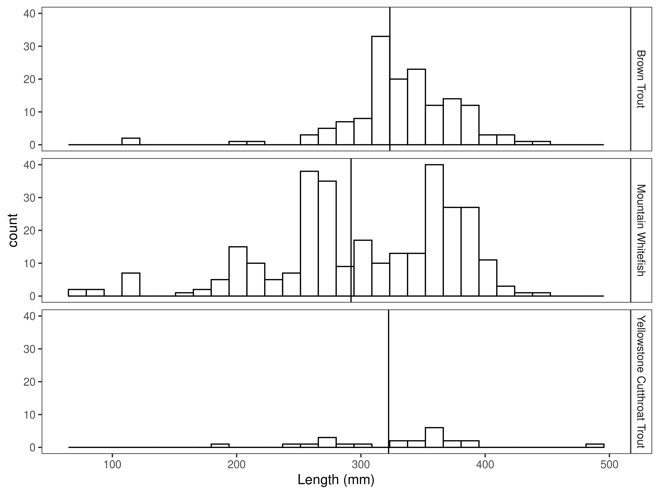
Figure 4. Length distribution by species in the Zimmerman Section for 2025, with long-term species-averages indicated by the vertical black line.

Mark-recapture abundance estimates
The abundance estimate for brown trout in the Zimmerman Section decreased significantly from 310/km in 2024 to 112/km in 2025 (Figure 5 and Table 2). As expected with the large abundance decrease, the biomass estimate for brown trout also decreased significantly from 114.9 kg/km in 2024 to 47.9 kg/km in 2025 (Figure 6 and Table 2).
The mountain whitefish abundance estimate increased from 286/km in 2024 to 422/km in 2025. Similarly, the biomass estimate for mountain whitefish increased from 88.5 kg/km in 2024 to 150.2 kg/km in 2025.
The Yellowstone cutthroat trout abundance estimate increased from 21/km in 2024 to 39/km in 2025 and their biomass estimate increased from 7.8 kg/km in 2024 to 18.8 kg/km in 2025.
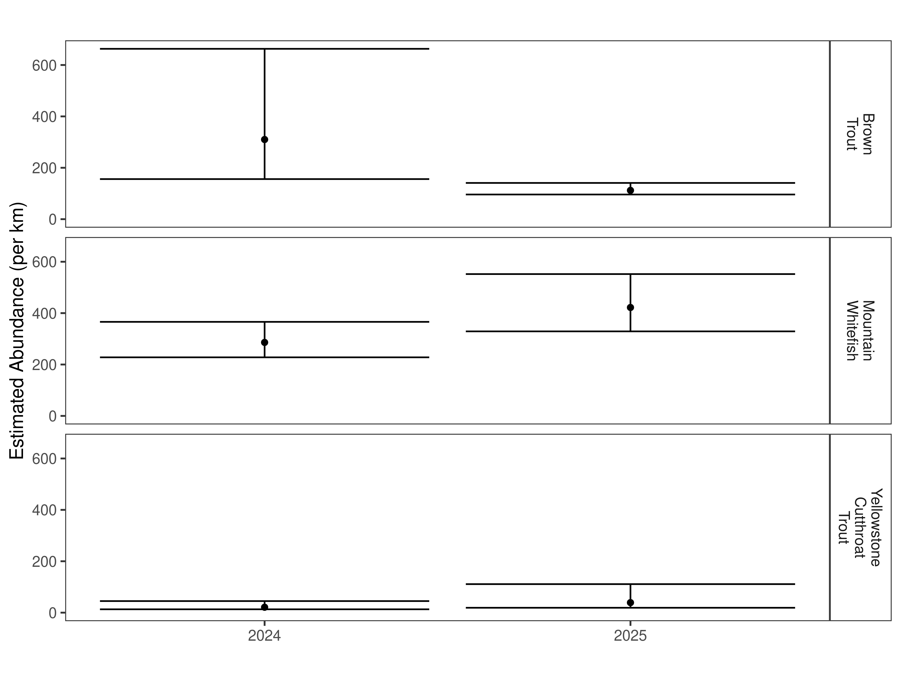
Figure 5. Zimmerman Section mark-recapture abundance estimates (fish per kilometer) for 2024 and 2025 using the Chapman estimator. These estimates (mean and 95% confidence intervals) represent the model-averaged estimates across all length groups.

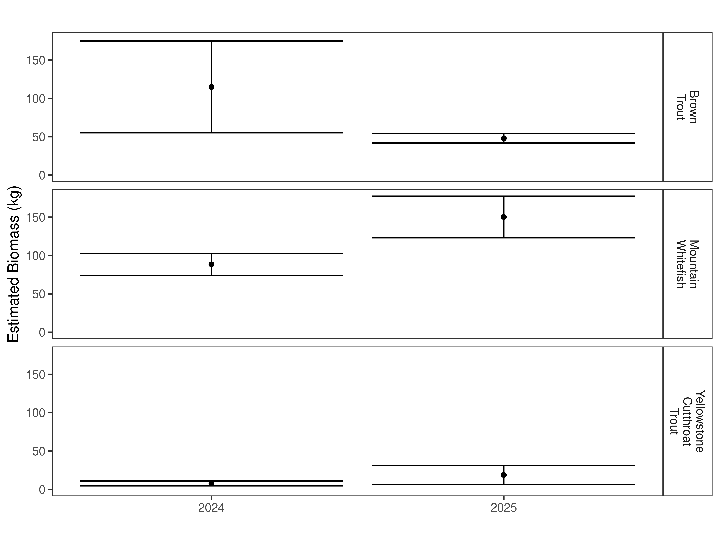
Figure 6. Zimmerman Section estimates of biomass for 2024 and 2025.

Table 2. Zimmerman Section abundance estimates of fish per kilometer (Pop. Estimate) across length groups and estimated biomass (Biomass Estimate, kg) for 2025.
 |  | Pop. Estimate | 2.5% | 97.5% | Biomass Estimate | 2.5% | 97.5%
Brown Trout | 2025 | 112 | 96 | 141 | 47.9 | 41.7 | 54.0
Mountain Whitefish | 2025 | 422 | 329 | 552 | 150.2 | 123.1 | 177.4
Yellowstone Cutthroat Trout | 2025 | 39 | 19 | 111 | 18.8 | 6.7 | 30.9

Clovis Section

Data summary
This is the first time that this section of the Shields River has been sampled. Due to high flow conditions, a recapture run was not conducted.
Only one brook trout with a length of 246.4 mm was captured in the Clovis Section in 2025 (Table 3). Fifty-seven brown trout with an average length of 362.2 mm were captured. A total of 45 Yellowstone cutthroat trout were captured in 2025. Their average length was 320.9 mm. In 2025, 4 trout that were hybrid crosses between rainbow and Yellowstone cutthroat trout were captured. These fish had an average length of 363.9 mm.

Table 3. Data summary for the Clovis Section in 2025.
 |  |  |  | Length |  |  |  |  | Weight |  |  | Condition |  |  | Relative Weight
 |  | n |  | Min | Max | Avg | SD |  | Avg | SD |  | Avg | SD |  | Avg | SD
Brook Trout |  | 1 |  | 246.4 | 246.4 | 246.4 | NA |  | 149.7 | NA |  | 36.2 | NA |  | 96.1 | NA
Brown Trout |  | 57 |  | 233.7 | 429.3 | 362.2 | 33.4 |  | 440.5 | 111.7 |  | 32.9 | 2.6 |  | 84.7 | 6.8
Rainbow X Yellowstone Cutthroat Hybrid |  | 4 |  | 320.0 | 444.5 | 363.9 | 56.0 |  | 488.8 | 303.4 |  | 33.8 | 4.8 |  | NA | NA
Yellowstone Cutthroat Trout |  | 45 |  | 213.4 | 391.2 | 320.9 | 51.2 |  | 344.2 | 152.0 |  | 34.7 | 2.6 |  | 84.0 | 6.0

Relative Weights
In 2025, the relative weight for brook trout was 96.1 and it was 84.7 for brown trout (Table 3 and Figure 7). Relative weight for Yellowstone cutthroat trout in the Clovis Section was to 84.0.
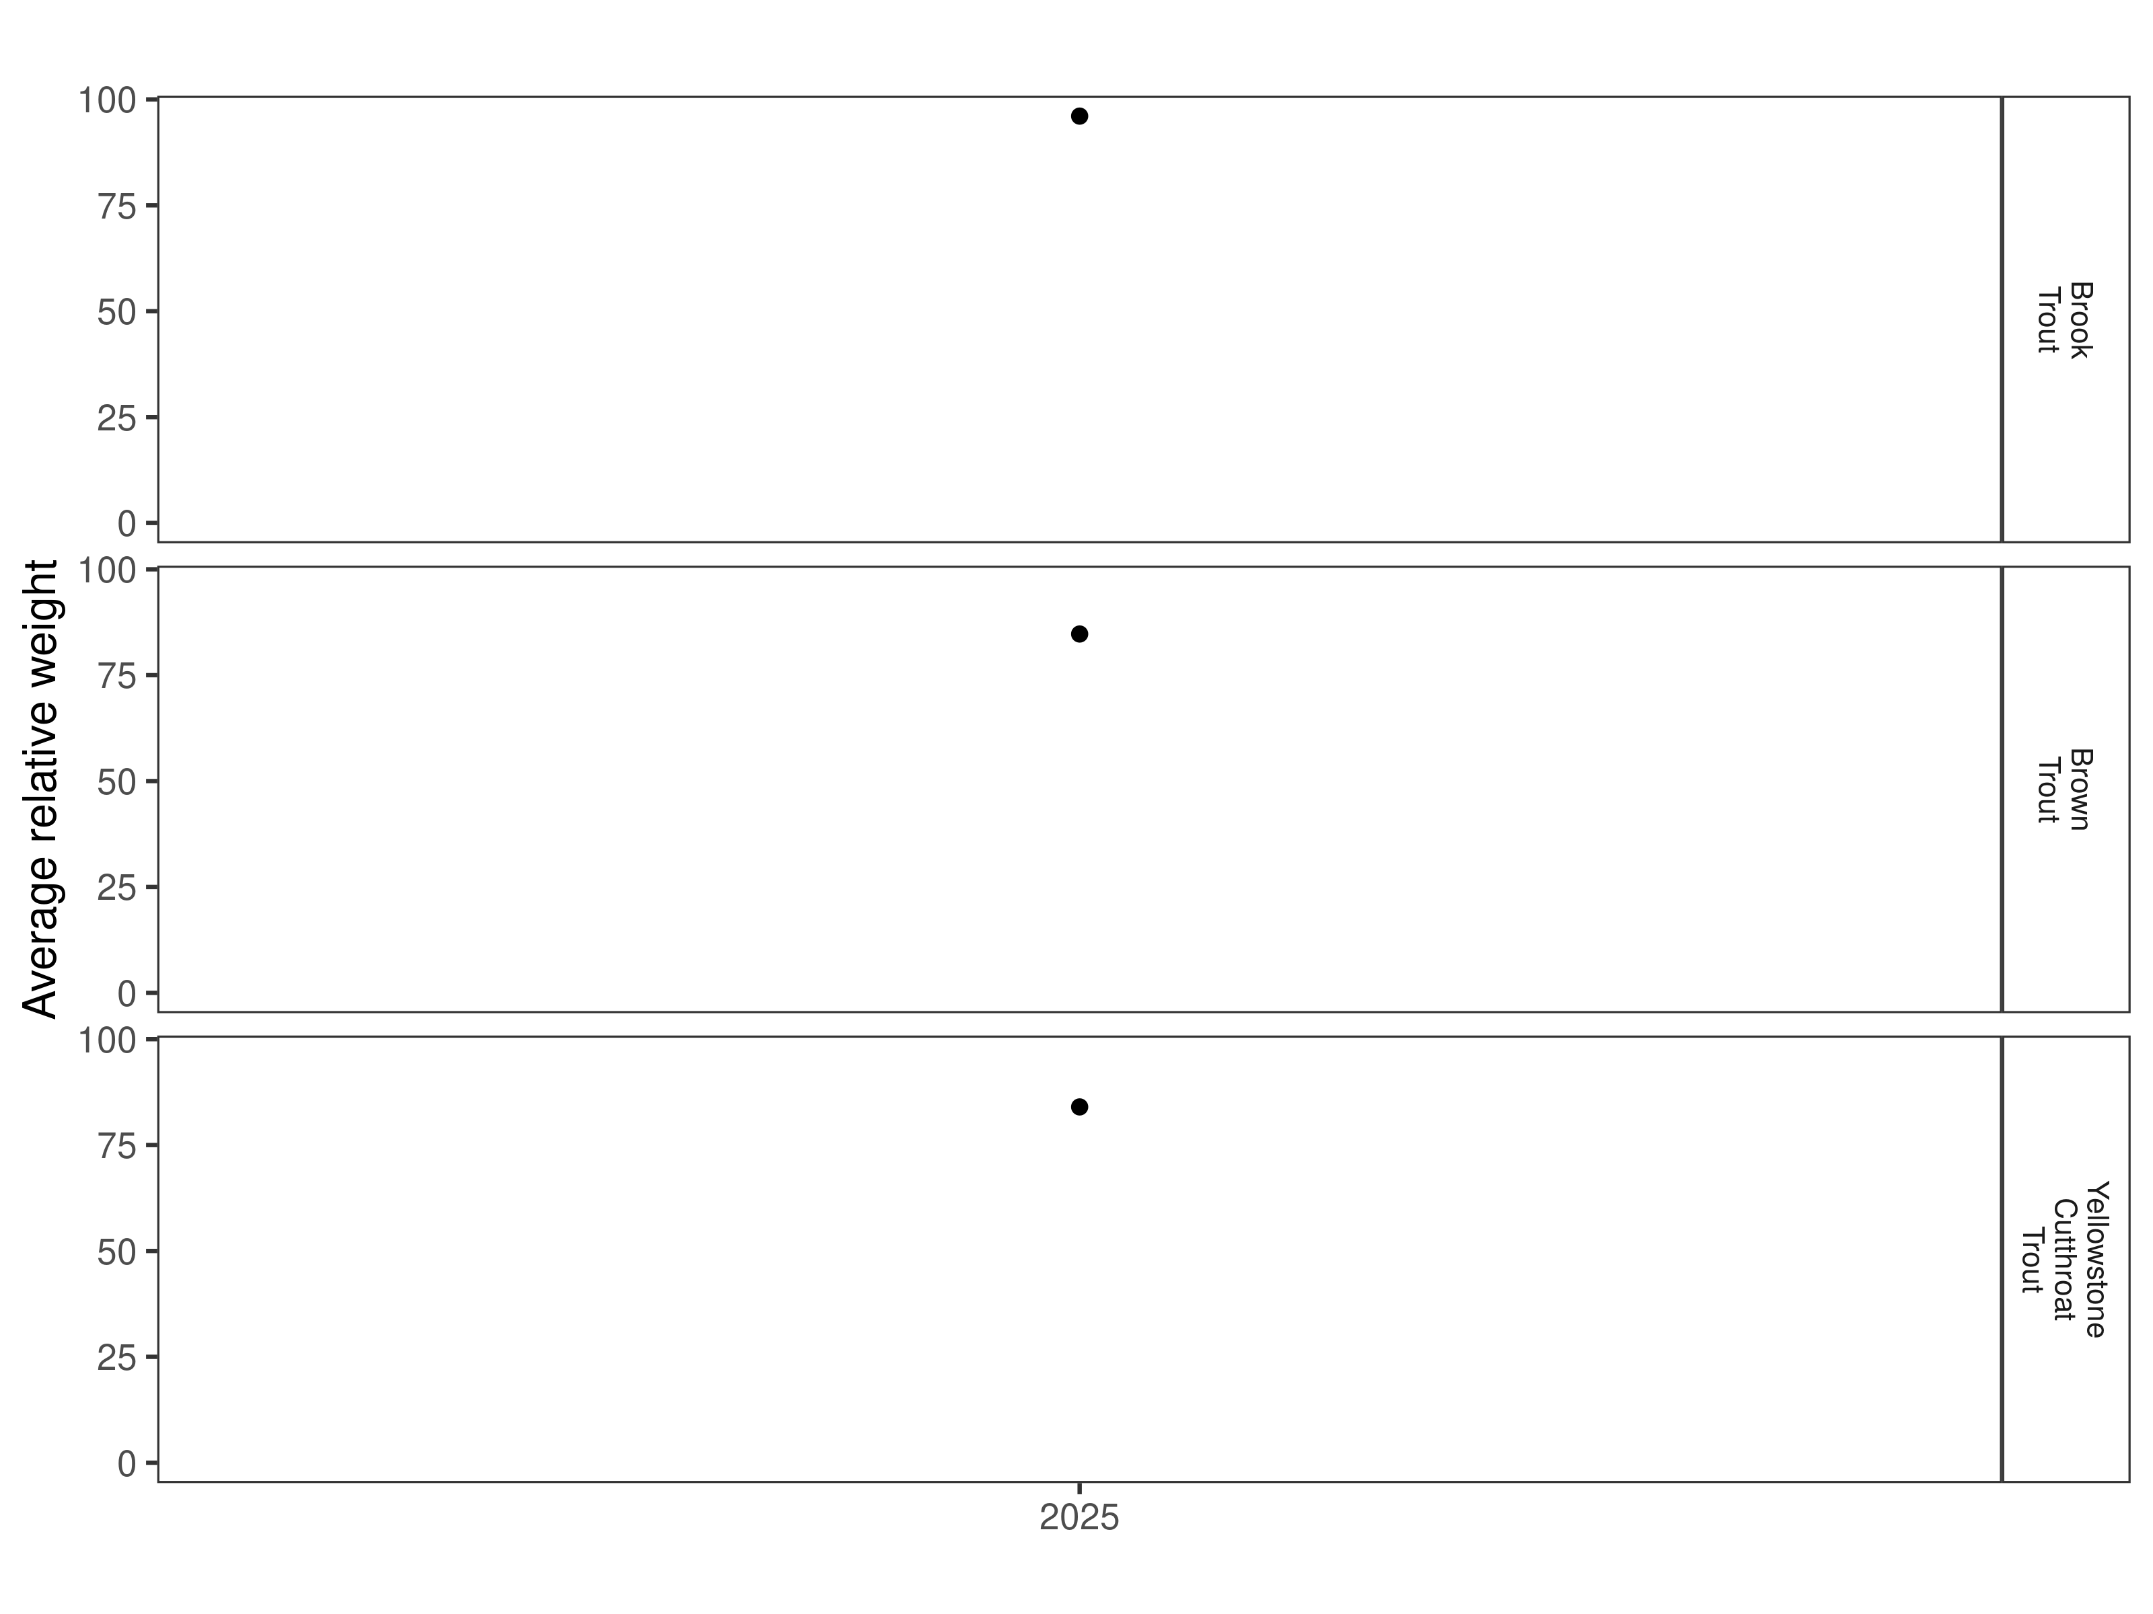
Figure 7. Relative weights in the Clovis Section for 2025.

Size Structure
Distribution of lengths for brook, brown, and Yellowstone cutthroat trout, in 2025, are displayed below (Figure 8 and Figure 9). Since this is the first sampling effort in this section there are no other data for comparison.
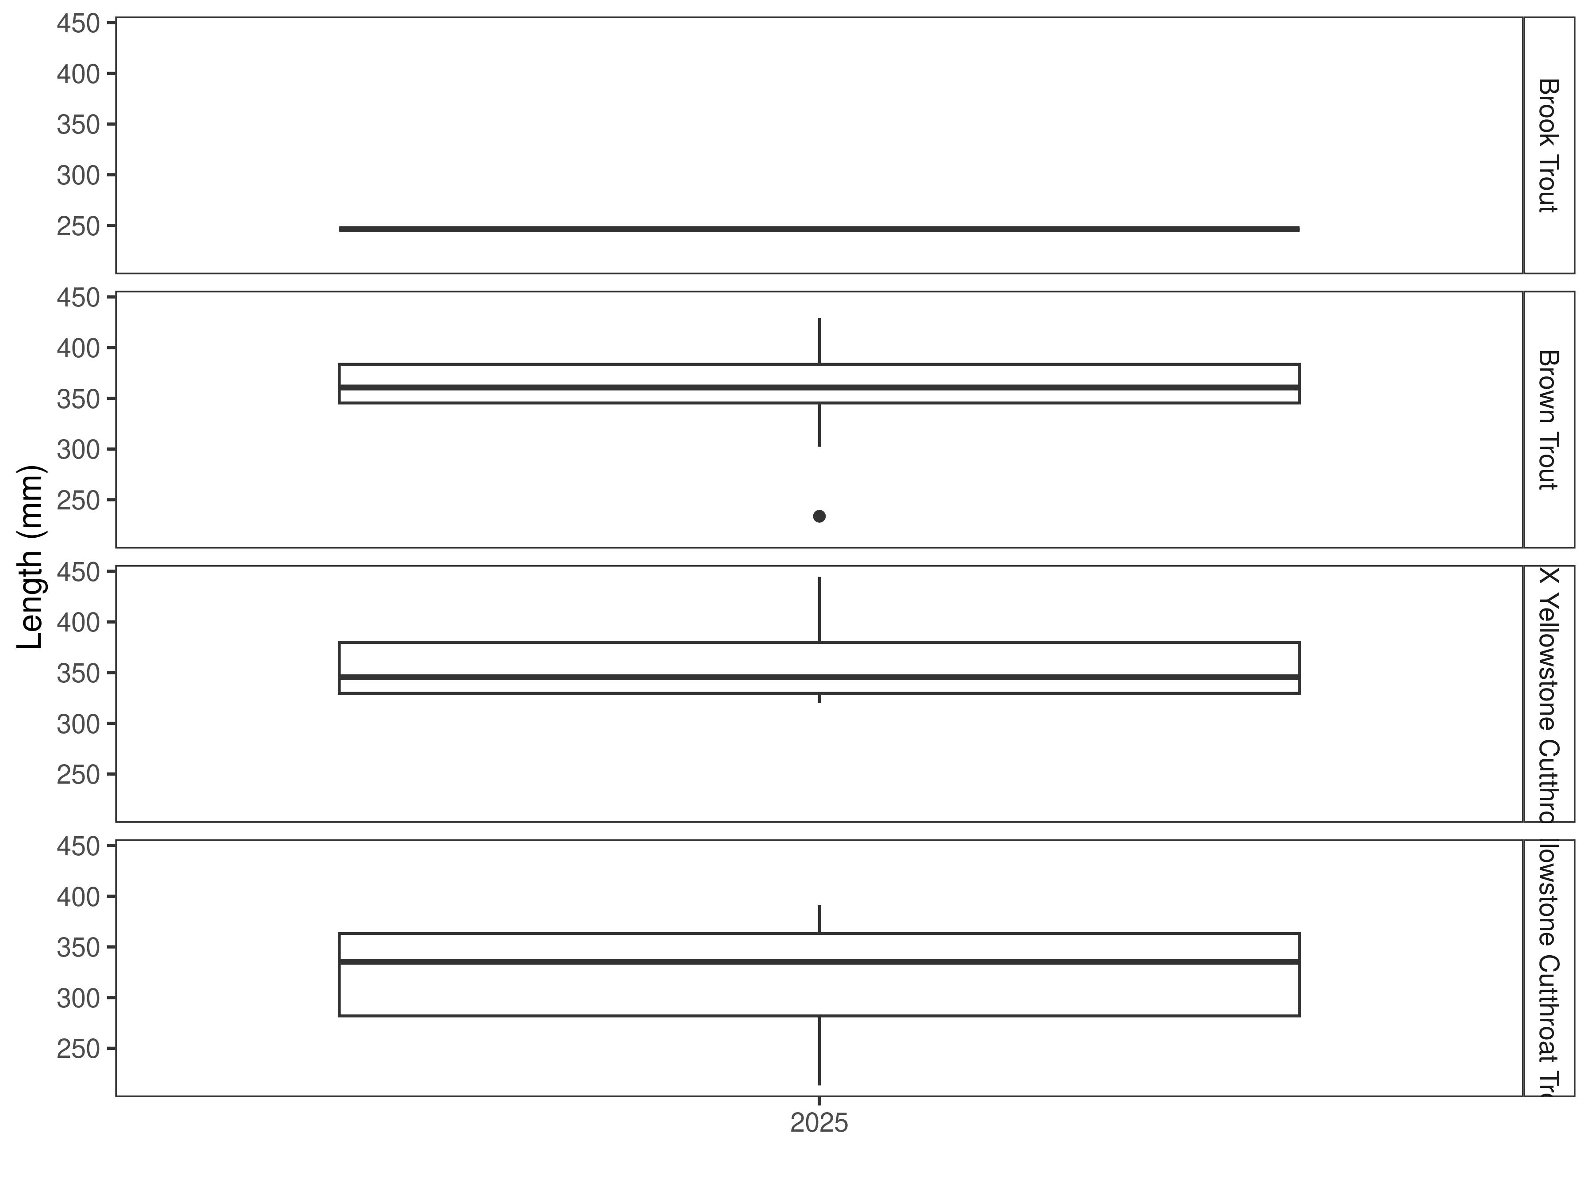

Figure 8. Distribution of lengths for 2025 in the Clovis Section. The box-and-whisker plots divide the distribution of the data into the first quartile (the lower limit of the box), the median (heavy black line), and third quartile (the upper limit of the box). The whiskers denote data points within 1.5 * the interquartile range (the difference between the first and third quartiles). Dots denote data points further than 1.5 * the interquartile range from the box.
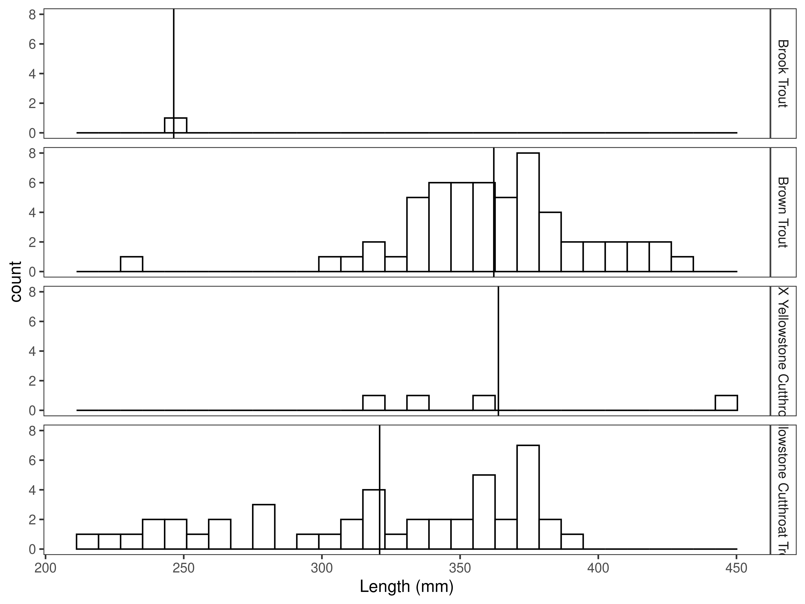
Figure 9. Length distribution by species in the Clovis Section for 2025, with species-averages indicated by the vertical black line.

Mark-recapture abundance estimates
Mark-recapture abundance estimates were not made in the Clovis Section in 2025. Rapid increase in flow conditions prevented the completion of a recapture run, necessary for the calculation of an abundance estimate.

Clyde Park Section

Data summary
This is the first time that this section of the Shields River has been sampled.
In 2025, two brook trout with an average length of 320.0 mm were captured in the Clyde Park Section (Table 4). A total of 190 brown trout with an average length of 351.2 mm were captured. Only one rainbow trout that was 226.1 mm in length was captured. Forty-six Yellowstone cutthroat trout were captured and had an average length of 325.4 mm. In 2025, 20 trout that were hybrid crosses between rainbow and Yellowstone cutthroat trout were captured. These fish had an average length of 346.2 mm.

Table 4. Data summary for the Clyde Park Section in 2025.
 |  |  |  | Length |  |  |  |  | Weight |  |  | Condition |  |  | Relative Weight
 |  | n |  | Min | Max | Avg | SD |  | Avg | SD |  | Avg | SD |  | Avg | SD
Brook Trout |  | 2 |  | 292.1 | 348.0 | 320.0 | 39.5 |  | 274.4 | 54.5 |  | 30.5 | 5.2 |  | 80.2 | 14.1
Brown Trout |  | 190 |  | 205.7 | 495.3 | 351.2 | 45.9 |  | 400.6 | 168.7 |  | 31.7 | 2.4 |  | 81.7 | 6.3
Rainbow Trout |  | 1 |  | 226.1 | 226.1 | 226.1 | NA |  | NA | NA |  | NA | NA |  | NA | NA
Rainbow X Yellowstone Cutthroat Hybrid |  | 20 |  | 172.7 | 492.8 | 346.2 | 94.5 |  | 504.2 | 348.0 |  | 35.2 | 3.5 |  | NA | NA
Yellowstone Cutthroat Trout |  | 46 |  | 236.2 | 424.2 | 325.4 | 48.4 |  | 346.2 | 179.3 |  | 33.3 | 3.9 |  | 80.3 | 9.0

Relative Weights
In 2025, the relative weight for brook trout in the Clyde Park Section was 80.2 and it was 81.7 for brown trout (Table 4 and Figure 10). Relative weight for Yellowstone cutthroat trout in this section was to 80.3.

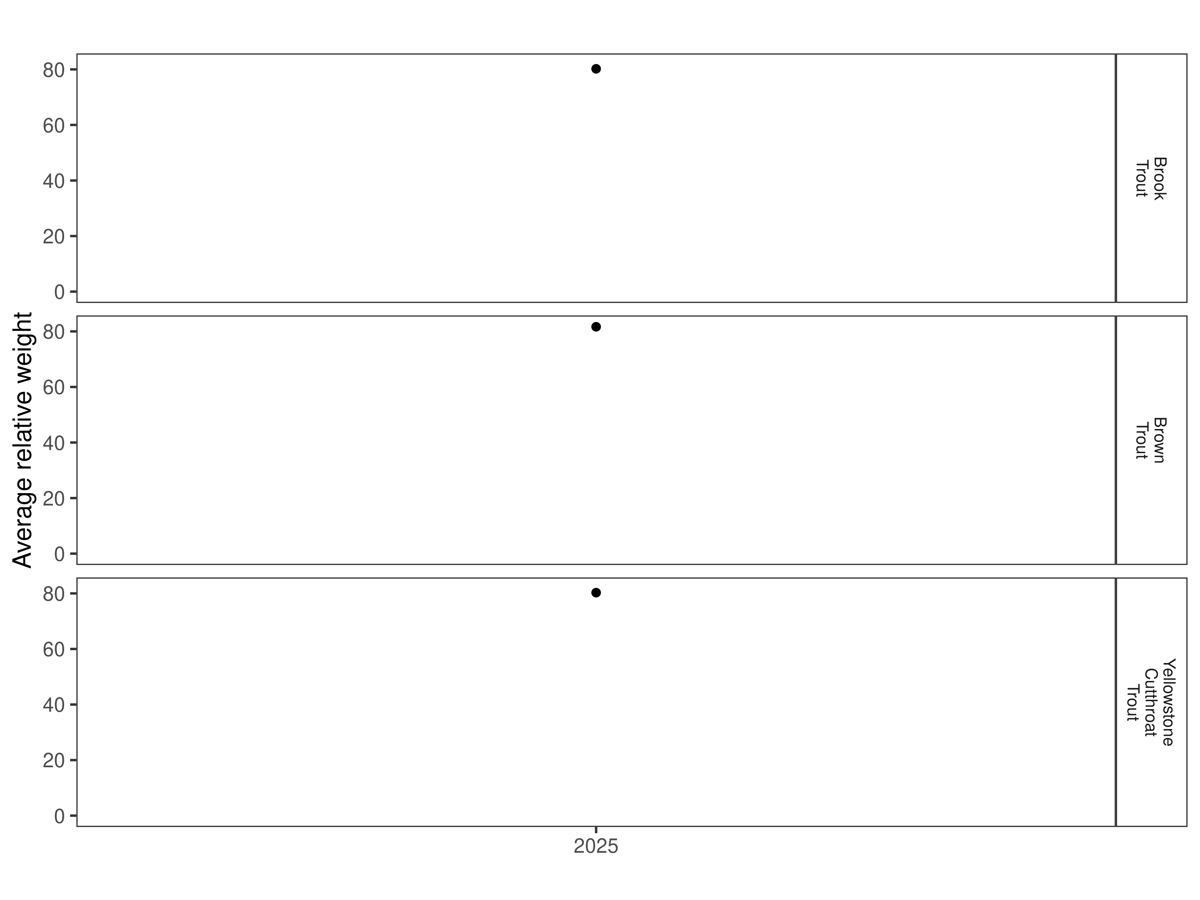
Figure 10. Relative weight in the Clyde Park Section for 2025.

Size Structure
Distribution of lengths for brown, rainbow x Yellowstone cutthroat hybrid, and Yellowstone cutthroat trout in the Clyde Park Section are displayed below (Figure 11 and Figure 12). Since this is the first sampling effort in this section there are no historic data to compare.

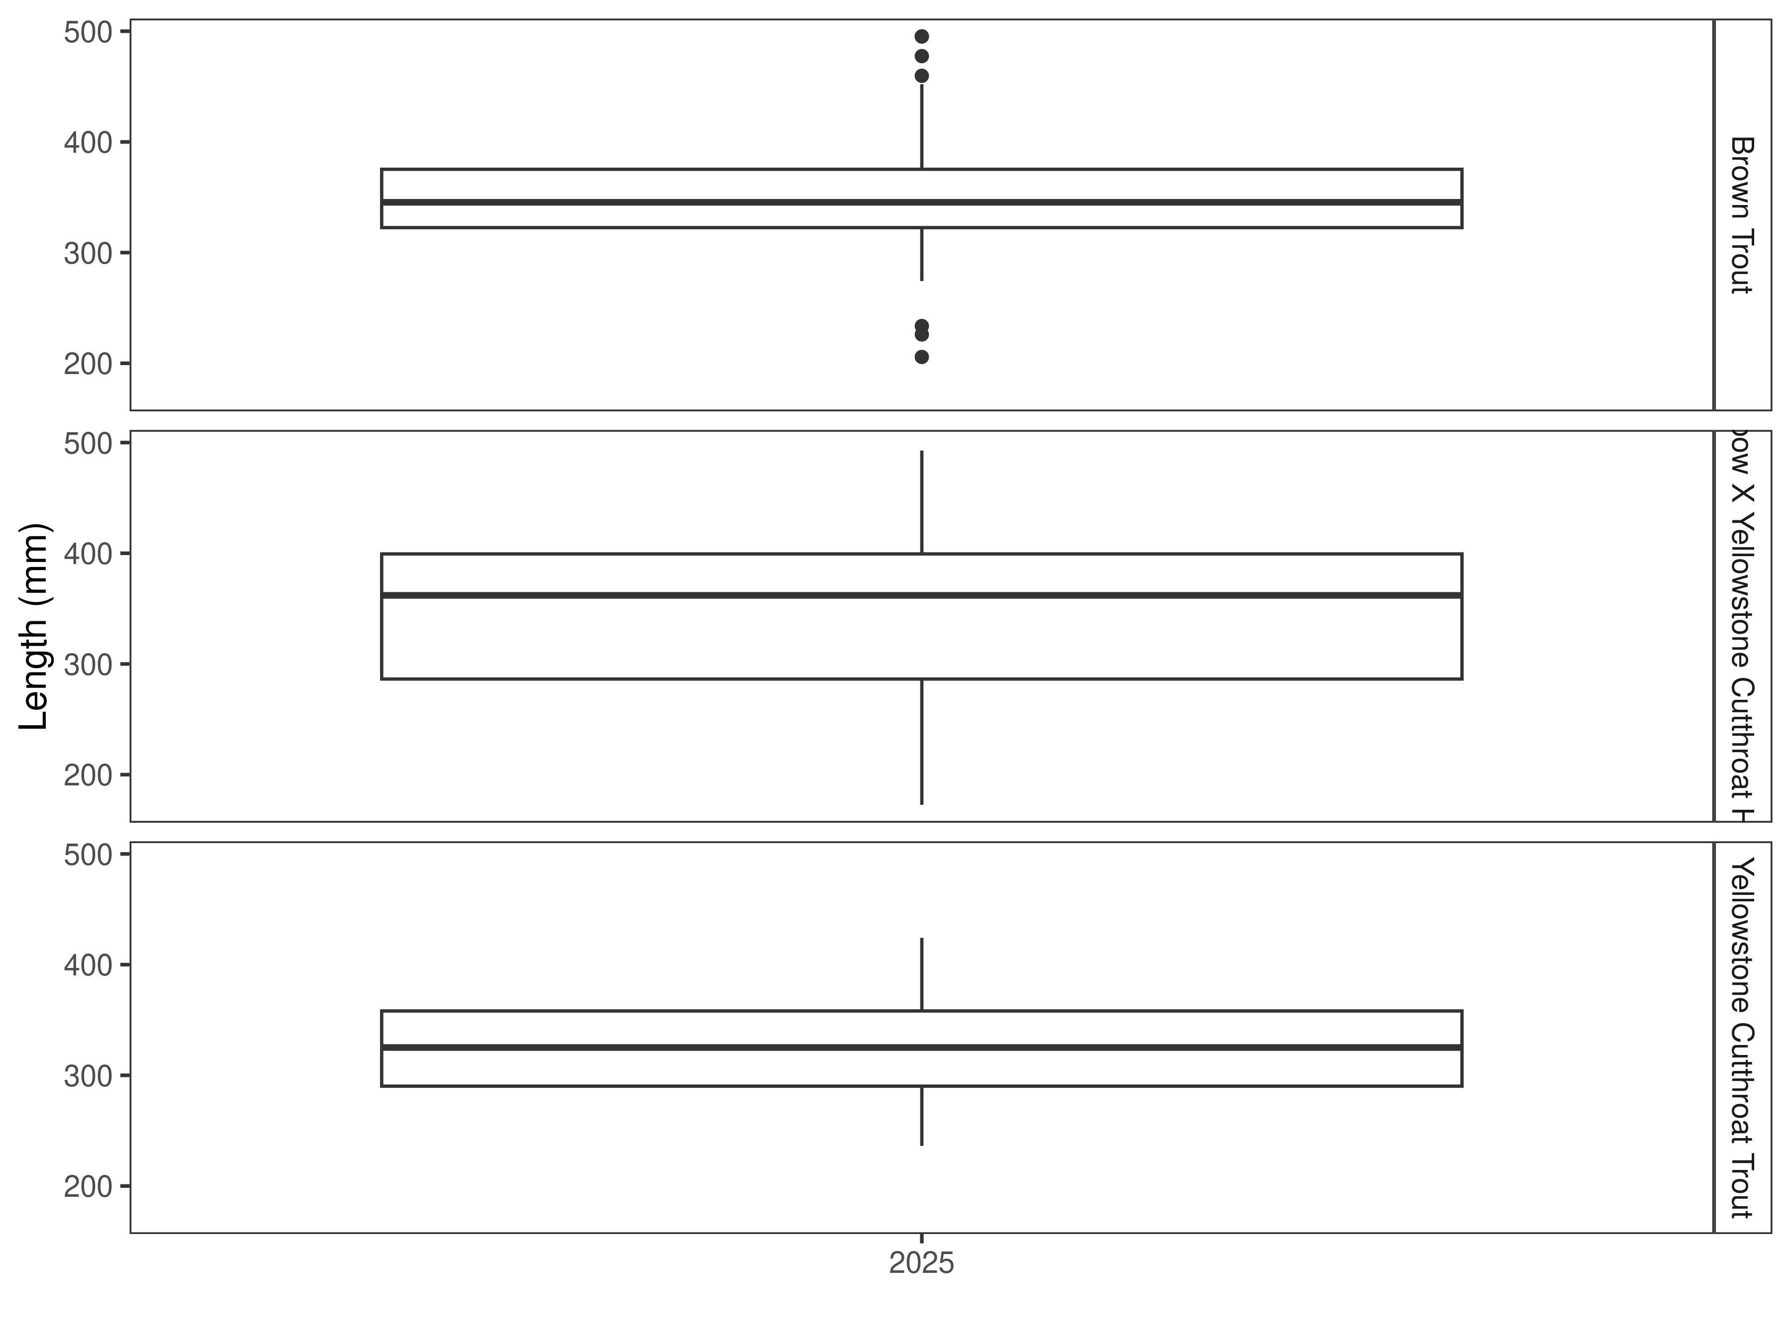
Figure 11. Distribution of lengths for 2025 in the Clyde Park Section. The box-and-whisker plots divide the distribution of the data into the first quartile (the lower limit of the box), the median (heavy black line), and third quartile (the upper limit of the box). The whiskers denote data points within 1.5 * the interquartile range (the difference between the first and third quartiles). Dots denote data points further than 1.5 * the interquartile range from the box.
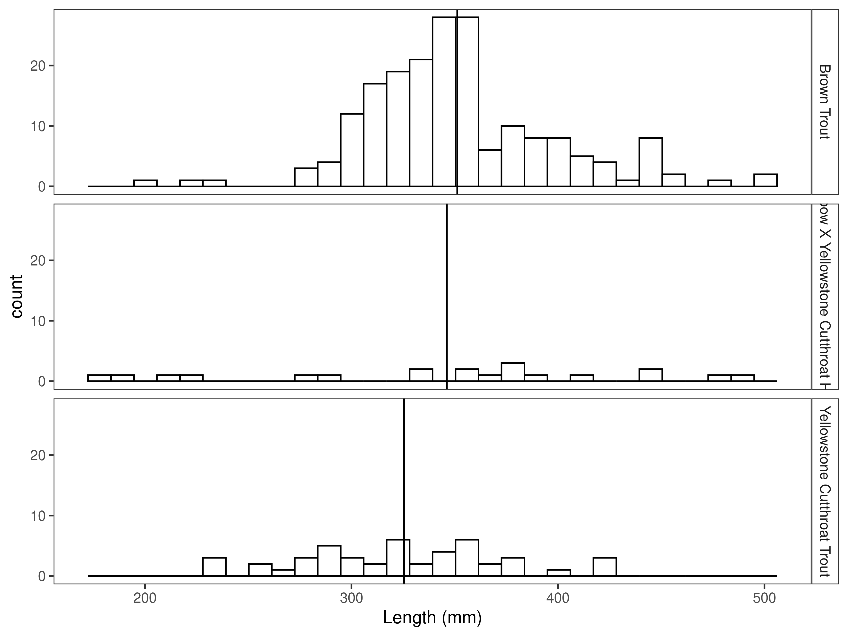
Figure 12. Length distribution by species in the Clyde Park Section for 2025, with species-averages indicated by the vertical black line.

Mark-recapture abundance estimates
In 2025, the abundance estimate for brown trout in the Clyde Park Section was 62/km (Figure 13 and Table 5). The biomass estimate for brown trout was 85.6 kg/km (Figure 14 and Table 5).
The rainbow x Yellowstone cutthroat hybrid abundance estimate was 11/km in 2025. The biomass estimate was 19.7 kg/km.
The Yellowstone cutthroat trout abundance estimate in 2025 was 41/km and their biomass estimate was 49.4 kg/km.
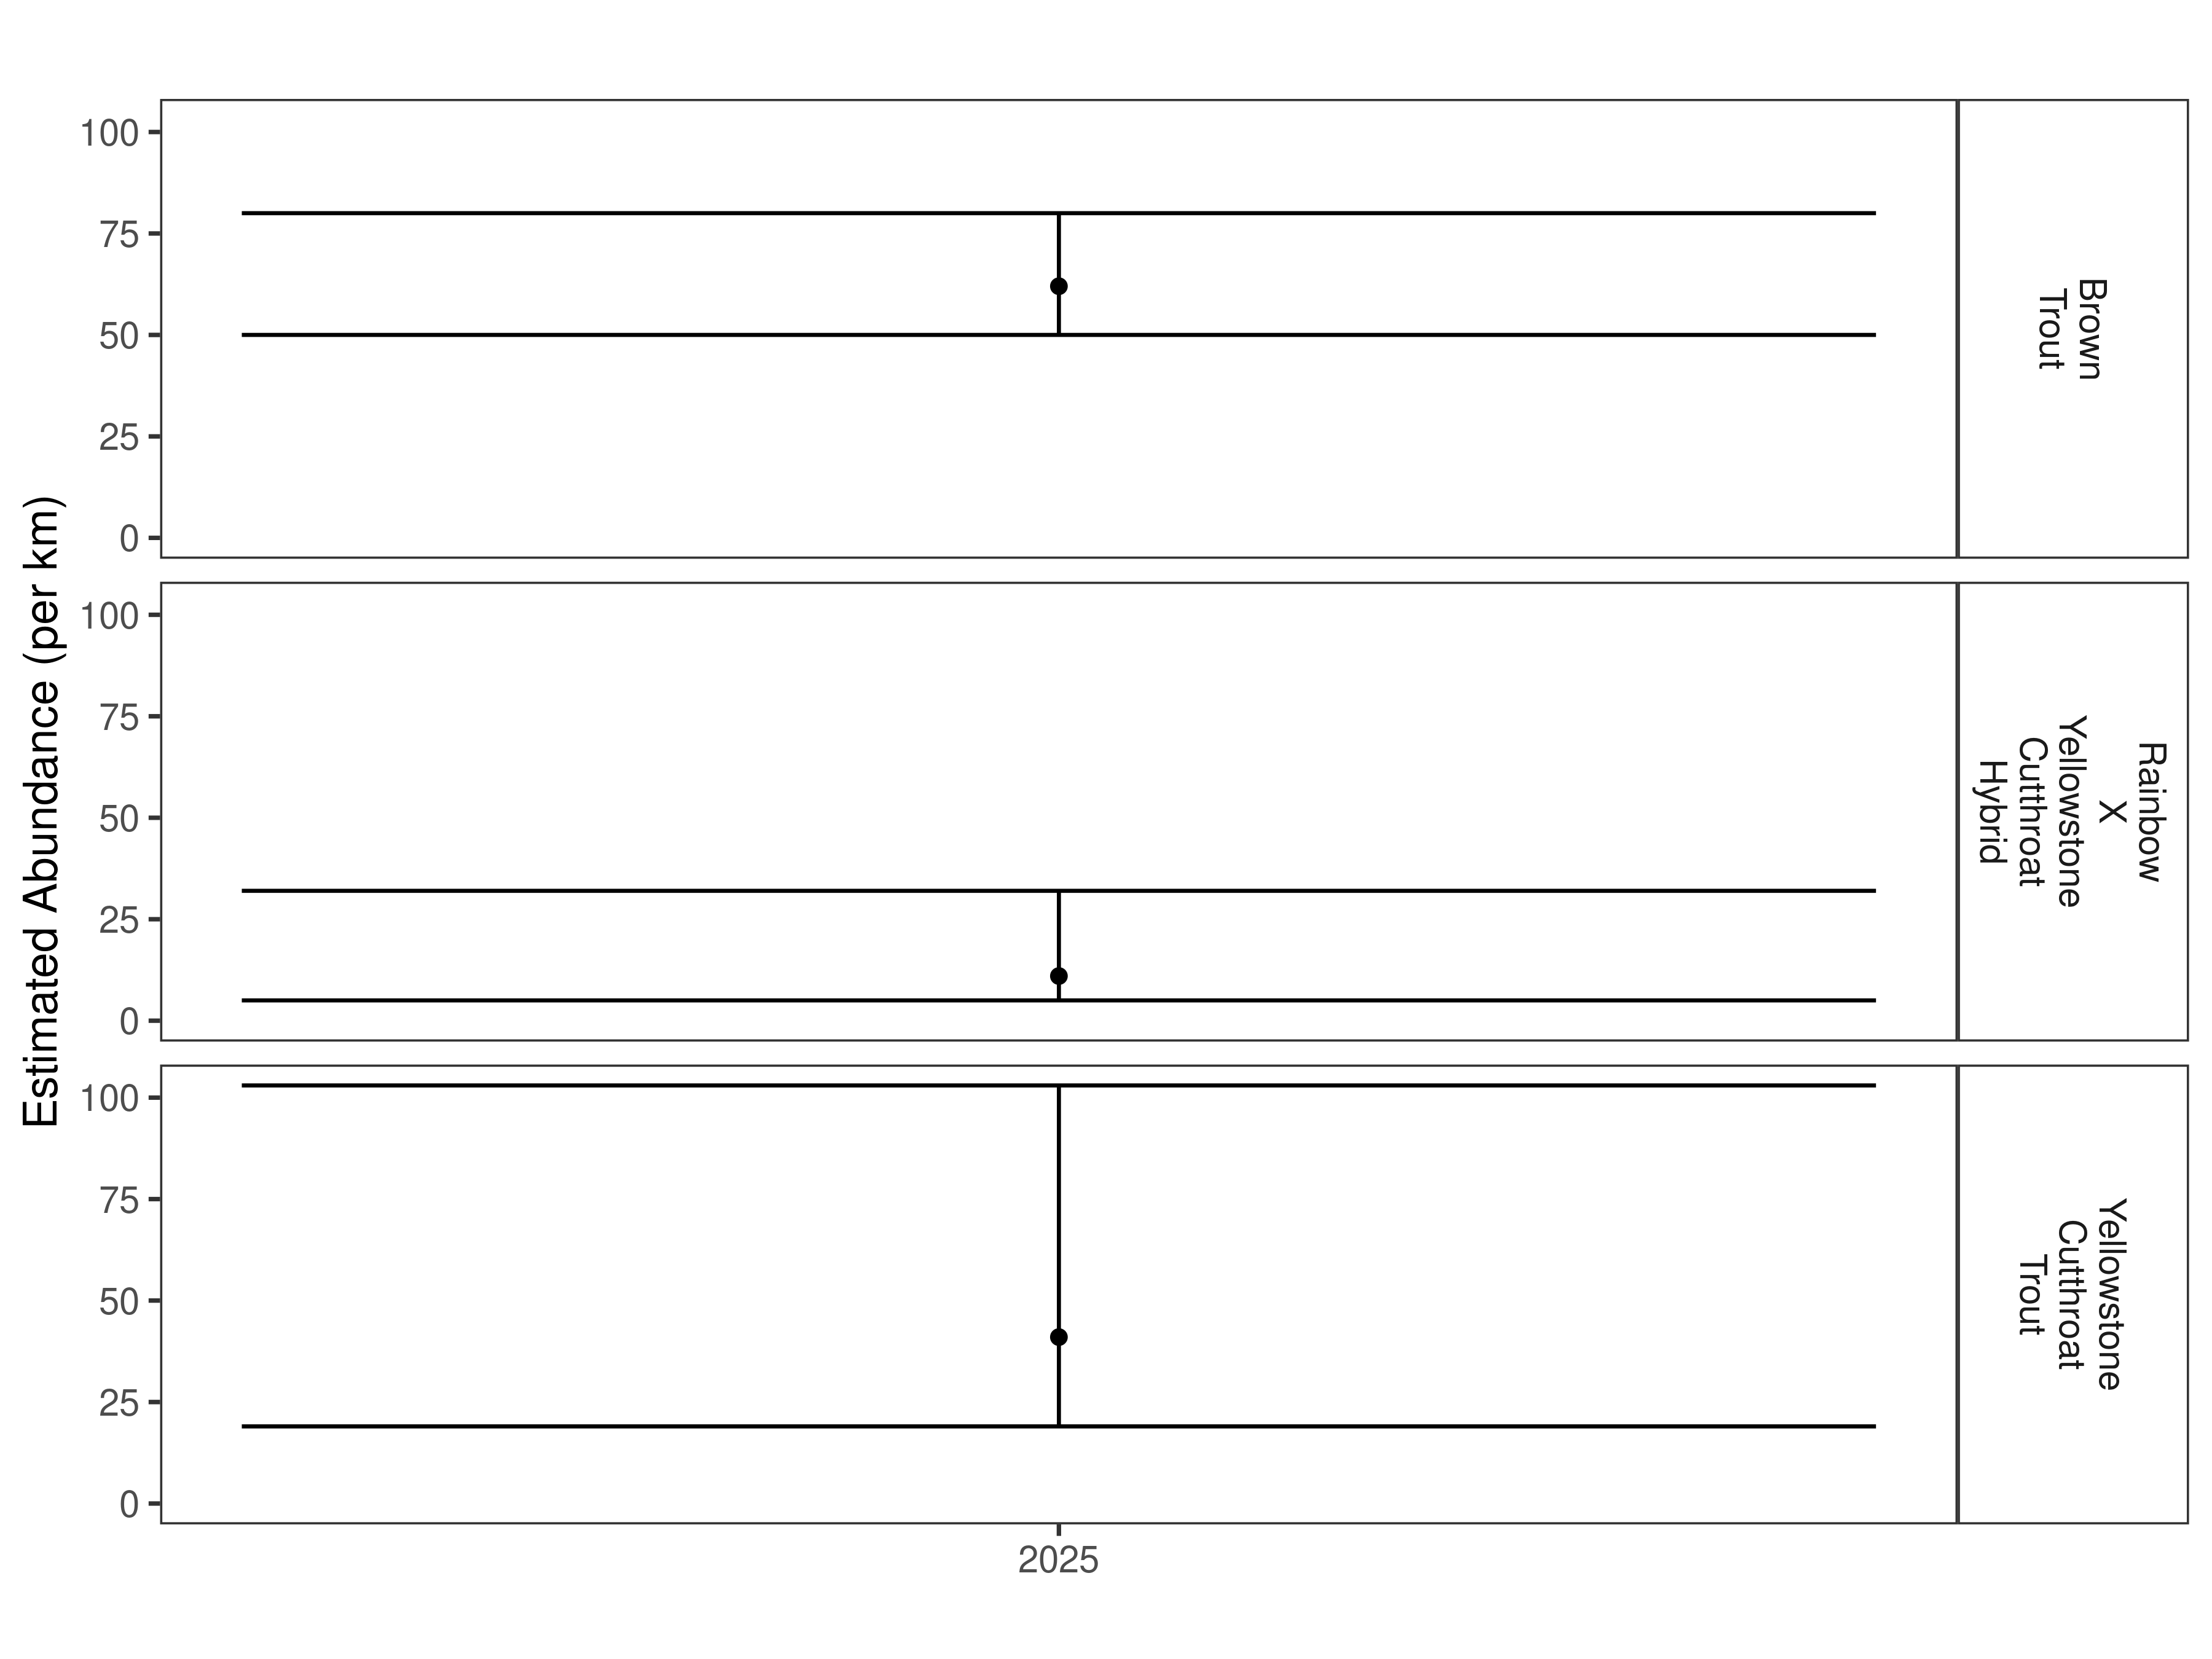
Figure 13. Clyde Park Section mark-recapture abundance estimates (fish per kilometer) for 2025 using the Chapman estimator. These estimates (mean and 95% confidence intervals) represent the model-averaged estimates across all length groups.
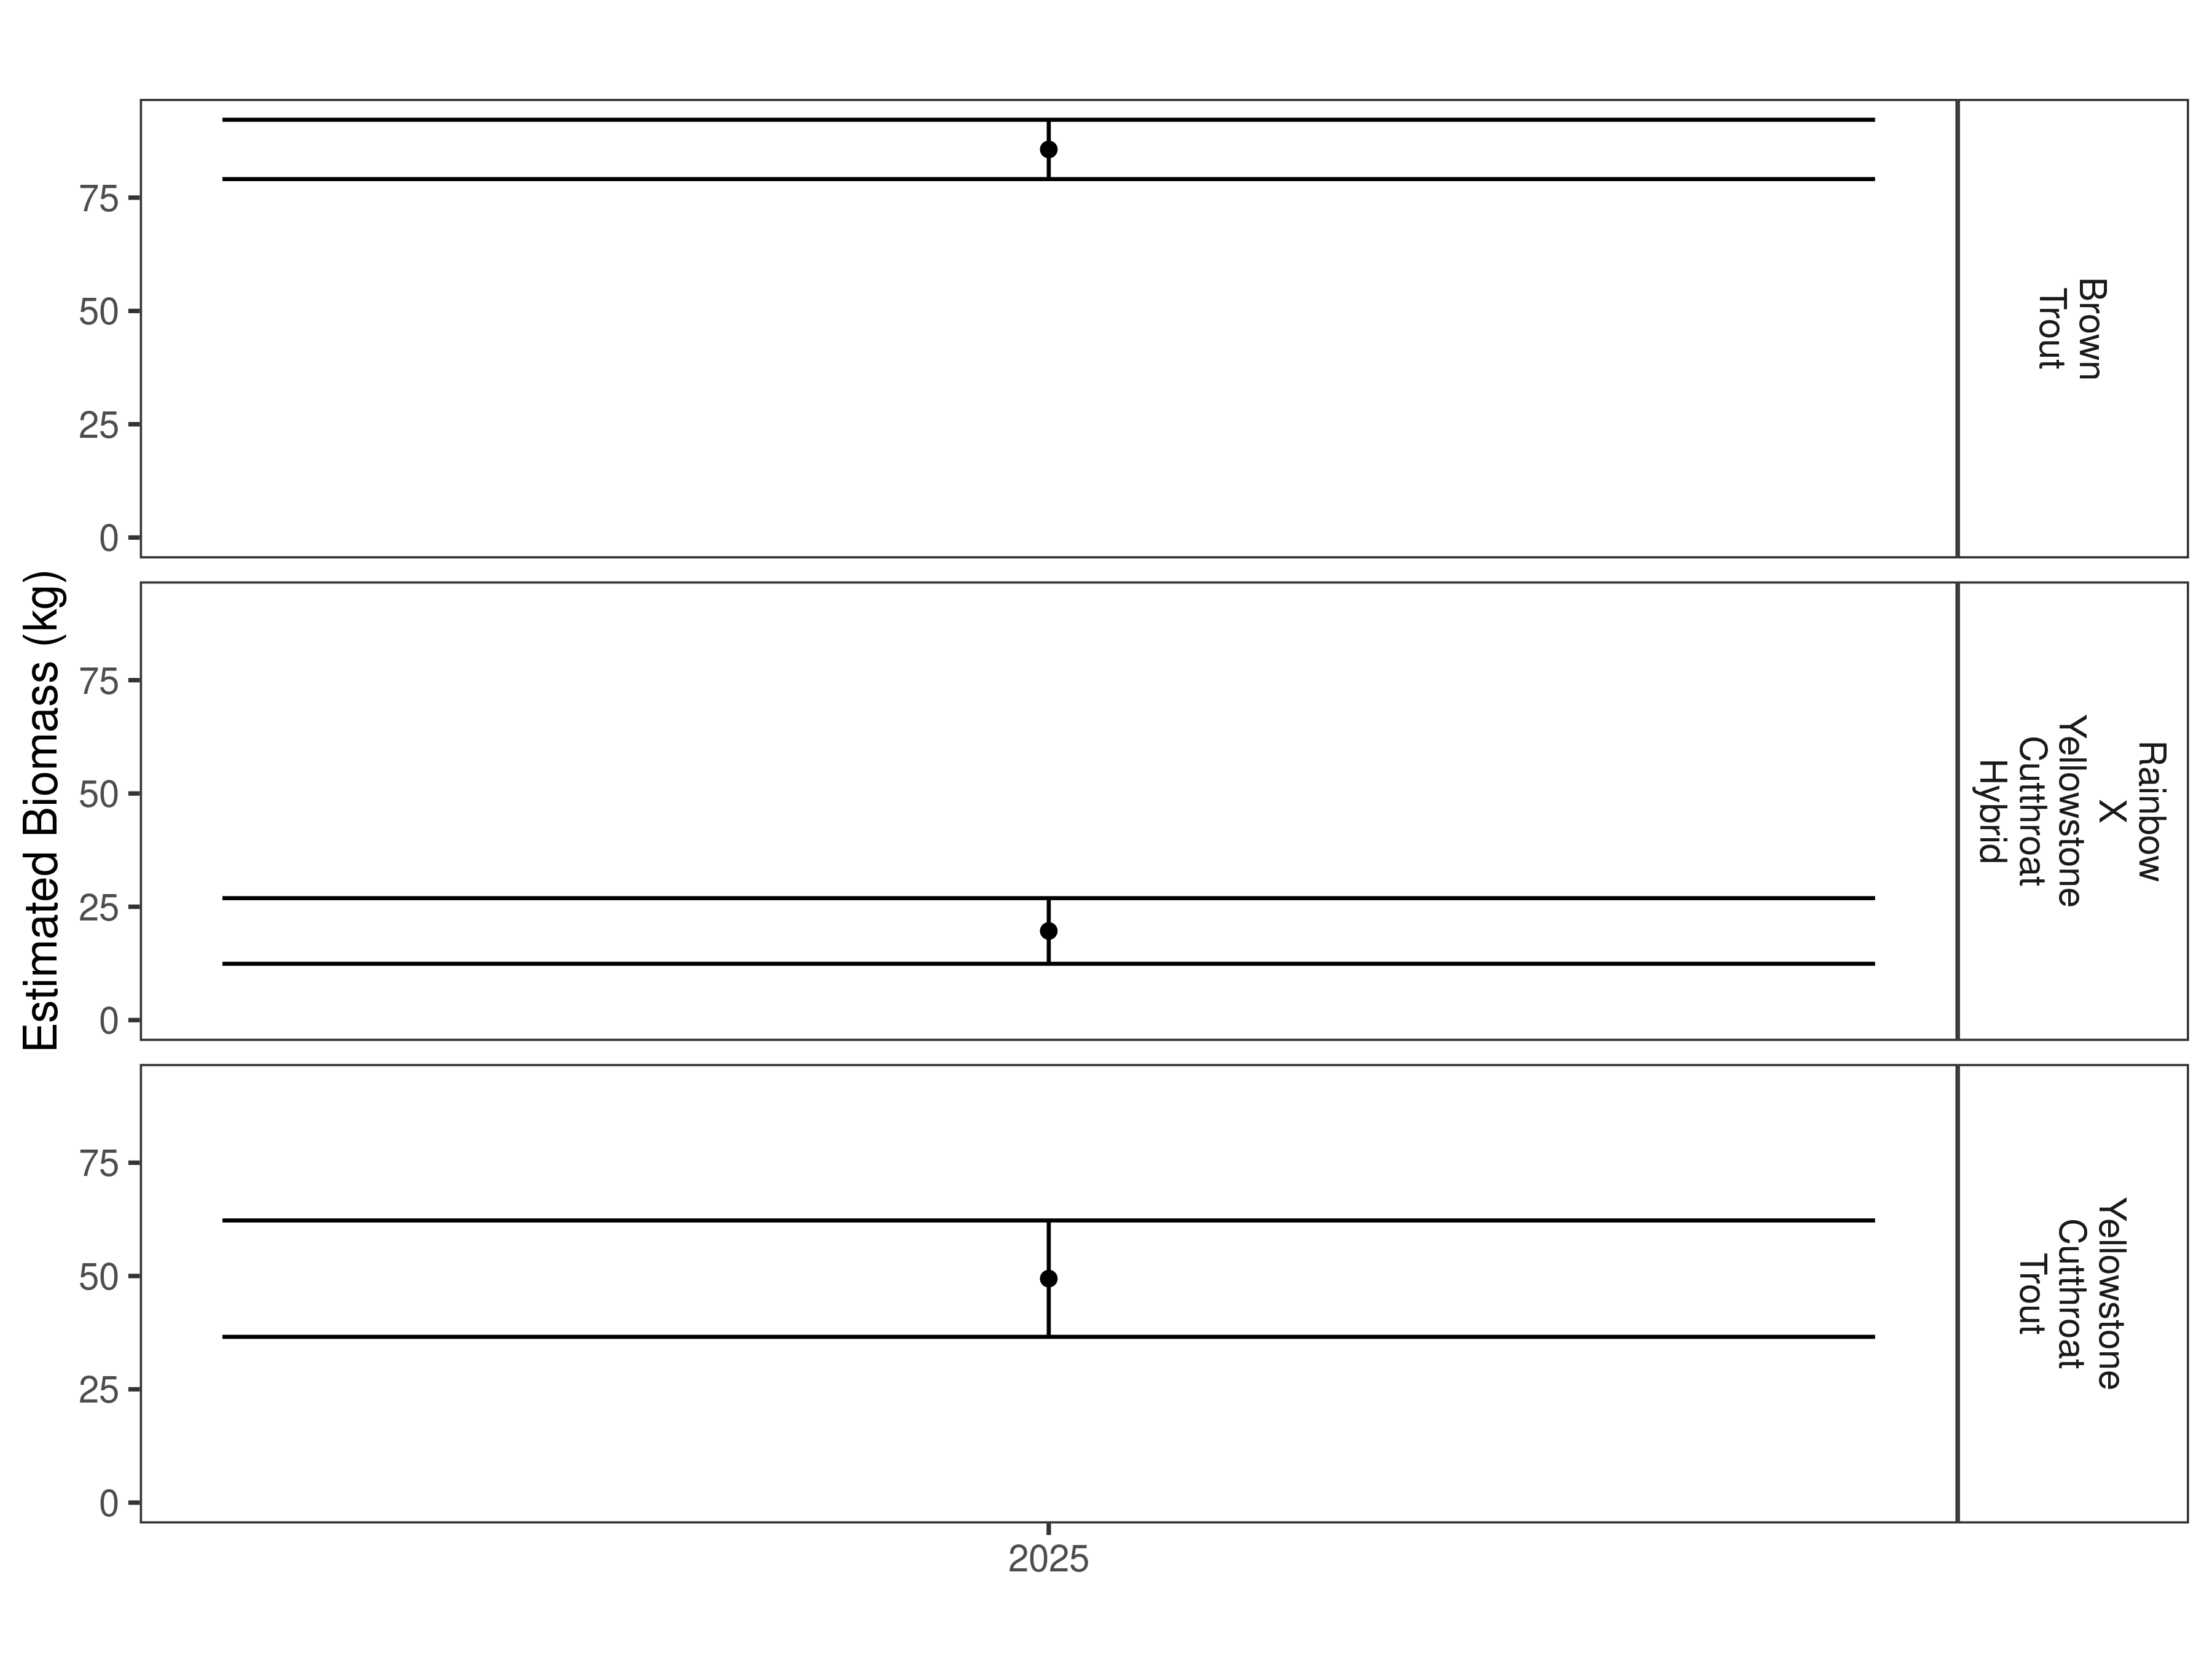
Figure 14. Clyde Park Section estimates of biomass for 2025.

Table 5. Clyde Park Section abundance estimates of fish per kilometer (Pop. Estimate) across length groups and estimated biomass (Biomass Estimate, kg) for 2025.
 |  | Pop. Estimate | 2.5% | 97.5% | Biomass Estimate | 2.5% | 97.5%
Brown Trout | 2025 | 62 | 50 | 80 | 85.6 | 79.1 | 92.2
Rainbow X Yellowstone Cutthroat Hybrid | 2025 | 11 | 5 | 32 | 19.7 | 12.4 | 26.9
Yellowstone Cutthroat Trout | 2025 | 41 | 19 | 103 | 49.4 | 36.6 | 62.3

Canyon Section

Data summary
This is the first time that this section of the Shields River has been sampled.
Two brook trout with an average length of 250.2 mm were captured in the Canyon Section in 2025 (Table 6). The total number of brown trout captured was 184 with an average length of 368.0 mm. A total of 49 Yellowstone cutthroat trout were captured with an average length of 350.6 mm. In this section, 39 trout that were hybrid crosses between rainbow and Yellowstone cutthroat trout were captured. These fish had an average length of 371.7 mm.

Results
Table 6. Data summary for the Canyon Section in 2025.
 |  |  |  | Length |  |  |  |  | Weight |  |  | Condition |  |  | Relative Weight
 |  | n |  | Min | Max | Avg | SD |  | Avg | SD |  | Avg | SD |  | Avg | SD
Brook Trout |  | 2 |  | 241.3 | 259.1 | 250.2 | 12.6 |  | 136.1 | 0.0 |  | 31.6 | 4.8 |  | 84.0 | 12.8
Brown Trout |  | 184 |  | 109.2 | 469.9 | 368.0 | 45.5 |  | 499.9 | 165.8 |  | 34.4 | 5.0 |  | 88.6 | 12.8
Rainbow Trout |  | 11 |  | 190.5 | 442.0 | 353.1 | 70.0 |  | 482.5 | 222.7 |  | 36.1 | 1.3 |  | 91.6 | 3.5
Rainbow X Yellowstone Cutthroat Hybrid |  | 39 |  | 251.5 | 586.7 | 371.7 | 74.0 |  | 537.3 | 377.2 |  | 34.6 | 7.4 |  | NA | NA
Yellowstone Cutthroat Trout |  | 49 |  | 259.1 | 495.3 | 350.6 | 52.9 |  | 453.7 | 225.5 |  | 36.3 | 3.2 |  | 87.0 | 7.3

Relative Weights
Rainbow trout had the highest relative weight in the Canyon Section at 91.6 (Table 6 and Figure 15). The relative weight for brook trout in this section was 84.0 and 88.6 for brown trout. Relative weight for Yellowstone cutthroat trout in this section was to 80.3.
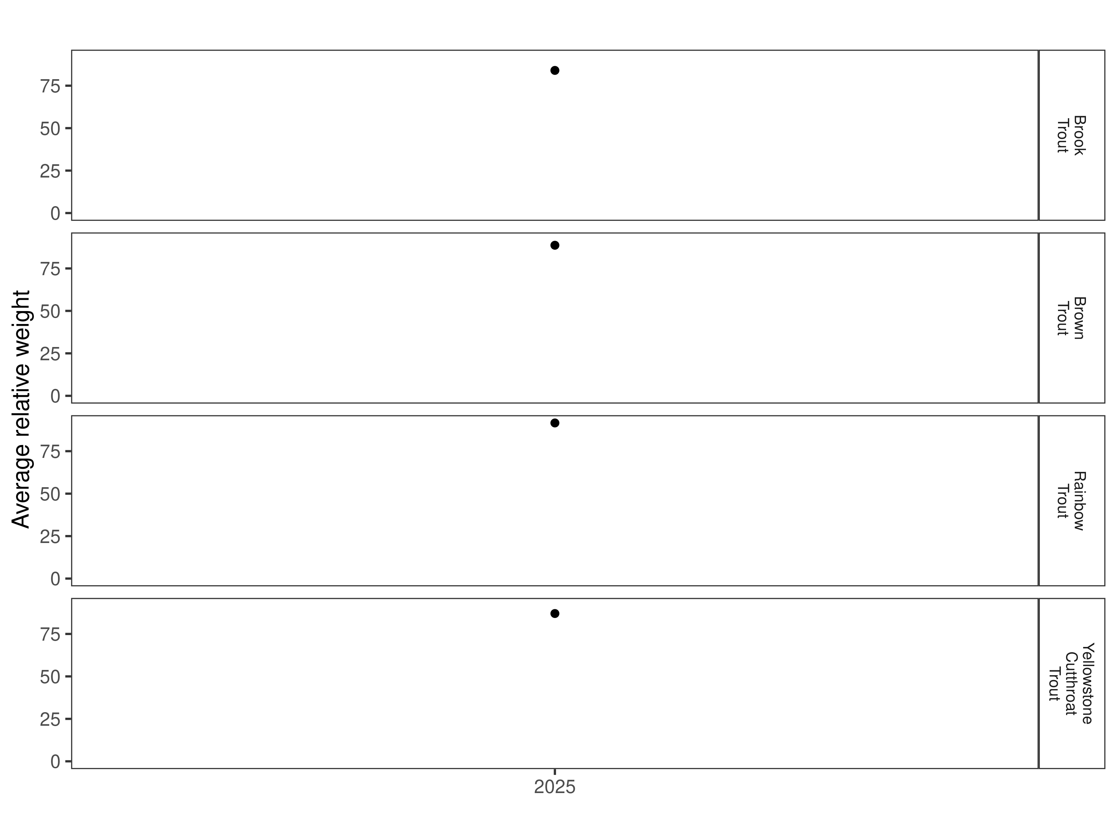
Figure 15. Relative weight in the Canyon Section for 2025.

Size Structure
Distribution of lengths for brown, rainbow, rainbow x Yellowstone cutthroat hybrid, and Yellowstone cutthroat trout in the Canyon Section are displayed below (Figure 16 and Figure 17). This is the first sampling effort in this section and there are no historic data for comparison.
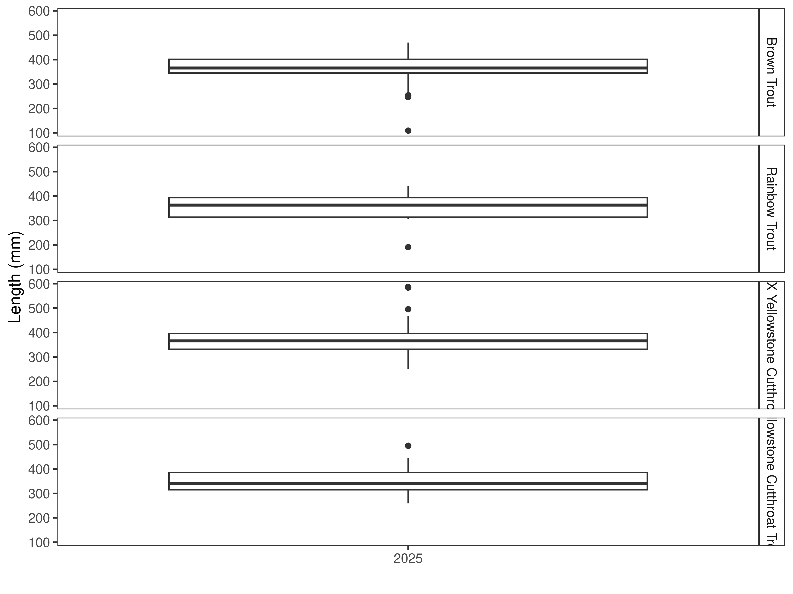
Figure 16. Distribution of lengths for 2025 in the Canyon Section. The box-and-whisker plots divide the distribution of the data into the first quartile (the lower limit of the box), the median (heavy black line), and third quartile (the upper limit of the box). The whiskers denote data points within 1.5 * the interquartile range (the difference between the first and third quartiles). Dots denote data points further than 1.5 * the interquartile range from the box.
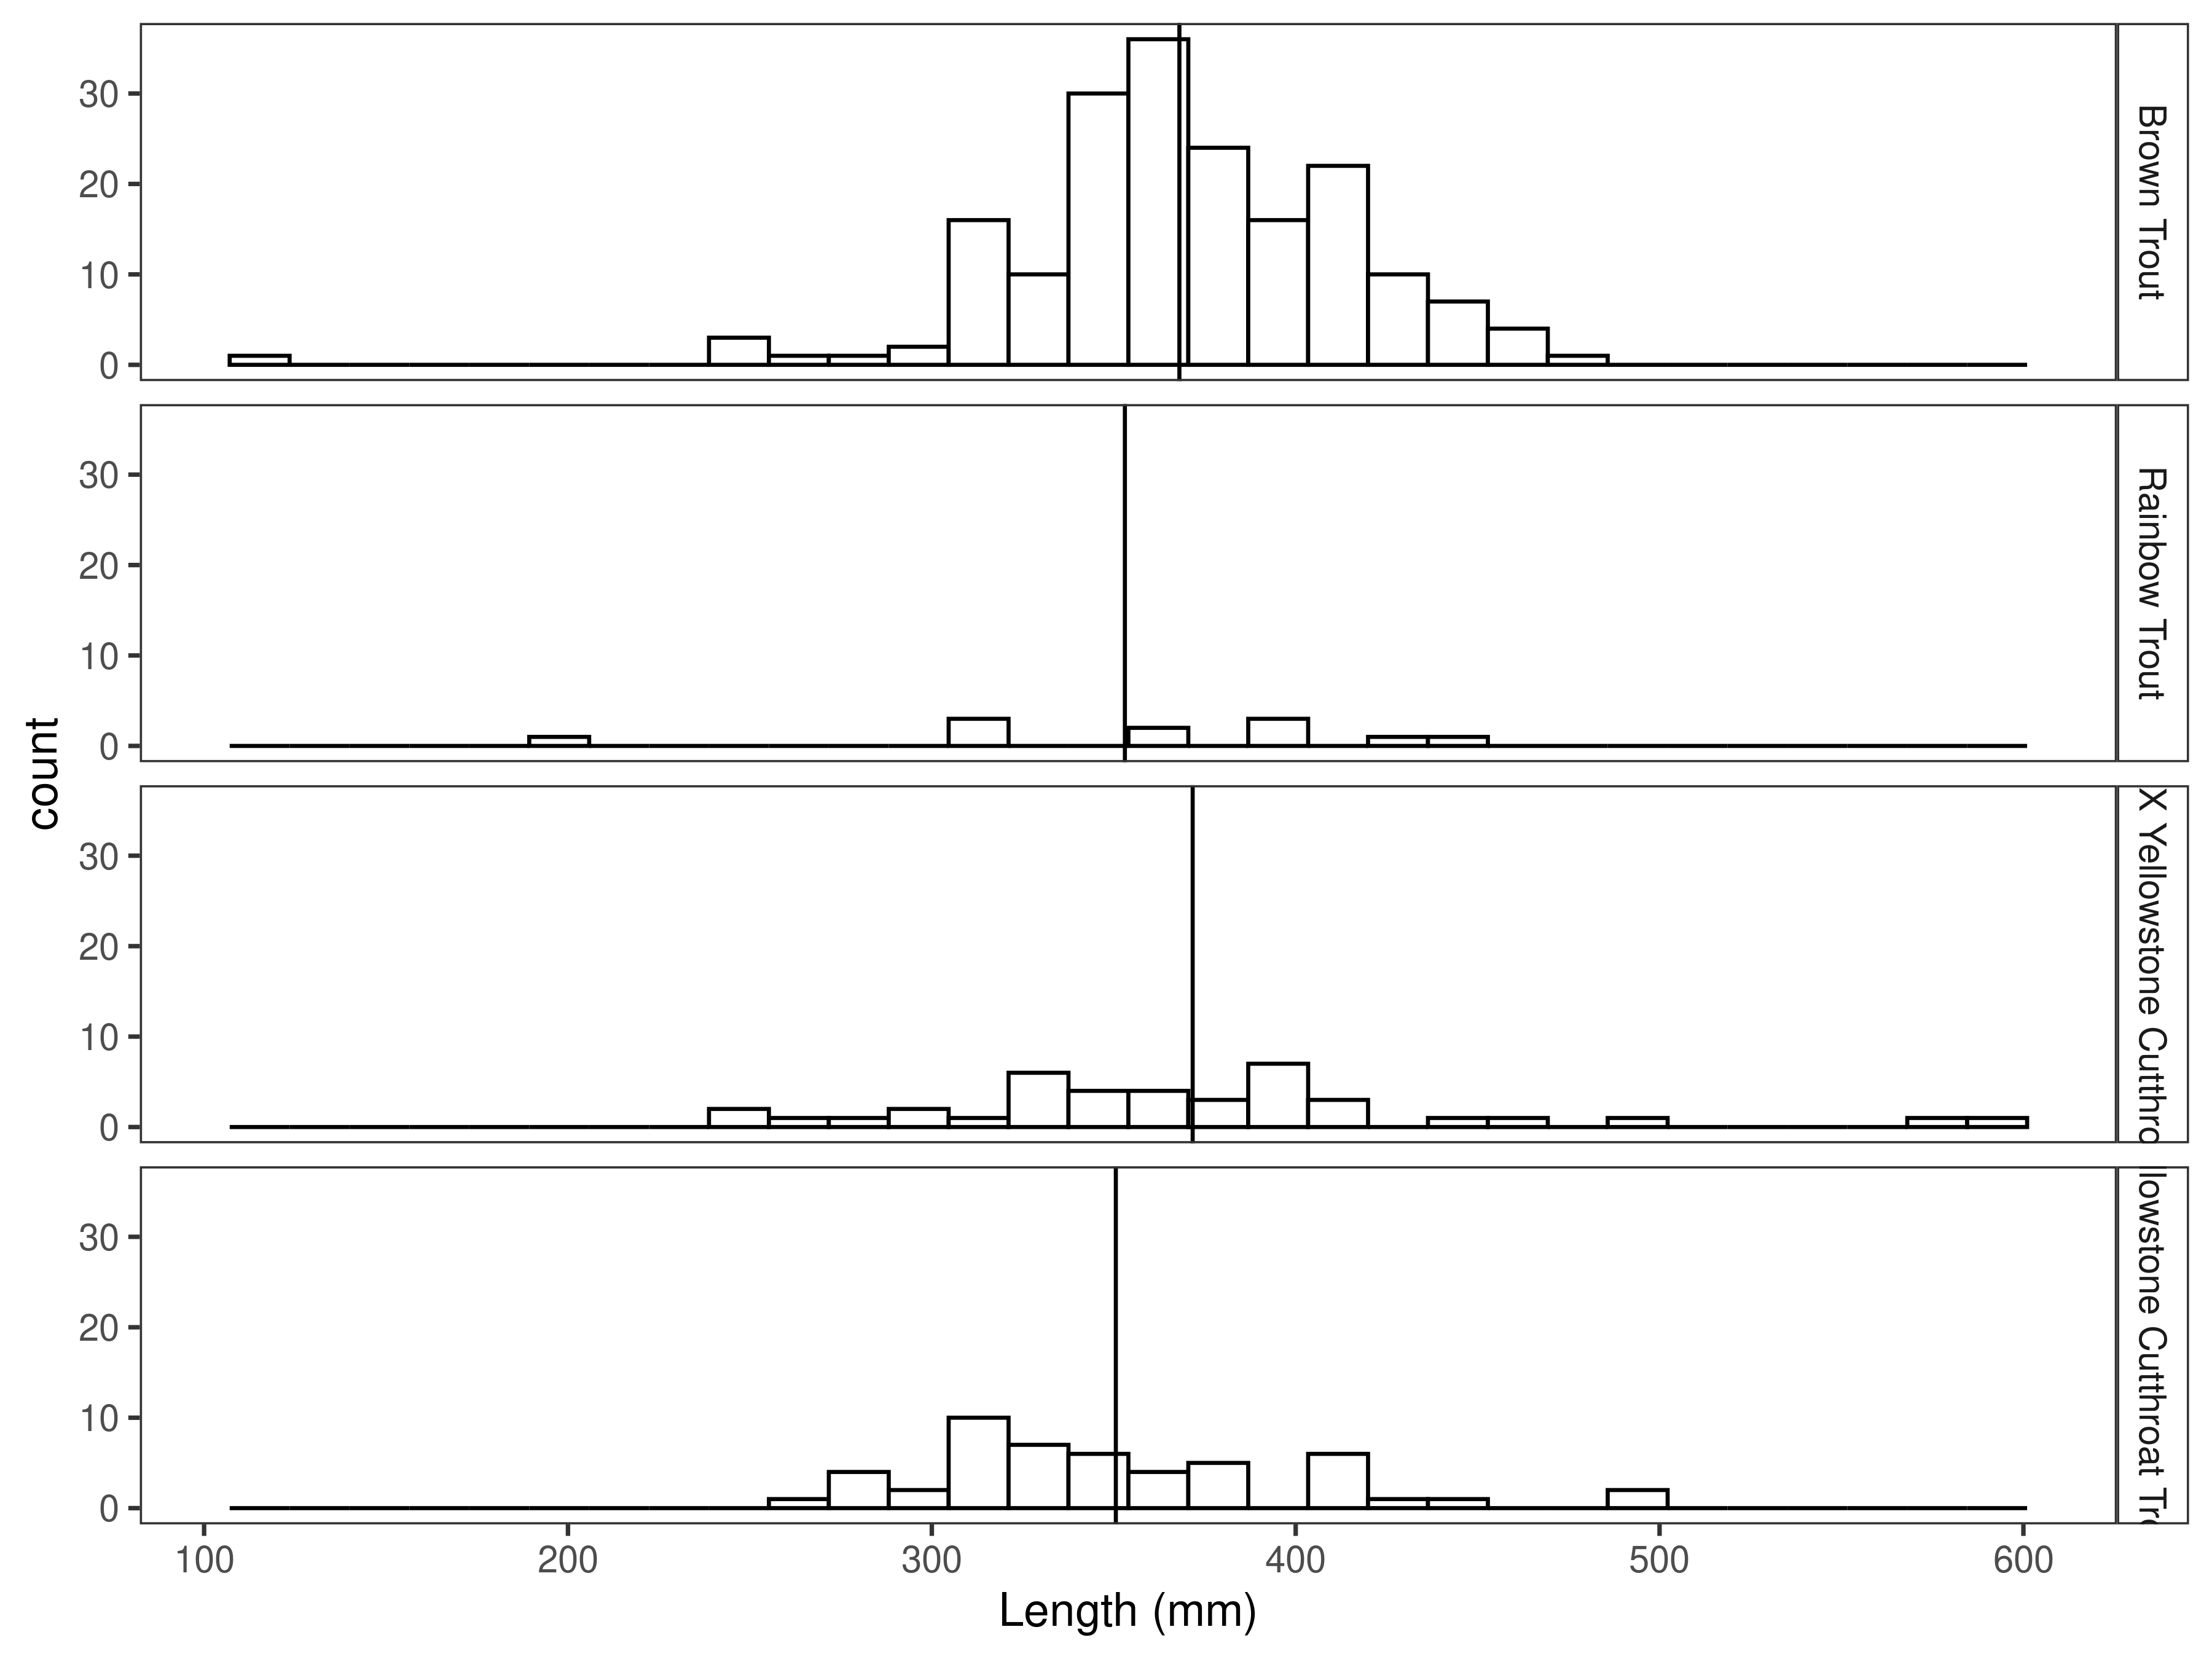
Figure 17. Length distribution by species in the Canyon Section for 2025, with long-term species-averages indicated by the vertical black line.

Mark-recapture abundance estimates
In 2025, the abundance estimate for brown trout in the Canyon Section was 69/km (Figure 18 and Table 7). The biomass estimate for brown trout was 137.9 kg/km (Figure 19 and Table 7).
The rainbow x Yellowstone cutthroat hybrid abundance estimate was 17/km in 2025. The biomass estimate was 34.9 kg/km.
The Yellowstone cutthroat trout abundance estimate in 2025 was 23/km and their biomass estimate was 41.5 kg/km.

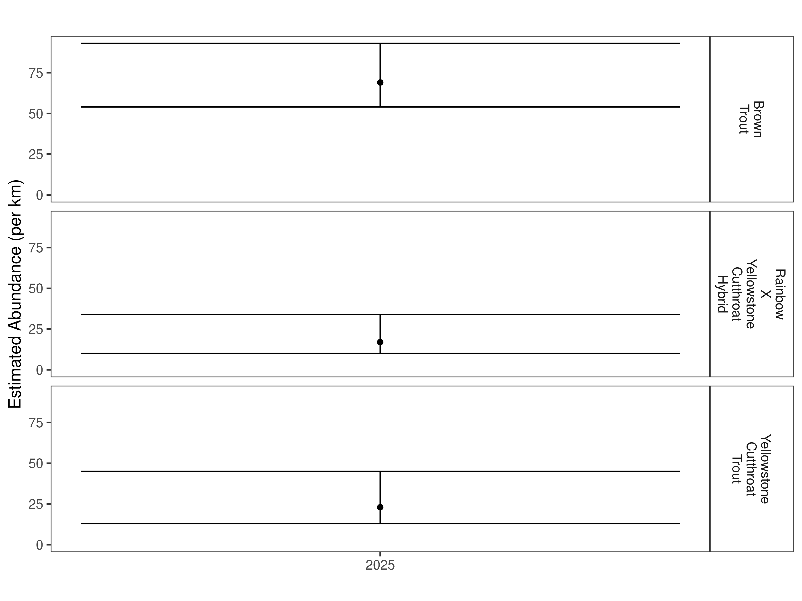
Figure 18. Canyon Section mark-recapture abundance estimates (fish per kilometer) for 2025 using the Chapman estimator. These estimates (mean and 95% confidence intervals) represent the model-averaged estimates across all length groups.
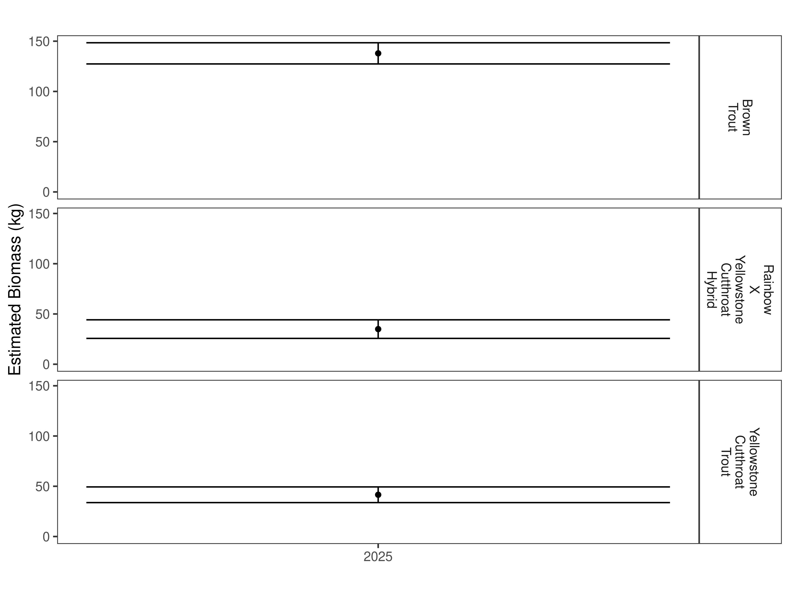
Figure 19. Canyon Section estimates of biomass for 2025.

Table 7. Canyon Section abundance estimates of fish per kilometer (Pop. Estimate) across length groups and estimated biomass (Biomass Estimate, kg) for 2025.
 |  | Pop. Estimate | 2.5% | 97.5% | Biomass Estimate | 2.5% | 97.5%
Brown Trout | 2025 | 69 | 54 | 93 | 137.9 | 127.4 | 148.4
Rainbow X Yellowstone Cutthroat Hybrid | 2025 | 17 | 10 | 34 | 34.9 | 25.7 | 44.2
Yellowstone Cutthroat Trout | 2025 | 23 | 13 | 45 | 41.5 | 33.8 | 49.4

Lower Chadbourne Section

Data summary
This is the first time that this section of the Shields River has been sampled.
Six brook trout with an average length of 221.8 mm were captured in the Canyon Section in 2025 (Table 8). The total number of brown trout captured was 255 and they had an average length of 312.5 mm. A total of 74 Yellowstone cutthroat trout were captured with an average length of 265.1 mm. In this section, 25 trout that were hybrid crosses between rainbow and Yellowstone cutthroat trout were captured. These fish had an average length of 229.4 mm.

Results

Data summary
Table 8. Data summary for the Lower Chadbourne Section in 2025.
 |  |  |  | Length |  |  |  |  | Weight |  |  | Condition |  |  | Relative Weight
 |  | n |  | Min | Max | Avg | SD |  | Avg | SD |  | Avg | SD |  | Avg | SD
Brook Trout |  | 6 |  | 172.7 | 264.2 | 221.8 | 44.0 |  | 114.9 | 62.4 |  | 34.7 | 4.1 |  | 92.5 | 11.0
Brown Trout |  | 255 |  | 121.9 | 525.8 | 312.5 | 81.7 |  | 338.0 | 185.6 |  | 34.5 | 3.9 |  | 88.2 | 9.5
Rainbow Trout |  | 58 |  | 127.0 | 459.7 | 297.0 | 80.7 |  | 298.2 | 204.6 |  | 35.0 | 4.5 |  | 89.3 | 11.7
Rainbow X Yellowstone Cutthroat Hybrid |  | 25 |  | 149.9 | 452.1 | 229.4 | 66.0 |  | 148.6 | 151.9 |  | 36.9 | 3.3 |  | NA | NA
Yellowstone Cutthroat Trout |  | 74 |  | 137.2 | 401.3 | 265.1 | 66.0 |  | 207.2 | 145.0 |  | 34.6 | 4.4 |  | 85.5 | 11.4

Relative Weights
Brook trout had the highest relative weight in the Lower Chadbourne Section at 92.5 (Table 8 and Figure 20). The relative weight for brown trout in this section was 88.2 and it was 89.3 for rainbow trout. Relative weight for Yellowstone cutthroat trout in this section was to 85.5.
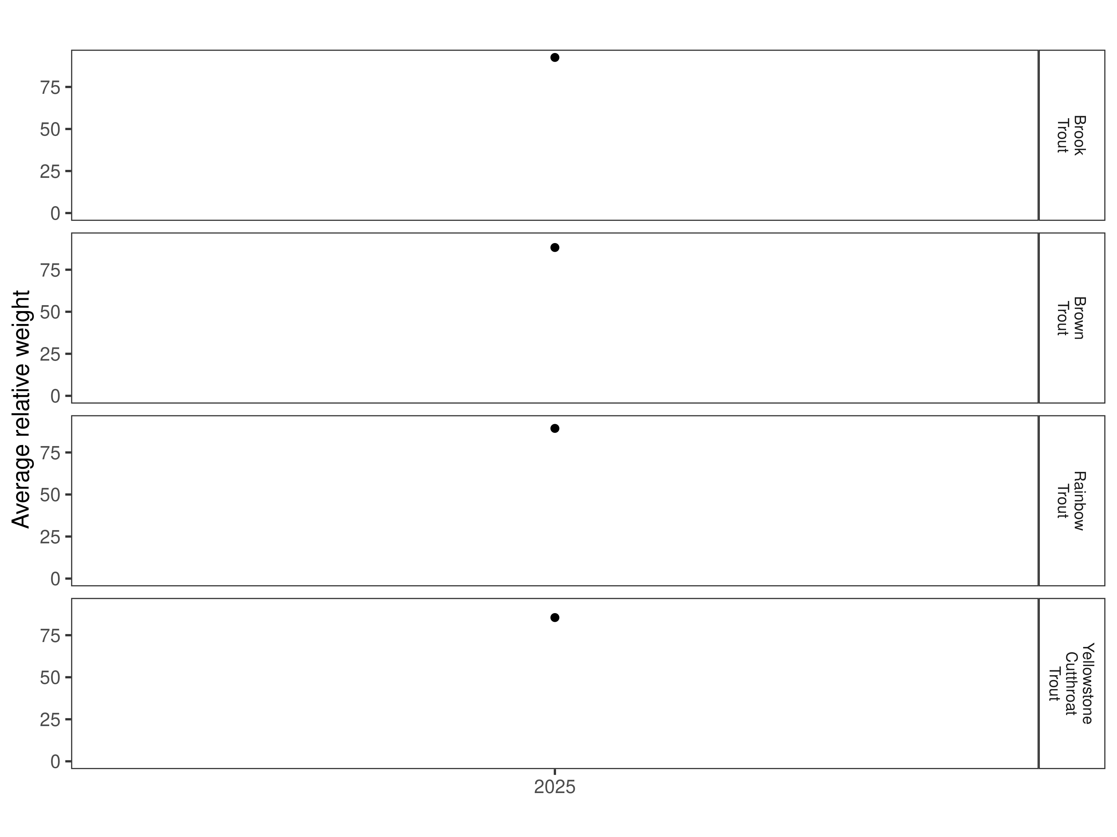
Figure 20. Relative weight in the Lower Chadbourne Section for 2025.

Size Structure
Distribution of lengths for brown, rainbow, and Yellowstone cutthroat trout in the Lower Chadbourne Section are displayed below (Figure 21 and Figure 22). This is the first sampling effort in this section and there are no historic data for comparison.
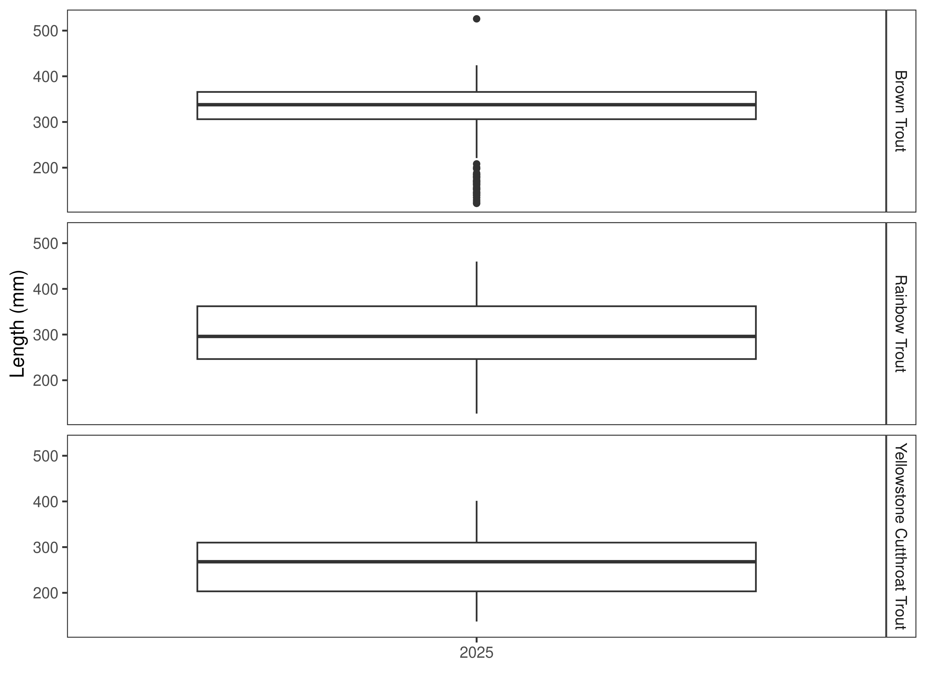 Figure 21. Distribution of lengths for 2025 in the Lower Chadbourne Section. The box-and-whisker plots divide the distribution of the data into the first quartile (the lower limit of the box), the median (heavy black line), and third quartile (the upper limit of the box). The whiskers denote data points within 1.5 * the interquartile range (the difference between the first and third quartiles). Dots denote data points further than 1.5 * the interquartile range from the box.
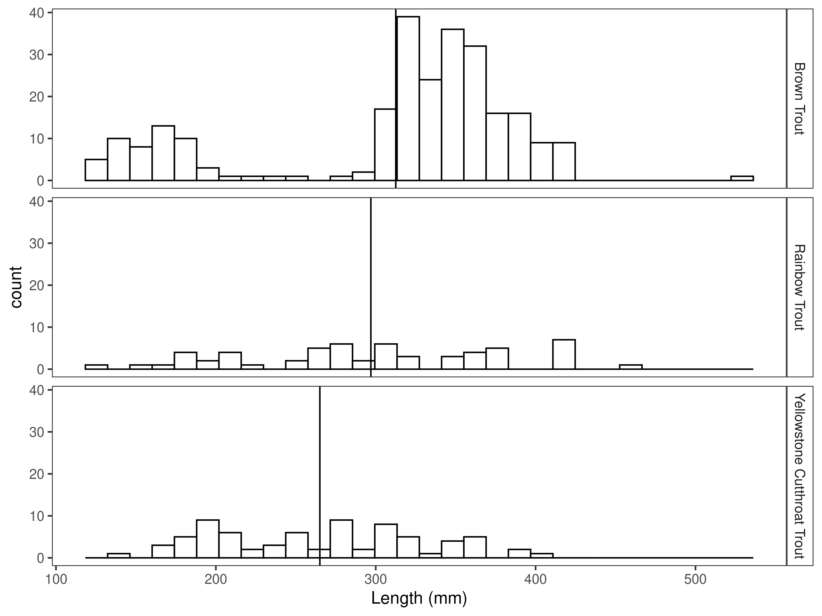
Figure 22. Length distribution by species in the Lower Chadbourne Section for 2025, with long-term species-averages indicated by the vertical black line.

Mark-recapture abundance estimates
In 2025, the abundance estimate for brown trout in the Lower Chadbourne Section was 389/km (Figure 23 and Table 9). The biomass estimate for brown trout was 296.1 kg/km (Figure 24 and Table 9).
The rainbow trout abundance estimate was 85/km and the biomass estimate was 57.0 kg/km.
The rainbow x Yellowstone cutthroat hybrid abundance estimate was 36/km in 2025. The biomass estimate was 11.9 kg/km.
The Yellowstone cutthroat trout abundance estimate in 2025 was 124/km and the biomass estimate was 57.8 kg/km.

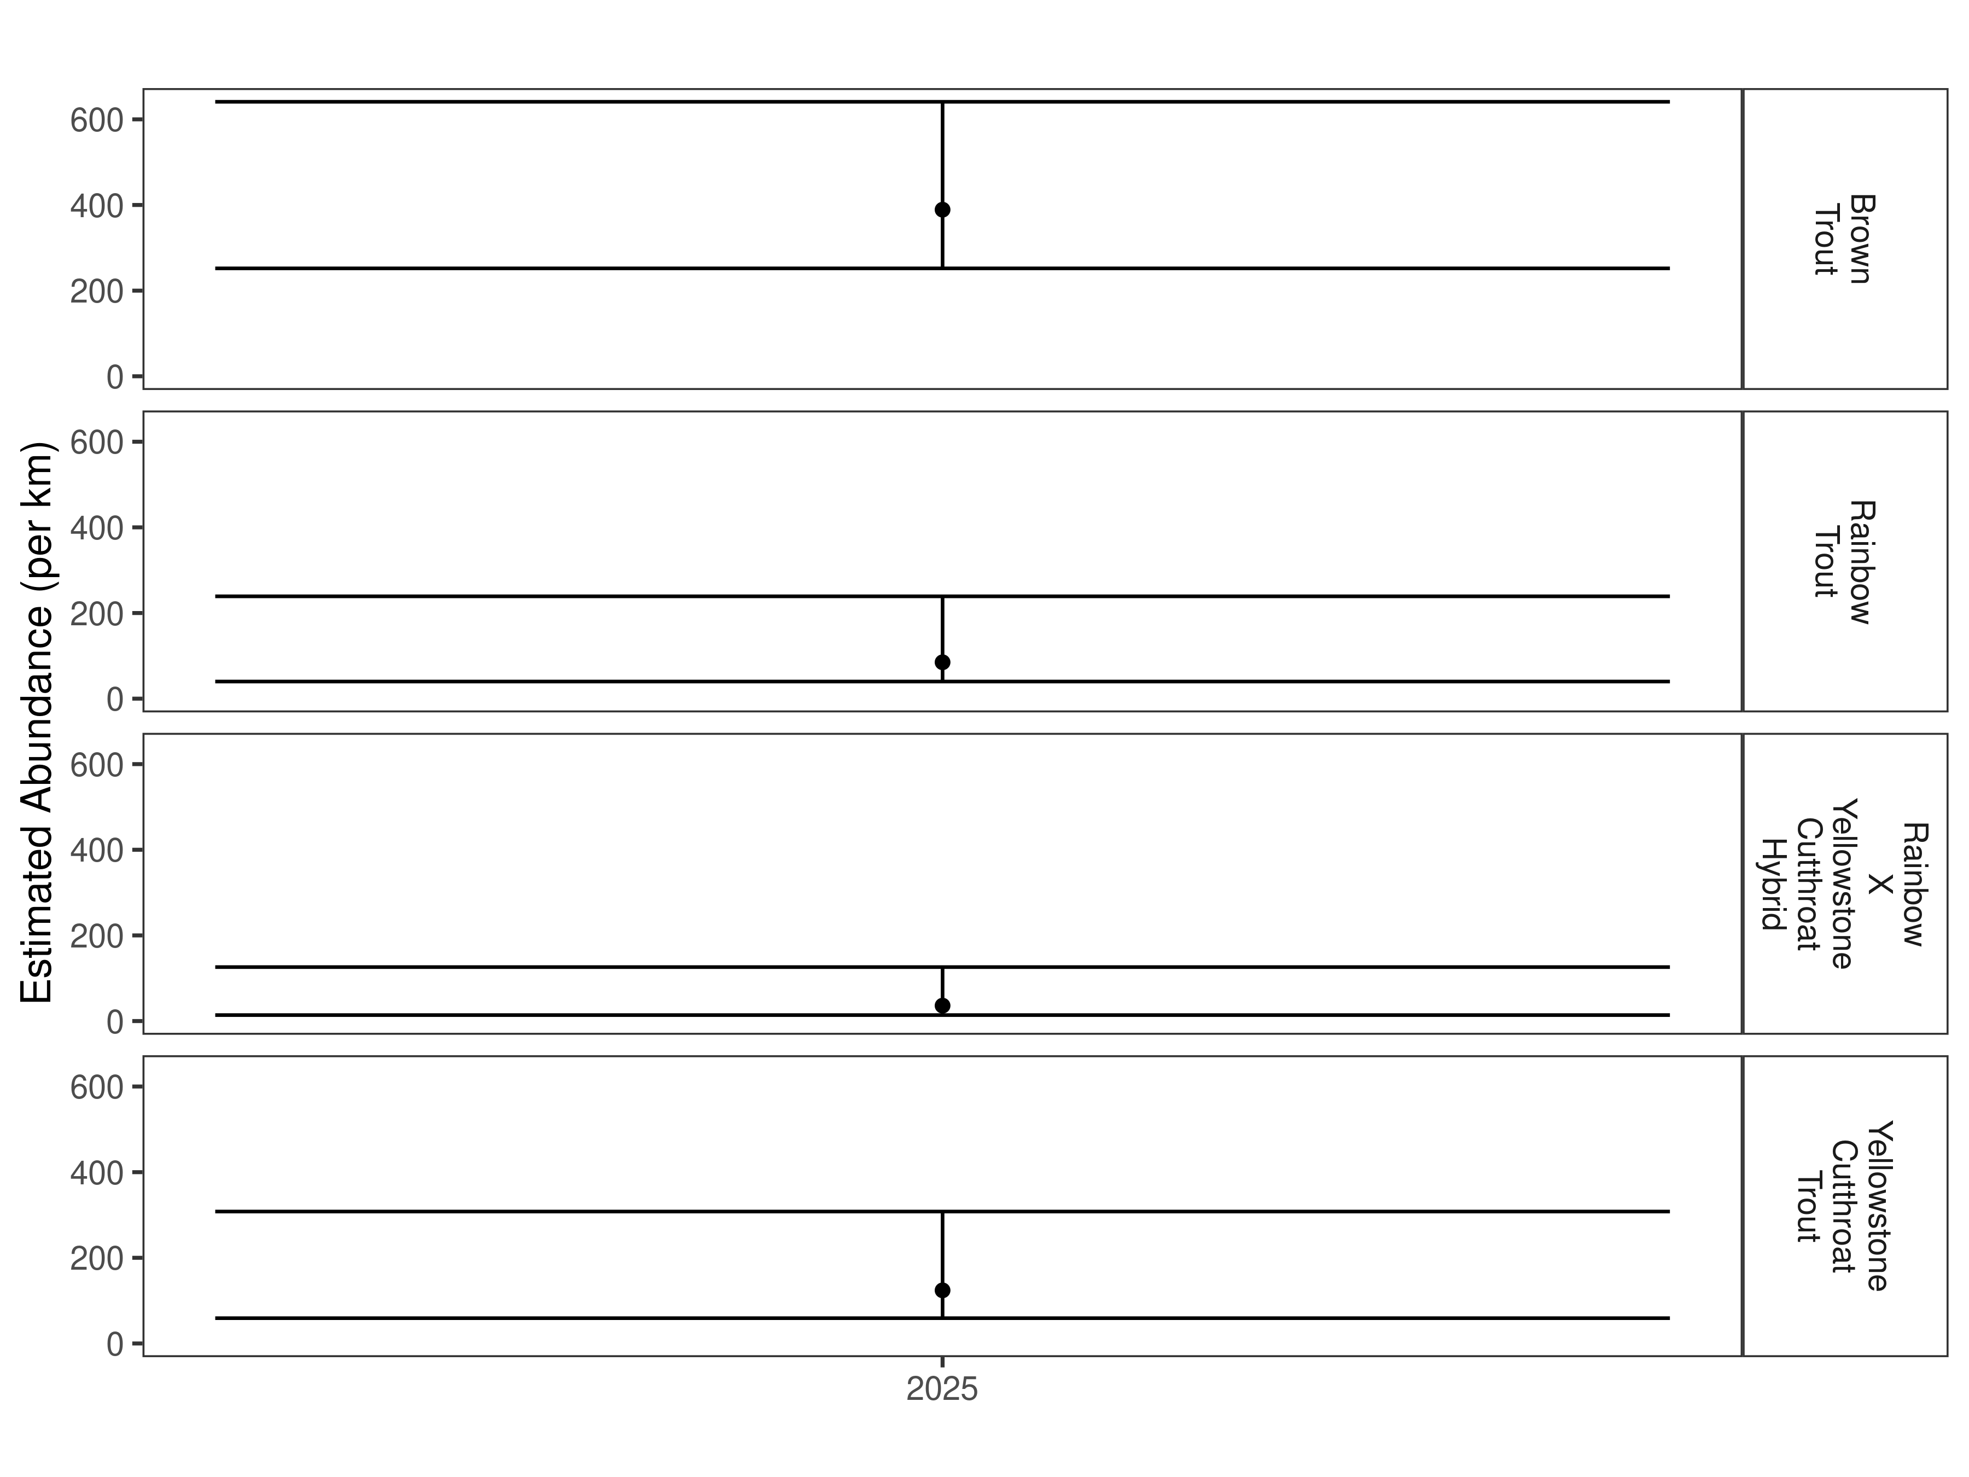
Figure 23. Lower Chadbourne mark-recapture abundance estimates (fish per kilometer) for 2025 using the Chapman estimator. These estimates (mean and 95% confidence intervals) represent the model-averaged estimates across all length groups.

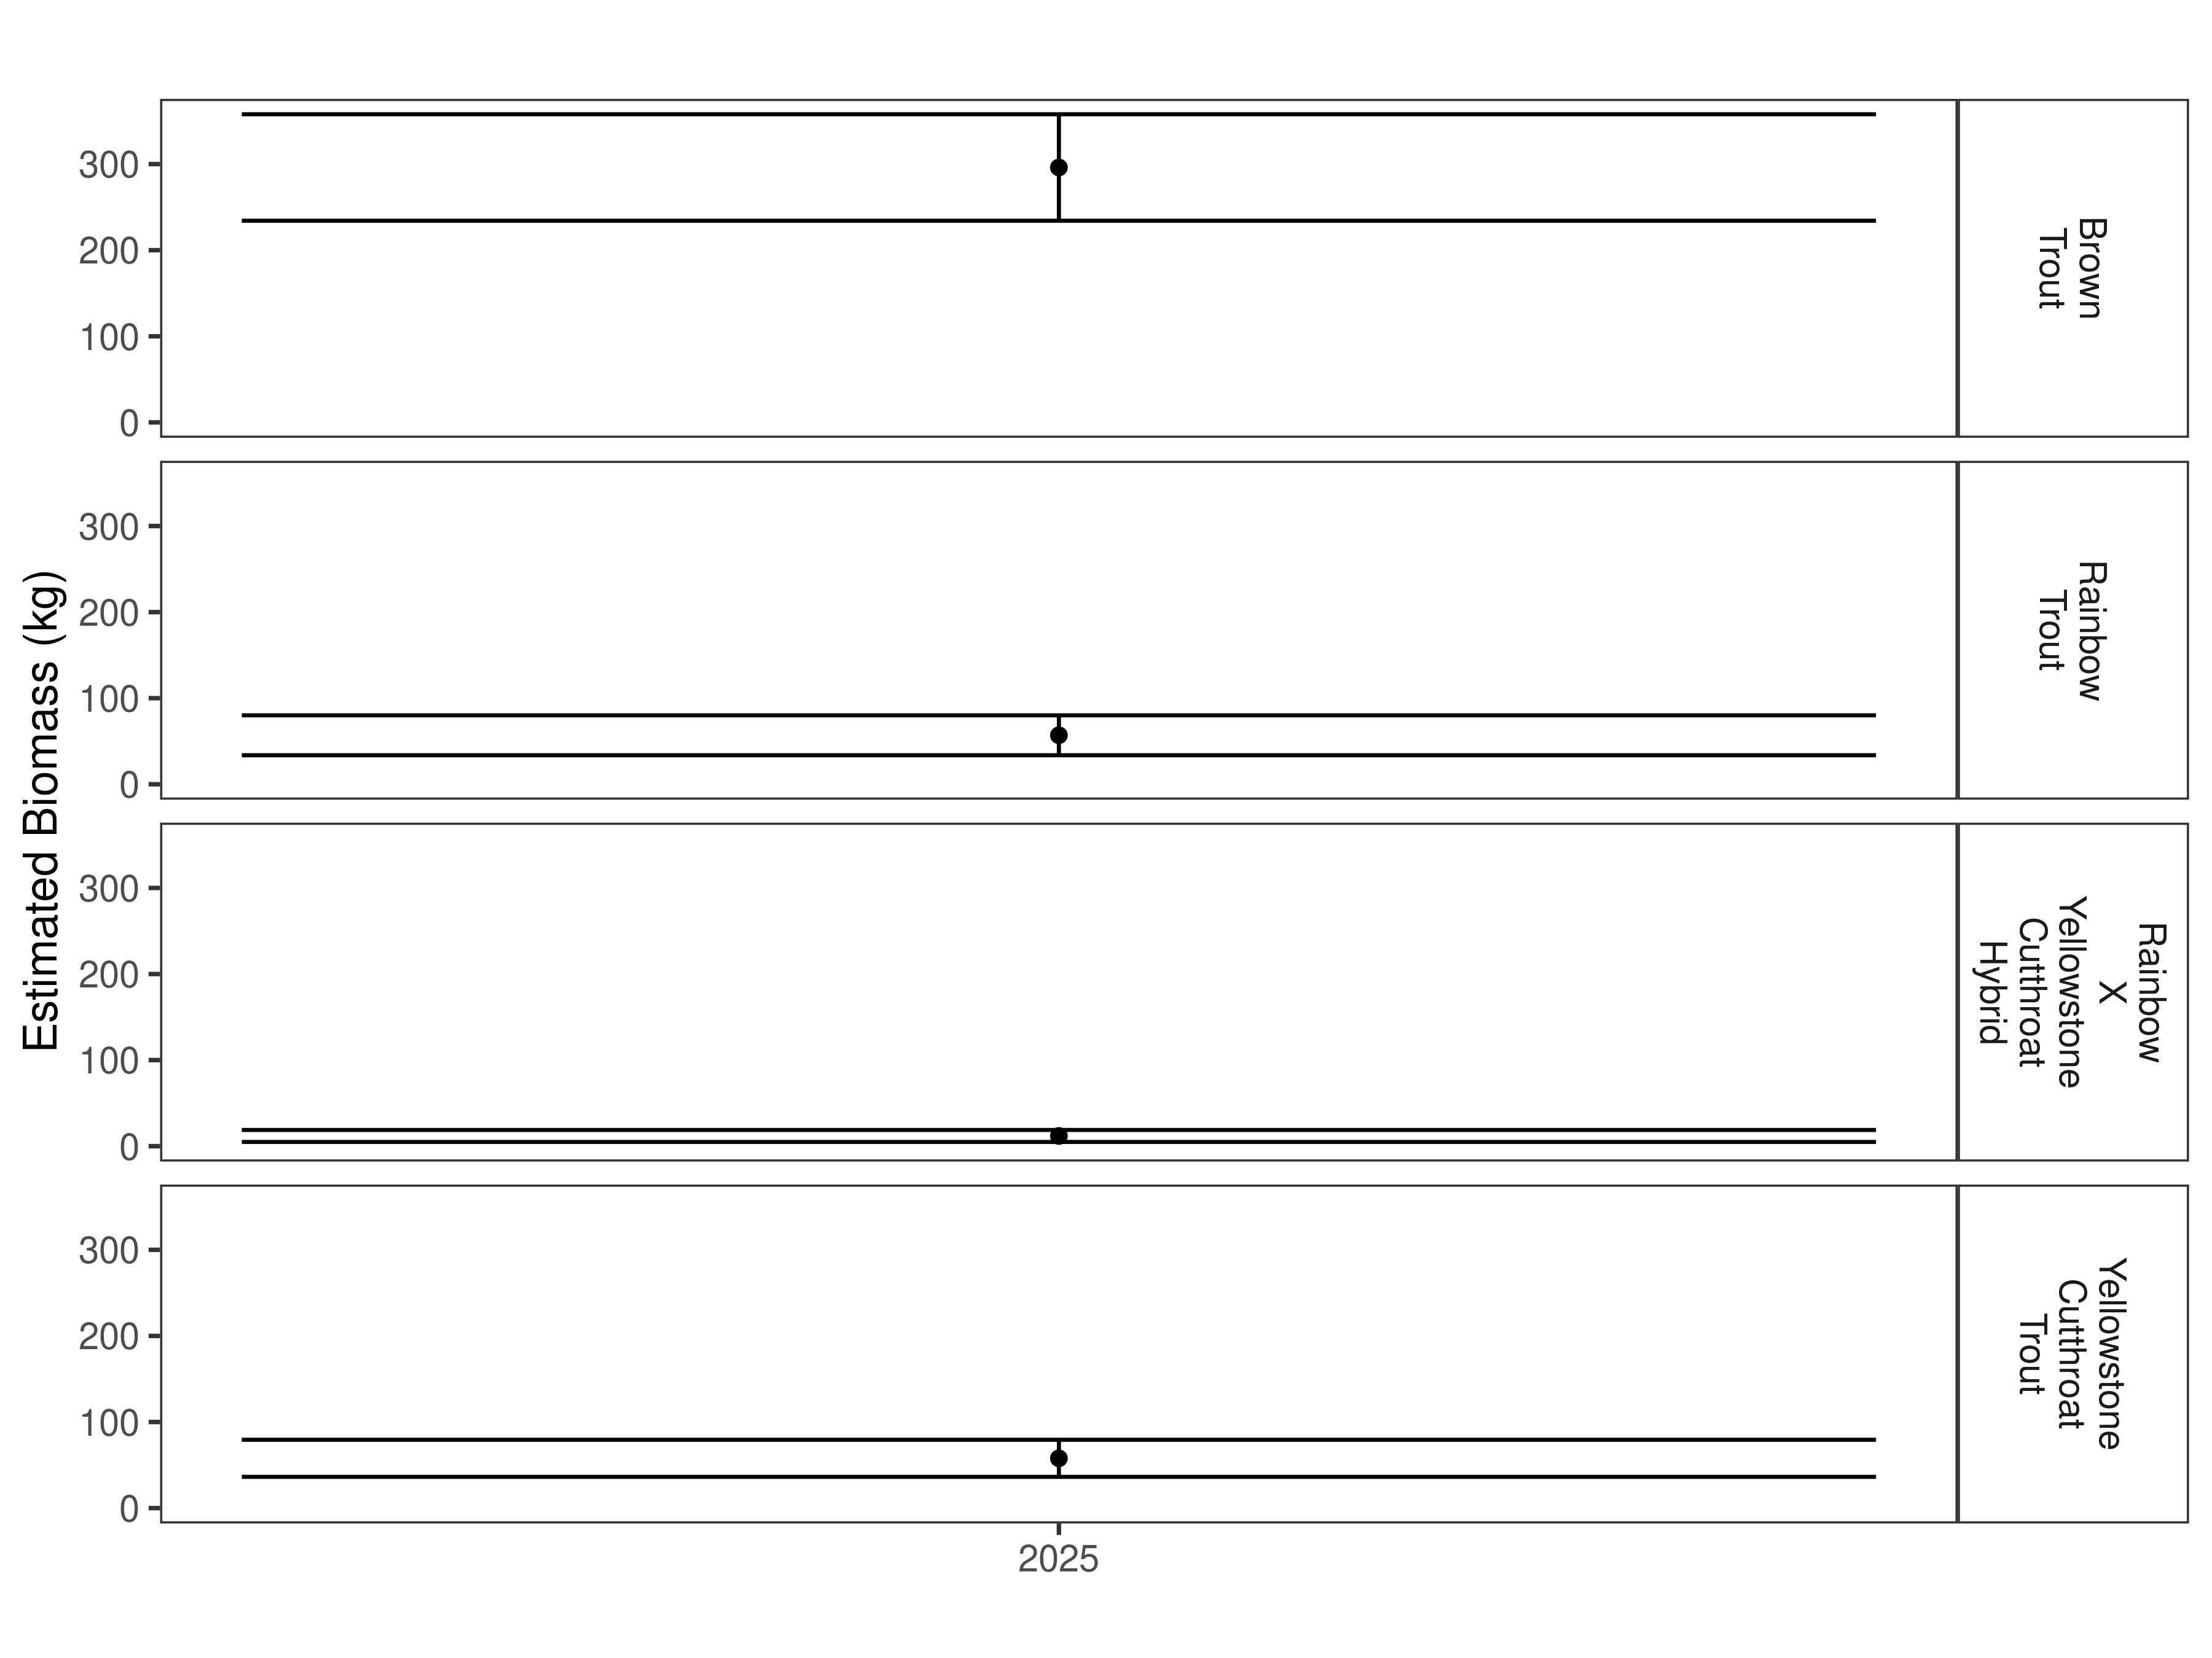
Figure 24. Lower Chadbourne Section estimates of biomass for 2025.

Table 9. Lower Chadbourne abundance estimates of fish per kilometer (Pop. Estimate) across length groups and estimated biomass (Biomass Estimate, kg) for 2025.
 |  | Pop. Estimate | 2.5% | 97.5% | Biomass Estimate | 2.5% | 97.5%
Brook Trout | 2025 | 2 | 2 | 8 | 0.6 | 0.3 | 0.8
Brown Trout | 2025 | 389 | 252 | 641 | 296.1 | 234.2 | 357.9
Rainbow Trout | 2025 | 85 | 40 | 239 | 57.0 | 33.8 | 80.1
Rainbow X Yellowstone Cutthroat Hybrid | 2025 | 36 | 14 | 126 | 11.9 | 5.0 | 18.8
Yellowstone Cutthroat Trout | 2025 | 124 | 59 | 308 | 57.8 | 36.3 | 79.3
Fiddle Creek Bridge Section

Data summary
This is the first time that this section of the Shields River has been sampled.
One brook trout with a length of 228.6 mm was captured in the Fiddle Creek Bridge Section in 2025 (Table 10). The total number of brown trout captured was 201 with an average length of 305.5 mm. A total of 30 Yellowstone cutthroat trout were captured in 2025. Their average length was 265.8 mm. In this section, 35 trout that were hybrid crosses between rainbow and Yellowstone cutthroat trout were captured. These fish had an average length of 294.3 mm.

Table 10. Data summary for the Fiddle Creek Bridge Section in 2025.
 |  |  |  | Length |  |  |  |  | Weight |  |  | Condition |  |  | Relative Weight
 |  | n |  | Min | Max | Avg | SD |  | Avg | SD |  | Avg | SD |  | Avg | SD
Brook Trout |  | 1 |  | 228.6 | 228.6 | 228.6 | NA |  | 190.5 | NA |  | 57.6 | NA |  | 153.6 | NA
Brown Trout |  | 201 |  | 129.5 | 469.9 | 305.2 | 98.2 |  | 348.9 | 237.7 |  | 35.3 | 4.5 |  | 90.2 | 11.1
Rainbow Trout |  | 138 |  | 129.5 | 462.3 | 303.9 | 78.4 |  | 319.4 | 201.8 |  | 35.3 | 2.8 |  | 90.0 | 7.6
Rainbow X Yellowstone Cutthroat Hybrid |  | 35 |  | 152.4 | 477.5 | 294.3 | 79.4 |  | 298.6 | 220.9 |  | 36.3 | 3.6 |  | NA | NA
Yellowstone Cutthroat Trout |  | 30 |  | 160.0 | 408.9 | 265.8 | 70.2 |  | 227.9 | 175.6 |  | 36.4 | 2.8 |  | 90.0 | 8.4

Relative Weights
Brook trout had the highest relative weight in the Fiddle Creek Bridge Section at 153.6 (Table 10 and Figure 25). The relative weight for brown trout in this section was 90.2. The relative weight for both Yellowstone cutthroat and rainbow trout in this section was 90.0.
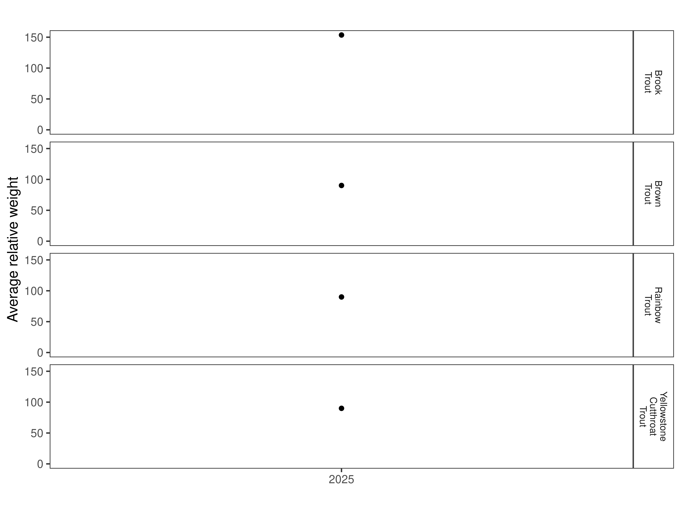
Figure 25. Relative weight in the Fiddle Creek Bridge Section for 2025.

Size Structure
Distribution of lengths for brown, rainbow, and Yellowstone cutthroat trout in the Fiddle Creek Bridge Section are displayed below (Figure 26 and Figure 27). This is the first sampling effort in this section and there are no historic data for comparison.
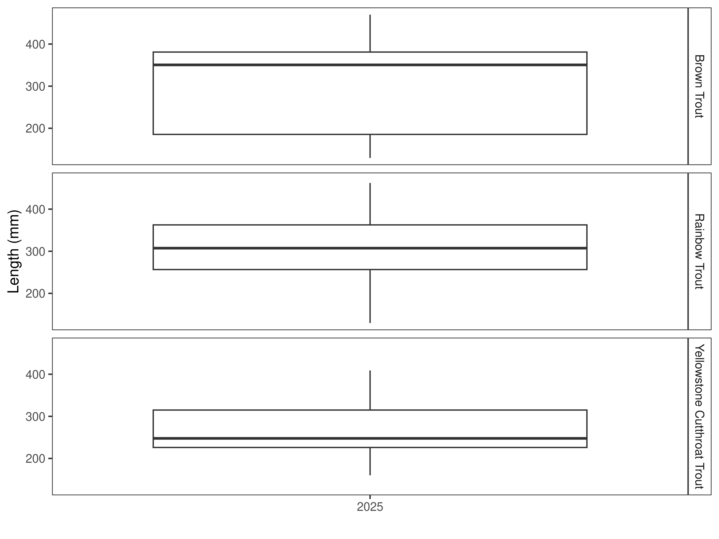
Figure 26. Distribution of lengths for 2025 in the Fiddle Creek Bridge Section. The box-and-whisker plots divide the distribution of the data into the first quartile (the lower limit of the box), the median (heavy black line), and third quartile (the upper limit of the box). The whiskers denote data points within 1.5 * the interquartile range (the difference between the first and third quartiles). Dots denote data points further than 1.5 * the interquartile range from the box.
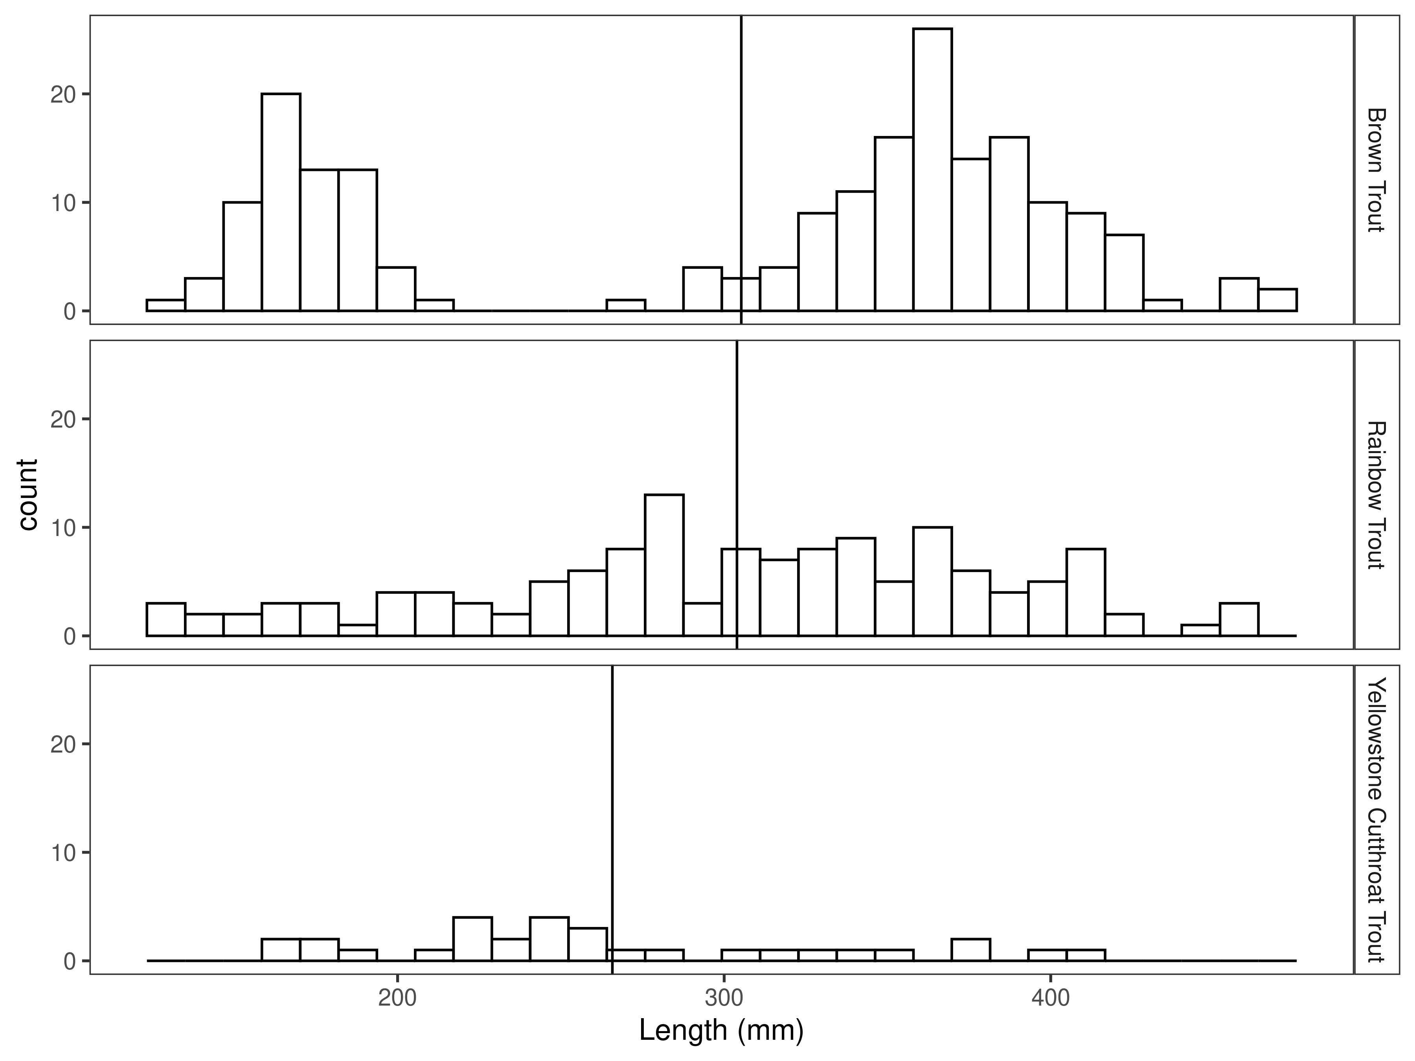
Figure 27. Length distribution by species in the Fiddle Creek Bridge Section for 2025, with long-term species-averages indicated by the vertical black line.

Mark-recapture abundance estimates
In 2025, the abundance estimate for brown trout in the Fiddle Creek Bridge Section was 161/km (Figure 28 and Table 11). The biomass estimate for brown trout was 325.8 kg/km (Figure 29 and Table 11).
Rainbow trout was the most abundant species with an abundance estimate of 188/km and a biomass estimate of 348.7 kg/km.
The Yellowstone cutthroat trout abundance estimate in 2025 was 21/km and the biomass estimate was 27.9 kg/km.
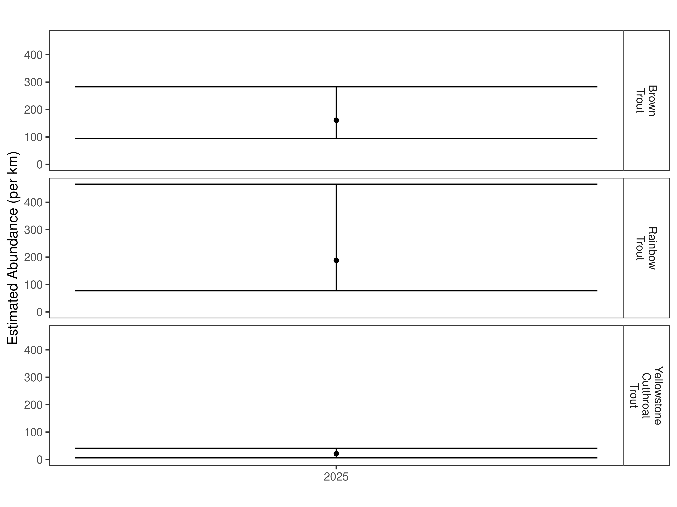
Figure 28. Fiddle Creek Bridge Section mark-recapture abundance estimates (fish per kilometer) for 2025 using the Chapman estimator. These estimates (mean and 95% confidence intervals) represent the model-averaged estimates across all length groups.
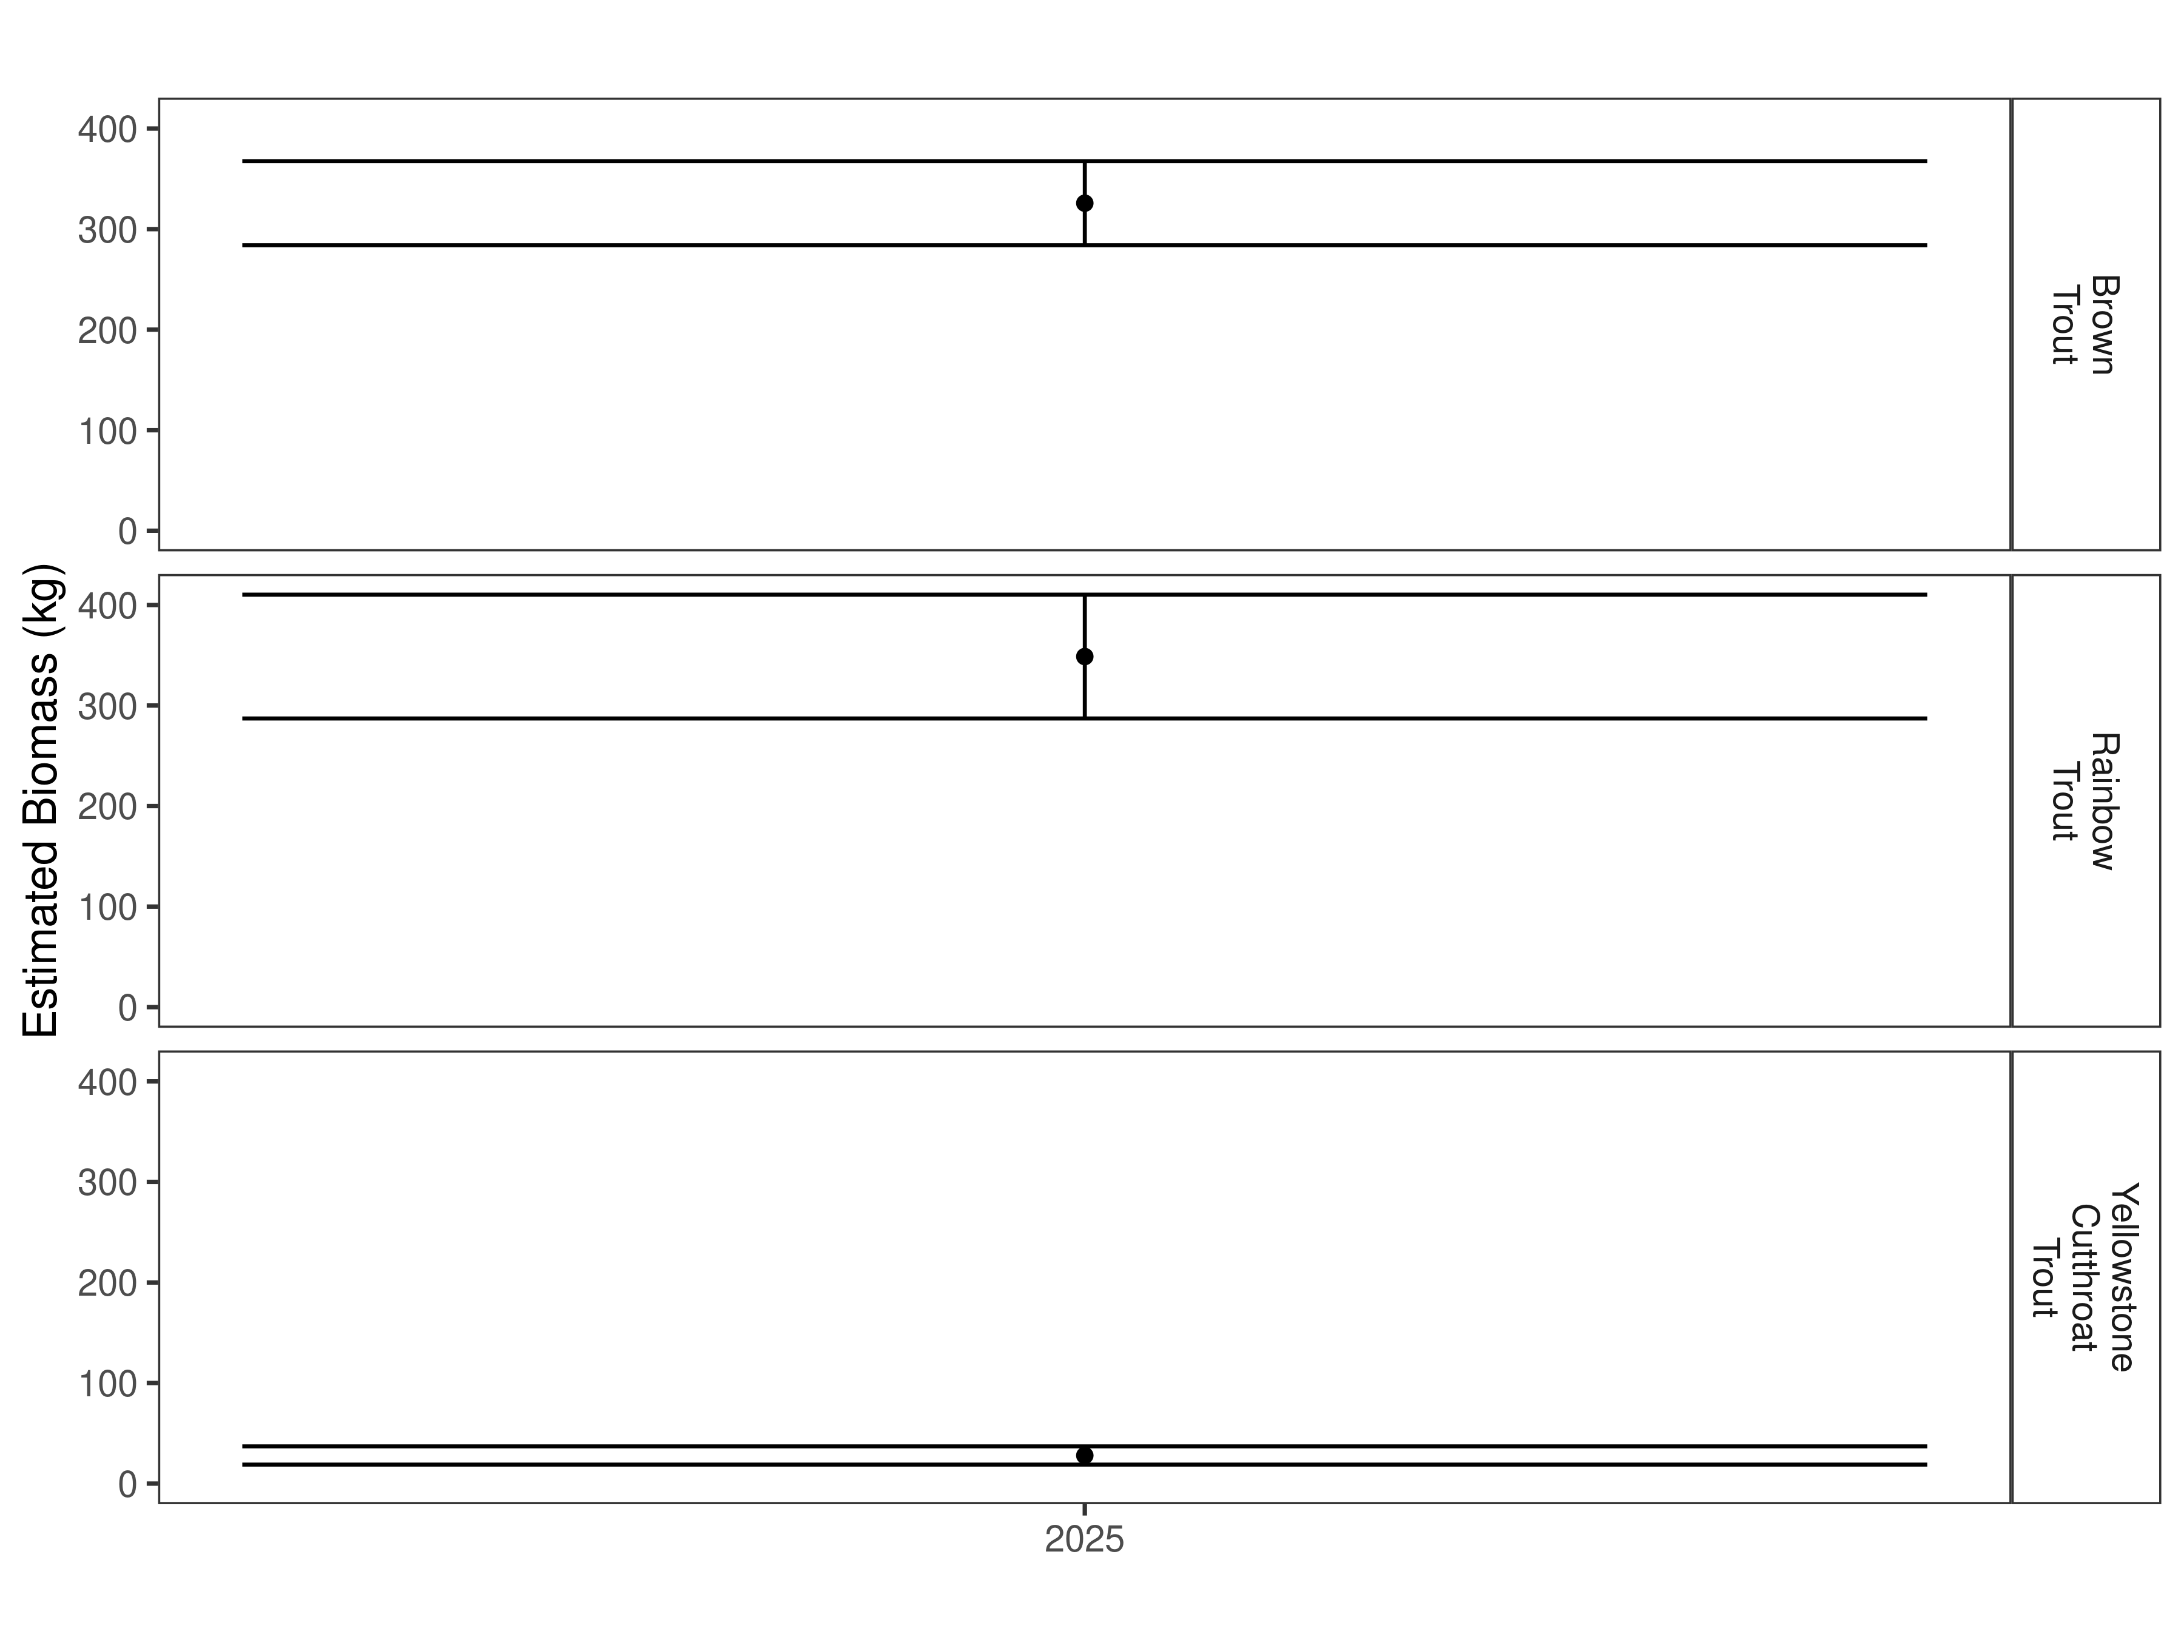
Figure 29. Lower Chadbourne Section estimates of biomass for 2025.

Table 11. Fiddle Creek Bridge Section abundance estimates of fish per kilometer (Pop. Estimate) across length groups and estimated biomass (Biomass Estimate, kg) for 2025.

 |  | Pop. Estimate | 2.5% | 97.5% | Biomass Estimate | 2.5% | 97.5%
Brown Trout | 2025 | 161 | 95 | 283 | 325.8 | 284.0 | 367.6
Rainbow Trout | 2025 | 188 | 77 | 466 | 348.7 | 287.1 | 410.3
Yellowstone Cutthroat Trout | 2025 | 21 | 6 | 41 | 27.9 | 18.9 | 37.0

Discussion
Zimmerman Section
From 2024 to 2025, the Zimmerman Section brown trout population decreased significantly in abundance and biomass. The current population is heavily weighted toward larger, older fish with most of the brown trout captured in 2025 being larger than 300 mm. This suggests a potential recruitment issue for brown trout in this section. The cause for the decline is currently unknown, and further monitoring will hopefully provide insight. Both mountain whitefish and Yellowstone cutthroat trout in this section saw increases in both abundance and biomass.
Clovis Section
The Clovis Section was new in 2025 and there is no historical data to compare. Increases in stream flow after the marking run was completed prevented the completion of a recapture run and ultimately a population estimate. There were 57 brown trout, 45 Yellowstone cutthroat trout, 1 brook trout, and 4 rainbow x Yellowstone hybrids captured in this section during the marking run.
Clyde Park Section
The Clyde Park Section was sampled in 2025 for the first time. Brown trout were the most abundant species captured in this section at 62/km. Yellowstone cutthroat trout were the next most abundant at 41/km, followed by rainbow x Yellowstone cutthroat hybrids at 11/km. Two brook trout and one rainbow were also captured in this section.
Canyon Section
The first time the Canyon Section was sampled was in 2025. Brown trout were the most abundant species at 69/km. Yellowstone cutthroat trout abundance was 23/km and rainbow x Yellowstone cutthroat hybrids were 17/km. Eleven rainbow trout and two brook trout were also captured in this section.
Lower Chadbourne Section
The Lower Chadbourne Section was first sampled in 2025. Brown trout were the most abundant species captured in the section at 389/km. This was also the highest abundance of brown trout in all sections sampled in the Shields River in 2025. Yellowstone cutthroat trout abundance in this section was 124/km. This was also the highest abundance for Yellowstone cutthroat trout in all sections of the Shields River this year. Rainbow trout abundance in the Lower Chadbourne section was 85/km and rainbow x Yellowstone cutthroat hybrids were 36/km. Six brook trout were also captured in this section in 2025.
Fiddle Creek Bridge Section
Fiddle Creek Bridge Section was new in 2025. Rainbow trout had the highest abundance in this section at 188/km. This was also the highest rainbow abundance in all sections of the Shields River sampled in 2025. Brown trout abundance in this section was 161/km and Yellowstone cutthroat trout abundance was 21/km. This was the lowest Yellowstone cutthroat trout abundance in all sections of the Shields River sampled in 2025.

References
Gabelhouse, Donald W. 1984. “A Length-Categorization System to Assess Fish Stocks.” North American Journal of Fisheries Management 4 (3): 273–85.
Neumann, R. M., and M. S. Allen. 2007. “Size Structure.” Analysis and Interpretation of Freshwater Fisheries Data. American Fisheries Society, Bethesda, Maryland, 375–421.
Ogle, D. H. 2018. FSA: Fisheries Stock Analysis. R Package Version 0.8. 20.9000.
R Core Team. 2018. R: A Language and Environment for Statistical Computing. Vienna, Austria: R Foundation for Statistical Computing.
Wege, Gary J., and Richard O. Anderson. 1978. “Relative Weight (Wr): A New Index of Condition for Largemouth Bass.” New Approaches to the Management of Small Impoundments. American Fisheries Society, North Central Division, Special Publication 5: 79–91.

Supporting Information

Mark-recapture abundance estimates
Table S2. Zimmerman Section model-averaged estimates of abundance (fish per kilometer) and biomass (kg) for species and year.
 |  | Pop. Estimate | 2.5% | 97.5% | Biomass Estimate | 2.5% | 97.5%
Brown Trout | 2024 | 310 | 156 | 663 | 114.9 | 55.1 | 174.8
Brown Trout | 2025 | 112 | 96 | 141 | 47.9 | 41.7 | 54.0
Mountain Whitefish | 2024 | 286 | 228 | 366 | 88.5 | 74.0 | 102.9
Mountain Whitefish | 2025 | 422 | 329 | 552 | 150.2 | 123.1 | 177.4
Yellowstone Cutthroat Trout | 2024 | 21 | 13 | 45 | 7.8 | 4.6 | 11.0
Yellowstone Cutthroat Trout | 2025 | 39 | 19 | 111 | 18.8 | 6.7 | 30.9

