Handout 1: Tree Matching
Match the tree to one of its defining features.

_____ 1. Ponderosa Pine

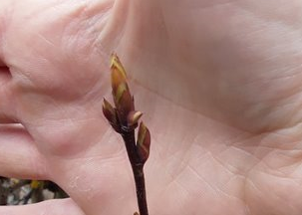

_____ 2. Western Serviceberry

_____ 3. Douglas Fir

_____ 4. Western Larch

_____ 5. Rocky Mountain Maple

- Smells like vanilla

- Loses its needles in the fall

- Leaves turn bright red in the fall

- Common Christmas tree

Handout 2: Who Lives in the Forest? Fill in the Blanks
- Label the four parts of a basic food chain:

- Producers ______________________ energy from the sun.

- What is an example of a producer?

- A(n) ____________________________________ eats plants.

- What is an example of an herbivore consumer?

- A(n)______________________________ eats plants and animals, while a(n)

________________________eats only animals.

- What is an example of an omnivore or carnivore consumer?

- A(n)_______________________________ helps recycle nutrients by breaking down plant and animal matter.

- What is an example of a decomposer or detritivore?

- Make your own food chain using different plants and animals than the ones in the example.

Handout 3: What’s in Your Backyard?
Take this worksheet outside with you for 5 minutes to practice your observation skills.
Come back inside at: ________________
- What does it feel like outside? What is the temperature, the wind, or other weather?

- Do you see any plants or animals?

- Close your eyes for a little while. What do you hear?

- Pick one thing you see, living or nonliving. Draw a picture with as much detail as possible:

