SHIELDS RIVER YELLOWSTONE CUTTHROAT TROUT CONSERVATION EFFORTS 2020

Durae Belcer and Scott Opitz
Montana Fish, Wildlife and Parks
December 2020
Introduction
Brook Trout removal and Yellowstone Cutthroat Trout (YCT) monitoring in the Shields River has continued annually from 2014 – 2020. 2020 marks the seventh year of YCT Conservation efforts in the Shields River and its tributaries. The primary method of removal has been electrofishing, however, hoop nets were used in 2015 and 2020 to capture adult Brook Trout moving upstream to spawn.
Brook Trout removal has occurred in varying lengths of stream at varying times of the year in each of the last seven years. Removal efforts have varied based on crew availability, stream conditions, and the number of YCT and Brook Trout present in a given water or reach of a water. This variability allows for limited direct comparison of efforts between reaches and streams, however, long-term sampling reaches have been established to track population changes and trends over time.
Methods for Brook Trout removal and YCT capture in 2020 were completed using the same methods as in the previous six years (see summary report for Shields River Yellowstone Cutthroat Trout Conservation efforts 2014-2019).
Shields River
Brook Trout Removal
Brook Trout electrofishing removal efforts took place in five sections of the Shields River in 2020. A total of 294 Brook Trout were captured and removed in 2020 for a total effort of 2,043 over the six years of removal. Section 1, closest to the barrier site, continues to have the highest number of Brook Trout removed compared to other sections of the Shields River (Figure 2). This may be due to favorable habitat for adult brook trout characterized by higher flows and deeper more complex pools than upper sections of the Shields River.

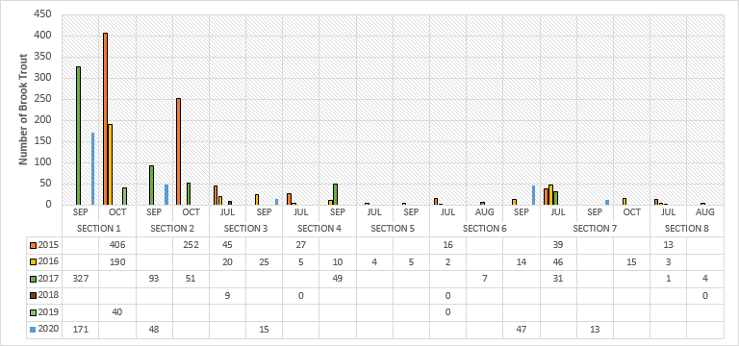
Figure 2. Brook Trout electrofishing removal results in the Shields River from 2015-2020.
Capture rates for Brook Trout have been decreasing since 2015 in the Shields River (Figure 3). Over the six-year period of Brook Trout removal there has been a 45% decrease in number removed per 100m of stream. Some of the decline can be attributed to varied level of effort each year.

Figure 3. Brook Trout removed per 100m sampled in the Shields River from 2015-2020.
Hoop Trap Captures
In 2020, two hoop traps were deployed in the Shields River to capture Brook Trout moving upstream. Shields trap #1 was run just below the mouth of Dugout Creek and Shields trap #2 was run just above the mouth of Lodgepole Creek. Traps were installed on September 9 and removed on October 8. Traps were run for 27 days total (not consecutive). During this time a total of 3 YCT were captured at Shields trap #1 and 3 YCT were capture at Shields trap #2. No Brook Trout were captured at either Shields River trap sites.
Yellowstone Cutthroat Trout Capture
Counts of YCT were completed in the Shields River during annual Brook Trout removal from 2015-2020 (Figure 4). A total of 264 YCT were counted in 2020. The last three years of YCT captures per 100 m of stream has been lower than the first three years of counts (Figure 5). It is hard to determine why catch rates for YCT have decreased throughout these sections. The variety and complexity of habitat throughout the eight sections of the Shields River, annual temperatures and annual flows may be creating favorable conditions in some sections rather than others and dictating the numbers of fish in each section. Comparison of electrofishing effort per year may be considered in future analysis.
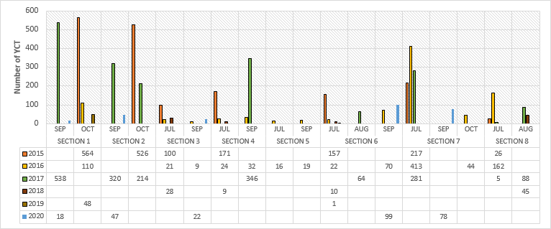
Figure 4. Yellowstone Cutthroat Trout electrofishing capture results in the Shields River from 2015-2020.

Figure 5. Yellowstone Cutthroat Trout captured per 100m sampled in the Shields River from 2015-2020.
Tributaries to the Shields River
Unnamed Tributary of the Shields River at RM 60.8.
Brook Trout removal and YCT counts occurred in two sections of the Unnamed Tributary of the Shields River at RM 60.8 in 2020. A total of 13 Brook Trout were removed from Section 1 and zero Brook trout were found in Section 2 (Figure 6). We believe the perched culvert is indeed functioning as a barrier to upstream migration of Brook Trout. No Brook Trout have been observed in Section 2 since 2014.
A total of 131 YCT were counted in Section 1 and 16 YCT were counted in Section 2 during 2020 (Figure 7). Section 1 continues to have the highest numbers of YCT.
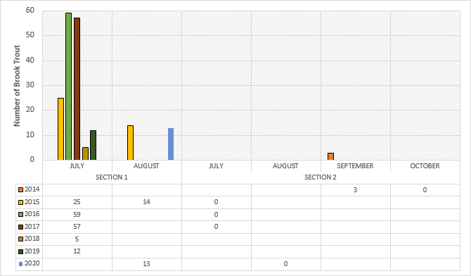
Figure 6. Brook Trout electrofishing removal results in Unnamed Tributary to Shields River at RM 60.8 from 2014-2020.

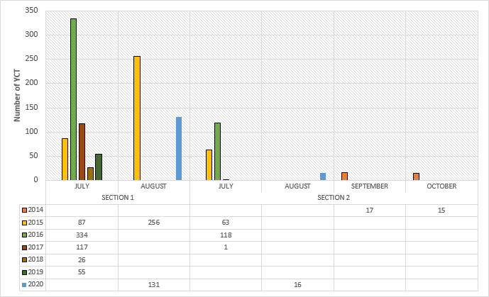
Figure 7. Yellowstone Cutthroat Trout electrofishing capture results in Unnamed Tributary to Shields River at RM 60.8 from 2014-2020.
Dugout Creek
In 2020, Brook Trout removal and YCT counts were completed in four sections of Dugout Creek. A total of 36 Brook Trout were removed and a total of 196 YCT were counted during electrofishing events. Figure 8 and 9 show electrofishing results by section in Dugout Creek over the last seven years for Brook Trout and YCT.

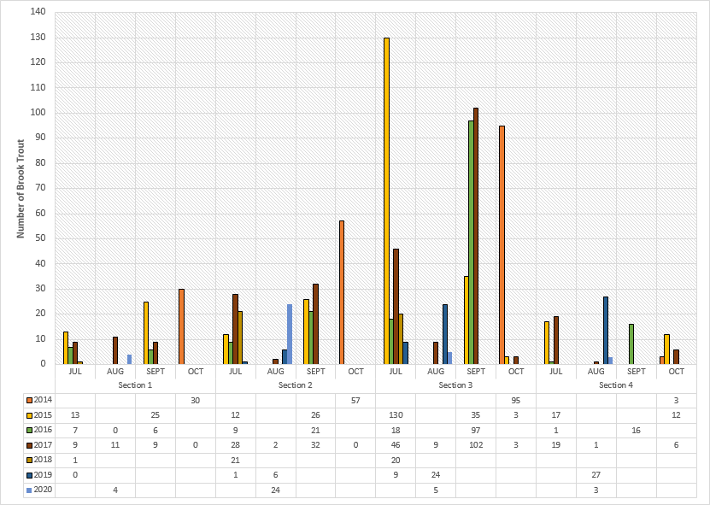
Figure 8. Brook Trout electrofishing removal results in Dugout Creek from 2014-2020.
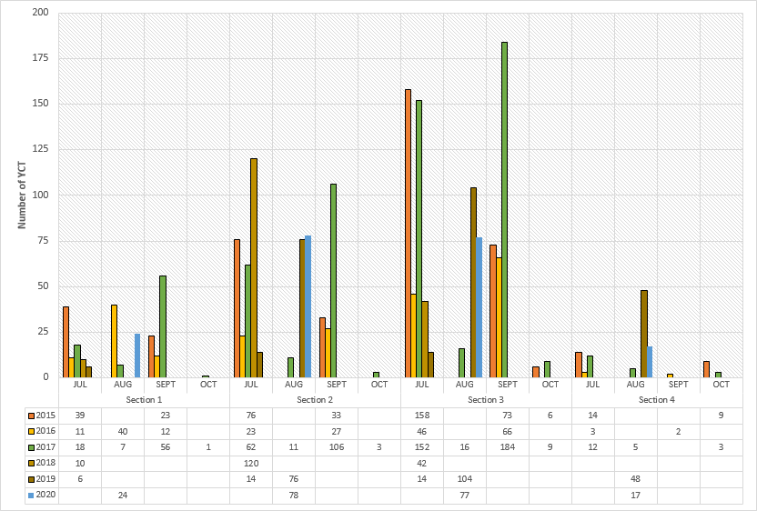
Figure 9. Yellowstone Cutthroat Trout electrofishing capture results in Dugout Creek from 2014-2020.
The number of Brook Trout removed per 100m continues to show a decrease over seven years of removal efforts. This shows that our electrofishing efforts are effective in keeping Brook Trout numbers low in some small creeks. Brook trout removed per 100m of stream has gone from 10.9 fish in 2014 to 1.3 fish in 2020 (Figure 10).

Figure 10. Brook Trout removed per 100 m sampled in Dugout Creek from 2014-2020.
In 2020, number of YCT captured per 100m of stream has remained similar to 2019 and overall been decreasing since the start of efforts in 2014 (Figure 11).

Figure 11. Yellowstone Cutthroat Trout captured per 100m sampled in Dugout Creek from 2014-2020.
Unnamed Tributary to the Shields River at RM 62.6
Brook Trout removal efforts and YCT counts were completed in 2020 in the Unnamed Tributary to the Shields River RM 62.6. One Brook Trout was removed and 118 YCT were counted (Figure 12 and 13). It’s possible that the low numbers of Brook Trout have made this tributary more desirable to YCT.
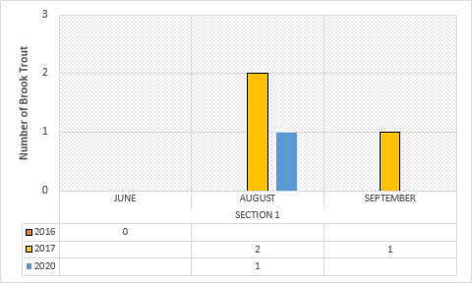
Figure 12. Brook Trout electrofishing removal results in the Unnamed Tributary to the Shields River at RM 62.6 in 2016, 2017 and 2020.

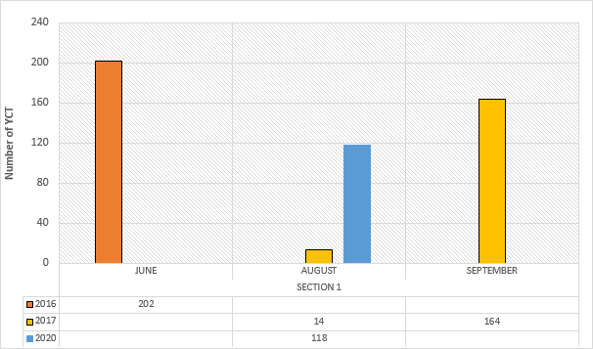
Figure 13. Yellowstone Cutthroat Trout electrofishing capture results in the Unnamed Tributary of the Shields River RM 62.6 near Lodgepole Creek in 2016, 2017 and 2020.
Fawn Creek
Brook Trout removal efforts and YCT counts took place in Sections 1 and 2 of Fawn Creek in 2020. In Section 1 a total of 15 YCT were counted and no Brook Trout were observed (Figure 14 and 15). Section 2 is located upstream of Section 1 and was sampled for the first time in 2020. No fish were observed in Section 2.
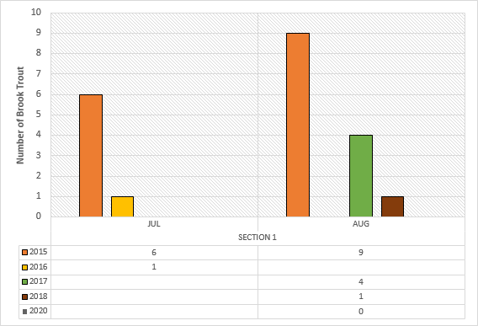
Figure 14. Brook Trout electrofishing removal results in Fawn Creek from 2015-2018 and 2020.

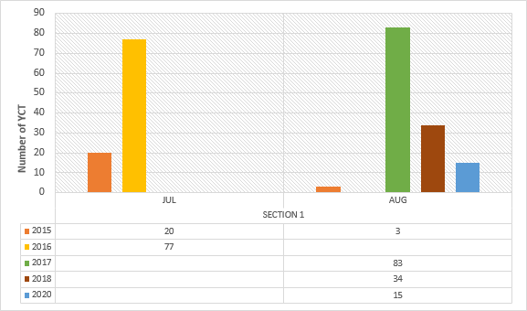
Figure 15. Yellowstone Cutthroat Trout electrofishing capture results in Fawn Creek from 2015-2018 and 2020.
Unnamed tributary to the Shields River at RM 62.8
Brook trout removal efforts were completed in 2020 in Section 1 from the mouth of this tributary up to the barrier/bedrock falls. A total of four Brook Trout were removed and nine YCT were counted (Figure 16 and 17). Both Brook Trout and YCT numbers have remained similar in this section compared to 2018. Sampling from the barrier upstream 696 meters was also completed in 2020 to confirm this section was fishless. No fish species were captured or observed above the barrier in 2020.
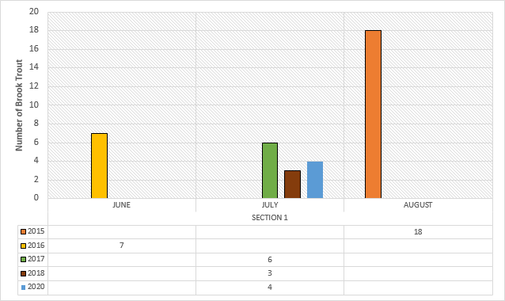
Figure 16. Brook Trout electrofishing removal results in Unnamed Tributary to the Shields River at RM 62.8 from 2015-2018 and 2020.
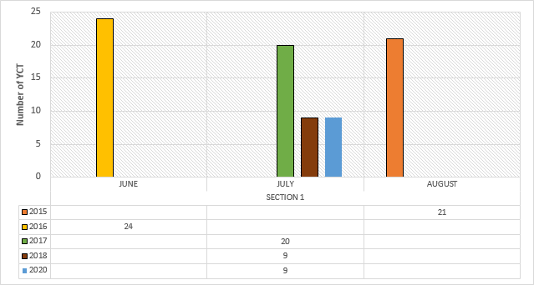
Figure 17. Yellowstone Cutthroat Trout electrofishing capture results in the Unnamed Tributary to the Shields River at RM 62.8 from 2015-2018 and 2020.
Buck Creek
In 2020 Brook Trout removal efforts and YCT counts took place in Section 2 of Buck Creek which is the section above the culvert barrier. Only one Brook Trout was removed and two YCT were counted during electrofishing efforts.
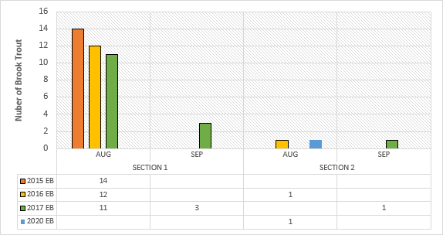
Figure 18. Brook Trout electrofishing removal results in Buck Creek from 2015-2017 and 2020.
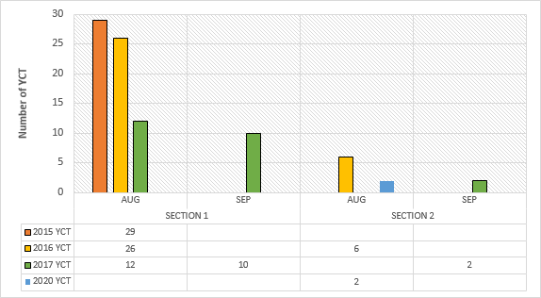
Figure 19. Yellowstone Cutthroat Trout electrofishing capture results in Buck Creek from 2015-2017 and 2020.
Hoop Trap captures in Shields Tributaries
Two hoop nets, one in Dugout Creek and one in Lodgepole Creek, were deployed in 2020 to capture Brook Trout moving upstream to spawn. Both traps were installed near the mouth of the creek on September 9 and removed on October 8. The traps were run for 27 days total (not consecutive). No fish were captured in the Dugout Creek trap and one large adult toad was captured and released. One YCT was captured in the Lodgepole Creek trap along with three sculpins. A third trap was also installed in the Unnamed Tributary to the Shields River at RM 62.6 on September 15 and removed on September 30. This trap was run for 13 days (not consecutive) and captured 18 sculpin and four YCT. No Brook Trout were captured at any of the hoop net sites.

Summary and plans for 2021
Mechanical removal of Brook Trout in the Shields River and its tributaries has shown mixed results. While removal efforts have decreased the numbers of Brook Trout over the years in some of the Shields River and its tributaries, the main Shields River still holds many sexually mature male and female Brook Trout. Not only were mature fish captured but spawning nests were observed throughout these sections of the river system. While the smaller tributaries may have limited spawning potential they could be providing safe rearing habitat for juvenile Brook Trout.
Buck Creek (Section 1), Scofield Creek, Lodgepole Creek and Turkey Creek would be potential removal locations for 2021 as they were not sampled in 2020.

